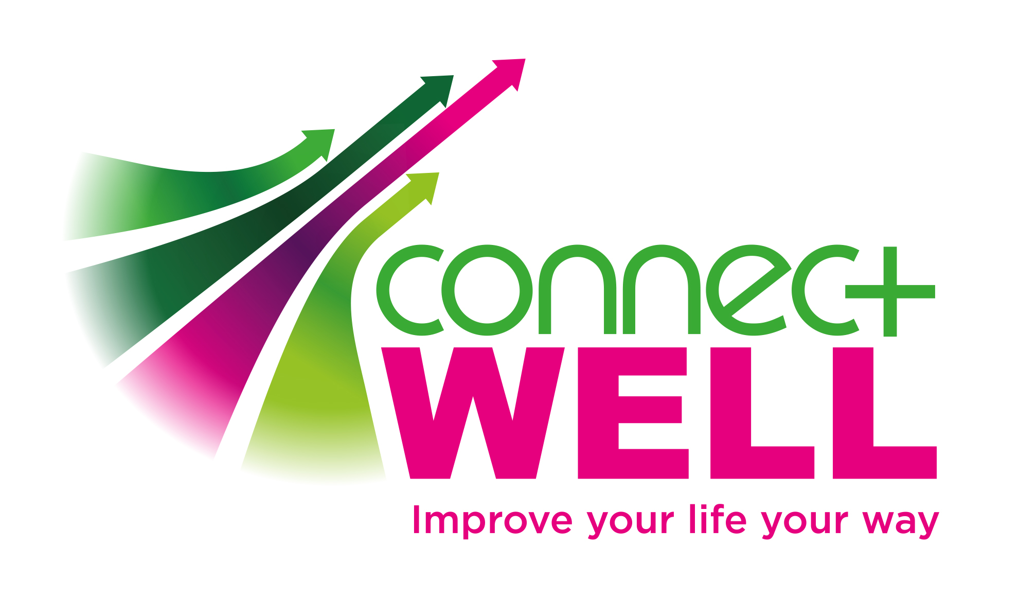

ConnectWELL – Social Prescribing Service
1 referral form to over 1000 local activities that can improve health and wellbeing

CONFIDENTIAL REFERRAL FORM - to be returned to crccg.connectwell@nhs.net
Name of Patient:  Address:  Post Code: | Contact telephone number:  D.O.B:
Date of referral:
Reason for referral:

Do you have any long-term conditions (LTCs) that you feel we should be made aware of? If yes, please specify:

I feel I would benefit from a Navigator session
(30 minute signposting session)

I feel I would from a Health Buddy
(One-to-one support to attend groups)
Would you class yourself as having a disability or any additional needs that we need to be aware of when organising your appointment:

Yes No

If yes, please specify

I confirm that I understand the service offered by ConnectWELL and have chosen to refer myself for this service.
Please tick to confirm
I am aware that ConnectWELL will hold and process my details on a secure database in accordance with data
protection regulations. I am aware that I can withdraw consent at any time by contacting ConnectWELL on
01788 539 572, for details of our Privacy Policy you can visit https://www.wcava.org.uk/connectwell. Please tick to confirm you agree
I would be prepared to take part in any marketing, case studies or one-to-one feedback if required by ConnectWELL.
Yes
No
Please be aware, that you can opt out at any time and can specify which marketing tool you do or do not want to be apart of.
Please email this to crccg.connectwell@nhs.net

For further enquiries contact: (01788) 539572

