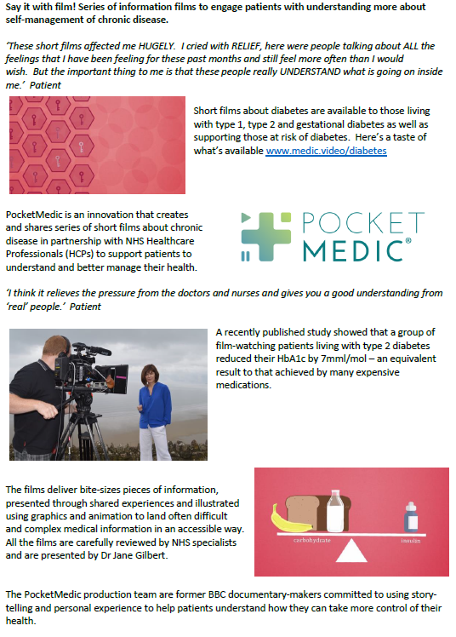 | POCKET MEDIC:  Type 1 series 2 and Attending Your Diabetes Review  We would like to ask you to watch a short series of films as part of your treatment plan.  Each film has been created by NHS healthcare professionals and patients, they are designed to help you to understand and manage your condition.  You can watch them on your mobile, tablet or PC by typing these links into the address bar at the top of your browser;  www.medic.video/cr12  www.medic.video/cr-review  You can watch them as many times as you wish and you may wish to watch them with your family and carers too.  Please could you kindly complete the very short survey after watching your videos, we do value your feedback;  https://www.surveymonkey.co.uk/r/PMCov1  If you have any difficulties accessing the films or have any comments, please email the team at;  patient@pocketmedic.org

