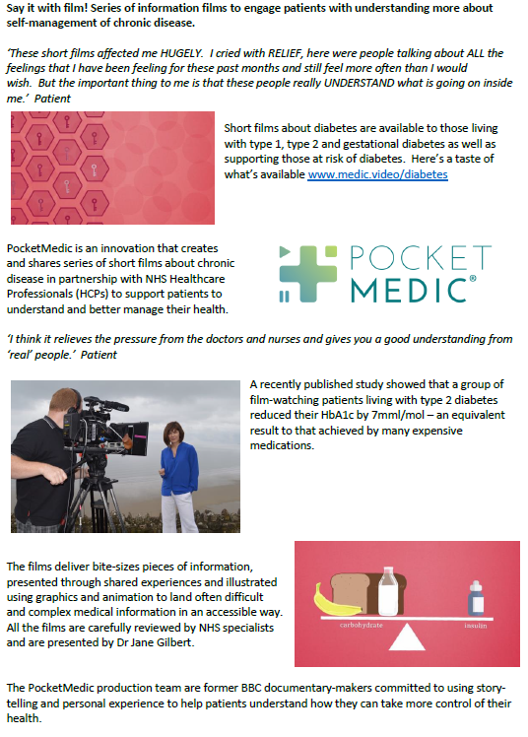 | POCKET MEDIC:  Type 2 for BAME Groups  We would like to ask you to watch a short film as part of your treatment plan.  This film has been created by NHS healthcare professionals and patients, it has been designed to help you to understand and manage your condition.  You can watch the video on your mobile, tablet or PC by typing this link into the address bar at the top of your browser;  www.medic.video/cr-bame  You can watch the video as many times as you wish and you may wish to watch it with your family and carers too.  Please could you kindly complete the very short survey after watching your video, we do value your feedback;  https://www.surveymonkey.co.uk/r/PMCov1  If you have any difficulties accessing the films or have any comments, please email the team at;  patient@pocketmedic.org

