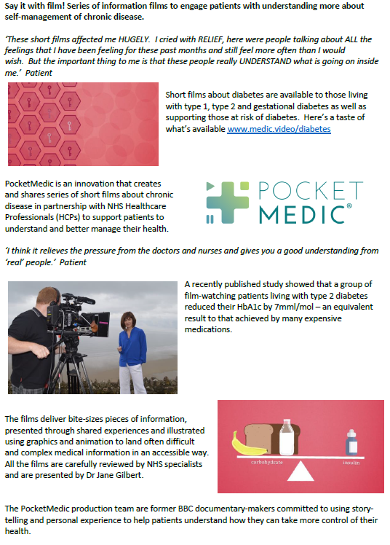 | POCKET MEDIC:  Gestational Diabetes and Attending Your Annual Review  We would like to ask you to watch a series of short films as part of your treatment plan.  These films have been created by NHS healthcare professionals and patients, they have been designed to help you to understand and manage your condition.  You can watch the videos on your mobile, tablet or PC by typing these links into the address bar at the top of your browser;  www.medic.video/cr-gest  www.medic.video/cr-review  You can watch the videos as many times as you wish and you may wish to watch them with your family and carers too.  Please could you kindly complete the very short survey after watching your video, we do value your feedback;  https://www.surveymonkey.co.uk/r/PMCov1  If you have any difficulties accessing the films or have any comments, please email the team at;  patient@pocketmedic.org

