
The Third International Consensus Definition for Sepsis
“A life-threatening organ dysfunction due to a dysregulated host response to infection.”

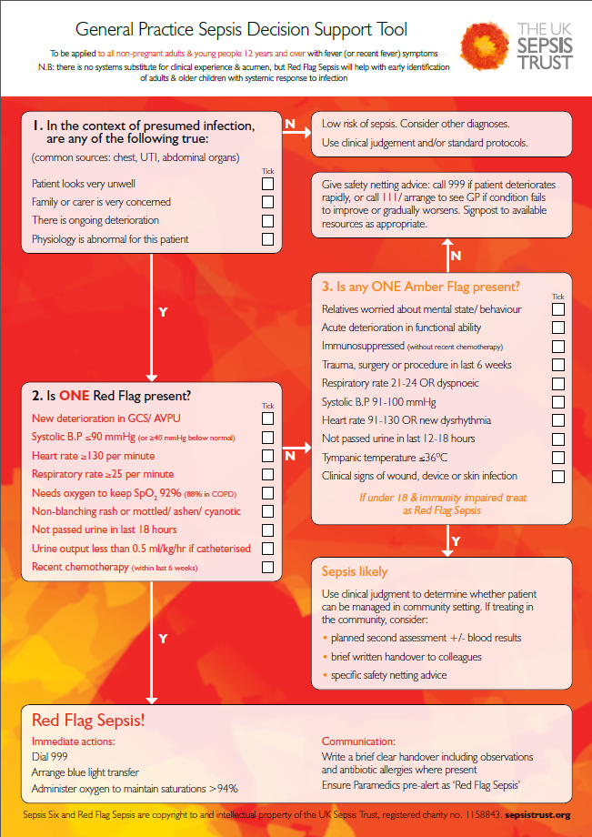
Useful sepsis screening tools can be found on the links below for the appropriate age ranges:
- General Practice for all children aged 0-4.

- General Practice for all children aged 5 to 11.

- General Practice for all patients aged 12 and over.

- General Practice; for all women who are pregnant, or who have given birth in the last 6 weeks

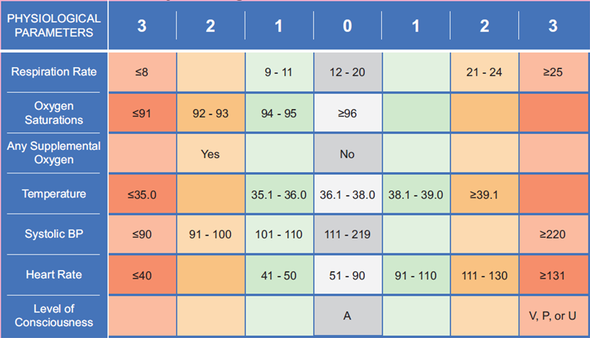
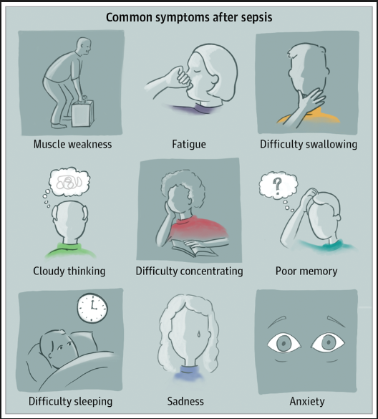

National Early Warning Score Chart (NEWS):
- National Early Warning Score: National Clinical Guideline No. 1
- New approach to NHS clinical assessment could save thousands of lives


Click here to enlarge picture:
Click below for more information
- Post Sepsis Syndrome:
- Post sepsis Syndrome:

