‘Caring for you’ page for patients to access:
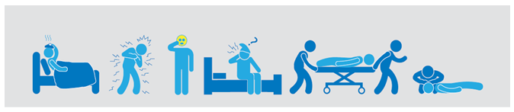
What is Sepsis?
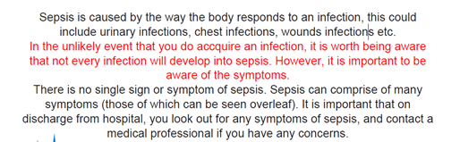

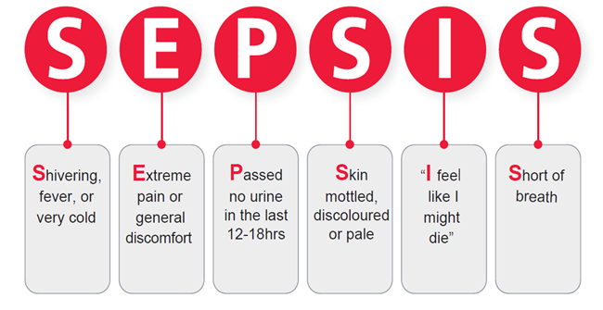
Who is at risk of Sepsis?
Anyone can get Sepsis, however some people are more at risk, these include:
- Those who are having or who have recently had treatment for cancer;
- People with diabetes (Type 1 and Type 2);
- Women who are pregnant or have just given birth;
- Those who have recently had an operation;
- People on long-term steroids;
- Those with a wound, cut or bite;
- The very young or very old;
- The immunosuppressed for any other reason (the body has difficulty fighting an infection).

Why did I get Sepsis?
Everybody is at risk of developing Sepsis however some people are more at risk than others. Those more at risk include;
- Those who are having or who have recently had treatment for cancer;
- Are diabetic;
- Are pregnant or have just given birth;
- Have recently had an operation;
- Take long-term steroids;
- Have a wound, cut or bite;
- Are very young or very old;
- Are immunosuppressed for any other reason (the body has difficulty fighting an infection).

What does Sepsis do to your body?
Initially, you may have felt like you were developing flu like illness. You may also have had some or all of the following symptoms;
- Felt very cold and shivery;
- Felt very hot and looked flushed;
- A high temperature;
- Aching muscles;
- Felt very tired;
- Sickness and diarrhoea;
- Low appetite;
- Seemed confused, drunk or had slurred speech.

Downloading letters:

Sepsis: General Information

Sepsis: A Guide for Patients and Relatives
(Could we link up these to our letters for the patients to download please)

Post Sepsis Support:
Sepsis Support Group

Sepsis Support groups are held across the country for those who have had a personal experience with and/or know of a friend or family member who has experienced Sepsis.
For further details about a support group in your area please contact the UK Sepsis Trust:

Tel: 0800 389 6255

Email: info@Sepsistrust.org
Web: http://Sepsistrust.org/support/support-groups

For details of our next sepsis support group in Coventry & Warwickshire:

Contact 02476 965132



