GP Practice
(Address line 1)
(Address line 2)
(Postcode)
(Tel No)
[Recipient Name]
[Address line 1]
Address line 2]
[Postcode]
Dear [name],
We’re inviting you to join the free Healthier You programme!
That’s because our records show that you have a history of gestational diabetes (GDM). This means you had high levels of sugar in your blood whilst you were pregnant. Even though your blood sugar levels may be back to normal now, you are still at high risk of developing type 2 diabetes in the future.
Did you know? Up to half of all women diagnosed with GDM develop type 2 diabetes within 5 years of diagnosis.
Being at risk doesn’t mean it has to happen. Many people can avoid or delay type 2 diabetes. You can lower your risk by eating healthily and keeping to healthy weight and weight size. This makes it easier for your body to manage your blood sugar levels.
About Healthier You
Healthier You is also known as the NHS Diabetes Prevention Programme and is delivered by Xyla, the commissioned programme provider. When you sign up, a qualified Xyla health coach will support you to make lifestyle changes that last. This includes helping you to manage your weight, get more active, choose healthier foods and manage stress.

- 14 sessions over 9 months. Each session is up to 90 minutes long.
- A choice of three options to participate, Tailored Remote Gestational Diabetes Group Sessions delivered online via
  - Microsoft Teams,
  - local Face-to Face groups or
  - digital 1:1 coaching via Teams.
- A helpful app with additional resources to support your journey.

If you are worried about caring for children during the sessions, please don’t let that stop you! Our Remote Online Gestational Diabetes group sessions are friendly, relaxed and flexible.

How to join Healthier You

Option A: Self-refer, with no need to speak to your GP. Just fill out the online form at https://preventing-diabetes.co.uk/gestational-diabetes/#register. You can also scan the QR code with your smart phone to access the form. You will need your NHS number, which is [NHS number]. If you can’t use the online form, call the Xyla Patient Support Team on 0333 577 3010 or email info@preventing-diabetes.co.uk

Option B: We’re happy to arrange a referral for you. To do this, call X, your Diabetes Care Coordinator on [phone number] or [email].

Meet our Gestational Diabetes Coaches
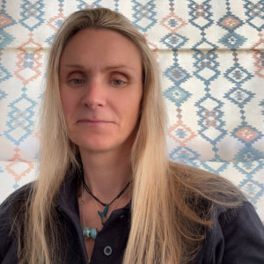
Hi, I’m Loren, a Gestational Diabetes Health Coach with a background in nutrition, diabetes prevention, and women’s health. I’m also a proud mum of two boys and someone who feels most at home outdoors or by the ocean. My own experience with endometriosis and ongoing hormonal health challenges inspired me to dedicate my career to supporting women through every stage of their health journey — particularly post-partum and through peri to post menopause, where many can feel overwhelmed navigating the changes to their health and wellbeing. My goal is to empower women to feel informed, supported, and able to thrive during these important chapters of their lives.

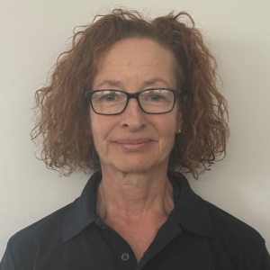
Loren Lever
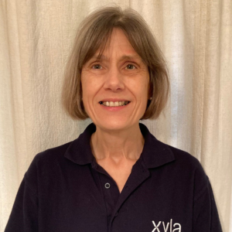
Shirley Ward Julie Watson

Remember, it’s important to have a yearly blood test at your GP practice. The test is to check the sugar levels in your blood. If they’re higher than last time, it can mean you are more likely to develop type 2 diabetes. Knowing this can help us give you the right support to help lower your risk.

For more information about diabetes, visit the Diabetes UK website at www.diabetes.org.uk.

Yours sincerely

[name]
[job title]

