PLEASE READ THIS DOCUMENT AND CALL THE TEAM IF YOU HAVE ANY QUESTIONS

Dear Patient,

You have been assessed by our Doctor as would benefit from monitoring of your respiratory condition or COVID-19 symptoms for 7 days (or longer if needed). Therefore, the Respiratory@home Team have provided you with this pack and information for you to refer to should you need.

Following the triage with our GP, you would have agreed on the best type of monitoring for your condition. These are as below:
Daily Monitoring

The Respiratory@home Remote monitoring Team will call you daily to check on your wellbeing and to pick up your readings, if applicable. At this point a follow up call from the doctor can be booked if there are any concerns.
At the end of the monitoring period, you will be asked if you are happy to be discharged, given improvement
Self-monitoring

We will not contact you during this period but if you feel like your symptoms are worsening and are facing difficulties in dealing with them, please contact us and we can book a follow up call with the GP.
A discharge confirmation text message will be sent after 7 days if no other advice has been provided by the GP (discharge call instead).

Service opening hours and contact details:

- Mon-Fri from 8am until 6pm (GP ward round between 11am-2pm)

- Sat-Sun from 9am until 2pm (GP ward round between 10:30am-1:30pm)

Mobile: 07881 359254
Landline: 02477 710 980 option 1 then 2 (different option may be available in weekends)
Email: crgpa.respiratoryathome@nhs.net

At the end of the 7-day period

You will be discharged from the service via a text message or confirmation call, followed by a survey link - we would appreciate any feedback that could help us improve.

A pulse oximeter will be provided if the GP has advised this is needed – these are not sent as standard.

The Pulse oximeter will be used to take your oxygen levels and pulse rate.

This device is for adult use only.
How to take your pulse and oxygen levels:
  - Sit down
  - Remove nail varnish or false nails
  - Switch the device on
  - Open the device and insert your finger
  - Ensure the soft part of your fingertip is over the red light inside the mouth of the device
  - Bend your finger so that the monitor is in the palm of your hand (see picture)
  - Wait 30 seconds to make sure it is reading correctly
  - Record the two numbers when you are sitting down

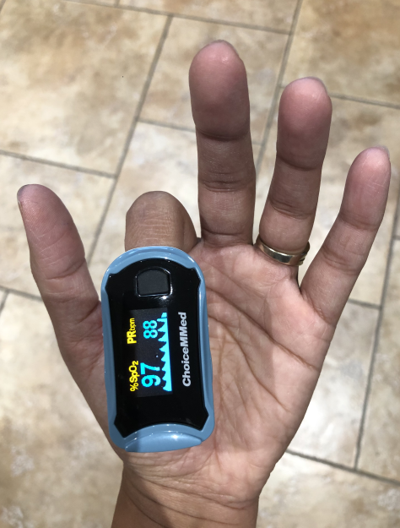
Oxygen levels
Pulse rate
Power Button

What to monitor:
You or your carer will need to take the following readings 3 times per day if possible, at approx. 8am, 12pm & 5pm and act as necessary*.

- Your oxygen levels (using Pulse Oximeter)
- Your pulse rate (using Pulse Oximeter)
- Temperature (Using own thermometer, don’t worry if you haven’t gone one)
- Are you feeling? Better/same/worse
- How is your breathing? Better/same/worse
- Log your results onto the “Remote monitoring diary”

*What to do if you experience the following symptoms:

Attend A&E within an hour or call 999 if you have one or more of the following symptoms and tell the operator if you have a positive Covid test:
- Your oxygen levels are 92% or less
- You are too breathless to complete short sentences
- Your breathing has suddenly got worse
- You feel cold and sweaty with blotchy or pale skin or a rash than does not fade when a glass is rolled over it
- You have collapsed or fainted
- You are very drowsy
- You are feeling confused or agitated
- You have stopped passing urine or are passing far less.

Red – Call 999
Severe breathlessness
Oxygen 92% or below
Confused / Collapsed
Green – Continue monitoring

Feeling stable
Oxygen 93–94%
Eating/drinking normally

Amber – Call Respiratory@home

Symptoms worsening
Struggling more than yesterday
Unable to manage symptoms

Long Covid

Many patients suffer with long term symptoms after they contracted Covid. If you experience the below for 6 weeks or longer, please raise this with a GP.

More information can be found at https://www.longcovidsos.org/

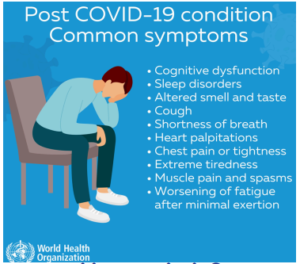

THANK YOU

Remote monitoring diary

Patient Details
First name |  | Surname
D.O.B.

Day | Time | Date | Pulse | Oxygen Level % | Temperature | Feeling: better/same/worse | Breathing: better/same/worse

