It Could be Long Covid – Communications toolkit
September 2024
Introduction
The ‘It Could be Long Covid’ campaign targets local people and communities in Coventry and Warwickshire and Primary Care staff (GPs seeing patients who have Long Covid or are presenting with symptoms that could be Long Covid).
The aim of the campaign is to increase awareness of the symptoms of Long Covid and what people should do if they are displaying symptoms (visit their GP) and what GPs should do (refer patients to the Long Covid clinic).
The toolkit provides you with key messaging for the campaign, to ensure we are consistent in our approach, as well as collateral and assets to raise awareness of Long Covid and the services available.
Included in this pack:
- Web article for external audiences.
- Newsletter article for internal audiences.
- Poster for external audiences – this is to be used to display in patient/public facing areas e.g. public rest rooms, patient waiting rooms/patient reception areas etc.
- A series of social media posts for external audiences.
Please help us to increase awareness of this campaign by sharing the resources through your internal and external channels. For any questions related to the toolkit, please contact cwicb.communications@nhs.net

Key messages
Audience | Messaging
Local people and communities in Coventry and Warwickshire | - If you have had Covid-19 and are suffering with fatigue, breathlessness, or a cough, it could be Long Covid. Symptoms also include headaches, muscle aches, brain fog, heart palpitations, and altered smell and taste, all of which can impact your emotional wellbeing.  - If you’re experiencing any of these symptoms and think it could be Long Covid, you should make an appointment to see your GP. They can carry out some tests and refer you to the Long Covid clinic.
Primary Care staff | - If you see a patient that has a clinical history for Covid-19 with symptoms like fatigue, breathlessness, or a cough, that aren’t going away, it could be Long Covid.  - Mental health and well-being can be impacted by living with Long Covid and a patient may feel anxious or low after a suspected Covid-19 infection.  - You can refer patients with a history of Covid-19 infection and ongoing/ worsening symptoms for 4 weeks to the Long Covid clinic. Before referral, patients are required to have a chest x-ray and blood tests to rule out other conditions.  - The Long Covid clinic team works with patients to create a personalised plan of support for as long as they need it.  - Following referral, patients are triaged by the service via telephone and discussed in MDT within 6-8 weeks. Patients are then followed up by the individual therapists or invited to a group therapy group.

Web article – for public facing channels

NHS encourages residents in Coventry & Warwickshire to think ‘it could be Long Covid’

The NHS is encouraging people that have been unwell with Covid-19 and who have lasting symptoms to think ‘it could be Long Covid’ and contact their GP.

Despite being post-pandemic, Covid-19 has not ‘gone away’ and even when people get over the initial illness, many continue to experience symptoms long after recovering from the virus. This condition, often called Long Covid or Post-Covid Syndrome, can affect anyone who has had Covid-19, regardless of the severity of their initial infection.
Long Covid is a term used to describe ongoing symptoms that persist for more than 12 weeks after Covid-19 and aren’t explained by an alternative diagnosis. Long Covid can affect people of all ages, including those who experienced only mild symptoms during their initial bout with the virus. While some individuals recover fully from Covid-19, others develop a range of lingering health issues, collectively referred to as Long Covid. The condition can significantly impact daily life, making it difficult for people to return to their normal routines.
If you have had Covid-19 and are suffering with fatigue, breathlessness, or a cough, it could be Long Covid. Symptoms also include (but are not limited to):

- Headaches
- Muscle aches
- Brain fog
- Heart palpitations
- Altered smell and taste

You can find out more about symptoms on the NHS website.
Dr Tim Robbins, Consultant Physician, said: “There are a broad range of symptoms that can be caused by Long COVID. If you’re experiencing any of these symptoms and think it could be Long Covid, you should make an appointment to see your GP. Even if your symptoms are mild, it’s important not to dismiss them, get them checked.
“Long COVID can impact your personal, family and work life amongst other things – support is available.
“The wide range of symptoms associated with Long Covid can be mistakenly linked with other conditions, so it's important to see your GP to be referred if appropriate.
“The clinic will provide support and guidance to help manage the impact that your symptoms’ have on your daily life, and different health and care professionals will work with you to tailor a care plan which addresses your specific health issues.”
To find out more about Long Covid click here.

ENDS

Newsletter copy – for GP Comms

NHS service to help patients with Long Covid

In March 2023, the Office for National Statistics estimated that 1.9 million people in the UK (2.9% of the population) were experiencing self-reported Long Covid symptoms.

Symptoms are fluctuating and wide-ranging, so it’s important to make sure you know the symptoms to look out for in case your patient has Long Covid.

The most common symptoms of Long Covid are:

- extreme tiredness (fatigue)
- feeling short of breath
- problems with your memory and concentration ("brain fog")
- heart palpitations
- dizziness
- joint pain and muscle aches

However, there are lots of symptoms you can have after a Covid-19 infection, including:

- loss of smell
- chest pain or tightness
- difficulty sleeping (insomnia)
- pins and needles
- depression and anxiety
- tinnitus, earaches
- feeling sick, diarrhoea, stomach aches, loss of appetite
- cough, headaches, sore throat, changes to sense of smell or taste
- rashes

If a patient has a positive Covid swab/antibodies OR clinical evidence of Covid infection + ongoing/ worsening symptoms for 4 weeks +, you can refer them to the Long Covid clinic via eRS.

A chest x-ray after Covid diagnosis (>6 weeks) and blood tests (FBC,U&E,LFT,CRP) are required.

Following referral, patients are triaged by the service via telephone and assessed within 6-8 weeks. Patients are then followed up by the individual therapists or invited to a group therapy group.

Contacting the Long Covid team:
- Coventry & Rugby Long Covid Advice and Guidance: DEM@uhcw.nhs.uk, please write in email title ‘FAO Dr.Tim Robbins Long Covid’.
- Coventry & Rugby Long Covid Rehabilitation team: 02476 961050; email Long.Covidrehab@uhcw.nhs.uk.
- South Warwickshire Foundation Trust Long Covid team: 01926 567115; email: PostcovidMDT@swft.nhs.uk.

Slide – for staff facing channels

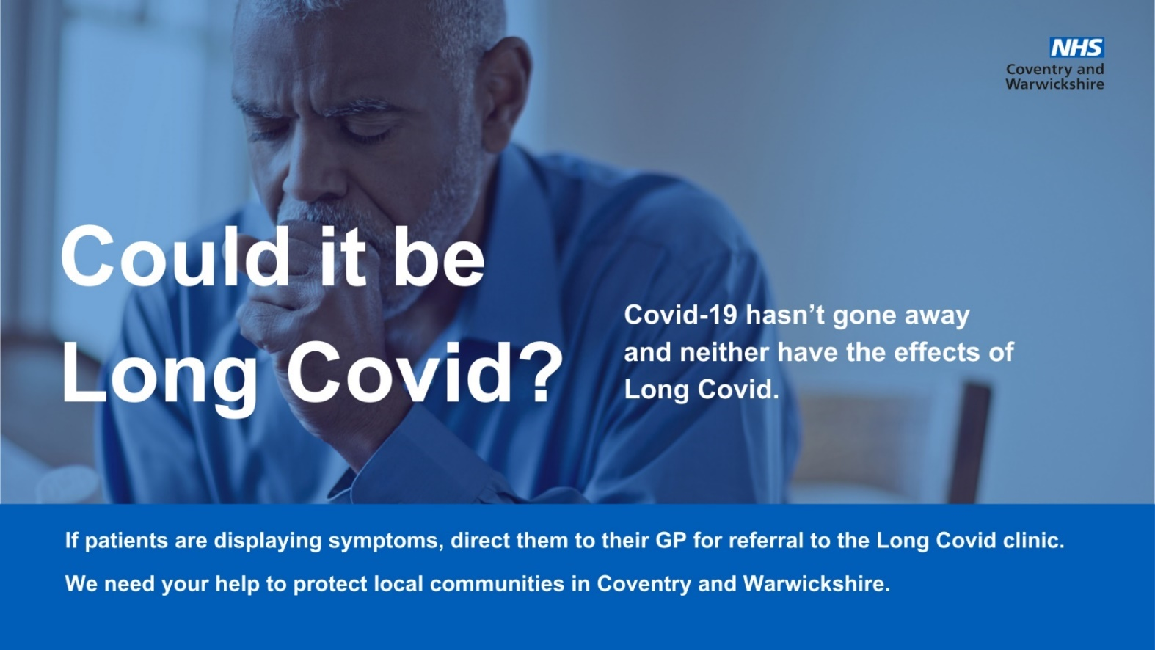

Poster for GP use

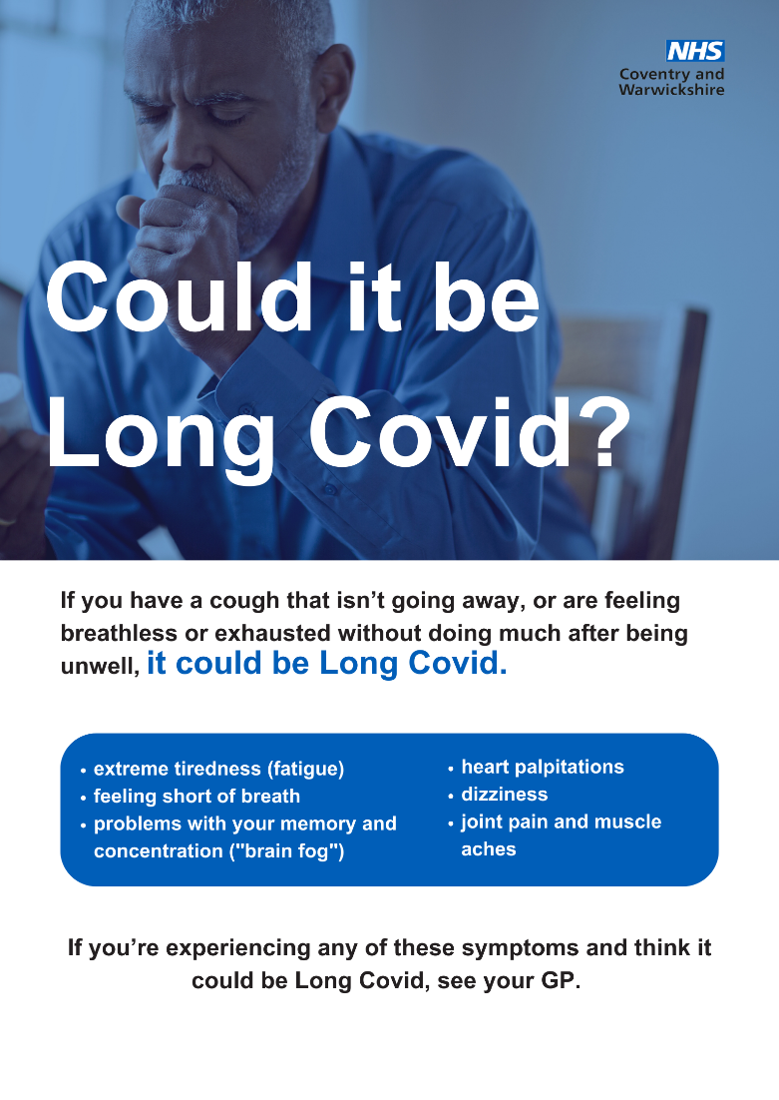

Social media – for public facing channels

Copy | Asset
If you have had Covid-19 and have a cough that isn’t going away, it could be Long Covid. If you’re concerned about symptoms, make an appointment to see your GP. Find out more about Long Covid by visiting https://www.nhs.uk/conditions/covid-19/long-term-effects-of-covid-19-long-covid/ | 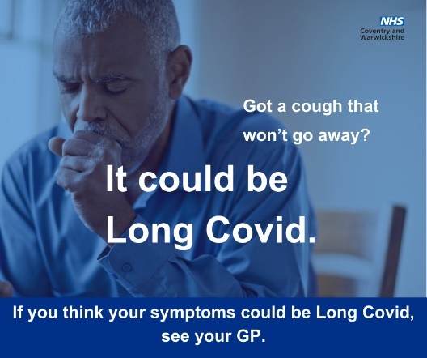
Do you get out of breath without doing much? It could be Long Covid. See your GP if you think your symptoms could be Long Covid. Find out more about Long Covid by visiting https://www.nhs.uk/conditions/covid-19/long-term-effects-of-covid-19-long-covid/ | 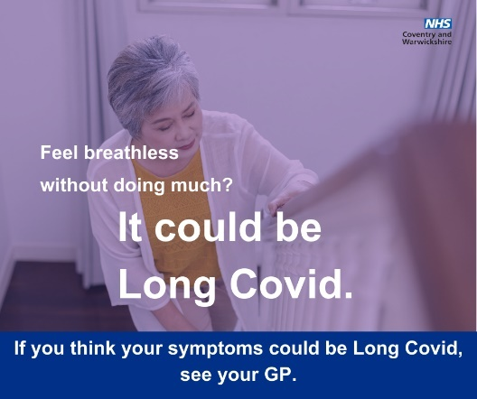
If you often feel like you’ve got no energy after having Covid-19, it could be Long Covid. See your GP if you’re concerned about persistent symptoms. Find out more about Long Covid by visiting https://www.nhs.uk/conditions/covid-19/long-term-effects-of-covid-19-long-covid/ | 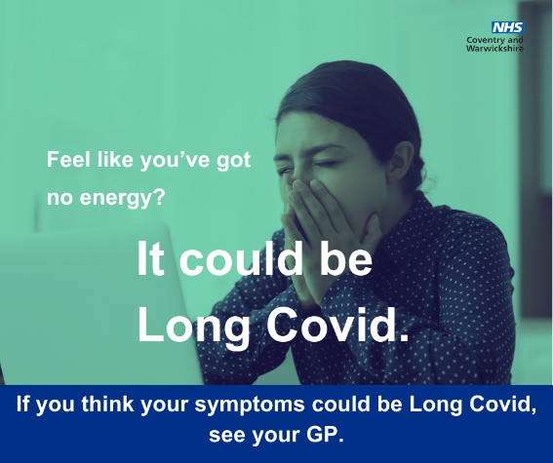
Getting a lot of headaches after having Covid-19? It could be Long Covid. If you think your symptoms could be Long Covid, see your GP. Find out more about Long Covid by visiting https://www.nhs.uk/conditions/covid-19/long-term-effects-of-covid-19-long-covid/ | 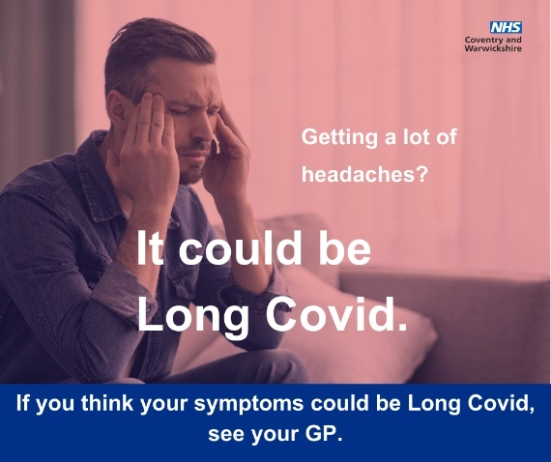
If your muscles often feeling achy after having Covid-19, it could be Long Covid. See your GP if you’re concerned about symptoms that aren’t going away. Find out more about Long Covid by visiting https://www.nhs.uk/conditions/covid-19/long-term-effects-of-covid-19-long-covid/ | 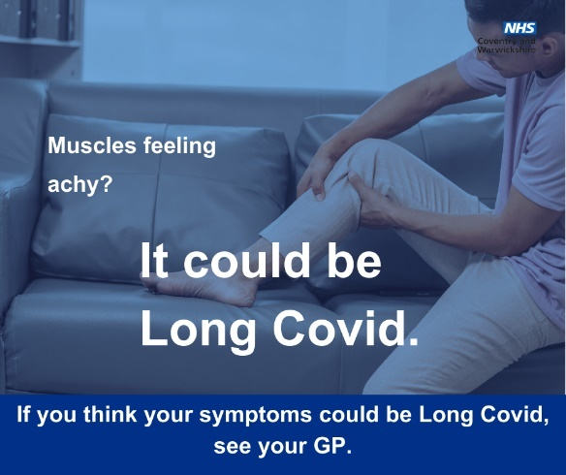
Getting heart palpitations after having Covid-19? It could be Long Covid. If you think your symptoms could be Long Covid, make an appointment to see your GP. Find out more about Long Covid by visiting https://www.nhs.uk/conditions/covid-19/long-term-effects-of-covid-19-long-covid/ | 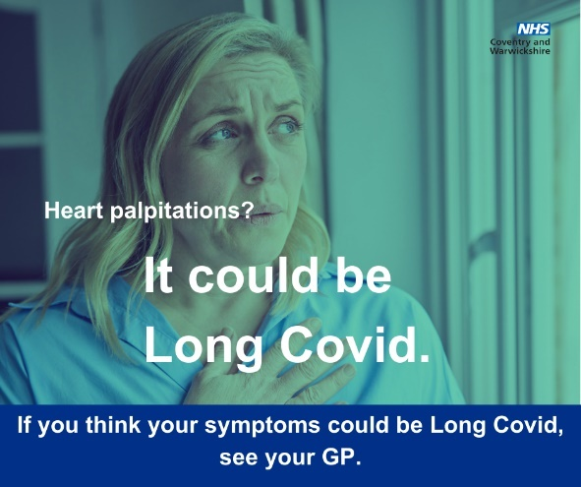
If you have had Covid-19 and are experiencing brain fog, it could be Long Covid. If you’re concerned about symptoms, make an appointment to see your GP. Find out more about Long Covid by visiting https://www.nhs.uk/conditions/covid-19/long-term-effects-of-covid-19-long-covid/ | 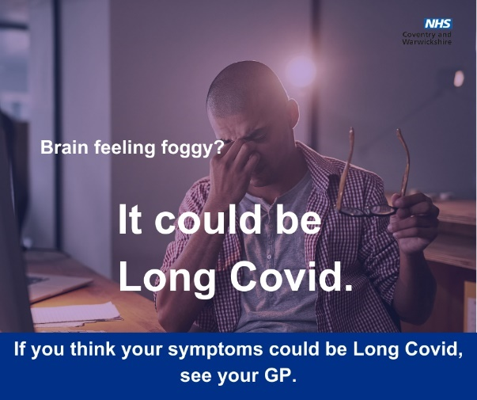
Feel like your sense of smell and taste has changed long after recovering from Covid-19? It could be Long Covid. Find out more about Long Covid by visiting https://www.nhs.uk/conditions/covid-19/long-term-effects-of-covid-19-long-covid/ | 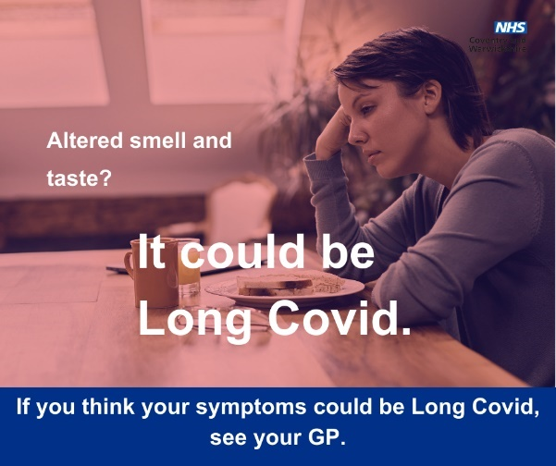
If you’re still feeling exhausted after having that bug, it could be Long Covid. If you’re concerned about symptoms, make an appointment to see your GP. Find out more about Long Covid by visiting https://www.nhs.uk/conditions/covid-19/long-term-effects-of-covid-19-long-covid/ | 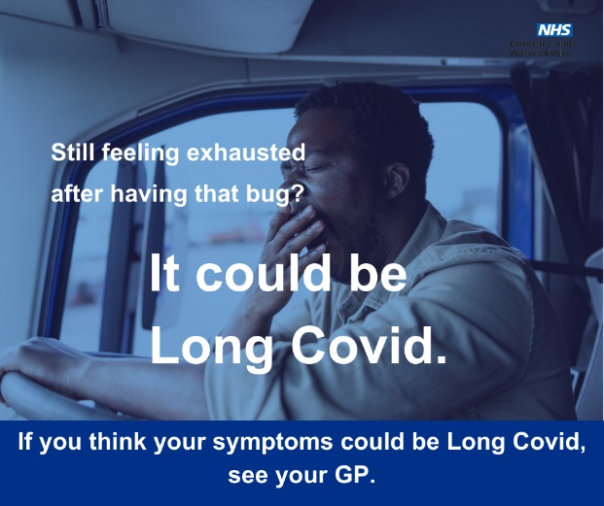

Appendices

FAQs:
What we offer:
A period of education, support and guidance to help manage long covid symptoms’ impact on daily life, including:
- fatigue management
- breathlessness management
- optimising rest and recovery
- cognitive strategies
- advice on self-care, e.g. sleep
- emotional well-being
- guidance about managing work, exercise and other daily activities
- optimising nutritional intake
This is achieved through 1:1 or group sessions.
We may liaise with other services involved in your care to support your recovery. People with severe symptoms, or the suggestion of other underlying conditions are jointly managed with medical doctors.

Specialities in the Long Covid Service include:
Occupational Therapy (OT): OT aims to support people to engage in the activities, roles and routines that are important to them, at home, at work and in community and leisure settings. This often involves fatigue management advice.
Physiotherapy: Physiotherapy aims to support you to maximise your function. This often involves advice around managing breathlessness.
Psychology: Aims to provide psychological support to help you manage any changes in your life after having Covid.
Medical management: Consultant review is available within the service.
Dietitian: (SWFT service only, not Coventry & Rugby service) Dietitians assess dietary intake and advise on ensuring a well-balanced diet. We also advise patients with gastrointestinal issues, reflux, weight loss, poor appetite, type 2 diabetes, weight management and smell and taste changes.

Where to find us:
South Warwickshire service: Stratford Healthcare, Arden Street, Stratford Upon Avon, Warwickshire, CV37 6NQ
Coventry: Newfield House, Kingfield Road, CV14NZ, for consultant review, UHCW
Rugby: St. Cross Hospital

Useful Links:
SWFT LC service webpage: https://www.swft.nhs.uk/our-services/long-covid-service - onward links to further useful information within this page.
Coventry & Rugby referral info on GP gateway: POST COVID SYNDROME (Adult) UHCW – GP Gateway (coventryrugbygpgateway.nhs.uk)
Coventry & Rugby Long Covid rehabilitation team link: Long Covid Rehabilitation Service - University Hospitals Coventry & Warwickshire (uhcw.nhs.uk)
General links:
Long-term effects of COVID-19 (long COVID) - NHS (www.nhs.uk) (opens in new window)
Recovering from COVID-19: Post viral-fatigue and conserving energy - RCOT (opens in new window)
Post-Covid-Syndrome-breathing-final.pdf (physiotherapyforbpd.org.uk) (PDF) (opens in new window)
Post-Covid Syndrome resources | CPFT NHS Trust (opens in new window)
https://www.plymouth.ac.uk/research/dietetics-and-health/covid-knowledge-hub/patients (opens in a new window)
Coventry Muslim Forum - Join us in building a brighter future for our community (opens in new window) Links to translated awareness videos at bottom of page
Translations | NHS inform (opens in new window) Leaflets on Long covid in multiple languages.
PATIENT LEAFLET | Long Covid SOS (opens in new window) : Managing Long Covid: A Practical Support Guide for Patients Planning a GP Visit

