Information for Referrers – Urgent Suspected Skin Cancer referrals

Urgent suspected skin cancer referrals will be reviewed to determine the patient’s suitability for teledermatology pathway. To ensure patients are booked the correct appointment, the teledermatology criteria on pg. 1 of the referral form must be fully completed.
Below is a system-level overview of the teledermatology pathway, including possible outcomes following consultant review of images, medical history and any further information collected at the image capture appointment.
NOTE: Trusts may differ in local process (e.g., appointment booking process, method of communication of outcome following review). Trust specific information will be provided to patients at the image capture appointment. Patient may be contacted (virtually, telephone) prior to further referral or procedure being booked, dependant on local process and individual patient circumstances.
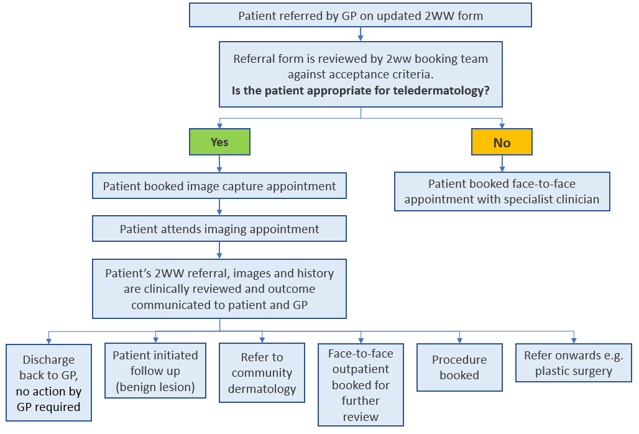
Patient information on the teledermatology service can be found here

FAQs

Who isn’t appropriate for teledermatology?

The additional information in the referral form supports risk stratification of patients, with higher risk patients excluded from teledermatology and continuing to be offered a first appointment with a specialist clinician which is face-to-face. Patients also have the choice to decline teledermatology.
Exclusion criteria for teledermatology pathway
About the patient
< 16 years old or > 70 years old
Skin type 5 or 6
Patient has a condition known to increase risk
- High risk e.g., atypical mole syndrome (dysplastic nevus syndrome), albinism
- Genetic risk e.g.., known carrier of CDK4 gene
- Family history/family known to dermatology service
Patient is immunosuppressed
Patient is unable to mobilise safely
Patient unable to provide informed consent
Patient declines teledermatology service
About the lesion(s)
More than 2 suspected lesions
Lesion(s) is genital, palmar, plantar or nail
Lesion(s) is open or wet
Lesion(s) needs to be redressed by a health professional
Lesion(s) fully excised or suspected recurrent, including partially treated melanomas.
- e.g. suspected recurrent or partially treated
Lesion(s) previously reviewed by teledermatology service
Already confirmed melanoma, SCC following GP referral for biopsy
GP has requested a full skin check

Why is skin type a criterion for teledermatology?

It is recognised that lesions may be more challenging to assess and diagnose in patients with brown or black skin when assessed using images. As such, patients with skin types 5 or 6 (Fitzpatrick scale) will follow a face-to-face pathway and are excluded from the teledermatology pathway.
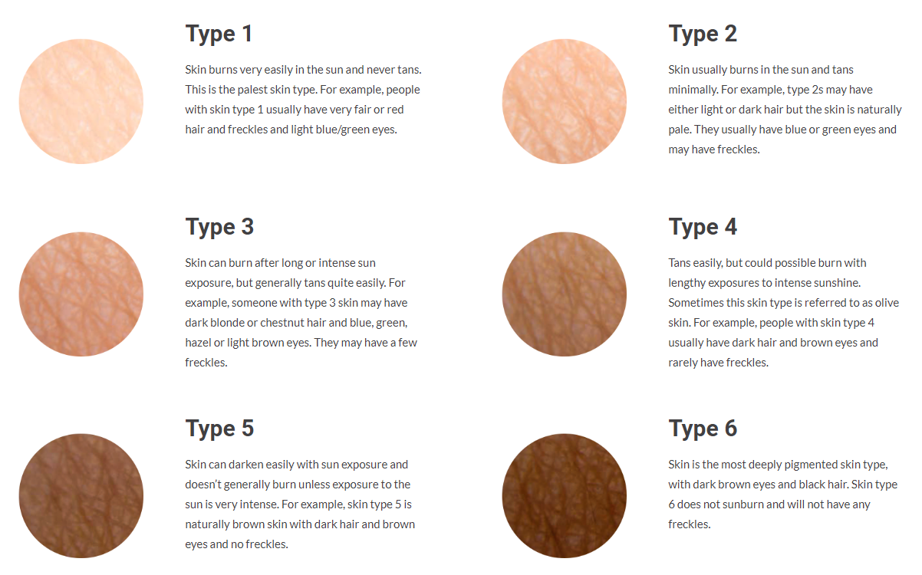
Skin of Colour - BAD Patient Hub (skinhealthinfo.org.uk)

Immunosuppression
Immunosuppression has been included in the previous 2ww wait form and increase in risk for skin cancer is determined by the referrer. Additional information regarding a patient’s condition should be included as ‘any additional clinical information.’

Already confirmed melanoma, SCC following GP referral for biopsy
If the lesion is already known to be cancer (GP referred biopsy or private), a face-to-face appointment is required.

Why are patients with more than 2 lesions excluded?
This is related to the time allotted for each image capture appointment. It is not possible to photograph more than 2 lesions in a single appointment.

Why are some lesion sites excluded?
Genital lesions are excluded due to the sensitive nature of the location. Palmar, plantar and nail lesions are excluded due to the difficulty of photographing these sites.

What can a patient expect at an image capture appointment?

- Patients will not see a clinician member of the dermatology team at this visit. The medical photographer or health care assistant will not be able to provide information/clinical assessment of the lesion.
- Patient will be booked an image capture appointment by the 2ww booking team. An appointment will be offered to a patient within 7 days of the referral being received.
- This appointment will take place at a Community Diagnostic Centre, community or acute hospital or other health site. The location will be identified when appointment is booked.
- The appointment will take approximately 20 minutes. Photos will be taken by either a medical photographer or specially trained health care assistant. Patients may be asked for further details regarding their medical history to ensure referral forms are complete.
- Photographs will be securely saved to the patient’s confidential medical record. Patient consent will be confirmed prior to any photographs being taken.
- Patients can expect to be given information at their image capture appointment regarding what happens next – time frame expected for a clinician to review their referral and images, possible outcomes of the review and how they will be contacted with that outcome. This is dependent on local Trust processes.

If a patient is discharged back to GP after review of referral and images, what information will the GP receive?

A discharge letter will be generated following the review of the referral and images as would occur following a face-to-face appointment in the standard pathway. GPs can expect to receive the same information as included in a discharge letter including diagnosis.
The discharge letter will also remind GPs that should any future concerns arise regarding the lesion(s), it should be noted in the referral that the lesion was previously reviewed by teledermatology as this would exclude the patient from the teledermatology pathway.

What information is helpful to include as ‘additional information’?

Additional information may include:
- History of blistering sunburns on the affected site and/or multiple sunburn episodes
- Use of sunbeds
- Occupational sun exposure – outdoor working
- Previous skin cancers (BCCs/SCCs)
- Transplants or on immunosuppression

