URGENT SUSPECTED CANCER (USC) REFERRAL FORM
HEAD & NECK
This referral is made on the basis that the referring doctor considers that the patient has clinical indications of a new malignancy and mindful of NICE Guidelines
All USC referrals should be made through the NHS eReferral Service.
(Adults over 16 years)

UR
GEN
T

SUSPECT
ED

CANCER

R
E
F
E
R
R
A
L

S
E
R
V
I
C
E

Clinical Narrative – Essential.
Supportive clinical information and examination findings on presentation and why you feel the patient may have cancer.
Your opinion is important: This field must be completed before form can be sent
Free Text

Risk Factors for Head and Neck Cancer
Previous Cancer (head, neck, thyroid or mouth) |  | ☐
Smoking? | Pulled from EMIS
Alcohol? | Pulled from EMIS
Family history of thyroid cancer | ☐
Family history of endocrine tumour | ☐
Previous radiotherapy to neck | ☐

Referral Criteria - at least one symptom/feature box must be marked ‘X’ to accept the referral

Throat |  |  |  |  | Oral cavity
Symptom/sign |  | ‘X’ |  |  | Symptom/sign | ‘X’
Unexplained hoarse voice for more than 3 weeks (age over 45) |  |  |  |  | Unexplained ulceration of the oral cavity lasting more than 3 weeks
Unilateral tonsil swelling and/or ulceration associated with unilateral throat pain for more than 3 weeks |  |  |  |  | Assessed by a dentist/doctor as having a red or white patch in the oral cavity consistent with erythroplakia/ erythroleukoplakia
Neck Lump |  |  |  |  | 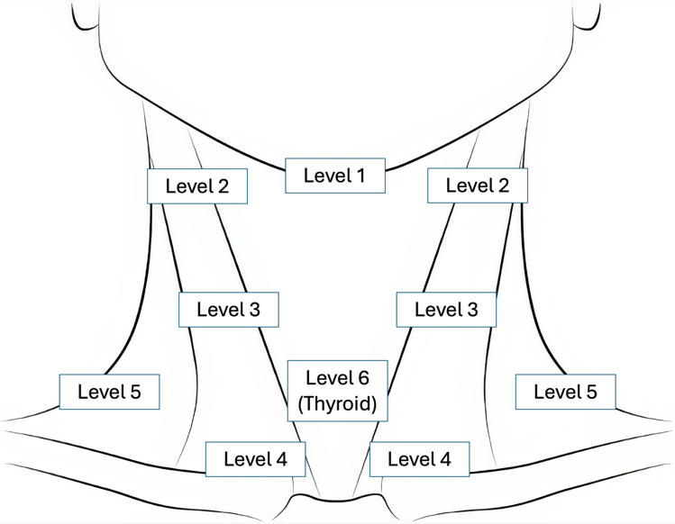
Thyroid/Salivary gland | ‘X’
Unexplained new onset lump in the thyroid
(please send thyroid function tests within the last 3 months)
A concerning lump of the salivary glands
New lymph node | R/L |  | 1-6
Using the diagram as a guide, please indicate the side and level of the neck node that has been present for over 3 weeks

Suitability For Diagnostic Tests
Does the patient’s mental capacity fluctuate ☐ YES ☐ NO ☐ NOT KNOWN
Patient must have had U&E’s within three months for contrast CT ☐ YES ☐ PENDING

Access Needs (to aid clinical triage)
Performance Status – W.H.O Grade
0 ☐ Able to carry out all normal activities without restriction.
1 ☐ Restricted in physically strenuous activity. Able to walk and do light work.
2 ☐ Able to walk and capable of all self-care. Unable to work. Up and about more than 50% of waking hours.
3 ☐ Capable of only limited self-care. Confined to bed or chair more than 50% of waking hours.
4 ☐ Completely disabled. Cannot carry out any self-care. Totally confined to bed or chair.
Interpreter required YES ☐ NO ☐ If so, language:
Dementia/Learning Disability/Mental Health/other issues that may impact engagement or access YES ☐
Details of access needs and reasonable adjustments free text

Please tell patient this is an urgent suspected cancer referral
I have provided the patient with urgent suspected cancer information (leaflets available to order CRUK website) or urgent cancer referral information sent on Accurx |  |  |  | ☐
Are there any dates in the next two weeks where the patient is not available? *free text
Patient Details |  | GP Details
Title:
Surname: |  | Name:
Forename: |  | Address:
Address: |  | Practice Code:
NHS No. |  | GP Code:
Date of Birth: | Auto pull through | Surgery Phone: | Auto pull through
Phone: | Auto pull through | Surgery Email: | Auto pull through
Email address: | Auto pull through
Sex assigned or registered at birth:
Is the patient transgender?
How can we communicate time and date of this urgent appointment to the patient?
Contact telephone number: | Auto pull max 3 numbers
Please attach the practice print out for medication, past medical history, repeat medication, allergies, BMI, recent investigations. (pulled from EMIS)

Medication ……………………………………………

Allergies…………………………………………………

Contact Information
University Hospital Coventry & Warwickshire | Cancer Services Team:  Via Switchboard  02476 964000  Booking Centre  0800 252060 | For emergency medical advice only – On Call ENT Resident On-Call/On-Call Consultant via Switchboard 02476 964000
South Warwickshire University NHS Foundation Trust | Cancer Services Team:  Via Switchboard  01926 495321 Ext 8622/8690

