Latest information for practices
System Gynaecology 2ww Update
The ICB Cancer Transformation Team has worked closely with Trust leads over the past few weeks. The Trusts have received an increased volume of 2ww referrals, for patients with PMB related symptoms. Education sessions have been delivered across C&W however the team felt it would be beneficial to remind colleagues of the Back to basics Menopause and HRT (cwtraininghub.co.uk) (password CWEducation) education session delivered last year. A summary of the pertinent topic areas (indicated with a *) and timings can be found below:
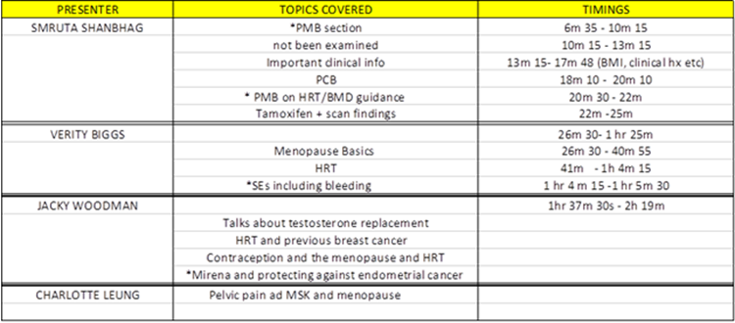

Primary Care Gynaecology service
Please be reminded that the latest Gynaecology 2WW form is available via Gynaecology 2WW – GP Gateway (coventryrugbygpgateway.nhs.uk)

In addition please see link for an information pack on the C&W Primary Care Gynaecology Service.

The Obstetric Gynaecologist – Menopause and Mental Health
The article attached has been recommended by Secondary Care as a further education article for Primary Care colleagues

Colposcopy waiting list backlog at GEH
The Trust has commissioned an insourcing company to reduce the current backlog. It is anticipated this will commence early September for a period of 8 weeks. We will continue to keep you updated.

Instability with Dermatology services at Worcestershire Acute Hospitals NHS Trust (WAT)
Please see below a communication that may be relevant especially to GP practices on the border with Worcestershire, in respect of instability with Dermatology services at Worcestershire Acute Hospitals NHS Trust (WAT) and advice around assistance the Trust is receiving from our Community Dermatology provider, Health Harmonie.

You may be aware that there is some instability at present in the Dermatology provision at Worcestershire Acute Hospitals NHS Trust (WAT) and there is currently a huge amount of work going on in the background to mitigate this. With immediate effect, Health Harmonie (who had been providing Herefordshire & Worcestershire ICB’s community Dermatology service) will provide a single point of access for all general, secondary care dermatology referrals. All new referrals or any advice and guidance requests for patients choosing to access Worcestershire services (i.e. likely because they live on the border with Worcestershire), should be sent, via eRS, to Health Harmonie. WAT will no longer accept new general dermatology referrals or requests for advice and guidance until further notice. Those patients already referred to WAT will shortly be contacted and advised of their treatment pathway. Please note that any 2ww referrals for patients choosing to access services in Worcestershire may continue to be referred to WAT via the usual 2ww pathway.

We will endeavour to keep you informed of further key pathway changes as and when they happen, we apologise they may be at short notice, as this is, given the nature of the situation.

Information for the public on industrial action
Please see NHSE link regarding information on upcoming industrial action.For more information on what the NHS is doing to mitigate the impact of the strikes please visit this link.

Respiratory Physiotherapy Outpatient services at George Eliot Hospital
Please see latest information attached on Respiratory Physiotherapy Outpatient service at GEH, for patients in North Warwickshire. You can also download the referral form here.

Reminder about Glucagon Like Peptide-1 Receptor Agonists (GLP-1 RAs)
Due to the ongoing national shortages of GLP-1 RAs, please remember the following key points from the MSN MSN_2023_061 GLP1 Receptor Agonist .

· Avoid new initiation of GLP-1 RAs
· Patients should not be switched between brands (injections and oral)
· Review need for GLP-1 RA and stop treatment
· Do not double up on doses of lower dose preparations
· Support people to access structured education and weight management programmes where available
· A clinical prioritisation list is provided to help support proactive management, along with an algorithm for selecting alternative glucose lowering therapies

Enabling primary care professionals to easily identify and connect with patients eligible to take part in clinical trials
EMIS Recruit
Recruit is a portal for research studies, embedded in EMIS Web, that uses advanced analytics and algorithms to surface eligible patients within your organisation, making it quick and easy for clinicians to engage and recruit potential patients for research studies.

Activate Recruit for your organisation for FREE
· Embedded in EMIS Web, Recruit is a completely free tool that allows your practice to identify and contact eligible patients for clinical trials recruiting in your area.
· Recruit is available via the Portals module in the EMIS Web main menu.
· The portal will give authorised users visibility of study details, inclusion and exclusion criteria, the value per patient to the practice and the number of potentially eligible patients at your practice. Once the list of potential participants has been generated, using the portal, you can also send direct invitations to patients via SMS message.
· If you have not yet activated Recruit, we’ve outlined the steps here to get you up and running.

Accelerating Citizen Access Programme Reminder
Following the Change to GP contract in 2023/24 for new/ prospective health information to be made available to all patients by 31 October 2023, EMIS practices can ‘book your slot’ for prospective record access enablement by completing the opt-in form and selecting an available date – there’s still time to request enablement in September (deadline 23rd August) or October (deadline 20th September), when EMIS will update access rights on behalf of practices. If EMIS practices do not take advantage of these enablement dates, then they will have to enable patient access manually – clinicians have reported that this takes on average 1 minute per patient.

Please submit your form in good time to avoid missing out on the remaining slots available. We will work through any required preparatory steps with you and guide you through the process.

Please note that be completing this form you will have a selection of dates to ‘go-live’ it is not automatic as the GP checklist is needed to be completed prior to going live.

See the latest updates section on the Access to patient records page.

Practices should:
Check global (organisation) configuration for online servicesagainst guidance screenshot to ensure correctly configured.
Ensure they resolve bulk application of the SNOMED CT exclusion (‘104’) code by checking out the following resources which outline the different scenarios and results when using the enhanced review and online access SNOMED CT codes in a patient's GP record: SNOMED guidance and 104 SNOMED Bitesize videos
GP checklist and bitesize videos - highly recommended by practices
FutureNHS online resources - FAQs, safeguarding, training

Electronic Patient Registration
Members of the public can now search specifically for a GP surgery offering the online registration service by using Find a GP. They enter their postcode and GP surgeries offering online registration will be clearly marked, for more information please see attached.

Training, events & surveys
Learning Disability Friendly Badge for GP Practices
On Wednesday 6 September we will be launching the Learning Disability Friendly Badge, a brand-new accreditation for GP practices in Coventry and Warwickshire.

The Learning Disability Friendly Badge has been developed alongside GPs and local charity Grapevine. It is designed to highlight and award the fantastic work already happening within primary care to make practices a welcoming place for people with a learning disability, and to those providing the best possible personalised care.

To be awarded the accreditation, GP practices will need to apply, demonstrating that they meet the following criteria:
1. The GP practice has an identified Learning Disability Champion
2. People with a learning disability receive personalised care
3. People with a learning disability receive high quality Learning Disability Annual Health Checks that improve their health outcomes
4. The GP practice makes reasonable adjustments to enable easier access and improve patients’ experience of their care.

Join us from 12-3pm on Wednesday 6 September in the Nightingale Room at Westgate House to find out more. To book your place head to: https://www.eventbrite.com/e/learning-disability-friendly-badge-launch-nhs-coventry-and-warwickshire-tickets-692330768967?aff=oddtdtcreator
Supporting ICBs to adopt the Register with a GP surgery service webinar resources
Join our next webinar
Registration is now open for our next webinar on 20 September.
Newsletters
EMIS Update
The latest edition of EMIS Newsletter is available, see attachment for latest updates in the world of EMIS Web in primary care, including new releases, latest functionality, content and services that GP Practices need to be aware of!
Vacancies
None.

