

Latest information for practices Trainings, events & surveys Newsletters Vacancies



Latest information for practices
UHCW Waiting Lists
UHCW are about to commence a piece of work to validate their waiting lists. Patients on in and out patient waiting lists will receive a text message, with a link notification to access a patient hub facility which will look like this https://patienthub.uhcw.nhs.uk

UHCW are about to launch a range of communications so that patients are made aware that these texts are not SPAM. If any patients or relatives contact your service please can you reassure them that this is a legitimate piece of work and that they would be grateful for a response. Many thanks.

If you have any queries please contact Merlisa at merlisa.dejesus@uhcw.nhs.uk

Prescribing Incentive Scheme 2023/2024
A new 9 month prescribing incentive scheme has been launched and practices are invited to sign up to the scheme by 31st June 2023. The scheme offers £1 per registered patient and has an engagement, planning and delivery of 3 quality/prescribing efficiency projects along with a financial component, focussing on reducing prescribing spend. Further details can be found in the attachment and please direct any questions to cwicb.mot@nhs.uk or your named ICB Medicines Optimisation (MO) pharmacist.

A reminder also that the current (2022/2023) prescribing incentive scheme is due to finish on 31st May 2023, so please don’t delay in uploading your evidence if your practice chose the self-care or respiratory quality incentive scheme options.

Prescribing Efficiencies/Quality indicators prescribing support
The ICB Medicines Optimisation (MO) team will be extending support to Warwickshire practices to help deliver a programme of prescribing efficiencies in a number of therapeutic areas including respiratory, mental health/CNS, diabetes and pain management. This will not only help practices to achieve expenditure within budget, but will also support a reduction in prescribing spend, which will be particularly helpful for practices that have signed up to the 2023/24 prescribing incentive scheme. The MO team will also be available to discuss your individual practice prescribing quality indicators dashboard results and provide expertise to help support practices to improve any of their chosen indicators. Each practice will be allocated a named ICB MO pharmacist and pharmacy technician who will be in touch with you over the forthcoming months.

For Coventry and Rugby practices your previously allocated pharmacist and technician will remain the same. If you have any questions about this please don’t hesitate to contact us on cwicb.mot@nhs.net

OFFICIAL: Hot Weather Guidance for Care Homes
UKHSA have produced hot weather guidance for care homes (published today)
Supporting vulnerable people before and during hot weather: social care managers, staff, and carers - GOV.UK (www.gov.uk)

Personal Health Budget leads – network with your peers
Sam Wisdom, Personal Health Budget Lead Nurse at Birmingham and Solihull ICB, is looking to network with PHB teams in other areas and explore the differences (or similarities) in approaches. Please email samantha.wisdom@nhs.net if you would like to join in the discussion.

Removal of the Panic Button in EMIS Web
As you have been made aware that EMIS will be removing the EMIS Web panic button functionality for all customers, beginning in June 2023. EMIS had recommended practices consider alternative arrangements and there are a number of specialist providers who provide both hardware and software solutions for emergency scenarios.

The ICB is addressing the situation by looking into the possibility of a systemwide purchase for economy of scale, it is being reviewed by the GP IT Strategy Group and the ICB is aware of timescales and will provide an update to practices as soon as possible.

NHSmail Online Archiving Reminder
Practice Users have given very good feedback on NHSMail Online Archiving and are making use of the extra storage facility.

Using the online archive gives at least an extra 100GB of storage, that’s 25 times more than the standard inbox. That’s particularly useful for someone with a lot of files in their inbox

- Online Archiving is a solution that enables you to store and manage older or legacy emails outside of your primary mailbox – freeing up quota space and improving Outlook performance
- Users are able to manage their own individual archiving setup to best suit their needs
- At the moment 100GB of automatically expandable online archiving storage space is available, alongside your standard 4GB mailbox
- Under your primary mailbox, there is a folder called ‘Archive’
  - it is important that users do not use this when attempting to move content into the Online Archive
- Exchange Online Archiving Guidance and FAQs – NHSmail Support

Your NHS-Mail .net account also gives you access to Office365 over the web, by logging in via www.office.com

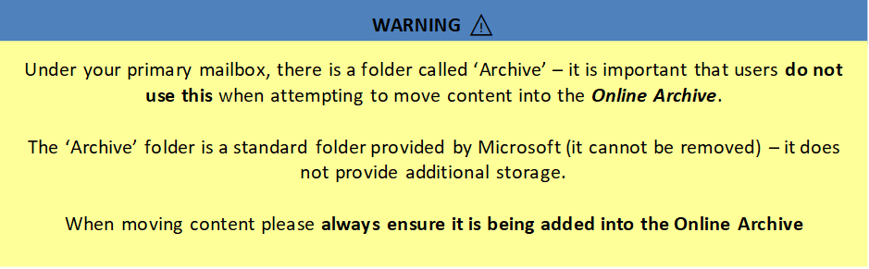

Microsoft Support and Guide Articles

Overview of Office 365 for the NHS available here (click link)
CWPT IT Microsoft N365 Page (click link)
Teams (click link)
Office365 (Click link)

Training, events & surveys

Population Health Management
Over the past few months we have shared information with the public about Population Health Management (PHM) and how their data is being used. We are keen to understand the impact of this communication and provide an opportunity for feedback. Please share this survey across your networks.

We ask that you continue to share PHM information across your channels using the social media assets within the attached communications toolkit.

We are also developing a suite of video case studies showcasing ‘PHM in Action’. Watch our first case study here, where two clinicians explain how they have been using the PHM approach to support people with lower backpain.

Read more.

Don’t forget to sign your Population Health Management Data Sharing and Data Processing Agreements!
Each practice will have received a Data Sharing and a Data Processing Agreement to complete via Adobe Sign. The agreements should be signed by your Clinical Lead or Caldicott Guardian. You will then receive a notification from EMIS asking you to confirm this authorization.

If you have any questions, or have not received these agreements, please email: cwicb.cwphm@nhs.net

Accelerating patient online access: Safeguarding update
A Safeguarding Update webinar delivered by Dr James Higgins
is scheduled for Wednesday, 31 May (12-1pm). Click here for further details and to register.
Please encourage all practice staff to register for our FutureNHS workspace where they will find the resources to support them with preparing for prospective access.
• Other webinars available to book
• Recorded sessions available here

CW Training Hub EDI Conference
An event is being launched via the Training Hub which is open to all in general practice. Please see attached event poster/agenda for further information. It's a completely virtual event with regional/national speakers. If you would like to register, please sign up here or use the QR code on the poster.

"In General Practice, we recognise the importance of creating a culture that is equal, diverse and inclusive and that reflects the rich diversity of our patients and workforce. With a wonderfully diverse team to support, we are committed to making this a priority. This conference will focus on why equality, diversity and inclusion (EDI) matters in General Practice, what the data shows us and what C&W Training Hub are doing to support EDI in General Practice. It will be a platform to share new ideas that will stimulate our thinking about EDI and an opportunity to draw on a wide range of best practice and learnings from across the country."
Newsletters
Wellbeing Wednesday - 10th May
As part of our Health and Wellbeing programme, we produce a weekly ‘Wellbeing Wednesday’post that shares wellbeing tips & tools, courses/events, support services etc.
This week’s Wellbeing Wednesday includes:
• How you can fit 20 minutes of walking into your day
• What support is available when you feel like you can't cope
• How to manage overwhelm
• How to register to the Equality Diversity and Inclusion conference for General Practice
• How you can create a more inclusive and positive culture in the workplace
• About the 24/7 confidential counselling service run to support you
The link to Wellbeing Wednesday is Wellbeing Wednesday: 10th May 2023 - Coventry & Warwickshire Training Hub (cwtraininghub.co.uk)
Visit the Health and Wellbeing page on our website for more resources

Vacancies

None.

