
Red Flags (1-2%)
Cauda Equina Syndrome
Cancer / Fracture / Infection

ED/Urgent Referral

LOW BACK PAIN PATHWAY

Low Back Pain & Sciatic symptoms
(5-10%) Spinal Stenosis / Disc Prolapse
See Low Back Pain with Sciatic symptoms
below
Suspected Inflammatory Back Pain
See Suspected Ankylosing Spondylitis & Spondyloarthritis (MSK Rheumatology) – GP Gateway

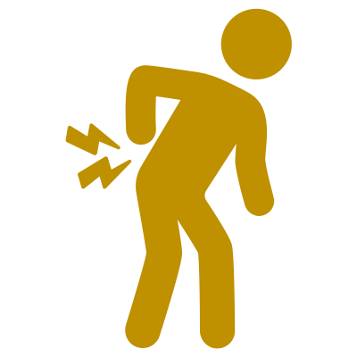
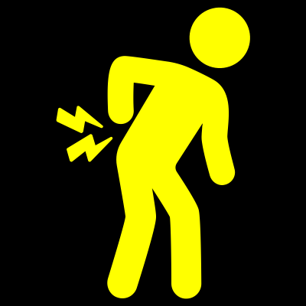
 OR OR
Low Risk

REFER TO MSK TRIAGE FOR CONSIDERATION OF COMBINED PHYSICAL AND BEHAVIOURAL PROGRAMME
High Risk

SELF MANAGEMENT, IF NEEDING FURTHER/ONGOING SUPPORT OFFER PHYSIO REFERRAL
Medium Risk
SELF MANAGEMENT, IF REQUIRING F/U REVIEW & NEEDING FURTHER SUPPORT OFFER FCP ASSESSMENT
Assess Recovery Outcome (use STarT Back Tool) Proceed as of risk level below

Non-Specific
Back Pain
(85-90%)

Common Associated Factors
A sprain/strain
A sudden increase or decrease in activity or exercise levels
Other comorbidities OA, RA, FMS
Stress, worry or low mood, poor sleep, fatigue or feeling run down
Other lifestyle factors such as being overweight and smoking
A flare up of longstanding back pain
Common Symptoms
Pain in the lower back area, buttocks, thighs or hips
Stiffness after a period of rest / reduced movement
Difficulty moving e.g., getting up from a chair/bed, bending and lifting

DO…AS PART OF SHARED DECISION MAKING
- PROVIDE EVIDENCE-BASED SELF-MANAGEMENT INFO AND ADVICE** E.G. ON RECOVERY TIMES (6-12/52)
- IT IS SAFE TO MOVE, BEND AND LIFT OVER TIME - EXERCISE IS HELPFUL – RETURNING TO NORMAL ACTIVITIES/WORK - GOOD SLEEP AND MANAGING STRESS ARE ALSO IMPORTANT
- CONSIDER LIFESTYLE MANAGEMENT OPTIONS www.hlscoventry.org EXERCISE REFERRAL, DIETICIAN/WEIGHT MANAGEMENT, SOCIAL PRESCRIPTION
- OFFER SIMPLE PAIN RELIEF E.G., NSAIDS
- OFFER F/U REVIEW (2-4/52)

USEFUL INFORMATION AND RESOURCES
NICE LBP GUIDANCE VISUAL SUMMARY: MANAGING LOW BACK PAIN AND SCIATICA | THE BMJ
CKS BACK PAIN - LOW (WITHOUT RADICULOPATHY) | HEALTH TOPICS A TO Z | CKS | NICE UHCW UHCW BACK PAIN SELF-MANAGEMENT GUIDANCE
DO NOT…
OFFER ROUTINE IMAGING FOR BACK PAIN IN THE ABSENCE OF RED FLAGS
OFFER STRONG OPIOIDS, GABAPENTINOIDS, SSRI’S, TCA’S AND PARACETAMOL ALONE
USE FEAR INDUCING LANGUAGE OR ADVICE E.G. DON’T BEND, LIFT, EXERCISE, ONLY SIT UPRIGHT

