Coventry MSK Referral Form
Inflammatory Back Pain
Patients: ≥16years with suspected inflammatory spinal pain requiring Specialist MSK Assessment & triage for management and possible Rheumatology referral
For Guidance, please refer to:
GP Gateway Back Pain: Suspected Ankylosing Spondylitis & Spondyloarthritis (MSK Rheumatology)
GP Gateway MSK Rheumatology Homepage

NICE guidance N65: Spondyloarthritis in over 16s: diagnosis and management
For Urgent Advice contact us: Myaxspa@uhcw.nhs.uk
Key features please tick all that apply:
Tick If Yes
Age of onset < 45 years
Insidious onset pain
Pain improved by exercise
Pain not improved by rest
Pain at night (with improvement on getting up & moving around)

SPADE Tool: Please tick all that apply - See www.spadetool.co.uk for online calculation
Please complete SPADE tool (see below) to assist with triage and prioritisation, and refer to Rheumatology AxSpA (AS) clinic. The SPADE tool has been designed to assist medical professionals define the probability of axial spondyloarthritis in a patient with chronic back pain, below the age of 45 with no definitive changes on X-ray
Inflammatory type of back pain

Heel pain (enthesitis)

Peripheral arthritis

Dactylitis

Iritis or anterior uveitis

Psoriasis

IBD (Crohn’s disease or ulcerative colitis)

Positive family history of axial SpA, reactive arthritis, psoriasis, IBD or anterior uveitis

Good response to NSAIDs

Raised acute-phase reactants (CRP/ESR)

HLAB27

Sacroiliitis shown by MRI

Probability Definition: _________ (please use in conjunction with clinical assessment)
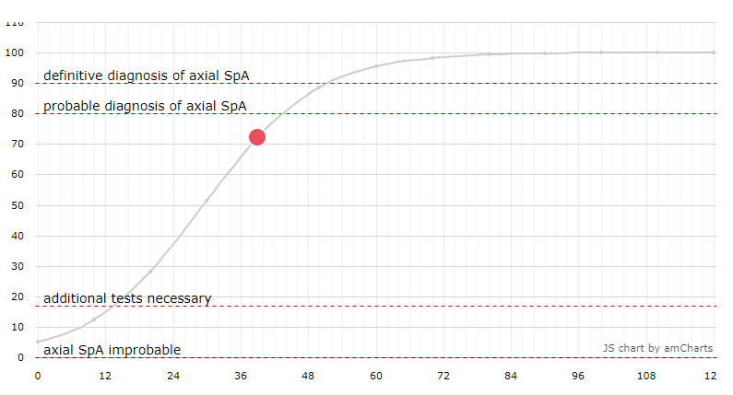
See www.spadetool.co.uk for online calculation

Referral Form Details
Patient Details |  | GP Practice Details
NHS No |  | Referral Date
Patient Name |  | Practice Name
Patient Address |  | Usual GP
DOB |  | Practice Address
Gender |  | Tel No:
Contact Number | Mobile:  Home: | Email
Email |  | Referring Practitioner (If different from above)
Main Spoken language |  | Name of Referrer/Clinician
Interpreter Needed?/  Any additional requirement needed | Yes No | Address of Referring Practitioner
Transport Needed | Yes No | Contact  Number | Tel:  Fax:
Appointment Urgency |  | Urgent Routine

Examination: Please include relevant clinical examination findings such as neurological assessment, any swollen or tender joints or extra-articular features, etc.

Treatment so far: (Analgesia,Physiotherapy, and response: Good /limited/no response)

Investigations: please tick which and where requested (so that we can get the images and reports)
X-ray SIJ views
MRI Ensure AxSpa Protocol specified including SIJs and STIR sequencing
Note, MRI is not essential at this stage and should not delay referral
CT
Bloods
HLA-B27
Any other relevant investigations:
Clinical Information – Pre-populated from patient Records:
Past Medical History
Medication
Allergies
Smoking Status
Alcohol Consumption
Latest BMI
Latest Blood Pressure

Triage Outcome (For Triage use only):
Physio
Self-management
Advice and Guidance
Pain Team
Advanced Practitioner Physio appt
Secondary care: Rheumatology AxSpa Clinic
Injection
Surgical referral

