

Welcome to this week’s edition of Practice News

If you'd like to have Practice News and other relevant ICB updates sent to you directly, please email cwicb.communications@nhs.net

Latest information for practices
Communication to GPs regarding A & G request process for cardiology
As you are aware, cardiology at UHCW has been piloting the use of consultant connect. As a trust, as well as a directorate, we feel that advice and guidance is important, but increasingly so in the current difficult climate we are all working in. ERS is an incredibly complex and “clunky” system to work with from our perspective and we have found consultant connect has a number of advantages.

Firstly it is quicker and allows us to respond in a more timely manner. It is also accessible in any computer and therefore allows even those who are working from home due to COVID isolation for example to be able to support the team within the hospital. We have much better access to images e.g. ECGs and it allows far better inter consultant working.
We do appreciate it may not be ideal for everyone but accept that there will be no one system which would be to everyone's liking. We also except that the ability to covert an ERS A&G into a referral directly, if we advise as such, is a bonus for primary care. We are therefore offering that if we suggest the patient needs referring, we will arrange that referral and state that on our reply. If as a primary care physician you would prefer that we do not do that, you can simply reply “No” , and we will cancel the outpatient appointment. We are hoping that by all referrals coming through consultant connect, we will be much quicker and responsive which will improve things both for your patients and yourselves.

We also have confirmation from Consultant Connect that any advice taken using CC where a valid NHS number is added, gets integrated into patient's EMIS notes directly. There is also the option of having a universal admin log-in for Practice admin who could have access to all A&G sought from that Practice using CC. This enables for any important information to be picked up appropriately by the Practice even if the clinician is on leave.

Given the above, we would be switching to the new process from the 1st of August and will therefore turn off ERS from that date for Cardiology. We will be sending a reminder with all A&G replies in the next 2 weeks, and we will check the ERS system weekly to ensure any rogue referrals do not get missed and thus patient safety is not affected.
We will continually review the activity and would appreciate if you could raise any concerns directly with Dr Dawn Adamson on dawn.adamson@uhcw.nhs.uk

Has your practice signed up the Digital Journey Planner (DJP) yet?
This is a fantastic opportunity to access the enhanced service which has been commissioned only until the end of September 2022. It is a diagnostic coaching and support web tool which will assess the practices current use and understanding of technology, discover new digital service opportunities, solve issues and map out a clear path for patients and practices to navigate their digital journey. It is a modular, step-by-step approach based on baseline, learn and improve and fully supported by a team of digital health professionals.

Click the following link Midlands - practical support to all GP practices and PCNs (redmoorhealth.co.uk) for information on the programme and then the ‘Start My Digital Journey’ Link at top of page.



The good news is that Coventry & Warwickshire ICS has the highest scoring based on the automated website reviews that have taken place across region with a 72% average score, the Regional Midlands average is 66%.

Please see the below for further reading as part of the Patient Digital Engagement (PaDE) project;

- Redmoor data showing the breakdown of website providers by ICS and their average scores
- National Digital First Primary Care report on usability of top 10 website provider templates

Development of new national safeguarding guidance for under 18s accessing early medical abortion services
Please see guidance letter from the Department of Health and Social Care attached.

GP Patient Survey Results
Please see below and attached the good results for Coventry and Warwickshire showing high access to appointments.

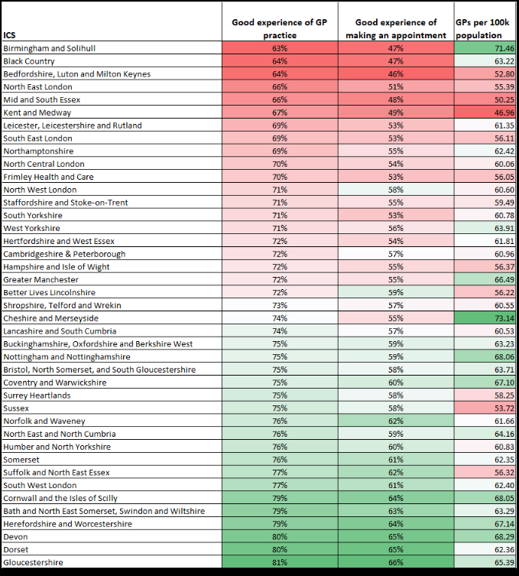

Training, events & surveys
GPAD: Cap Gemini
The national GPAD programme have recruited Cap Gemini to lead on discovery work for two improvements to GPAD data one is Mode (method of appointment) and the second is exception reporting (helps with IIF).

Part of the work is a survey to be completed by practice staff to capture views on exception reporting linked to IIF indicator ACC – 08 Percentage of patients who waited two weeks or less for an appointment in general practice. The survey is self-explanatory takes 5-10 mins and upon completion is sent straight to Cap Gemini.

The link to the survey is below. Please circulate to practice staff and encourage completion to capture views regarding how future data is recorded and represented in relation to this IIF indicator.

The link to the survey https://forms.office.com/r/DUGxR3hHnH

EMIS: ICR: GP Drop-in sessions
An Integrated Care Record (ICR) is a way of bringing together the various electronic records of a patients care. It takes information directly from existing systems used by health and social care organisations and presents it in a structured, easy-to-read format for GP’s, health and care professionals.
The ICR will provide health and care professionals with a more joined-up view of people’s care and treatment across all care settings.

The benefits to your Practices include:
- Not having to repeat your details every time you have a different episode of care
- Better and potentially faster treatment due to health and care professionals having access to better information
- Reduction in potential medication errors through clinicians having access to your medication history (past and present)
- More effective treatment should you need care for COVID-19 due to fast access to information about any pre-existing conditions and your medications
We will be having informal Drop-in sessions every Wednesday 12:30-13:30 from the 10th July to the 28th September.

The link to join is : Click here to join the meeting
Or
https://teams.microsoft.com/l/meetup-join/19%3ameeting_ZmI2NDBhZTctMTUyYy00NDA5LTg2MWItNGJlMDgxZmM3ZDFi%40thread.v2/0?context=%7b%22Tid%22%3a%2221162ae0-3c09-4f25-90e2-fe933255a400%22%2c%22Oid%22%3a%22b70a8d66-da7d-4874-ab50-c74f4c1f2bfa%22%7d

Good Patient Comms Survey
NHSE are looking to find examples of good patient communication from GP practices from across the region, as well as contact details for person responsible for patient communication in each practice.

Please use this link with your GP networks and colleagues across the region. The survey deadline is Friday 19 August.

MENtalk online course link
Starting Monday 25th July - New online mental health course for men (MENtalk). Our friendly, understanding team will deliver a six-week block of targeted discussions around a range of common, relatable mental health topics which affect men. We’ll teach techniques on how to deal with different issues in an environment where men make friends and feel supported. Topics include:
- Understanding anxiety
- Managing depression
- Cognitive behavioural approaches
- A compassionate mind
- Sleep, exercise and stress
- Guest slot from our Independent Mental Health Advocate to discuss the support available with a focus on managing medication, navigating NHS services and receiving financial/housing support.

The sessions will take place from 13:00pm until 14:00pm and can be accessed using this link:
Microsoft Teams meeting

Join on your computer or mobile app
Click here to join the meeting
Learn More | Meeting options

Please feel free to send this information and link on to anyone you feel may benefit from attending the session.

Local Transgender Patient Care Talk
Please find information on a Transgender patient care Q&A Talk attached.

Advance care planning listening and learning event

Online on Tue, 4 October 2022
13:30 – 15:00

This session is for anyone interested in supporting people to plan ahead, so their end-of-life decisions are heard, understood and respected.

This ‘person centred advance care planning’ session is being delivered by Compassion in Dying and hosted by Healthwatch Warwickshire. Our shared goal is to improve the knowledge and confidence of professionals when supporting people to plan ahead for their end of life. It will offer an insight into how valuable the advance care planning process can be, using examples from real people about how they planned ahead and how it helped them. It will also explain people’s rights to plan for their end of life in line with the Mental Capacity Act 2005, and the person-led tools people can use to communicate their wishes, so that their end-of-life care decisions are heard, understood and respected when it matters most.

Book here.

If you are unable to attend but would like to be able to watch a video recording of this event, please book and you will be given the option to request the link to the recording only.

Please forward this invitation to any contacts you think may be interested.

Thank you for any support you can give in promoting this event.

Newsletters
EMIS Weekly Roundup
Please see Certifying fit notes, QOF version 47 v1.1 and more attached.

Cancer Update newsletter
Please see link Cancer Update - Coventry and Warwickshire (cwccg.net)

PCTRB Weekly Update w/c 25.07.22
Please find the PCTRB weekly update for the week commencing 25 July 2022 attached, this includes information on GPAD, Access Training and Enhanced Access FAQ.

NHS Arden & Greater East Midlands Commissioning Support Unit Medicines Matter - Edition July 2022
Welcome to the July edition of Medicines Matter – a prescribing update for primary care clinicians. This monthly newsletter aims to keep GPs, nurses, pharmacists and other healthcare professionals up to date with medicines-related news.

The Medicines Optimisation Team aims to provide evidence-based information and updates, with recommendations and advice for application to everyday practice, to all the CCGs we support.
Please see attached newsletter which you can download to discuss at team meetings and/or print off to put up in staff rooms. We would however encourage use of this information on screen (with internet access), as it contains useful links to further information.

Read, digest, discuss and disseminate to any colleagues you think might find this information useful! We recommend the newsletter is printed and displayed on staff notice boards so that all staff are aware of current prescribing messages (but do not display on public facing notice boards, as the information is not designed for a lay audience).

If you require further support please contact the Medicines Optimisation Team at AGCSU.medicines@nhs.net.

Vacancies
Salaried GP Partner- The Atherstone Surgery
Please see job advertisement attached.

Advanced Nurse Practitioner- The Atherstone Surgery
Please see job advertisement attached

Mental Health Co-Ordinator Role at SBitC
Over recent years, it’s become clear just how important active lifestyles and social inclusion are to our communities. At Sky Blues in the Community we promote these positive behaviours to everyone we work with to improve physical/mental health and wellbeing.

As Coventry (and Birmingham) prepare for a festival of sport with the Commonwealth Games, we continue to work at grassroots level to support people’s health through sports and group activities across Coventry and Warwickshire. We want to support the legacy of this huge event by motivating people to be more active and take control of their own wellbeing.

Currently, I’m recruiting for a new role and would like to find a mental health professional who would like to work in this exciting area. I’m looking for someone who will work on our successful mental health projects, which have already proven to be a huge support to people across the county. I’d be really grateful if you’d share this opportunity so we can improve the wider community’s health and wellbeing. So, if you know anyone with an interest in sports, physical activity and positive mental health promotion, please share the link below:
https://www.ccfc.co.uk/news/2022/june/vacancy-mental-health-co-ordinator-at-sky-blues-in-the-community/

For further information, please email tim.hatton@sbitc.org.uk

