

Welcome to this week’s edition of Practice News

If you'd like to have Practice News and other relevant ICB updates sent to you directly, please email cwicb.communications@nhs.net

Latest information for practices
New provider for NHS111 service
As you will be aware West Midlands Ambulance Service University NHS Foundation Trust (WMAS) currently provides the local NHS111 service here in Coventry and Warwickshire however, the Trust has recently decided to step away from the current contract.

Our Integrated Care Board (ICB) has been working with the Black Country ICB, who are the lead commissioners, to make arrangements for a new provider to step into the contract.

I am pleased to say that DHU Healthcare have been successful in the competitive process and are now preparing to step-in and run the West Midlands NHS111 service from the end of October 2022.

The decision by WMAS to step away comes as the service develops nationally and becomes an even more important part of the NHS. Part of this development will involve a move towards closer working between the NHS111 service across the East and West Midlands, which mirrors the increasing collaboration across some other regions in England.

The contract, initially covering an 18-month period – has been awarded by the NHS Black Country Integrated Care Board (ICB) after a recent competitive process. It offers DHU an opportunity to expand its NHS111 service portfolio within the Midlands. The areas of Shropshire, Herefordshire, Worcestershire, Warwickshire, Coventry, Birmingham and the Black Country conurbation will connect with the East Midlands - through the 111 contract that they already deliver. Other arrangements are in place for Staffordshire.

West Midlands Ambulance Service Chief Executive, Anthony Marsh, said: “As the focus of our emergency and urgent service is based on the West Midlands only, and the move in 111 is move to a regional basis, it makes sense to step back and allow a new 111 provider to take the service to the next level.

“What is important is that patients will not see any change in the way they access NHS111 across the East and West Midlands.

“As a Trust we will also be able to concentrate on making the improvements necessary to improve our 999 service. As such, we feel a new 111 provider will be able to embed the changes in telephony that are set to be introduced which will allow the 111 service to develop further.

Stephen Bateman, Chief Executive at DHU comments: “Our 111 service has a well-deserved outstanding rating from the Care Quality Commission, and we look forward to a close partnership with West Midlands Ambulance Service to transition this contract. Our intention is to build on the exceptional service they have grown over the last three years, and to support the staff who join us. We know they deliver compassionate, high-quality patient care and we welcome the knowledge, skills and experience they will bring to our DHU family.”

Mr Marsh added: “This change should not be seen as any reflection on our staff who continue to work incredibly hard to provide the highest quality patient care - our service is one of the highest performing in the country. The team help thousands of people every day and they should all be immensely proud of what they have achieved.

“We understand this change will be an unsettling time for staff so we will be working with individuals and their representatives as further information becomes available about how DHU will run the contract. We will work with them and Commissioners to minimise disruption for staff and patients alike.”

Mr Mark Axcell, CEO Black Country ICB: “The 111 service is a hugely important part of the NHS and is constantly being developed and enhanced so that it can help more people. We were notified by the current service provider (West Midlands Ambulance Service) of their intention to step away from the current contract and we are now mobilising plans with a new provider DHU Healthcare to step into this contract.

“We are confident that the new provider will be in place ahead of the winter period and that they will work with WMAS to ensure a smooth transition. Those using the NHS 111 service in the West Midlands will continue to be able to access the service as usual.”

We are confident that these new arrangements will ensure a smooth transition for staff and patients in Coventry and Warwickshire ensuring that the NHS111 service can be accessed in the same way.
If you have any concerns with regards to this news, please do get in touch with cwicb.communications@nhs.net

Accurx Patient Triage Integration
What will change with the integration?

For practices:
No change in the way that they manage Patient Triage requests: All Patient Triage requests will come directly into the ‘To Assign’ inbox on the accuRx toolbar. There will be no distinction between the Patient Triage requests that come in via the practice website or from the NHS App. On average, practices who are already live with this integration have seen an increase of 1-2 requests per day. Note: This can vary depending on App uptake in your area.

For patients:
Accessing Patient Triage through the NHS App can provide an alternative access point for patients who may otherwise struggle to find or use Online Services.
To access Patient Triage via the NHS App, patients will click on the ‘Advice’ tab for medical queries or use the ‘Messages’ tab on the App for admin queries.

Managing incoming requests
If at any point, the number of requests becomes overwhelming, practices can amend Patient Triage settings to ‘Temporarily disable’ the service or set ‘Out of Hours’ to control incoming demand. Any Patient Triage settings you amend will also reflect within the NHS App.

Please see our FAQ page here and document which provides further information, and the option to Opt Out if you know practices who would not like to be part of this just yet. Please see attached NHS Digital Acceptable Use Policy for both NHS login and NHS App

Please see communication attached.

Administrative Triage using Digital Tools in General Practice
There is an e-learning programme available to general practice colleagues to enable staff to support patients to choose the most appropriate appointment type to meet their needs.
Online consultation tools can support practices to better match demand to capacity by sorting and signposting patient requests to the correct member of staff or service and enabling clinicians to prioritise requests based on clinical need.
These e-learning sessions will help support general practice staff to:
- introduce administrative triage and understand the evidence behind using an online consultation system to support patient requests
- design your practice workflow and set up a triage list
- understand some of the considerations for your practice team when working remotely
- confidently take patients, or their nominated carer, through an online consultation request over the telephone or in person
Details of how to access this useful course can be found on below link:
Administrative triage using digital tools in General Practice - elearning for healthcare (e-lfh.org.uk)

GPAD PCN Dashboard
We wanted to make the PCNs aware that a new GP Appointment Data dashboard which is available to them.

To gain access to the dashboard, PCN staff will need to fill out this form which will be processed by our onboarding team: https://digital.nhs.uk/dashboards/pcn-appointments-data-dashboard/access-request-form

Once their application is successfully processed, users will be able to access the dashboard using their smartcard via this link: https://www.cis.dashboards.data.digital.nhs.uk/#/views/PCNAppointmentsDashboard/Home

If you have any queries, please contact england.gpad@nhs.net.

EPS Performance Enhancements
EMIS recently introduced two EPS performance improvements which are designed to improve speed and performance by enabling you to move between tasks more quickly.
The improvements enable you to turn off user-defined warnings and protocols (user-defined or EMIS authored except clinical safety and QOF) which are triggered on loading a patient's record when opening awaiting signing tasks.

These settings need to be turned on in Workflow Manager.
The settings can be turned on at both organisation and user level. User settings take precedent over organisation settings, therefore, if configured at organisation levels, these settings will be the default for all users unless they update their own user settings.

Organisation level
Access Workflow Manager > Config > Organisation Options > Medicine Management.

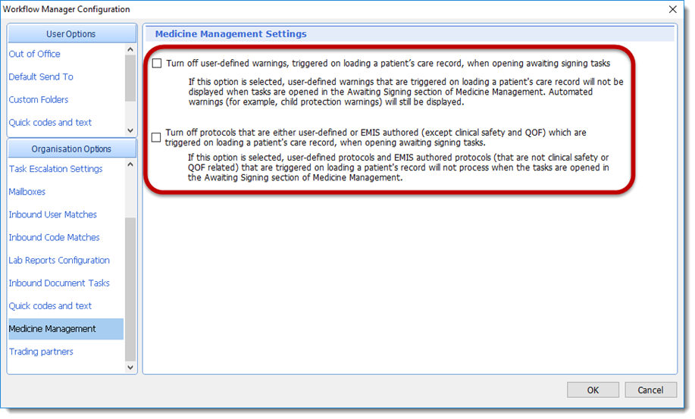

Tick the relevant option to activate and press OK.

User level
User settings will take precedence over organisation settings.
Access Workflow Manager > Config > User Options > Medicine Management.

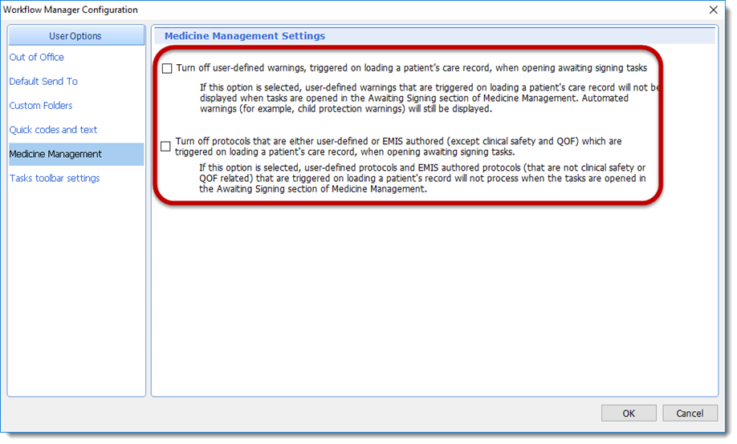

Tick the relevant option to activate and press OK.

Top tips on SGLT2i
Please see attached on Top Tips and Recommendations for use of Sodium Glucose Co-transporter 2 inhibitors (SGLT2i) in people with Type 2 Diabetes (T2DM) For Glycaemic Control.

C&W primary care guidance re monkeypox
Following a recent case of confirmed MPX in South Warwickshire whereby the patient was initially seen in Primary Care, we thought it would be prudent to share again with PC colleagues the MPX toolkit attached and guidance slide attached, to raise the awareness.

Please find attached letter outlining the current service UK Health Security Agency Birmingham are providing for Monkeypox testing.

Updated firearms resources on EMIS Web
In light of the latest information sharing guidelines between the police and GPs, EMIS recently updated the resources on EMIS Web to help you identify a patient with medical risk factors, such as mental health issues, that has access to a firearm. You can find more about the Firearm protocol on EMIS Now.

At the time of updating the resources, a code for reviews undertaken was not available. We are aware of the challenge this is causing for some practices and so, in agreement with NHS Digital, EMIS switched off the protocol and alerts on Friday 15th July, whilst they work to address the issue and improve the user experience.

They intend to release a replacement protocol that will ensure the pop-up alert (centre-screen) is only seen on the day that the relevant code is entered, and they are also working to release an EMIS code as soon as possible, which will be replaced by a national code once available. They will provide further updates when release dates for the replacement protocol and codes are confirmed.

Please note: If you are a Resource Publisher practice and the protocol is still showing after tomorrow, please manually refresh the module. If the problem persists, please contact their Service Desk for investigation.

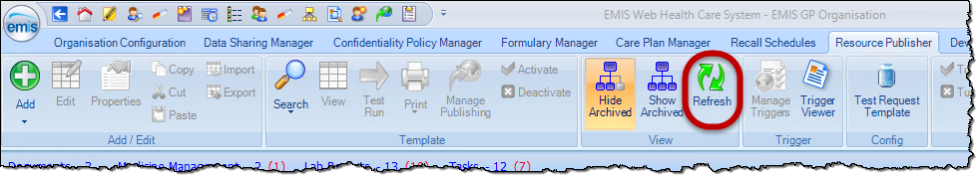

Patient Access to GP Data through the NHS App
General practices were previously informed that from April'22 (originally Dec '21) there will be system changes for all practices using TPP and EMIS systems to provide all patients with easy access to their future health records.
• Go-live date is now expected to be November 2022. GPs will be given 2 months' notice and provided with resources to support preparations.
The change also supports existing GMS contract requirements to promote and offer online patient access to all future information, unless exceptional circumstances apply.
Support highlights
• Link for upcoming webinars
• Link to NHS for latest information and FAQs - NHSD Website.
• 6 YouTube “How to” videos covering various subjects including safeguarding and redaction currently being filmed is now available
• EMIS and TPP system guidance for record access in final review, end of June 22
• Generic Inbox for the Record Access programme monitored daily
• A GP practice readiness checklist is being produced. This will guide practice staff to understand and implement the process for future record access.

Control of Patient Information – COPI
A COPI update has been provided by NHS Digital on GP Connect and Summary Care Record Additional Information

DFPC National Team have provided assurance that the temporary changes made to GP Connect and Summary Care Record Additional Information in response to the COVID-19 pandemic will continue in place beyond the end of the COPI Notice
You can be assured that you have the legal basis to continue to provide and use these vital services, under the UK General Data Protection Regulation (UK GDPR) and the Common Law Duty of Confidentiality.

The changes made to both services have shown benefits, including improved patient safety. You can find out more on their website, including contact details for further questions.
Health and care services will need to update their privacy notices to ensure they no longer make reference to the COPI Notice. Guidance should be available soon.
CSO Training update
Bookings
16 August 2022
Total = 12 out of 16
15 September 2022
Total = 1 out of 16

Mental Health in Schools Teams Results Day Leaflet
Please find attached, a flyer from the Mental Health in Schools Teams which Rise are scheduling for their social media on and around results days in August. The flyer has also been loaded to the MHST webpage: https://cwrise.com/mhst

Multi Agency Risk Assessment Committee (MARAC) letters
Following several queries from GPs regarding the MARAC letters that Practices are now receiving, in respect of patients at high risk of domestic abuse, please note the following RCGP guidance in relation to recording alerts on the system.

Principles relevant to all recording of domestic abuse information:
- ALL information in the EMR (Electronic Medical Record) about domestic abuse MUST be hidden from patient online access.
- Family records should be linked in practices where possible.
- The name of anyone accompanying a patient in a consultation should be documented
- The name of any alleged perpetrator/s should be included when documenting disclosure of DA.
- Ensure that any reference to DA on a victim’s records is not accidently visible to the perpetrator during appointments. The computer screen showing the medical record should never be seen by third parties (i.e. family or friends accompanying a patient). When providing a summary printout for a hospital admission for example, care should be taken that information about DA is not inappropriately included when printing out these summaries to give to patients as the perpetrator may see this.
- Never disclose any allegation to the perpetrator or other family members.
- Ensure that any decision to record the information in the perpetrator’s EMR is made with due regard to the associated risks.
- Ensure that any reference to DA in a perpetrator’s record is redacted if provided to the perpetrator unless you are certain it is information that the perpetrator already knows. For example, the perpetrator has disclosed this information themselves to you, or there is a relevant conviction which the perpetrator has disclosed or is aware has been disclosed to you such as in Child Protection Conference minutes when the perpetrator has been present at the conference and is aware this information is being shared.
- Be aware of the potential danger of the perpetrator having access to information about their abuse and to information in children’s EMRs; this includes via online access to their own information and their children’s information, as well as coercive access to the victim’s EMR.
- If you are not sure whether someone is a victim or perpetrator of abuse, or there is suggestion or evidence that someone is both, we recommend following the guidance on documenting victimisation.

https://elearning.rcgp.org.uk/pluginfile.php/170658/mod_book/chapter/349/Guidance-on-recording-of-domestic-violence-June-2017.pdf

CWCCG to CWICB - Generic mailbox changes
As you will be aware, as we finalise our transition process from CCG to ICB, all generic mailbox names are due to change.
We can confirm that the change to all generic mailboxes has taken place. This means all generic mailboxes named: cwccg.mailboxname@nhs.net have now changed to: cwicb.mailboxname@nhs.net

Previous cwccg mailbox names will still receive emails and there is an auto forward in place to ensure all emails are still received.
Any queries please email: cwicb.communications@nhs.net

As a reminder, please see attached, a list of Primary Care and other ICB Email Contacts.

Supply issue with Paroxetine (Seroxat®) 20mg/10ml oral suspension and Alendronic acid 70mg tablets
Please find attached Medicine Supply Notifications for:

- A Tier 2 medicine supply notification for Paroxetine (Seroxat®) 20mg/10ml oral suspension

- A Tier 2 medicine supply notification for Alendronic acid 70mg tablets

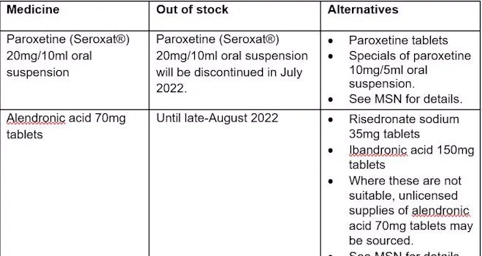

DHSC and NHSE have now launched an online Medicines Supply Tool, which provides up to date information about medicine supply issues. The contents of these MSNs can now be viewed on the Tool.

The Tool also details any changes to resupply dates and updates to the entries. To access the Tool you will be required to register with the SPS website.
Please note that for supply issues that have been categorised as tier 1 or 2, DHSC and the MSRG have requested that the NHSE&I commissioning routes are used to reach community pharmacy and GP practices. More serious supply issues are communicated via the Central Alerting System for action.

If you have any queries please contact: DHSCmedicinesupplyteam@dhsc.gov.uk

Supporting patients (and colleagues) who stammer
Please follow the link https://bjgplife.com/supporting-patients-and-colleagues-who-stammer for an article which is relevant to NHS Clinicians in Primary Care so they have a better understanding of stammering and how to interact with people who stammer in a supportive manner, in order to optimise clinical consultations. This will minimise the risk of misdiagnosis and poor care.

Cost of living crisis and support to families this summer
As you will be aware that there is a very severe cost of living crisis in the UK and we are very worried about how this will affect families this summer, and beyond. This will impact the most vulnerable, but will also impact new groups of people that have not applied for benefits, discretionary payments and exemptions before so we all need to help people understand their rights and entitlements and how they can get help.
People may well come to their GP or have an appointment and talk about these issues, but also it is well worth having a conversation with anyone we are seeing in our front line services, such as your GP practice.

Coventry City Council would be grateful if you could include the attached flyer in your practice, and if you could share on the practice website to promote the new CCC website where this and other information could be provided, please follow the link https://www.coventry.gov.uk/cost-living-wellbeing-support

COVID-19 Autumn booster and flu vaccine programme expansion UPDATE
Please see attached C1674 COVID-19 Autumn booster and flu vaccine programme expansion which has been shared with all Trusts and ICB COVID SPOC accounts and vaccination PMO (with action to share with vaccination sites and SVOCs) on behalf of National SPOC.

Training, events & surveys
Records Access - Safeguarding Webinars
NHS England, Implementation team are excited to inform you of two upcoming records access webinar sessions that will be focussed on safeguarding.

Tuesday 26th July at 12-1pm
Michelle Sharma, named GP for Safeguarding and Co-Chair of the National Network of Named GPs for Safeguarding (NNNGP) will presenting and discussing how processes were implemented in practice, giving advice and guidance to manage records access and safeguarding. Michelle will join an expert panel that will answer questions from the audience.
To register, please follow the link

Thursday 11th August 12-1pm
James Higgins, GP and named GP for safeguarding will be presenting on detail specific scenarios including circumstances that may cause harm, changes in circumstances, vulnerability and coercion. Additionally, there will be discussions on when to consider not providing record access to a patient.
To register, please follow the link

Intended audience
This session is for clinicians, operational staffs and managers responsible for safeguarding, domestic violence and abuse, caldicott guardians and managers responsible for information governance in general practice and in CCGs. The session will focus on risks associated with online records access, so that they can be mitigated and inform training plans associated with data entry into clinical systems.

For more information on upcoming webinars and topics please visit link .

EMIS: ICR: GP Drop-in sessions
An Integrated Care Record (ICR) is a way of bringing together the various electronic records of a patients care. It takes information directly from existing systems used by health and social care organisations and presents it in a structured, easy-to-read format for GP’s, health and care professionals.

The ICR will provide health and care professionals with a more joined-up view of people’s care and treatment across all care settings.

The benefits to your Practices include:
- Not having to repeat your details every time you have a different episode of care
- Better and potentially faster treatment due to health and care professionals having access to better information
- Reduction in potential medication errors through clinicians having access to your medication history (past and present)
- More effective treatment should you need care for COVID-19 due to fast access to information about any pre-existing conditions and your medications

We will be having informal Drop-in sessions every Wednesday 12:30-13:30 from the 10th July to the 28th September.
The link to join is : Click here to join the meeting
Or
https://teams.microsoft.com/l/meetup-join/19%3ameeting_ZmI2NDBhZTctMTUyYy00NDA5LTg2MWItNGJlMDgxZmM3ZDFi%40thread.v2/0?context=%7b%22Tid%22%3a%2221162ae0-3c09-4f25-90e2-fe933255a400%22%2c%22Oid%22%3a%22b70a8d66-da7d-4874-ab50-c74f4c1f2bfa%22%7d

Good Patient Comms Survey
NHSE are looking to find examples of good patient communication from GP practices from across the region, as well as contact details for person responsible for patient communication in each practice.
Please use this link with your GP networks and colleagues across the region. The survey deadline is Friday 19 August.

Wellbeing4Life event at Claremont Children & Family Centre 10.8.22 10am till 2pm
Rugby Borough Children & Family Centres is a free service which provides support, activities and sessions aimed at parent/carers with children up to 19 years old (or 25 for young people with additional needs) and their families.
They are hosting an Wellbeing4Life event at Claremont Children & Family Centre on Wed 10thAug 2022, 10am till 2pm at Claremont Children and Family Centre l Claremont Road l Rugby lCV21 3LU.

Please see attachment, can you promote through your social media channels, distribute to colleagues, mailing list, families with children and young people, and anyone you may think would benefit from Rugby in attending this event.

We will have the pleasure of the company of the Rugby Rock Choir at 12 noon.

Newsletters
NGO bulletin
Please find attached the NGO bulletin.

Weekly Round-Up from C&W Training Hub
Please click here to view the training hub weekly update.

Vacancies
Domestic Abuse Health Advocate Educator (Part Time)
Contract type: Permanent Hours: Part Time, 18.75 hours per week (Wednesday 1:15pm – 5pm, Thursday 9am - 5pm and Friday 9am – 5pm)
Location: Warwickshire Salary: £12,552 per annum (full time equivalent is £25,104 per annum)
Deadline to Apply: Monday 25 July 2022 at 09.00 am
https://refugecareers.ciphr-irecruit.com/Applicants/vacancy/4220/Domestic-AbuseHealth-Advocate-Educator-Part-Time

Tutor Positions
The C+W Primary Care Education team is recruiting to tutor roles in South and North Warwickshire, to work within our team. The roles are open to clinicians working in the region, please find links to applications below.

Any informal questions please contact education lead Maria Ceurstemont on maria.ceurstemont@nhs.net
South Warwickshire:
https://beta.jobs.nhs.uk/candidate/jobadvert/E0046-22-4380
North Warwickshire
https://beta.jobs.nhs.uk/candidate/jobadvert/E0046-22-5230

