This message originated from outside of NHSmail. Please do not click links or open attachments unless you recognise the sender and know the content is safe.
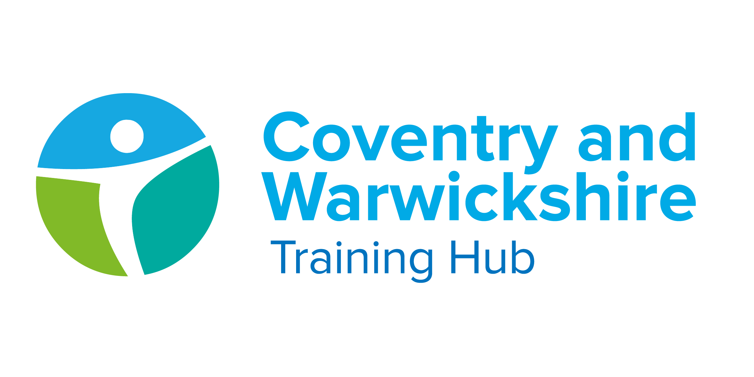

Issue 20 July 2022

Welcome to your latest Training Hub update – your monthly download of upcoming training and development opportunities for primary care in Coventry and Warwickshire, including nursing news and additional roles integration.

This is a summertime bumper special …you are of course very welcome to read the whole newsletter and find out all the exciting things happening across general practice in Coventry and Warwickshire or feel free to use the 'Jump to' facility to quickly get to the areas you are most interested in.
AND please don’t forget to share this newsletter with new colleagues and encourage them all to sign up to the distribution list so you can all be kept up to date with what’s happening locally to support you and your colleagues.
In the meantime have a great summer and enjoy your holidays!

Jump to:

Training Hub News
Latest News
Training & Education
GPN
GP
Physician Associate
Allied Health Professionals

*New* Pharmacy
Placements
Wellbeing
PLT Programme
Careers
Resources




Coventry & Warwickshire Training Hub have three exciting opportunities, please click on the roles below for more information!
- South Warwickshire Place GP Tutor - Closing 7th Aug
- Warwickshire North Place GP Tutor - Closing 7th Aug
- Training and Placement Quality Assurance Office - Closing 10th Aug



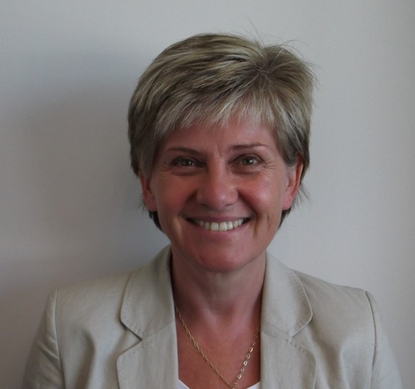
Lead for Workforce Planning and Additional Roles
Hi I'm Sue Phillips, I joined the NHS in 2007 as a Practice Manager in Solihull following a 22 year career in retail financial services. I increasingly became more and more involved in Practice Based Commissioning and over time moved to Solihull Care Trust and the Lead for Primary Care in south Solihull.

After several years in this role and a 2 year period as Head of Planned Care at Heart of England Foundation Trust I joined NHS South Warwickshire CCG where I eventually became the Head of Primary Care
In 2018/19 workforce became a large part of this role and I have maintained responsibility and interest in this area ever since and am now delighted to have joined the Training Hub to help drive the workforce agenda forwards.
Outside of work I am married (and have been for decades 😊) and have 2 grown up children. I love watching sport – especially football and rugby - and enjoy walking, cycling and Pilates.

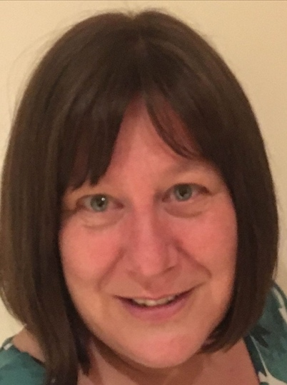
Clinical Pharmacist Ambassador
Hello, I am Roz Payne, I have recently been appointed as Clinical Pharmacist Ambassador at Coventry & Warwickshire Training Hub. Many of you may already know me as well as working as the Lead Pharmacist at Coventry & Rugby GP Alliance I am a Clinical Mentor for CPPE and previously worked as Lead Care Pharmacist for Coventry and Warwickshire CCG.
Please take a look at the new Pharmacy section to the newsletter with updates, training and events and feel free to email me via rosalynepayne@nhs.net with ideas on how you feel the training hub can support you in your role. I look forward to working with you!

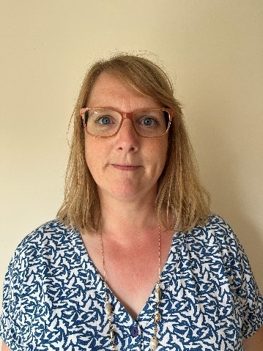
Primary Care Transformation Nurse - Rugby
Hi, my name is Corinna, and I am one of the newly appointed Primary Care Transformation nurses covering Rugby Place. My role will be to deliver, develop and drive key parts of the nursing strategy as it relates to general practice.

I am looking forward to providing leadership and a voice for general practice with the aim to drive recruitment and placements for the student nurses with a hope to encourage and support a new wave of nurses into Primary Care. I also work as a student nurse mentor and assessor therefore I have a thorough understanding of the current nurse training and the New to Practice Fellowship training.
I have been working in Primary Care for many years as a Practice Nurse within Warwickshire which puts me in a prime position to assess the training needs of my peers and provide strong leadership to ensure greater visibility of General Practice Nurses.
I am really looking forward to starting this role and along with my colleague’s we aim to champion a new way forward for general practice.


Primary Care Transformation Nurse - South Warwickshire
Hi, I'm Kate, and I would like to introduce myself as Transformation Nurse for South Warwickshire. I will be working as part of the Transformation Nurse team to support nurse recruitment and retention through student placements, apprenticeships, training and mentorship.

I am excited to be part of the nursing strategy to increase student placement and tNA apprenticeships. I have worked as a Practice Nurse for six years, and I am also Lead Nurse at Castle Medical Centre in Kenilworth.
I am passionate about health inequalities and part of the Transformation Nurse role will be to work with the South Warwickshire practice nursing workforce to identify health inequalities and training to improve these outcomes.
I am really looking forward to getting started and working with you all.

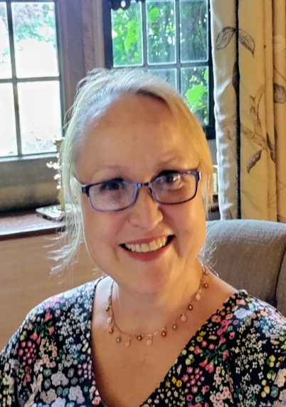
Primary Care Transformation Nurse - Warwickshire North
Hi, my name is Kay and I am one of the newly appointed primary care transformation nurses. I have some 35 years’ experience in the NHS in both acute and primary care sectors. Currently working as a GPN in Bulkington, I am fully aware of the present climate and the challenges facing us.

My new post will focus on 3 key areas: - Recruitment and Retention, Student Placements and Digital Technology. I am thrilled to be supporting my colleagues in Warwickshire North and look forward to meeting with you.
Want to get in touch? You are welcome to contact me via kayline.lines@nhs.net

Health and Wellbeing Champions

'If we don’t look after ourselves, and each other, we cannot deliver safe, high-quality care' - NHS People Plan


What are the benefits of a Health and Well Being Champion:
- They will keep you updated on regional, national and local Health & Well Being support offers
- They will work with you to understand your Health and Well Being needs, providing support, guidance and signposting to services.
- They may introduce events and activities to support such as lunchtime and evening walks.

The number of Health and Well Being Champions within each PCN

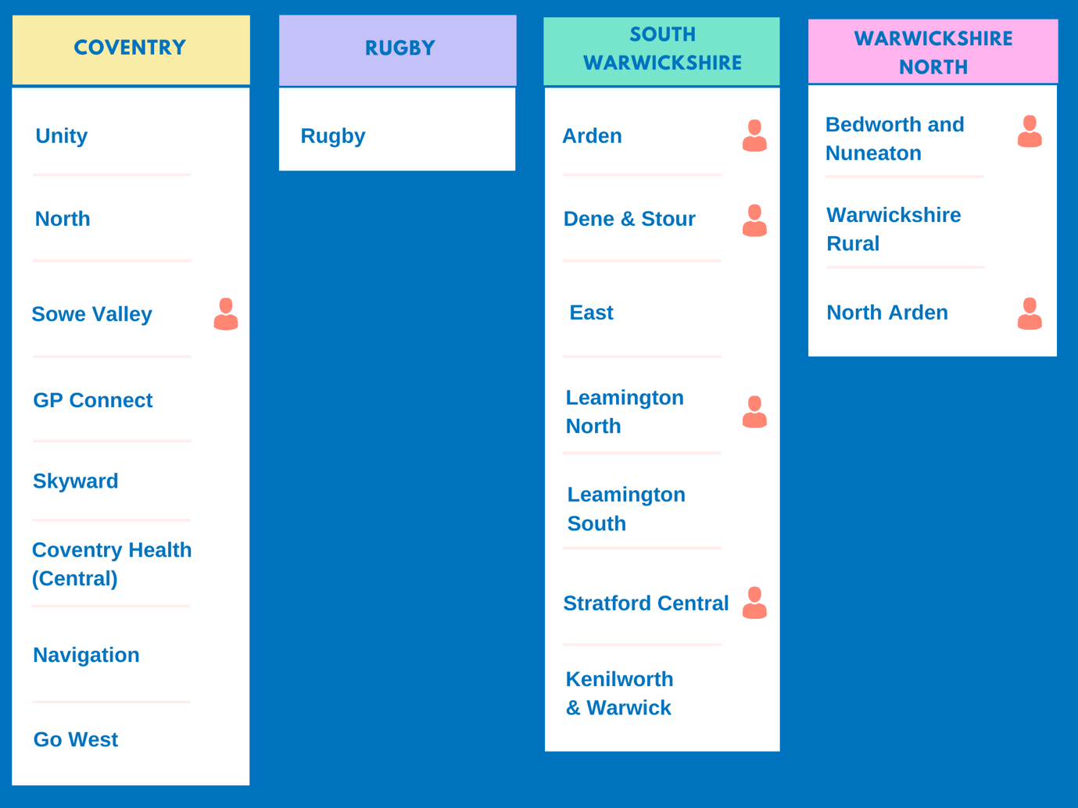

Our HWB Champions in the image above come from a variety of roles, they are: Receptionists, Clinical Pharmacists, GPs, Social Prescribing Link Workers and Care Coordinators!
Take a look at the image above - does your PCN have a Health and Well Being Champion?
If the answer is no and you are enthusiastic about Health and Well Being and want to share your passion with your colleagues and create a healthier, happier workplace click on the button below and get in touch for more information!

I am interested in becoming a Health and Well Being Champion



We encourage you to keep up to date with the latest news, events and updates via the Latest News page on our website or to ensure you don't miss out on anything - sign up for regular updates!
Your Training Hub weekly round-up is signing off for the summer and will return in the Autumn.

Development Programme for GP Partners
Qualitas are running their next Pathway to Partnership programme in October 2022. This is for experienced and new Partners working in General Practice looking to accelerate their professional development and help their practice thrive and succeed.

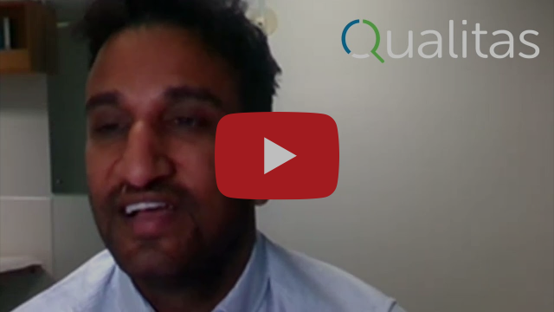

Funding is available for new partners through the NHS England New to Partnership Scheme https://www.england.nhs.uk/gp/the-best-place-to-work/new-to-partnership-payment-scheme/. In addition, experienced partners (both clinical and non-clinical) may be able to access funding via their PCN from either the PCN Leadership and Management Payment or the IIF.
Full course details can be found here - https://qualitasconsortium.uk/training-programmes/


Fit Notes
It was announced from the 1st of July Nurses, Occupational Therapists, Pharmacists, and Physiotherapists will all be able to legally certify fit notes.

To support this, Coventry & Warwickshire training hub are putting on 3 live teaching sessions as well as signposting staff to the non-statutory guidance and a training package on E-learning for healthcare. These resources are to be used together to support eligible healthcare professionals ensure that they have the required expertise and knowledge to be able to certify and issue fit notes.
For more information click here

Looking After You Too: bespoke coaching for ethnic minority colleagues


Primary Care colleagues from ethnic minority backgrounds can speak to coaches from similar backgrounds about their wellbeing.
Coaching offers a safe, confidential and judgement free space to talk about whatever is on your mind.
Bespoke health and wellbeing support

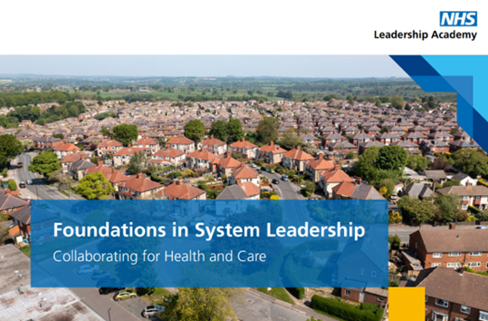
Foundations in System Leadership
Open to all colleagues who have a desire to improve the way they collaborate across organisational, professional and hierarchical boundaries to design and deliver better health outcomes for the communities they serve.
Find out more here

Decision Support Tools
NHS England has published eight decision support tools to support Shared Decision Making conversations between clinician and patient by explaining treatment, care and support options to help patient consider what matters most to them.
NHS England » Decision support tools

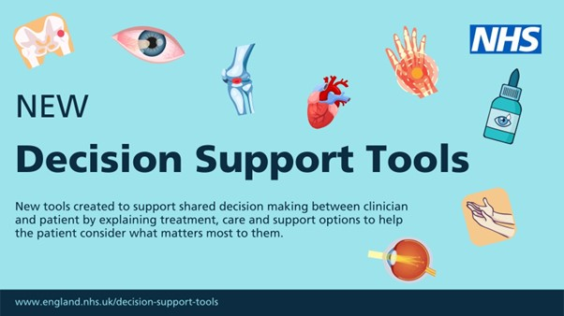

Aspiring Leaders Fellowship Celebration Event
Wednesday 28th September 2022, 12:30 - 14:00

This is a chance for you to hear from the Fellows, about their achievements & experiences and the projects & initiatives that they have been involved in across Coventry & Warwickshire during 2021-22
Click here to join the event


Physical health care for people with severe mental illness
A half-day, interactive course for primary care staff which looks at ways to improve the physical health of patients with severe mental illness.
Read more here

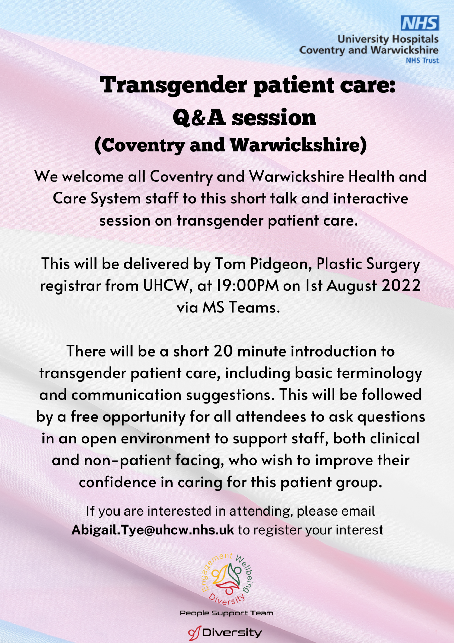



Training & CPD Calendar

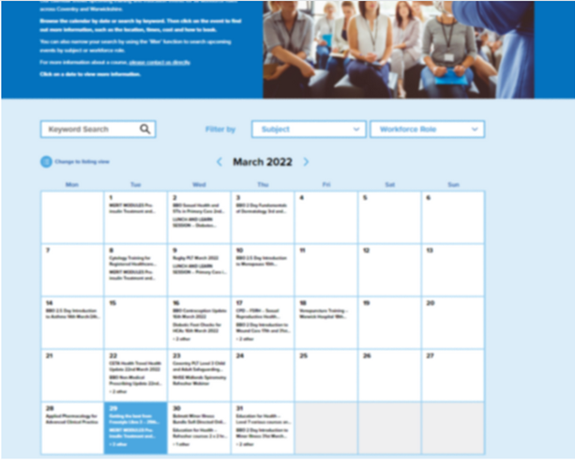
Our calendar shows upcoming training and education events for all workforce rolesacross Coventry and Warwickshire.
Browse the calendar by date or search by keyword. Then click on the event to find out more information, such as the location, times, cost and how to book.

Training & CPD Calendar

Online Practice Assessor Training


This is an online two-day preparation to enable you to take on the role of Practice Assessor. This online event will be held using Zoom and a link to join will be sent to you prior to the course commencing.

The Practice Assessor is responsible for conducting evidence-based assessments of students to confirm student achievement of proficiencies and programme outcomes of practice learning and to record findings.
Upcoming dates and links to book and Practice Assessor documentation



Have you seen:
(These are links to other areas in the newsletter that share new and important updates for GPNs)

Introduction to Place Transformation Nurses

Latest News

Online Practice Assessor training

Trainee Nursing Associates
We have had 7 successful candidates for the September tNA Apprenticeship at Coventry University through our Grow Your Own nursing strategy workstream to increase GPNs in Primary Care .
We will begin seeking expressions of interest for January 2023 intake in September 2022.
Get in touch with us now if you are interested via cw.traininghub@nhs.net

Introduction to the Training Hub for GPNs - 18th August

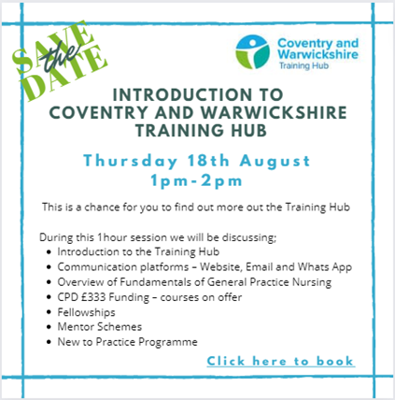

CPD Funding - Year 3
We are pleased to share the timetable of courses available for you to book using your CPD Year 3 allocation of £333 funding this year.

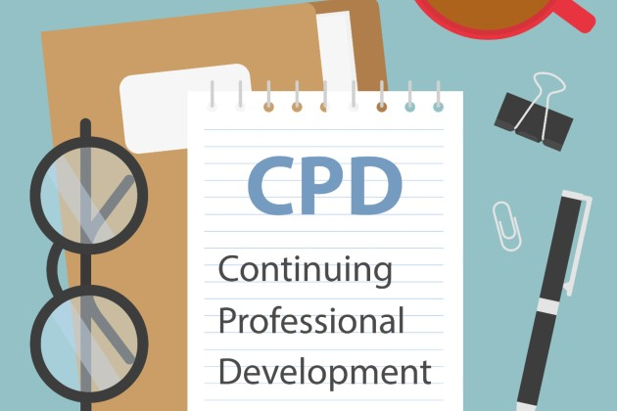
Click here for timetable with links or to go straight to the training calendar
Other options for using your CPD funding:
- Book a course independently and be reimbursed via your practice up to £333
- Apply for a part funded place using your £333 - take a look below for details on the University courses and GPN Development programme
If you have any queries please email via cw.traininghub@nhs.net


CPD Funded - University Courses
We would like to invite expressions of interest for the following funded university courses (using individual’s Year 3 CPD allocations).

- Diploma in improving Diabetes (Warwick University)
- Health Assessments (Coventry University)
Places are limited and will be considered on a first come first served basis, and will need the support from your practice to apply.
Please ensure that you/the proposed candidate meet the criteria for their preferred course and are eligible to CPD funding before emailing - stating name, role and the course of interest, preferred start date e.g. September 2022 or January 2023 to cw.traininghub@nhs.net

CPD Funded - General Practice Nurse Development Programme
This six-day CPD programme has been designed in collaboration with the Black Country and West Birmingham Sustainability and Transformation Partnership (STP). It will prepare General Practice Nurses to develop their career and enhance their leadership skills and potential.


We would like to invite expressions of interest for this exciting fully funded programme with Birmingham City University. There are ONLY 10 places available. The cost for this programme would be covered in part using your Year 3 CPD allocation of £333 and in part by C&W Training Hub.
For more information click here

Peer Support for Nurses and ACPs


We realise how isolating General Practice can be and how much we rely on agile platforms such as WhatsApp to answer questions and vent.
We invite you to join the monthly peer support sessionhosted by Gillian Schweigert for Nurses and ACPs across Coventry and Warwickshire.

We meet the 1st Thurs of every month from 1-2pm - click here to join!

Practice Nurse Mentoring

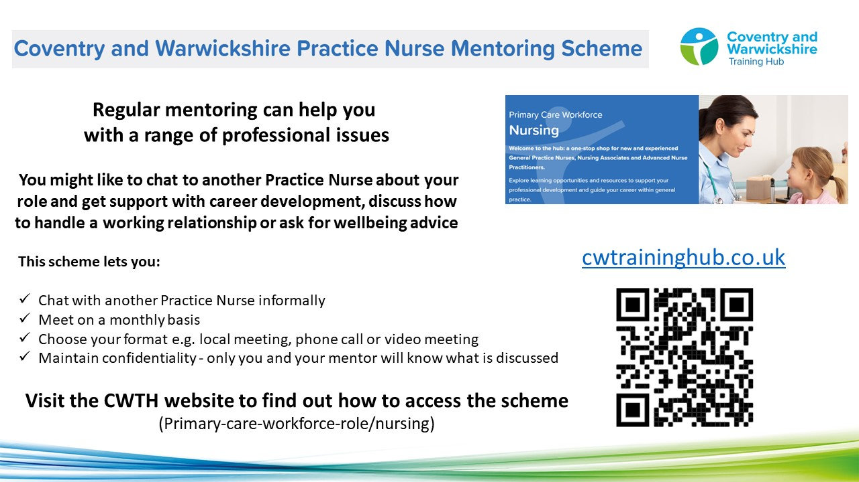

To find a mentor, complete the online registration form. During this registration process you will have the opportunity to view the Mentor Profile Pack and decide which mentor you think would be a good fit for you. The Clinical Lead will assign a mentor to you, considering your preferences and the mentor’s current capacity

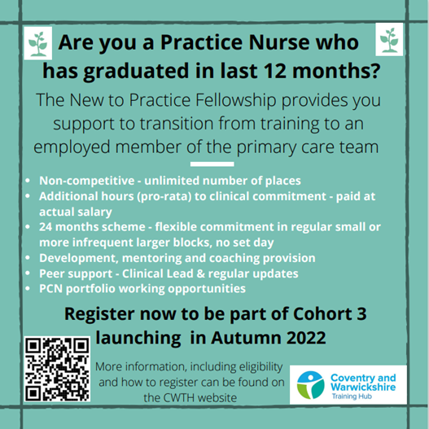



Have you seen:
(These are links to other areas in the newsletter that share new and important updates for GPs)

Latest News

Welcome from Dr Nicola Moerdyk, CWTH Clinical Lead


As a practicing GP, I am very aware of the significant pressures that GPs and the wider practice team are under. The last few years have left some of us battered and bruised, stretched beyond what we had ever imagined and working in ways we never thought possible.

As Clinical Lead for the Training Hub, with oversight of the GP workstreams in particular, my intention is to develop and provide a suite of offers to GPs across the system, to support them in their day-to-day practice, ensuring that they feel valued and appreciated and that they thrive both, personally and professionally.
Our workforce is our most precious asset – we need to invest in it and nurture it, for ourselves, and for the wellbeing of our patients. CWTH has a programme for every stage of a GP’s career, from brand new post-CCT GPs through to exploring potential ways to utilise the wealth of experience experienced GPs will no doubt possess, as they look towards retirement.
There is clinical input through the Medical Education Team’s PLT offerings and programmes such as our Aspiring Leaders Fellowships, which are designed to upskill in areas beyond the consulting room. Our GP mentors are available to offer support and a confidential sounding board on anything and everything from partnership issues to career development and beyond. There are also courses such as Phoenix, which are designed to reinvigorate and inspire.
My intention is to provide a suite of offerings for all C&W GPs, helping them sparkle and be the very best doctor that they can be!


Phoenix GP
We are very pleased to announce that Phoenix GP will be back in C&W in 2023. Many thanks to all the GPs that showed their support and made this happen!
Watch this space for registration in Autumn 22

Professional Curiosity Scheme - Matches in progress!!


Applications remain open.....
Exciting times at the Training Hub this month after we officially launched the Professional Curiosity Scheme in July!
This is the first time ever that a formalised Consultant and GP shadow scheme has been facilitated in our area and we are so excited to see what fantastic experiences and opportunities will occur as a result.

We now have over 25 GPs signed up for the scheme and are currently in the process of matching them with their chosen consultant specialty. Emails will soon be sent out informing those involved about the next steps in the scheme including advice on how to arrange the placements and the plans for celebratory social events to feedback on experiences gained and thoughts for the future.
Matches are made on a first come first served basis however we do still have many consultants who remain unmatched due to a lack of GPs. We would love more GPs to get involved and would urge you to consider the benefits eg clinical and organisational CPD plus networking and collaborating with secondary care.
It’s never too late to get on board so if you haven’t yet got in touch but are curious and keen to get involved then please complete the sign up link below
www.surveymonkey.co.uk/r/PCSReg-GP
Thanks in advance,
Dr Lucy Blunt
Clinical Lead for the Professional Curiosity Scheme

New to Practice Fellowship

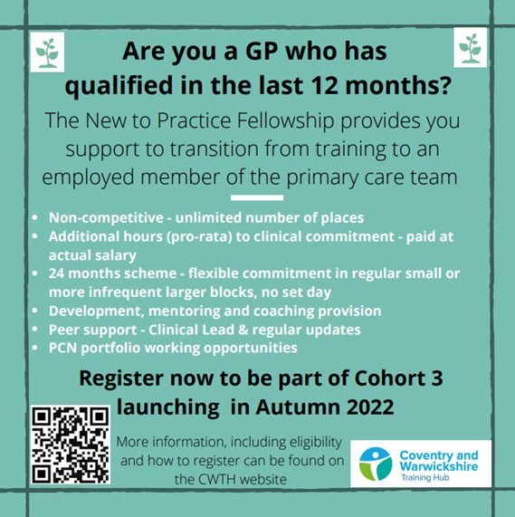

GP Mentoring Scheme

If you decide that you would like a Mentor, you will get the opportunity to view the GP Mentor Profile Pack and decide which Mentor you think would be a good fit for you. Apply here to view the Profile Pack: GP Mentor Scheme Registration.

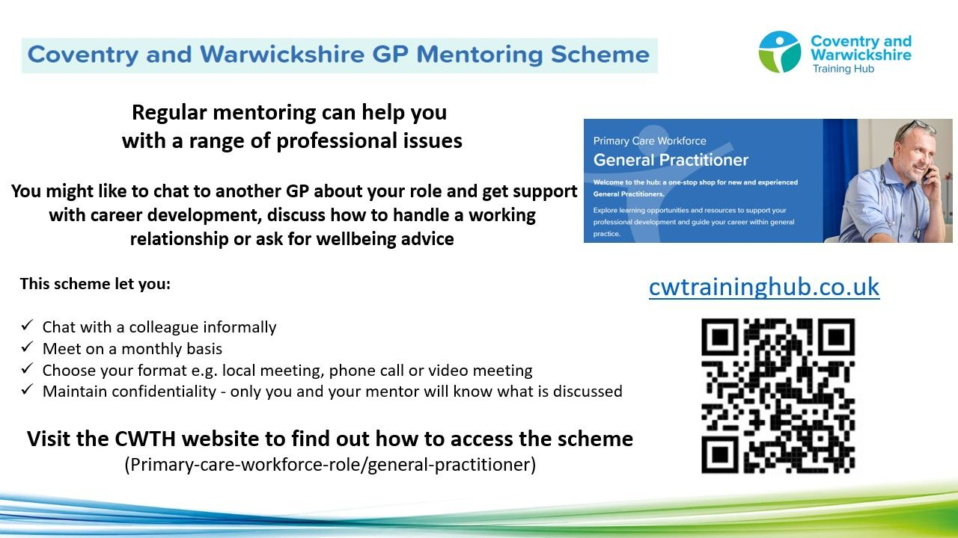

Taking into consideration each Mentor’s capacity, you will be allocated a Mentor, based on your preferred choices.
The Mentor will not disclose any details of any conversations between you both. You and your mentor will be asked for feedback, which can be given anonymously. We currently have 53 mentees utilising the scheme, which is supported by 20 Mentors from a wide range of background an experience. The offer is open to all GPs in C&W at any stage of their career.



Have you seen:
(These are links to other areas in the newsletter that share new and important updates for PAs)

Latest News

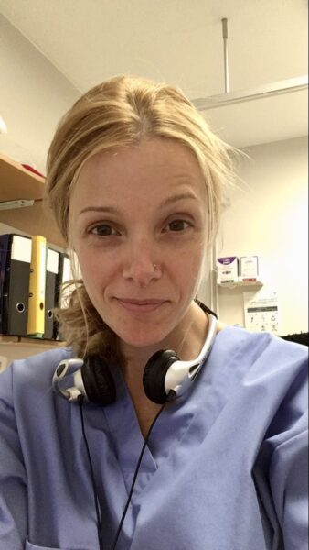
The fantastic work the PAs in our area are doing to help support their teams is important to acknowledge as part of the huge teamworking effort that is feeding into general practice for our patients.
Emma Lomas, Physician Associate Ambassador, Training Hub
Email: emma.lomas6@nhs.net

Physician Associates (PAs) are flexible, clinical team members who provide continuity of care working alongside the Doctors and extended team to support delivery of primary care services to patients. PAs have an undergraduate degree and have studied an intensive 2-year course in general medicine with relevant specialist rotations that enable them to practice as generalists in primary or secondary care.
In the UK there are over 3000 PAs and in Coventry & Warwickshire there are currently 25 working in primary care. These PAs have been either directly employed, employed through the ARRS scheme and work across PCNs and/or locum within the area. Recently 4 PAs were employed under the preceptorship (internship) scheme where their education and training is partially funded by HEE.

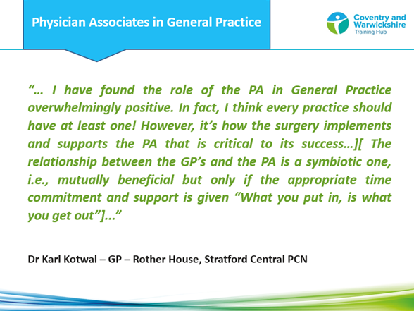

The role of the PA is flexible and adaptable to the ever-changing needs of primary care. PAs are increasingly qualified in advanced practice such as (and not limited to) minor surgery, coil fitting, implant fitting, mental health/dementia reviews etc. and can adapt, with the right support and training to the needs of the practice or PCN
Click here to 'hear' from PAs, their supervising GPs and the wider team - it is the best way to 'see' how PAs work within their team!



Have you seen:
(These are links to other areas in the newsletter that share new and important updates for AHPs)

Latest News

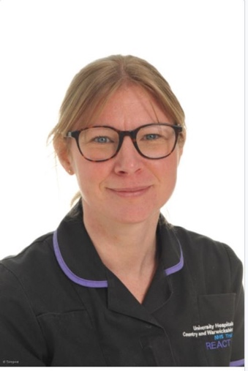
June and July have seen some significant events take place for AHPs, take a look below for updates!
Please keep a look out in your inboxes for the AHP staff survey, the results from which will help the training hub shape the support for your roles over the coming months.
For more information on any of the below updates or if you are interested in finding out more about the role of Dietitian, Occupational Therapist or Podiatrist please get in touch.
Hannah Stroude, AHP Ambassador
Email: hannah.stroude1@nhs.net

How NHS Knowledge and Library services can support AHPs

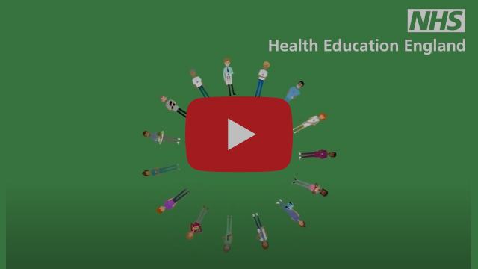

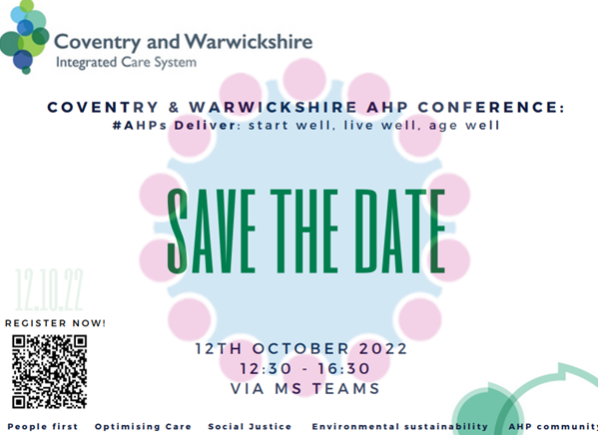

Register now using the QR code above or by clicking on this link

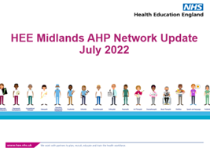
HEE Midlands AHP Network Update - July 2022
Stay up to date with the latest opportunities and news across the region!
Click here to view the AHP Network Update for July 2022

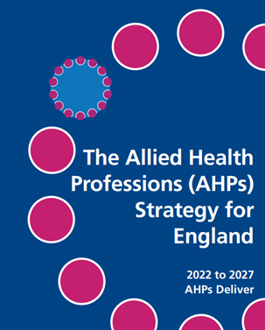
AHP Strategy
The Allied Health Professions (AHP) Strategy for England: AHPs Deliver, has been developed to provide strategic direction to the AHP community across England, to help the AHP community and those they work with maximise their contribution to the aim of improving health outcomes for all, providing better quality care, and improving sustainability of health and care services.

Follow the link to read the Strategy: The Allied Health Professions (AHP)for England: 2022 to 2027 AHPs Deliver



Have you seen:
(These are links to other areas in the newsletter that share new and important updates for Clinical Pharmacists and Pharmacy Technicians)

Latest News

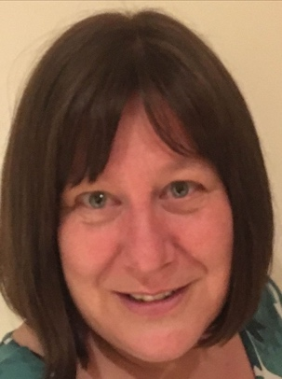
Below are some updates I hope you will find useful, please also take a look at the Clinical Pharmacist and Pharmacy TechnicianProfessional Development pages on the Training Hub website where you will find learning opportunities, training and resources.
Roz Payne, Clinical Pharmacist Ambassador
Email: rosalynepayne@nhs.net

C&W Clinical Pharmacy Conference


We will be holding our first conference for clinical pharmacy on Wednesday 5th October 2022 at Woodland grange.
This is an opportunity for our PCN clinical pharmacy teams from across Coventry & Warwickshire to come together to learn and network. The day will include learning on the CVD IIF indicators delivered by the West Midlands AHSN and presentations from Arden CSU and the medicines optimisation team of C&W ICB.
Register here

Pharmacy Technician Network - 1st event!


We are initiating a network especially for our pharmacy technician workforce. Our first event is a workshop on DOACs run by Clinical Pharmacy Solutions and will take place on Wednesday 28th September.

Book here https://www.clinicalpharmacistsolutions.co.uk/event-details/doac-part-i-training-session-for-coventry-and-warwickshire-training-hub
Use the code: TH99OFF2809 in the coupon box for your free place!

Clinical Pharmacist - Training, Events and Development courses
Leadership Development Programme
21st July 2022, 18:30 - 20:30pm - Course info & booking link
15th Sep 2022, 18:30 - 20:30pm - Course info & booking link
Specialist Pharmacy Service
Mental Health - 14th Sep 2022, 13:00 - 14:00pm - Course info & booking link
Community Health Services - 21st Sep 2022, 13:00 - 15:00pm - Course info & booking link
PCN/ICS Developments - The latest insights for Pharmacy
15th Sep 2022, 09:30 - 15:00pm - Course info and booking link




The Training Hub is working with Coventry University and practices in Coventry and Warwickshire to arrange placements for Nurse, Paramedic and OT students in general practice.

We would like to extend a huge thank you for those practices supporting and inspiring our future nursing workforce into primary care by offering placements to student Nurses and Nursing Associates.
If you would like more information on Placements, please take a look at our dedicated Placements page on the website for more information or contact us via cw.traininghub@nhs.net

Register your interest - Host a student in your Practice




You are always there for your patients, providing a first-class healthcare service.
So we want to support you to look after your own health and wellbeing.

We have compiled a variety of health and wellbeing support resources and services on our website to support you, below are some additional wellbeing resources for you. Our wellbeing page on the website can be found here.


Wellbeing Wednesday
Each and every Wednesday we will be sharing upcoming events, tips, activities and more to help support you to look after your mental health and wellbeing!
You can find your weekly wellbeing update here

The art of inviting people to practice self-care


Do you want to know more about how you can improve the health of your population by personalising self-care?
Would you like to hear about empowering patients to better look after their own physical health, mental wellbeing, and its inherent pitfalls?
Read more here



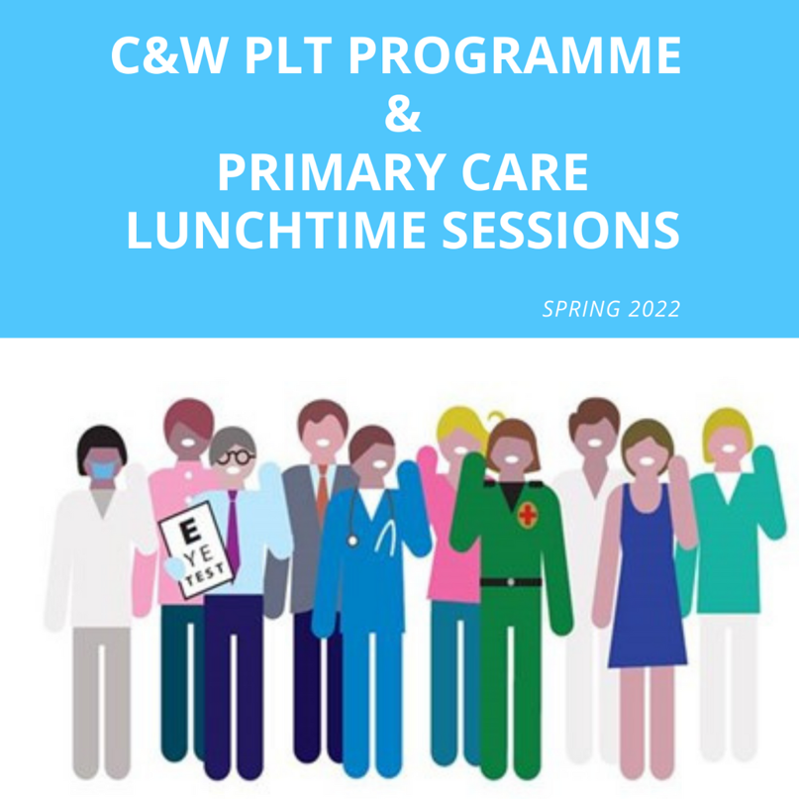

Click here for upcoming Lunch and Learn sessions & to view recordings of previous sessions. (Username: CWGP, Password: CWGP)

Click here for Coventry and Warwickshire PLT Dates for 2022, a programme with topics will be released shortly.



General Practice vacancies

Medical Receptionist - Woodside Medical Centre (21.5hrs) | Coventry
Medical Receptionist - Woodside Medical Centre (16hrs) | Coventry
Salaried GP - Hastings House Medical Centre | Wellesbourne
GP Locum - Vale of Redhorse Healthcare Centre | Warwick

Showcase your vacancies with us!

Our aim is to highlight the exciting and varied opportunities available in Primary Care across Coventry and Warwickshire.
This is not a duplication of NHS Jobs but rather an opportunity to showcase your vacancies.
If you would like to advertise a role with us, click on the button below to complete the short form or contact cw.traininghub@nhs.net

Post your job with us!



Below are a selection of resources for you, to view all resources, visit the 'Resources' page on our website by clicking here.


Primary Care New Roles Resource
HEE have developed the 'New Roles in Primary Care' National toolkit.

Long COVID elearning session
This elearning session has been developed to provide you with a basic introduction to long COVID and post-COVID-19 syndrome.


Cervical Screening Best Practice Poster
The poster contains important failsafe checks taken from the Cevical Sample Take Training guide and the Sample Take Acceptance policy.


To help us evaluate the C&W Training Hub Newsletter please take a few moments to complete the survey.
CLICK HERE

Copyright © 2022 C&W Integrated Primary Care, All rights reserved.
Want to change how you receive these emails?
You can update your preferences or unsubscribe from this list.


