Issue 18 May 2022

Welcome to your latest Training Hub update – your monthly download of upcoming training and development opportunities for primary care in Coventry and Warwickshire, including nursing news and additional roles integration.
We are extremely proud of the hard work you all put in to provide a caring and resilient service to support patients. We are here to help you do what you do best, by delivering additional training, attracting new recruits and providing support.
This newsletter is one of the ways we’re able to keep you up to date with new opportunities – please take a few minutes each month to read it and share with colleagues as appropriate.

Jump to:

Training Hub News
Latest News
Training & Education
GPN
GP
Equality, Diversity and Inclusion

First Contact Physiotherapist
*NEW* Physician Associate
Placements
Wellbeing
PLT Programme
Careers
Resources





AHP Ambassador and Place Transformation Nurses
We are very pleased to be welcoming Hannah Stroude, AHP Ambassador and our 3 Place Transformation Nurses to the Training Hub team.

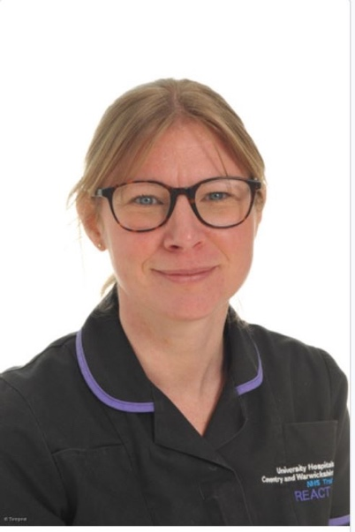
Hi all, I'm Hannah and I'd like to introduce myself as the new AHP Ambassador supporting the Occupational Therapists, Dieticians and Podiatrists in Primary Care across Coventry and Warwickshire.
I am really excited to be taking on this role championing AHPs in Primary Care, the fantastic work they do, supporting role development and training needs.

I have some 20 years' experience working as an Occupational Therapist within the NHS mostly within acute care. Alongside my role as AHP Ambassador, I am in a seconded role as an AHP Workforce Lead and was the REACT service lead at University Hospital, through which I have had the opportunity to support the set-up of the OT service within some of the Coventry PCNs.
I am really looking forward to getting started in this role, meeting you all and working together. Please feel free to drop me an email if you have any queries or if I can offer support.
Hannah Stroude, AHP Ambassador, Training Hub
Hannah.stroude1@nhs.net

Place Transformation Nurses


We are in the process of on boarding 3 new place Transformation Nurses (1 day/week) to support geographical intel and local support for the Nursing Strategy across Warwickshire North, South Warwickshire & Rugby (Coventry supported by Helen Elsaghir).

The main focus points are:
- Placement Support
- Population Health and Social Disparities as relates to Education and training
- Digital Innovation
We will be working with SWFT Placement Team for joint goals related to placement



Health and Wellbeing Programme showcase - 15th June 2022
If you are unsure about what the Health and Wellbeing Champions are doing and want to find out more - hold the above date in your diary to come and hear them share:
- Why they started
- What they have been doing
- What they have coming up
There will also be presentations from Vivup and Shapes Toolkit (created by Dr Rachel Morris).
Invitations will be sent in the coming weeks



Tell us how you are - Primary Care Wellbeing survey
The latest wellbeing survey is now open for all staff working across primary care. The survey takes 10 minutes to complete - please let us know how you are and how we can further support you and your teams.

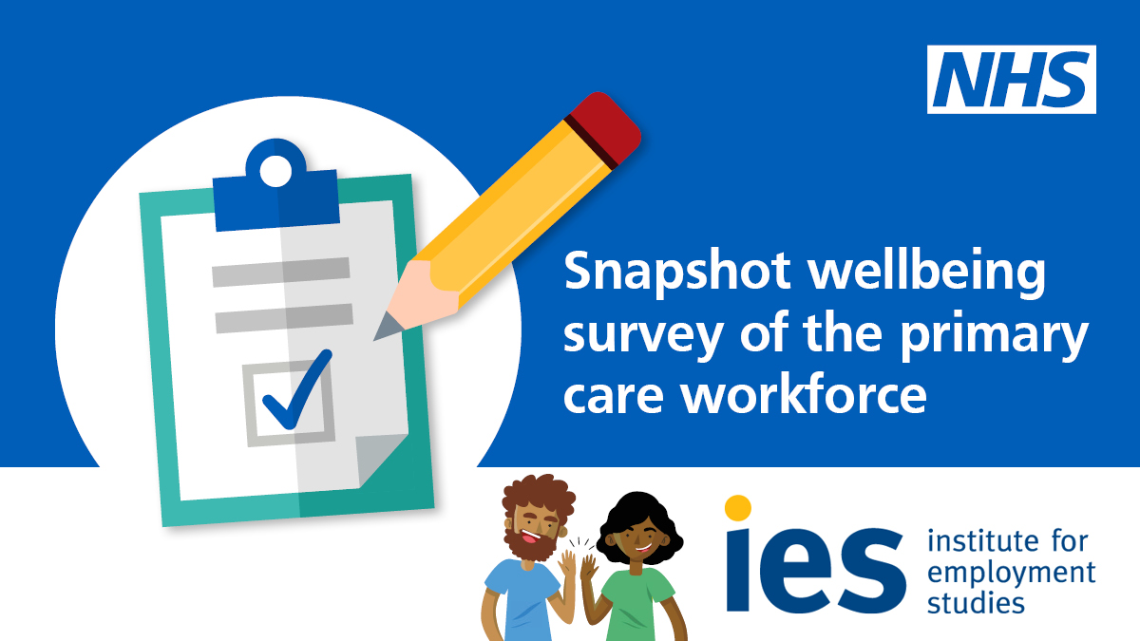

Thank you to everyone who completed the previous wellbeing survey back in January. Results show that wellbeing and resilience of the workforce remains a challenge. As we continue to work under many pressures, we encourage you and your teams to seek support if needed.
The health and wellbeing support is available on the NHSEI FutureNHS space. This includes the award-winning coaching programme, support for managing patients and promotional resources to share with teams.

Wellbeing survey



Training & CPD Calendar

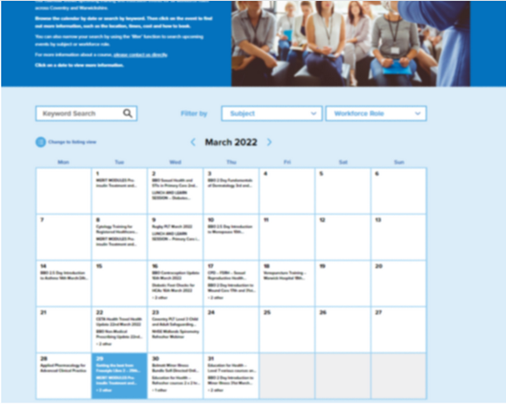
Our calendar shows upcoming training and education events for all workforce rolesacross Coventry and Warwickshire.
Browse the calendar by date or search by keyword. Then click on the event to find out more information, such as the location, times, cost and how to book.

Training & CPD Calendar

Online Practice Assessor Training


This is an online two-day preparation to enable you to take on the role of Practice Assessor. This online event will be held using Zoom and a link to join will be sent to you prior to the course commencing.

The Practice Assessor is responsible for conducting evidence-based assessments of students to confirm student achievement of proficiencies and programme outcomes of practice learning and to record findings.

Click here to view upcoming dates and links to book

Diabetes Programme for Healthcare professionals

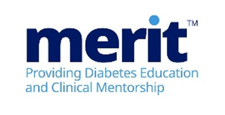
MERIT™ (Meeting Educational Requirements Improving Treatment) is a two-part flexible programme developed by Novo Nordisk. MERIT™ is a competency-based programme and is for all healthcare professionals involved in diabetes care.

Click here to view the Modules and for details on how to Book



Have you seen:
(These are links to other areas in the newsletter that share new and important updates for GPNs)

Online Practice Assessor training

International Nurses Day - 12th May 2022
Our very own home grown Trainee Nursing Associates (through ARRS) were invited to lead the International Nurses Day procession.
What an honour for them!

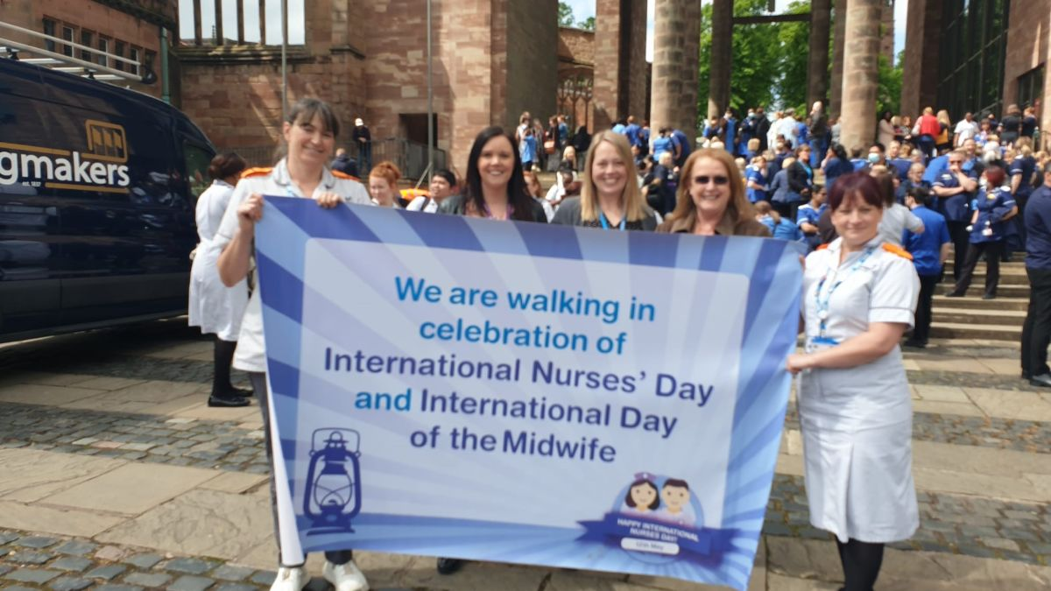

Trainee Nursing Associates
We have 5 Trainee Nursing Associate students out in Practices across Coventry and Warwickshire.
Following presentations of the GPN Strategy and Grow Your Own process to the wider system we have had a fantastic 400% increase of Trainee Nursing Associates (due to start in September).

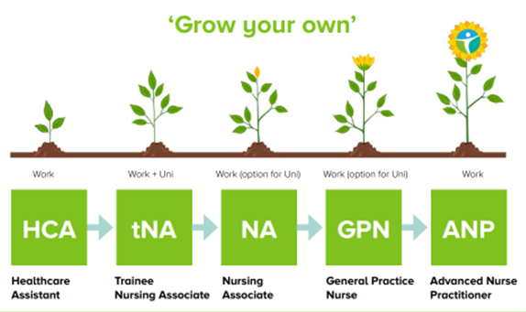

There is ongoing work to support this initiative and get students and employers through the on boarding system

Coventry & Warwickshire GPN Strategy
We are so excited and proud to share with you the FULL Coventry and Warwickshire General Practice Nursing Strategy.
Click on the image below to open the document

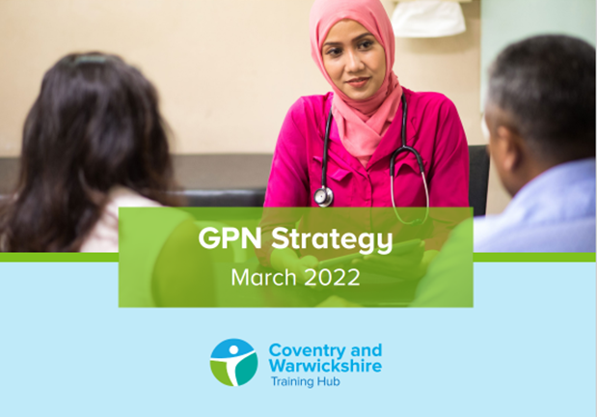

Monthly Leg Ulcer MDT
Monthly Leg Ulcer MDT going from strength to strength. We have had great attendance and feedback. We are keeping a picture log that showcases some real successes which we will share in upcoming weeks.

Peer Support for Nurses and ACPs


We realise how isolating General Practice can be and how much we rely on agile platforms such as WhatsApp to answer questions and vent.
We invite you to join the monthly peer support sessionhosted by Gillian Schweigert and Heather Randle for Nurses and ACPs across Coventry and Warwickshire.

We meet the 1st Thurs of every month from 1-2pm - click here to join!

Practice Nurse Mentoring

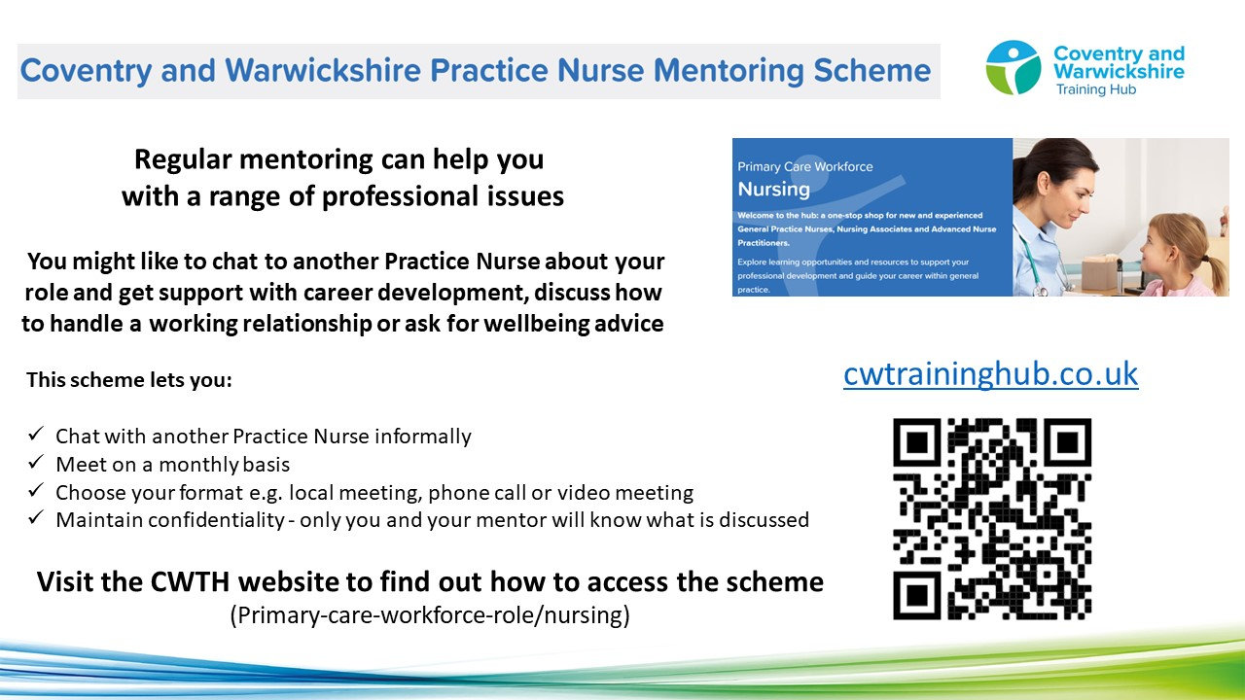

To find a mentor, complete the online registration form. During this registration process you will have the opportunity to view the Mentor Profile Pack and decide which mentor you think would be a good fit for you. The Clinical Lead will assign a mentor to you, considering your preferences and the mentor’s current capacity

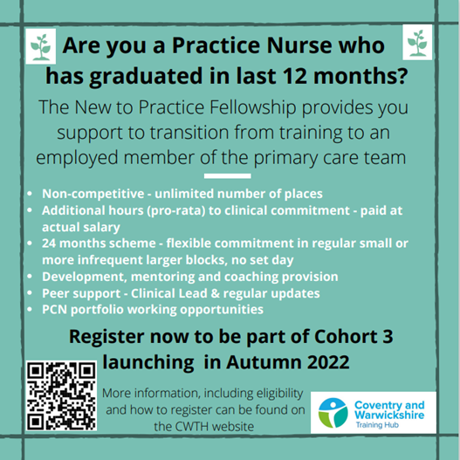



Wellbeing event for First5 GPs


Come on a journey, ending in Rome, learning along the way evidenced based, free and accessible tips and tools to recognise and prevent burnout, promoting wellbeing and happiness in life and work.
In this energetic and interactive session, you will learn about the five keyways to wellbeing and will be facilitated to identify goals to take forward to make sure you are mentally and physically fit for the challenges ahead.
Takeaways:
- Recognising when you or your colleagues may be struggling with their mental health
- Learn about the most powerful legal performance enhancing drug we have and how to get it
- Learn 5 key, evidenced based, easy wellbeing wins that you can implement today

Book your place here

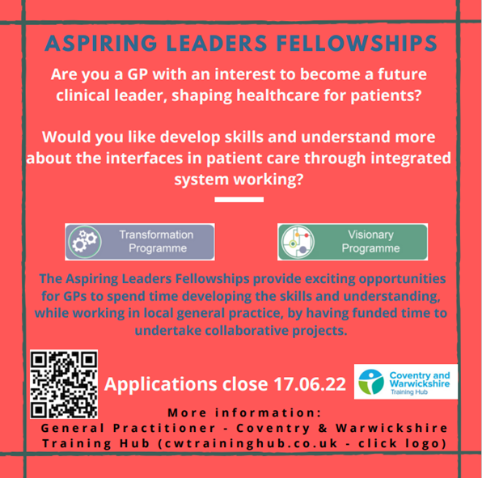


Phoenix GP
Phoenix GP provides fully funded career development and leadership programmes, designed specifically for mid-career GPs.
From Sept 21 - Feb 22, 35 C&W GPs were provided with this fanatic opportunity.

Would you like to see this programme be hosted for a second time in your area? We would be looking to start the programme in January 2023 but only if there is sufficient interest
Click here to find out more or simply reply to C&W Phoenix GP with “I’m interested” by Close of Play on Thursday 30th June.

Professional Curiosity Scheme


A very well attended and informative focus event was held in May, providing GPs and Consultants from across Coventry & Warwickshire to voice their views, hopes and aspirations as to the potential of a Professional Curiosity Pilot.

Providing opportunities for collaborative working across primary and secondary care, it is hoped that the scheme will provide potential future outcomes for:
- Research
- Pathway Development
- Joint Clinical meetings
- Shared training
- Improved communications methods
Dr Lucy Blunt (Clinical Lead - PCS) will launch the pilot over the coming months and more information will be available in due course. Contact PCS Scheme Admin if you would like to know more.

New to Practice Fellowship

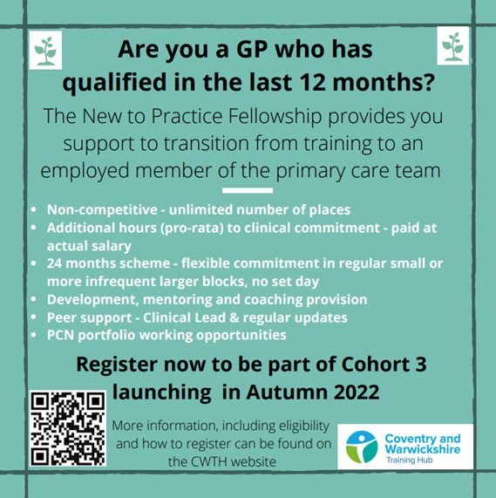

GP Mentoring Scheme

If you decide that you would like a Mentor, you will get the opportunity to view the GP Mentor Profile Pack and decide which Mentor you think would be a good fit for you. Apply here to view the Profile Pack: GP Mentor Scheme Registration.

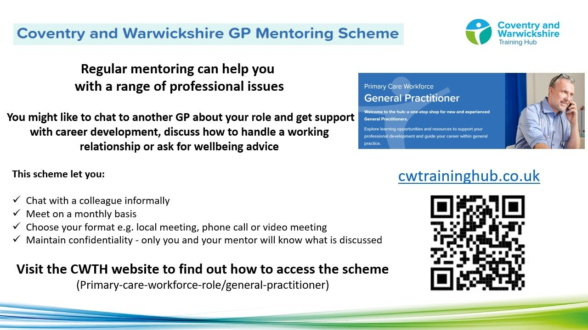

Taking into consideration each Mentor’s capacity, you will be allocated a Mentor, based on your preferred choices.
The Mentor will not disclose any details of any conversations between you both. You and your mentor will be asked for feedback, which can be given anonymously. We currently have 53 mentees utilising the scheme, which is supported by 20 Mentors from a wide range of background an experience. The offer is open to all GPs in C&W at any stage of their career.



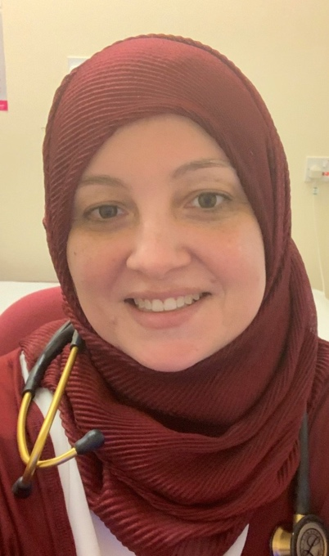
Hello,
A huge thank you to everyone who took part in Equality, Diversity and Human Rights week there are some fantastic resources and links available here to continue the work you have been doing.
Take a look below for details on upcoming events and training.
Mai Elftise, Equality, Diversity and Inclusion Lead, Training Hub
Email: m.elftise@nhs.net

Equality, Diversity and Inclusion training
There are 3 events that have been organised by the CCG EDI Staff network who are extending their invitation to Primary Care:
- Age Inclusion in the workplace webinar - 24th May, 10:30 - 11:30am
- It's about Race training - Wednesday 22nd June, 1:00 - 2:30pm
- Unconscious Bias training - Thursday 30th June, 12:00 - 1:00pm
For details on the events, joining instructions and agendas, please click here

PRIDE Month event - Monday 13th June
This event is open to all colleagues, click this link to book your place.

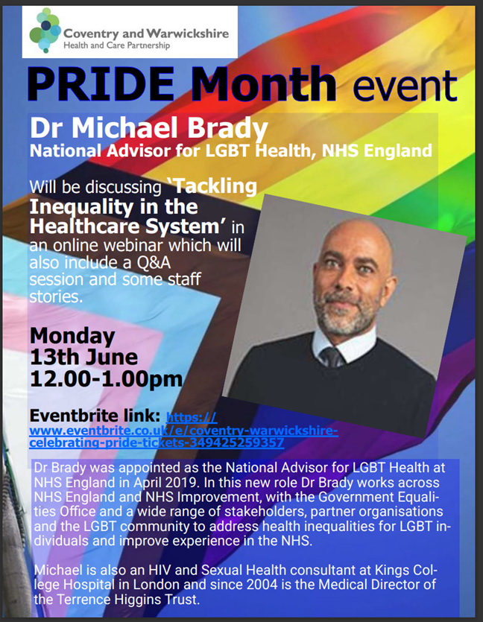



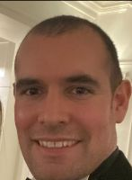
I am happy to share the results of the First Contact Physiotherapist (FCP) survey which was conducted across Coventry and Warwickshire to determine some base line data. We had a fantastic 46% of FCPs complete the survey.
Take a look at the results below!
Ed Baker, First Contact Physiotherapist Ambassador, Training Hub
Email: edward.baker2@nhs.net

First Contact Physiotherapist Survey results

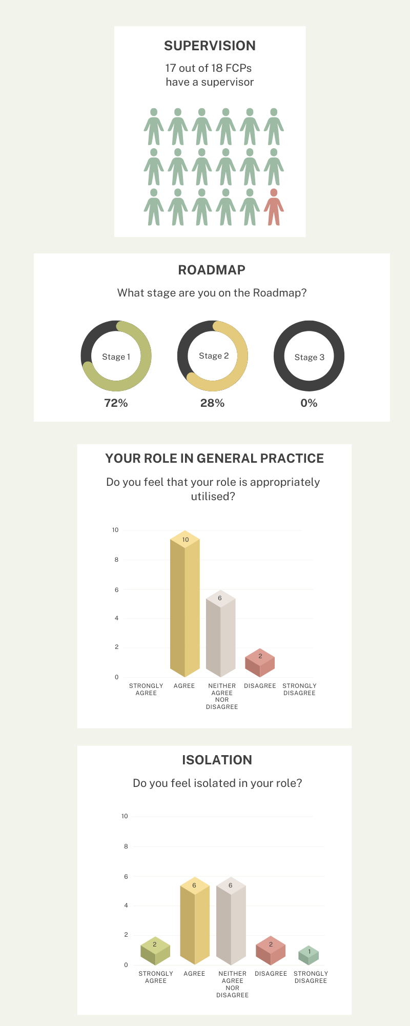

In summary the feedback from the survey is positive, there are areas for further work, and this survey will be repeated later on in the year to determine how successful we have been in addressing issues brought up in the survey.

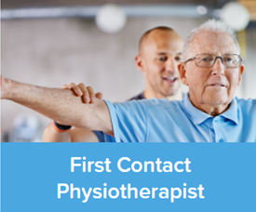
Explore learning opportunities and resources to support your professional development and guide your career within general practice - visit the First Contact Physiotherapist web page on the Training Hub website today!



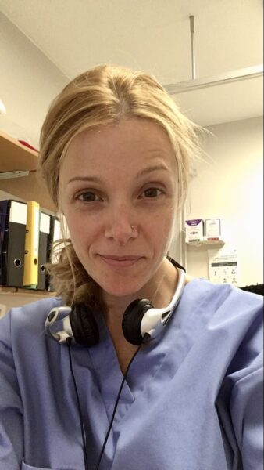
We continue to look at ways to support the PAs through 2022/2023 and plan to have events working collaboratively with PAs working in secondary care in the region. I look forward in the coming months to start highlighting the PAs and their teams in our area and follow the lives of our new preceptor PAs.
Below are some updates I hope you will find useful.
Emma Lomas, Physician Associate Ambassador, Training Hub
Email: emma.lomas6@nhs.net

Physician Associates in C&W General Practice
In Coventry & Warwickshire there are at least 25 PAs in primary care (who have engaged with me) many supported through ARRS funding.


The varied work we do has been invaluable to the wider teams and on a small but just as important (research) level, we have several PAs who are active in contributing to PCN audits and Quality Improvement Projectswhich is an important part of our role.

I thoroughly support and encourage all PAs taking on clinical audit and research for continued learning and contribution to the wider team for our patients in these continued challenging times.


Funded CPD
We have supported the PAs this year with free and training hub funded CPD, working also with Nuffield Health, local GPs and the FPA; PAs have been able to access clinically relevant training to maintain their professional requirement of annual 50 hours of CPD.

Regulations update


It has been a slightly frustrating few months for the Physician Associates who have, yet again, heard that their regulation has been delayed now looking at 2024 at the earliest. If you have followed the regulation journey, we are waiting for the government to 'tick the boxes' for GMC regulation and of course the long-awaited move to a prescribing qualification.

The Faculty of Physician Associates are raising awareness through the #regulatePAsnow campaign - which will be launched imminently.
We, as a profession need as much support as possible from our clinical and non-clinical colleagues, patients, friends, family etc. - please watch out for the campaign which will be highlighted on the TH website as soon as it is live.


If you are thinking of employing a PA for your practice team and want some more information, or want to know how best to continue to support your practice PAs - head to the Physician Associate web page on the Training Hub website today and/or contact me as the PA Ambassador for the region - emma.lomas6@nhs.net




The Training Hub is working with Coventry University and practices in Coventry and Warwickshire to arrange placements for Nurse, Paramedic and OT students in general practice.

We would like to extend a huge thank you for those practices supporting and inspiring our future nursing workforce into primary care by offering placements to student Nurses and Nursing Associates.
If you would like more information on Placements, please take a look at our dedicated Placements page on the website for more information or contact us via cw.traininghub@nhs.net

Register your interest - Host a student in your Practice




You are always there for your patients, providing a first-class healthcare service.
So we want to support you to look after your own health and wellbeing.

We have compiled a variety of health and wellbeing support resources and services on our website to support you, below are some additional wellbeing resources for you. Our wellbeing page on the website can be found here.

Health and Wellbeing - Employee Benefits
Combat the cost of commuting with top savings on cycle essentials - With petrol and public transportation costs continuing to climb, discover an affordable way to travel to and from work while improving your fitness and reducing your carbon footprint.
Whether you’re an avid commuter cyclist or you’re looking to get back in the saddle, you can enjoy savings of up to 42%* on big brand bikes, accessories and high-vis clothing options for your commute to and from work by visiting our Cycle to Work employee benefit today!
Learn more about your cycle savings at vivup.co.uk
*Excluding disposal fee (if applicable), figures are a guide only and dependent on personal situation. Savings are realised through a salary sacrifice arrangement. Cycle to Work is provided via a salary sacrifice arrangement



Vivup have developed a range of handy bitesize videos to help explain everything you need to know (including ‘How to register’ and ‘Making big savings with your Lifestyle Savings staff benefit’). Videos are available to view on https://campaigns.vivup.co.uk/p/4JGI-CEM/explainer-videos.

Rising cost of living - free support for you
As the cost of living is rising, it is placing pressure on many households. We recognise that this could be impacting you or those around you.
Across Coventry and Warwickshire there is support available to help with household costs including fuel and access to food, financial management advice and access to free mental health wellbeing support.



Coventry
- Information, advice and advocacy support – Coventry City Council
- Free, impartial, independent, confidential advice – Coventry Citizens Advice
- Solutions to Tackle Energy Poverty – Coventry Citizens Advice
- Big Difference Scheme – Coventry Citizens Advice
- Locations – Coventry Foodbank
Warwickshire
- Hardship support leaflet
- Food and fuel support – Warwickshire County Council
- Citizens Advice, South Warwickshire – Fuel Poverty
- Warwickshire Local Welfare Scheme
- Warwickshire Rural Community Council – Warm Hubs and Mobile Warm Hub
- Find your nearest foodbank
- The Community Pantry – When someone finds themselves in a place where they are struggling to make ends meet, a Community Pantry can help
- Act on Energy



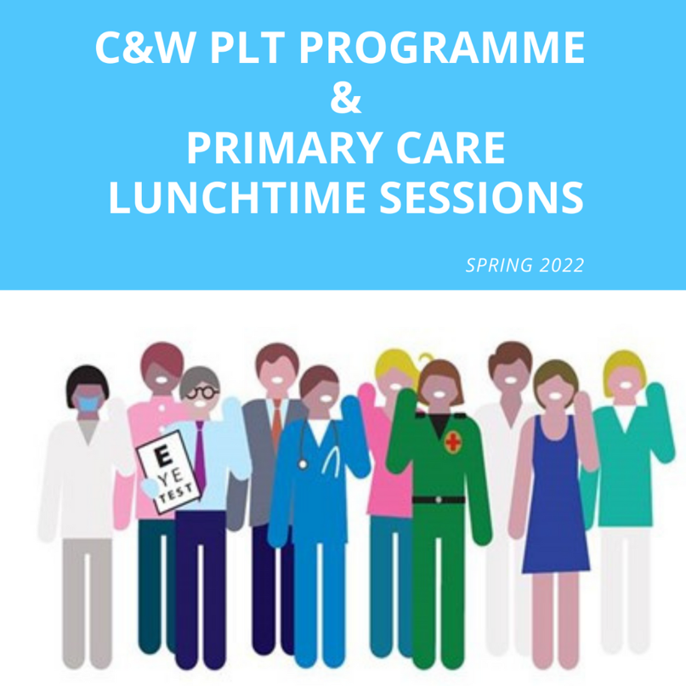
Click here for Coventry and Warwickshire PLT Programme and Primary Care Lunchtime sessions during Summer 2022.





Showcase your vacancies with us!

Our aim is to highlight the exciting and varied opportunities available in Primary Care across Coventry and Warwickshire.
This is not a duplication of NHS Jobs but rather an opportunity to showcase your vacancies.
If you would like to advertise a role with us, click on the button below to complete the short form or contact cw.traininghub@nhs.net

Post your job with us!



Below are a selection of resources for you, to view all resources, visit the 'Resources' page on our website by clicking here.


Primary Care New Roles Resource
HEE have developed the 'New Roles in Primary Care' National toolkit.

Long COVID elearning session
This elearning session has been developed to provide you with a basic introduction to long COVID and post-COVID-19 syndrome.


Cervical Screening Best Practice Poster
The poster contains important failsafe checks taken from the Cevical Sample Take Training guide and the Sample Take Acceptance policy.


To help us evaluate the C&W Training Hub Newsletter please take a few moments to complete the survey.
CLICK HERE

