Issue 19 June 2022

Welcome to your latest Training Hub update – your monthly download of upcoming training and development opportunities for primary care in Coventry and Warwickshire, including nursing news and additional roles integration.
We are extremely proud of the hard work you all put in to provide a caring and resilient service to support patients. We are here to help you do what you do best, by delivering additional training, attracting new recruits and providing support.
This newsletter is one of the ways we’re able to keep you up to date with new opportunities – please take a few minutes each month to read it and share with colleagues as appropriate.

Jump to:

Training Hub News
Latest News
Training & Education
GPN
GP
*New* Allied Health Professionals

Placements
Wellbeing
PLT Programme
Careers
Resources




Lead for Workforce Planning and Additional Roles
We are very pleased to be welcoming Sue Phillips, Lead for Workforce Planning and Additional Roles to the Training Hub team.

Watch this space for a full introduction from Sue Phillips in next months edition!

Health and Wellbeing Champions

'If we don’t look after ourselves, and each other, we cannot deliver safe, high-quality care' - NHS People Plan


What are the benefits of a Health and Well Being Champion:
- They will keep you updated on regional, national and local Health & Well Being support offers
- They will work with you to understand your Health and Well Being needs, providing support, guidance and signposting to services.
- They may introduce events and activities to support such as lunchtime and evening walks.

The no. of Health and Well Being Champions within each PCN

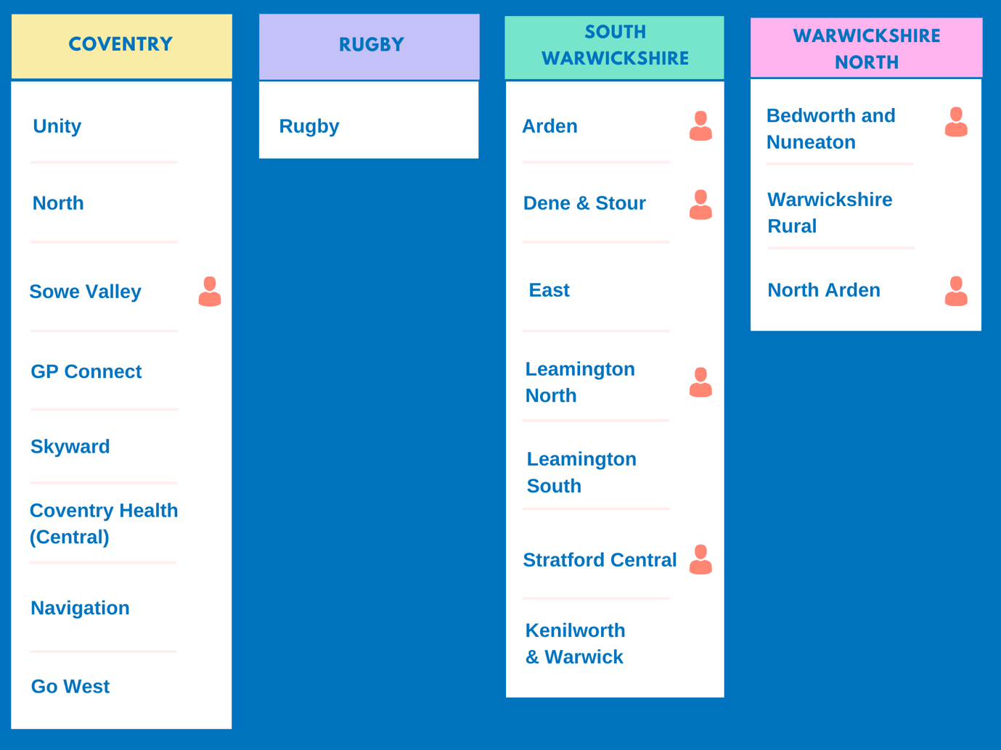

Our HWB Champions in the image above come from a variety of roles, they are: Receptionists, Clinical Pharmacists, GPs, Social Prescribing Link Workers and Care Coordinators!
Take a look at the image above - does your PCN have a Health and Well Being Champion?
If the answer is no and you are enthusiastic about Health and Well Being and want to share your passion with your colleagues and create a healthier, happier workplace click on the button below and get in touch for more information!

I am interested in becoming a Health and Well Being Champion

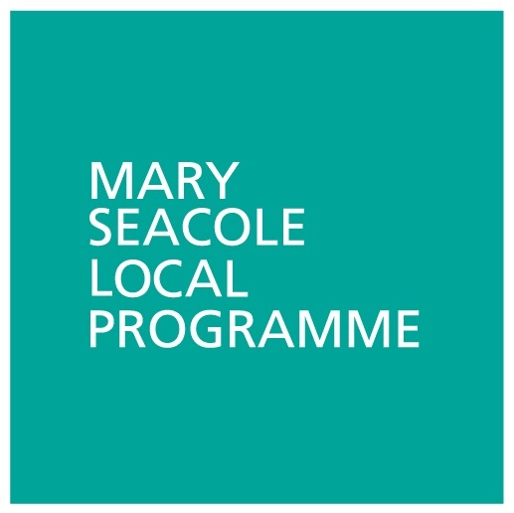
Fully Funded - Mary Seacole Programme
We are offering an opportunity to new, existing or aspiring leadersof teams or services to register for a fully funded place on the Mary Seacole Local Programme.

Click here for more information and to apply



A Guide to your GP practice

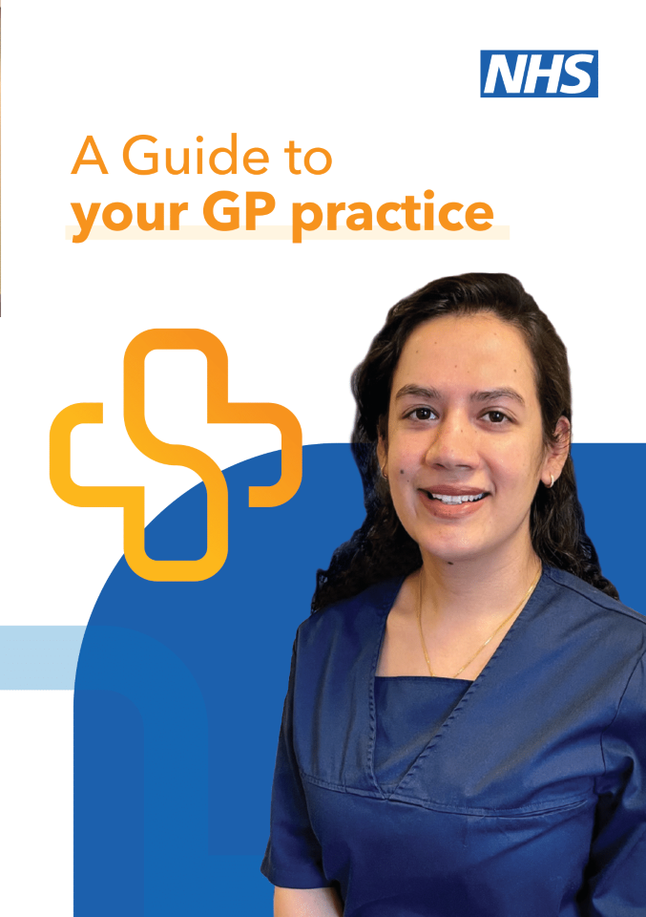
Coventry & Warwickshire Clinical Commissioning Group has produced a useful guide to the different types of appointments and support patients can expect to receive at their local practice.
It runs through the different roles within a healthcare team which may be useful if you're wanting to explain the structure and various positions within primary care with patients or even family and friends.
Read the short guide: NHS Guide to Practices A5

Our People, Our Purpose - Big Conversation



The Our People Our Purpose Big Conversation is launching on 27th June, to bring together leaders from Coventry and Warwickshire’s health and care organisations to co-create a system-wide ‘One People Plan’ - the workforce strategy that will define the way ahead for our Integrated Care System (ICS).
We all have a part to play in creating happier, healthier lives for our communities and through Our People Our Purpose, we aim to explore the art of the possible and understand what would add the most value to you, your people and the services you deliver, to ultimately improve population health and reduce health inequalities.
The Big Conversation will give leaders the opportunity to have their voice heard in an anonymous online discussion about what we can do together now and what we can do in future to reimagine our workforce, to inform the development of Coventry and Warwickshire’s One People Plan and ultimately make our system a better place to work and live.
Please register here to join now and represent the voices of your people and your communities.

Midlands Workforce Transformation Improvement Collaborative - PGDME - Locally Employed Doctors


This session is open to all Locally Employed Doctors and those in organisations that employ them. It will update the audience on the new contract and the results of the National Training Survey. There will be breakout sessions looking at the role of the LED Tutors and explore how HEE can support with education supervision. A look at Best Practice for LED contracts and discussion of equality and inclusivity.

Click here to join

Coventry and Warwickshire Women's Network Launch Event
You are invited to the launch event of Coventry & Warwickshire System-wide Women’s Network on Wednesday 13th July 2022, 16:00 -17:00pm
Book your place here

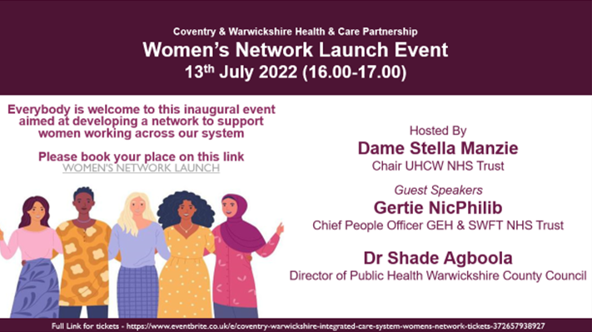

Quality Improvement Facilitation Development Programme


Want to build on your existing knowledge and experience of quality improvement?
The programme will support all attending to enhance their ability to be effective facilitators and leaders of change in their own workplace. It combines quality improvement tools and techniques, practical approaches to the human dimensions of change, as well as presentation and facilitation skills.
Click here for more information.



Training & CPD Calendar

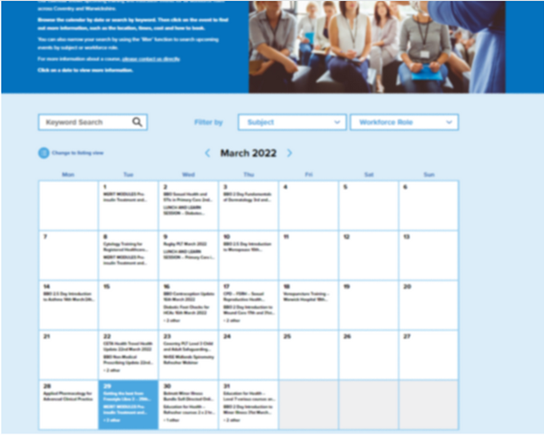
Our calendar shows upcoming training and education events for all workforce rolesacross Coventry and Warwickshire.
Browse the calendar by date or search by keyword. Then click on the event to find out more information, such as the location, times, cost and how to book.

Training & CPD Calendar

Online Practice Assessor Training


This is an online two-day preparation to enable you to take on the role of Practice Assessor. This online event will be held using Zoom and a link to join will be sent to you prior to the course commencing.

The Practice Assessor is responsible for conducting evidence-based assessments of students to confirm student achievement of proficiencies and programme outcomes of practice learning and to record findings.

Click here to view upcoming dates and links to book



Have you seen:
(These are links to other areas in the newsletter that share new and important updates for GPNs)

Online Practice Assessor training

Latest News

Fully Funded - Mary Seacole Local Programme

CPD Funding - Year 3
We are once again pleased to confirm that funding under the CPD funding allocation has been confirmed for the third year. Eligible staff are allocated £333 (to be spent by March 2023).
We will be publishing a list of courses available to book via our website shortly and of course individuals have the option to book and pay for their own training, claiming back the cost to a maximum of £333 via practice invoice. If there are any courses you would like to see being offered via the website please do let us know.
Take a look below for details on University courses and a fantastic GPN Development programme that you can use your CPD funding towards!


CPD Funded - University Courses
We would like to invite expressions of interest for the following funded university courses (using individual’s Year 3 CPD allocations) as follows:

- Diploma in improving Diabetes (Warwick University)
- Independent Prescribing (Coventry University)
- Health Assessments (Coventry University)
Places are limited and will be considered on a first come first served basis, and will need the support from your practice to apply.
Please ensure that you/the proposed candidate meet the criteria for their preferred course and are eligible to CPD funding before emailing - stating name, role and the course of interest, preferred start date e.g. September 2022 or January 2023 to cw.traininghub@nhs.net

CPD Funded - General Practice Nurse Development Programme
This six-day CPD programme has been designed in collaboration with the Black Country and West Birmingham Sustainability and Transformation Partnership (STP). It will prepare General Practice Nurses to develop their career and enhance their leadership skills and potential.


We would like to invite expressions of interest for this exciting fully funded programme with Birmingham City University. There are ONLY 10 places available. The cost for this programme would be covered in part using your Year 3 CPD allocation of £333 and in part by C&W Training Hub.
For more information click here

Developing Aspiring Ethnic Minority Nursing Leaders Programme
The NHSEI Midlands Nursing team are running a second cohort of the Developing Aspirant Ethnic Minority Nursing and Midwifery Leaders Programme starting in September 2022.
3 places are available for Nurses, Band 6-8a( or equivalent) across Coventry and Warwickshire Integrated Care System.

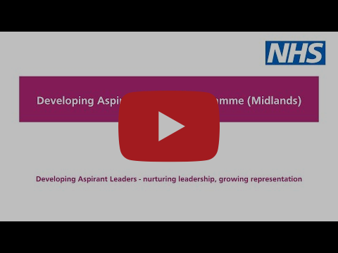

See here for participant application pack which outlines the programme.
All applicants need to have the support of their line manager and a sponsor, the information packs for your line manager and sponsor are below, these can be shared with them if you wish to apply.
- Line manager information pack
- Sponsor information pack
If you have any queries about the programme, please contact:
England.midlandsnursingworkforce@nhs.net

Peer Support for Nurses and ACPs


We realise how isolating General Practice can be and how much we rely on agile platforms such as WhatsApp to answer questions and vent.
We invite you to join the monthly peer support sessionhosted by Gillian Schweigert for Nurses and ACPs across Coventry and Warwickshire.

We meet the 1st Thurs of every month from 1-2pm - click here to join!

Practice Nurse Mentoring

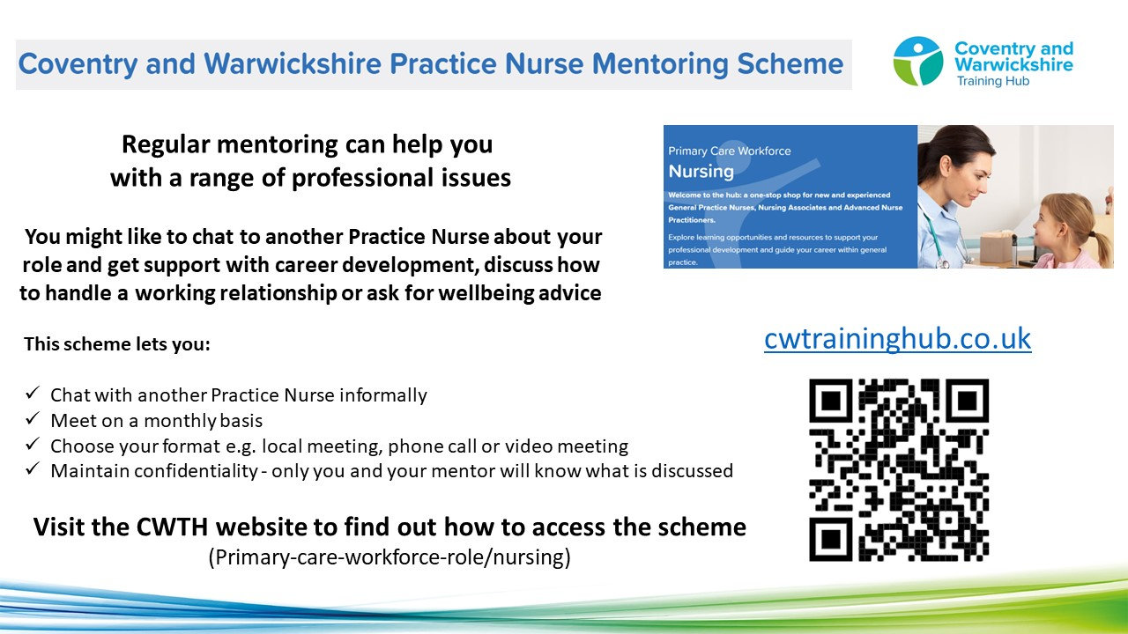

To find a mentor, complete the online registration form. During this registration process you will have the opportunity to view the Mentor Profile Pack and decide which mentor you think would be a good fit for you. The Clinical Lead will assign a mentor to you, considering your preferences and the mentor’s current capacity

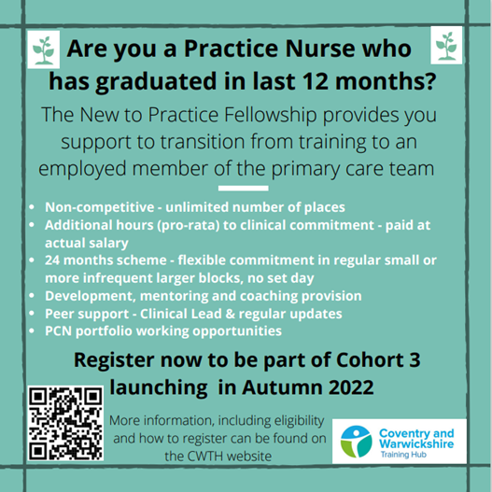



Have you seen:
(These are links to other areas in the newsletter that share new and important updates for GPs)

Latest News


Phoenix GP
Phoenix GP provides fully funded career development and leadership programmes, designed specifically for mid-career GPs.
From Sept 21 - Feb 22, 35 C&W GPs were provided with this fanatic opportunity.

Would you like to see this programme be hosted for a second time in your area?
We would be looking to start the programme in January 2023 but only if there is sufficient interest
Click here to find out more or simply reply to C&W Phoenix GP with “I’m interested” by Close of Play on Thursday 30th June.

Complaint Signposting Service


Are you a GP who has received a complaint?
Do you need someone to talk to but are unsure where to turn?
If you have answered yes to these questions, please contact our free and confidential complaint signposting service. You will be offered up to a 30-minute appointment to discuss the issues you are facing and signpost you to support services available if necessary.

We all recognise the huge strain and workload that general practice is facing at the moment and want to understand the impact complaints are having directly on a doctor’s wellbeing.
We want you to know there are people out there who can help whilst going through what can be an isolating and difficult experience. Complaints are difficult no matter how big or small so whether you simply need a confidential conversation, a guiding hand, or signposting to other services we want to hear from you. Equally if you know someone who you feel would benefit, please do not hesitate to get in touch.
Natalie.flood2@nhs.net
This service is for any GP within Coventry and Warwickshire including trainees.

Professional Curiosity Scheme - Launching in July!


Following on from the successful focus event held in May we are delighted to be launching the Professional Curiosity Scheme this month!

Whilst we already have a breadth of enthusiastic consultants and GPs who have engaged with the scheme so far, the more clinicians we have on board the better. Please encourage your colleagues to join us with this exciting scheme as soon as possible so that we can fully maximise the potential positive outcomes which are likely to occur.
It’s never too late to get on board so if you haven’t yet got in touch but are curious and keen to get involved then please contact PCS Scheme Admin for more information.
We are excited to see what fantastic opportunities and experiences this scheme will offer and can’t wait to hear back from those who take part over the next few months.
Watch this space for the formal launch material and further details on the official signup process.
Thanks in advance
Dr Lucy Blunt
Clinical Lead for the Professional Curiosity Scheme

New to Practice Fellowship

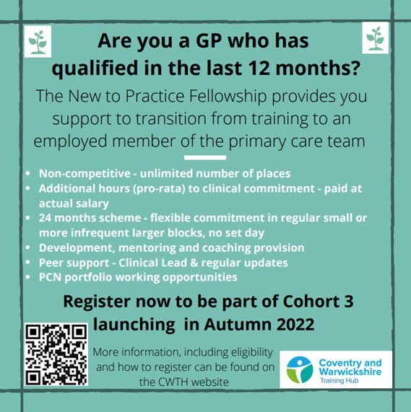

GP Mentoring Scheme

If you decide that you would like a Mentor, you will get the opportunity to view the GP Mentor Profile Pack and decide which Mentor you think would be a good fit for you. Apply here to view the Profile Pack: GP Mentor Scheme Registration.

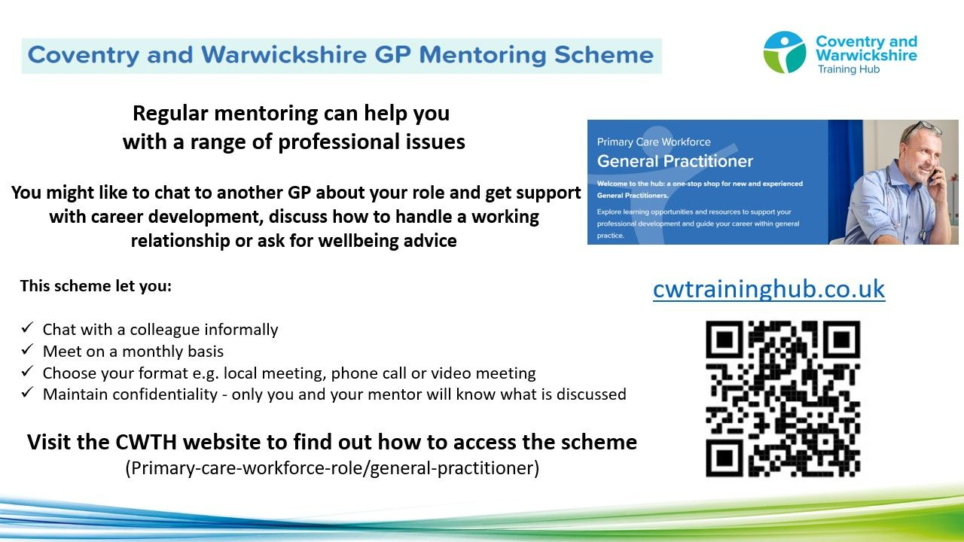

Taking into consideration each Mentor’s capacity, you will be allocated a Mentor, based on your preferred choices.
The Mentor will not disclose any details of any conversations between you both. You and your mentor will be asked for feedback, which can be given anonymously. We currently have 53 mentees utilising the scheme, which is supported by 20 Mentors from a wide range of background an experience. The offer is open to all GPs in C&W at any stage of their career.



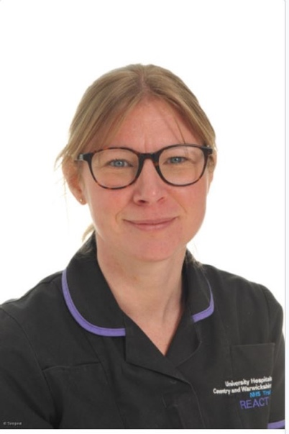
This month I have enjoyed getting to know some of the AHPs in our area, hearing about the valuable work they are doing and getting out to shadow and I look forward to meeting those who I haven't yet met.
This coming month we will be sending out a staff survey to the AHPs so please look out for that; we are keen to hear your views and what learning opportunities you would like to see.

For anyone thinking of employing a Dietician, Podiatrist or Occupational Therapist or would like to know more about their roles in Primary Care please do get in touch.
Below is a link to the latest AHP network update, hope you find it useful!
Hannah Stroude, AHP Ambassador
Email: hannah.stroude1@nhs.net

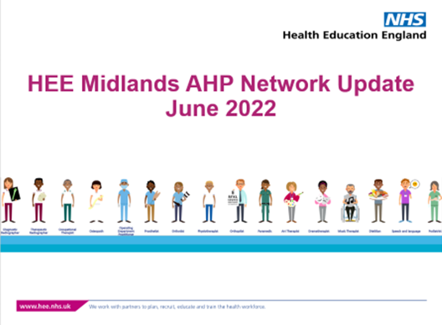
HEE Midlands AHP Network Update - June 2022
Stay up to date with the latest opportunities and news across the region!
Click here to view the AHP Network Update for June 2022




The Training Hub is working with Coventry University and practices in Coventry and Warwickshire to arrange placements for Nurse, Paramedic and OT students in general practice.

We would like to extend a huge thank you for those practices supporting and inspiring our future nursing workforce into primary care by offering placements to student Nurses and Nursing Associates.
If you would like more information on Placements, please take a look at our dedicated Placements page on the website for more information or contact us via cw.traininghub@nhs.net

Register your interest - Host a student in your Practice




You are always there for your patients, providing a first-class healthcare service.
So we want to support you to look after your own health and wellbeing.

We have compiled a variety of health and wellbeing support resources and services on our website to support you, below are some additional wellbeing resources for you. Our wellbeing page on the website can be found here.


Wellbeing Wednesday
Each and every Wednesday we will be sharing upcoming events, tips, activities and more to help support you to look after your mental health and wellbeing!
You can find your weekly wellbeing update here


Flexible working toolkits
NHS England have created two new flexible working tookits for line managers and colleagues offer help and advice on how to implement flexible working opportunities.
Click on the links below for more information
- Toolkit for Line Managers
- Tooklit for Individuals



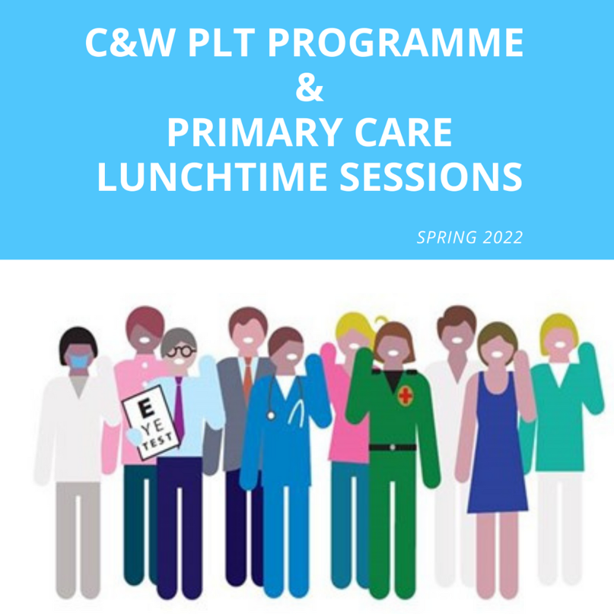
Click here for Coventry and Warwickshire PLT Programme and Primary Care Lunchtime sessions during Summer 2022.





Showcase your vacancies with us!

Our aim is to highlight the exciting and varied opportunities available in Primary Care across Coventry and Warwickshire.
This is not a duplication of NHS Jobs but rather an opportunity to showcase your vacancies.
If you would like to advertise a role with us, click on the button below to complete the short form or contact cw.traininghub@nhs.net

Post your job with us!



Below are a selection of resources for you, to view all resources, visit the 'Resources' page on our website by clicking here.


Primary Care New Roles Resource
HEE have developed the 'New Roles in Primary Care' National toolkit.

Long COVID elearning session
This elearning session has been developed to provide you with a basic introduction to long COVID and post-COVID-19 syndrome.


Cervical Screening Best Practice Poster
The poster contains important failsafe checks taken from the Cevical Sample Take Training guide and the Sample Take Acceptance policy.


To help us evaluate the C&W Training Hub Newsletter please take a few moments to complete the survey.
CLICK HERE

Copyright © 2022 C&W Integrated Primary Care, All rights reserved.
Want to change how you receive these emails?
You can update your preferences or unsubscribe from this list.

