

Welcome to this week’s edition of Practice News

If you'd like to have Practice News and other relevant ICB updates sent to you directly, please email cwccg.communications@nhs.net

Latest information for practices
Spirometry Results Error
As previously communicated earlier in the week, there has been an error for the sending out of GEH spirometry results, this has now been rectified and practices should continue to receive all spirometry results through DOCMAN as normal. Should practices experience any further delay in receiving results, please email respiratory.physiologists@geh.nhs.uk

Hot weather Communications
Please find this time limited link to a comms toolkit and images for Hot weather. Please share via all of your internal and external channels. Some of you may be doing this already. Please note that there is a level 3 Hot weather warning which extends the previous one until next Tuesday 19th July.

Level 3 - Heatwave Action
https://www.metoffice.gov.uk/public/weather/heat-health/?tab=heatHealth&season=normal#?tab=heatHealth

There is a 90 % probability of Heat-Health Alert criteria being met between 0900 on Saturday and 2100 on Tuesday in parts of England.

An update will be issued when the alert level changes in any region. Alerts are issued once a day by 0900 if required and are not subject to amendment in between standard issue times.

Note that the details of the forecast weather are valid at the time of issue but may change over the period that an alert remains in force. These details will not be updated here unless the alert level also changes, the latest forecast details can be obtained at the following link:

https://www.metoffice.gov.uk/public/weather/forecast/#?tab=map

Regional Risk Assessments for occurrence of Heat-Health Alert criteria between 09:00 Local Time on Saturday and 21:00 Local Time on Tuesday.

The areas that are likely to be affected are:

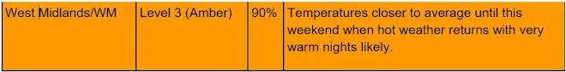

Cooler air is likely across England from Wednesday through to Friday. It will still feel warm for many, and particularly the southeast will remain very warm or hot by day with warm nights.

Renewed hot or very hot conditions develop during this coming weekend and into the new working week. However there remains some uncertainty at present in the extent, intensity, and duration of the renewed hot or very hot conditions at this lead time, and this alert will be kept under daily review as forecast confidence increases. Organisations providing health and social care should be aware of the advice and guidance set out in the Heatwave Plan for England, as to the actions necessary before and during a Level 2 or Level 3 heatwave. Specific advice to be followed by health care professionals, and the managers and staff of residential and nursing homes in the event of an episode of heat is available from UK Health Security Agency’s website www.gov.uk/government/publications/heatwave-plan-for-england .

The Heat-Health Alert Service is designed to help healthcare professionals manage during periods of hot weather. The service acts as an early warning system forewarning of periods of high temperatures, which may affect the health of the public. Heat-Health Alerts are sent to the Chief Executive of every Health Trust provider of NHS commissioned care, Local Authority and Social Care Organisation in England.

If you would like to add a colleague to receive these alerts, or change your own email address, please go to https://public.govdelivery.com/accounts/UKMETOFFICE/subscriber/new?qsp=UKHSA . Feel free to share this link within your organisation, or other health and social care administrations you think may benefit from this service. If you have questions or technical problems with the subscription service, please see the page subscriberhelp.govdelivery.com . All other enquiries can be directed to enquiries@metoffice.gov.uk

The Heat-Health Alert Service operates in England from 1 June to 15 September each year, in association with UK Health Security Agency. This is the period when temperature thresholds are most likely to be reached. However, should thresholds for an alert be reached outside of this period, an extraordinary Heat-Health Alert will be issued and stakeholders are advised to take the usual public health actions.

Notes from Extreme Heat Response Co-ordination Group meeting
Please find attached notes from the Extreme Heat Response Co-ordination Group meeting.

GP Liaison Nurse at UHCW MDU
Many of you will be aware of the role of Paula Dodgson, GP Liaison Nurse at UHCW and have regular contact with her to refer patients into the MDU. We have received notification that the email address for Paula Dodgson, GP Liaison Nurse at UHCW Medical Decisions Unit will change as of 1st August, please do cascade this to appropriate members of the practice team.
As of the 1st August all GP referrals to go through: GpLiaison@uhcw.nhs.uk

Paula Dodgson - GP liaison Nurse
Medical Decisions Unit
Phone 02476966223 (int 26223)
Bleep 1424
Working hours are Monday, Tuesday, Thursday and Friday 08.30-18.00

Two new, FREE products to help staff communicate with patients, families and carers
Our Health Literacy and Patient Information team have produced two new products for health and care staff and students/trainees to use themselves, particularly with patients, carers and their families but also any regional partners.

In the attached relevant doc:
- short article/content for web and intranet – general
- shorter bulletin pieces (different lengths to cater for limitations from 100 words)
- suggested social media post and tweets
- a selection of graphics to use on social and other platforms.
The products are:

1) Easy Read guides on health care consultations –see attached for people with learning disabilities and autism co-produced with those with a lived experience. One guide is how to prepare for an appointment the second is on what to ask in an appointment.
While for people with an LD or autism they are broadly useful for anyone – including students/learners and professionals who may not have considered some people’s needs.

2) Your Health Collection –see attached for all health and care staff to use themselves and with patients/contacts, families and carers. The books and digital resources are designed to help people with their general health rather than specific conditions.
- 3 Questions Right Choices
- 10 Book Titles, 30 Digital Resources
- Good and bad
- Your Health Collection

Warwickshire County Council Drugs Needs Assessment
Warwickshire County Council have recently commissioned Tonic, to conduct a Drugs Needs Assessment to inform its decisions, resource allocation and service design over the next 3-5 years.

The Needs Assessment will;
- Inform the upcoming re-tendering process for Drug Misuse Services in 2024.
- Present the picture of needs, gaps, and demand for drug services across Warwickshire.
- Understand the needs of those individuals with vulnerable or protected characteristics.
- Utilise the latest evidence base, relating to effective interventions.
- Identify preventative interventions that are effective to reducing drug misuse.
- Outline recommendations for future commissioning considerations and models of support.
- Reflect interdependencies with other strategies, such as Homelessness Strategy, Community Safety Strategy etc.
- Compliment Warwickshire’s Alcohol Joint Strategic Needs Assessment 2022.

It is crucial we reach individuals who are not currently accessing services, as well as those who are in treatment, to identify how we could increase engagement.

Please distribute this email within your professional networks and services - It would be greatly appreciated if the survey could be promoted on your social media platforms using the assets within the comms pack attached.

The survey is now LIVE until Friday 19th August and can be completed using the following link - https://eu.surveymonkey.com/r/wardana

Participants can sign up for an interview here: https://wardana.youcanbook.me or by emailing: talk@tonic.org.uk or texting: ‘WARWICKSHIRE’ to 07597 266 708.

Please contact helendevine@warwickshire.gov.uk or daisy@tonic.org.uk with any questions.
- Poster
- Poster 2
- A
- B
- C
- D
- E
- F

New online eating disorder learning available for GPs and primary care clinicians
We are pleased to launch, with experts by experience, NHS England and NHS Improvement, and the charity Beat, new to online eating disorder learning for GPs and primary care clinicians. This learning will support primary care colleagues in understanding and supporting people of all ages with an eating disorder.

The two learning sessions can be completed at the learner's own pace and take approximately 30-40 minutes to complete each. The learning also includes an assessment framework and a GP appointment involving an eating disorder assessment role-play demonstration.

Eating disorders are common and Anorexia Nervosa has the highest mortality rate of any mental illness. However, people with eating disorders have better recovery rates and a reduced risk of relapse when they receive the right support as early as possible.

To further increase the support for people with eating disorders, mental health services, including eating disorder services, will see an additional £2.3 billion every year as part of the NHS Long Term Plan ambitions and an expansion of community-based mental health care to provide support for 370,000 adults.

Alongside the expansion, HEE and NHS England and NHS Improvement are working in partnership to develop and deliver a comprehensive training programme. This programme will improve the support received by those with eating disorders, including training in NICE-recommended psychological therapies, whole team training and training for non-specialist staff to improve identification and support throughout the system.

We have attached a stakeholder communication toolkit for you to use.

Thank you to our partners at Beat for contributing and developing this learning programme with us and their ongoing mission to end the pain and suffering caused by eating disorders.

To find out more, visit the health and care staff eating disorders learning programme webpage. Additional mental health and eating disorders learning can be accessed via HEE’s website.

Diabetes Prevention Programme- Revised Referral Form
Please find attached updated information about the Diabetes Prevention Programme

With Staff in Mind Team support offer
Please find attached information from the With Staff in Mind service, who offer team-based sessions for teams who work in Health and Social Care across Coventry and Warwickshire. Please do share via your internal networks, for anyone who may be interested.

Supply issue with Promethazine hydrochloride 25mg tablets
Please find attached a Medicine Supply Notification for:

- Tier 2 medicine supply notification for Promethazine hydrochloride 25mg tablets

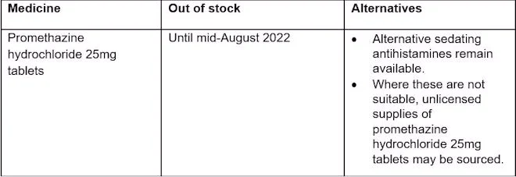

DHSC and NHSE/I have now launched an online Medicines Supply Tool, which provides up to date information about medicine supply issues. The contents of this MSN can now be viewed on the Tool. The Tool also details any changes to resupply dates and updates to the entries. To access the Tool you will be required to register with the SPS website.

Supply issue with Buserelin (Suprefact®) 5.5mg/5.5ml solution for injection vials, Buserelin (Suprecur®) 5.5mg/5.5ml solution for injection vials and Buserelin (Suprecur®) 150microgram/dose nasal spray
Please find attached a Medicine Supply Notification for:
• A Tier 2 medicine supply notification for Buserelin (Suprefact®) 5.5mg/5.5ml solution for injection vials, Buserelin (Suprecur®) 5.5mg/5.5ml solution for injection vials and
Buserelin (Suprecur®) 150microgram/dose nasal spray

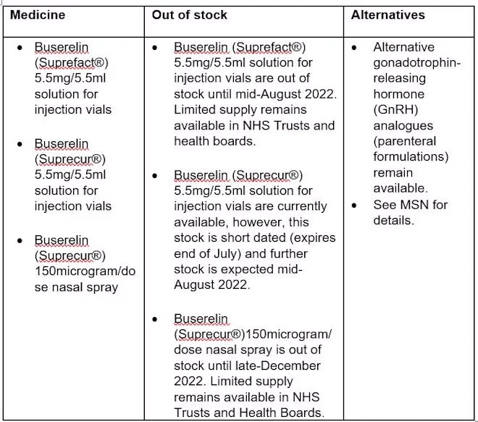

Letter to all NHS organisations re: the timing of the statutory medical examiner system
Please see attached B1701- Letter to all NHS organisations re: the timing of the statutory medical examiner system.

Training, events & surveys
Understanding Extremism and Radicalisation - FREE Training Courses - available to book now
As part of our Understanding Extremism and Radicalisation training programme, we have new dates available for The Far-Right Ideology and Understanding the Dark and Deep Websessions.

Both courses have been updated and include information and case studies with local content.
Please share the attached posters with your teams and circulate to notice boards and team sites.

GP CPCS Summary & Demonstration
Please see this flyer relating to GP-CPCS, there is also an invite for practice

Patient Digital Engagement (PaDE) Webinars
Please see below some forthcoming online webinars provided as part of the Patient Digital Engagement (PaDE) project, details of which can be accessed from this link: Midlands - practical support to all GP practices and PCNs (redmoorhealth.co.uk)

Thurs 21st July 12.30-1.30pm- Making the most of your Practice Website:
Weds 27th July 1.30-2.00pm- Introduction to GP Online Module:
• Explore how you enable patients to access services online
• How patients can order medication online
• Booking and cancelling appointments online
• Messaging, online and video consulting

EMIS: ICR: GP Drop-in sessions
An Integrated Care Record (ICR) is a way of bringing together the various electronic records of a patients care. It takes information directly from existing systems used by health and social care organisations and presents it in a structured, easy-to-read format for GP’s, health and care professionals.

The ICR will provide health and care professionals with a more joined-up view of people’s care and treatment across all care settings.

The benefits to your Practices include:
- Not having to repeat your details every time you have a different episode of care
- Better and potentially faster treatment due to health and care professionals having access to better information
- Reduction in potential medication errors through clinicians having access to your medication history (past and present)
- More effective treatment should you need care for COVID-19 due to fast access to information about any pre-existing conditions and your medications

We will be having informal Drop-in sessions every Wednesday 12:30-13:30 from the 10th July to the 28th September.

The link to join is : Click here to join the meeting
Or
https://teams.microsoft.com/l/meetup-join/19%3ameeting_ZmI2NDBhZTctMTUyYy00NDA5LTg2MWItNGJlMDgxZmM3ZDFi%40thread.v2/0?context=%7b%22Tid%22%3a%2221162ae0-3c09-4f25-90e2-fe933255a400%22%2c%22Oid%22%3a%22b70a8d66-da7d-4874-ab50-c74f4c1f2bfa%22%7d

CPCS training session for practices
GP Community Pharmacist Consultation Service (CPCS) - Coventry and Warwickshire
The GP CPCS enables practice teams to direct patients with defined minor illness to a community pharmacist for their first contact, where they will receive clinical assessment and advice with an aim to reduce the burden on general practices. Its aim is to make sure that patients have access to the same levels of care, close to home and with a self-care emphasis.
Arden and GEM CSU Medicines Optimisation Team have arranged MS Teams drop-in sessions to support implementation of CPCS in practices which can be booked via agcsu.medicines@nhs.net. Or by clicking this link: AGEM CSU CPCS training

See attached for dates.

Newsletters
Digital Health Newsletter
Please find attached the first edition of the Digital Health Newsletter.

Weekly training hub round-up
https://www.cwtraininghub.co.uk/wp-content/uploads/2022/07/Weekly-Round-Up-15.7.22.pdf

Vacancies
CRGPA Alliance Teaching Practice Manager- Coventry And Rugby GP Alliance
Please see details in following link: https://beta.jobs.nhs.uk/candidate/jobadvert/E0046-22-3924

Domestic Abuse Health Advocate Educator (Part Time)
Contract type: Permanent Hours: Part Time, 18.75 hours per week (Wednesday 1:15pm – 5pm, Thursday 9am - 5pm and Friday 9am – 5pm)
Location: Warwickshire Salary: £12,552 per annum (full time equivalent is £25,104 per annum)
Deadline to Apply: Monday 25 July 2022 at 09.00 am

Find out more here: Domestic Abuse Health Advocate Educator (Part Time) | CIPHR iRecruit . (ciphr-irecruit.com)

