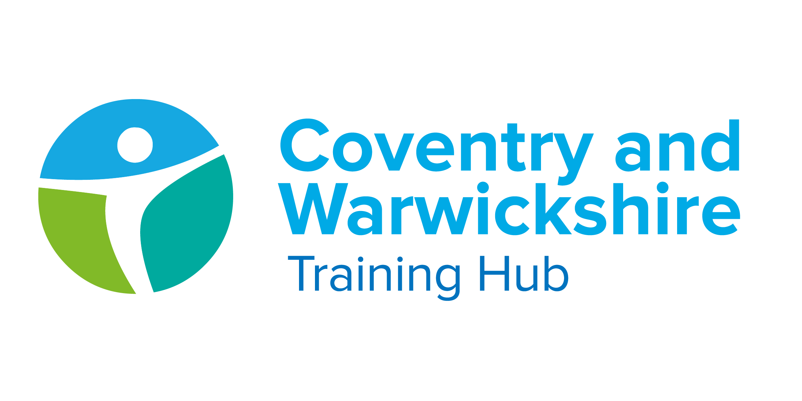

Issue 17 April 2022

Welcome to your latest Training Hub update – your monthly download of upcoming training and development opportunities for primary care in Coventry and Warwickshire, including nursing news and additional roles integration.
We are extremely proud of the hard work you all put in to provide a caring and resilient service to support patients. We are here to help you do what you do best, by delivering additional training, attracting new recruits and providing support.
This newsletter is one of the ways we’re able to keep you up to date with new opportunities – please take a few minutes each month to read it and share with colleagues as appropriate.

Jump to:

Training Hub News
Latest News
Training & Education
GPN
GP
*NEW* Equality, Diversity and Inclusion

First Contact Physiotherapist
Placements
Wellbeing
PLT Programme
Careers
Resources



Coventry & Warwickshire Health & Well Being programme

New employee benefits for General Practice, PCN, Federation & Alliance staff!
We are offering you an exciting selection of staff benefits from our health and wellbeing partner Vivup that are designed to improve your physical, financial and mental health.

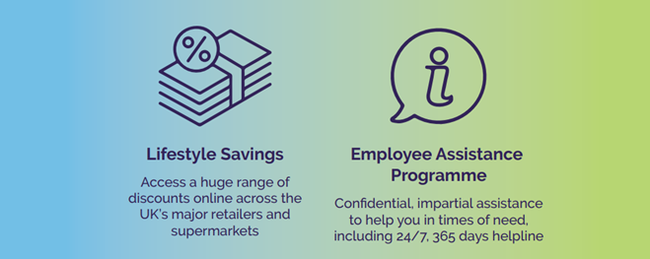

To access your staff benefits you must register on www.vivup.co.uk. If you register before midnight on Thursday 30th June 2022 you will automatically be entered into a prize draw for a chance to win one of four incredible prizes (Air Pods, Sony PS 5, Toshiba TV, Dyson Hairdryer) prizes supplied by Vivup.

Vivup have developed a range of handy bitesize videos to help explain everything you need to know (including ‘How to register’ and ‘Making big savings with your Lifestyle Savings staff benefit’). Videos are available to view on https://campaigns.vivup.co.uk/p/4JGI-CEM/explainer-videos.

In addition to these handy videos, we will be holding FAQ webinars on Friday 27th May– if you have any queries about the platform, drop in at the most suitable time for you
Links to join us are:
Morning Session - 9:30am – 10:30am Click here to join
Lunchtime Session - 12:00pm – 13:00pm Click here to join
Afternoon Session - 15:00pm – 16:00pm Click here to join

Health and Well Being Champion - Spotlight
As we approach national walking month, we are really excited to showcase the work being carried out in C&W by one of our Health and Well Being Champions - Hussain.
Read on to find out what Hussain has been up to and how you and your patients can get involved.


They came… they solved… they got chocolate! Thank you to all those who attended our Easter egg hunt on the 5th April. It was a lovely event & reminded us of the importance of community, physical activity & conversation

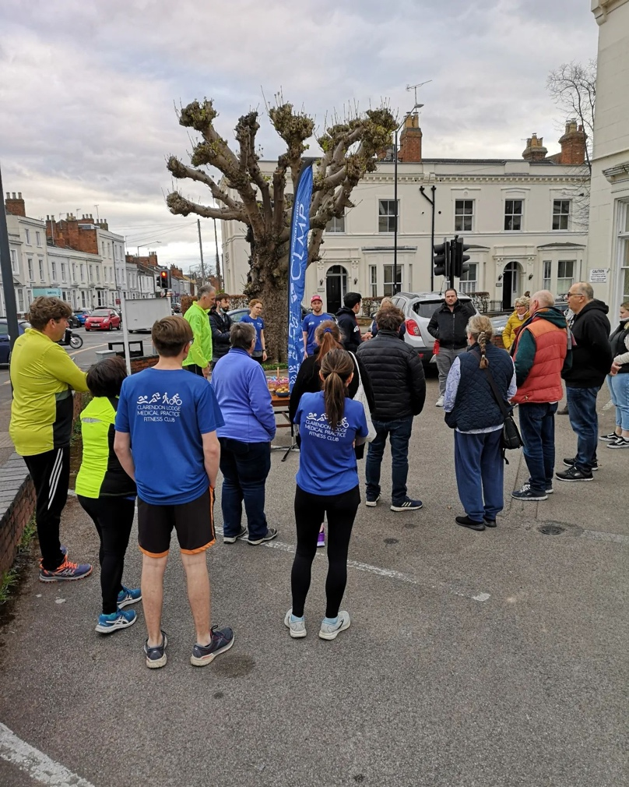
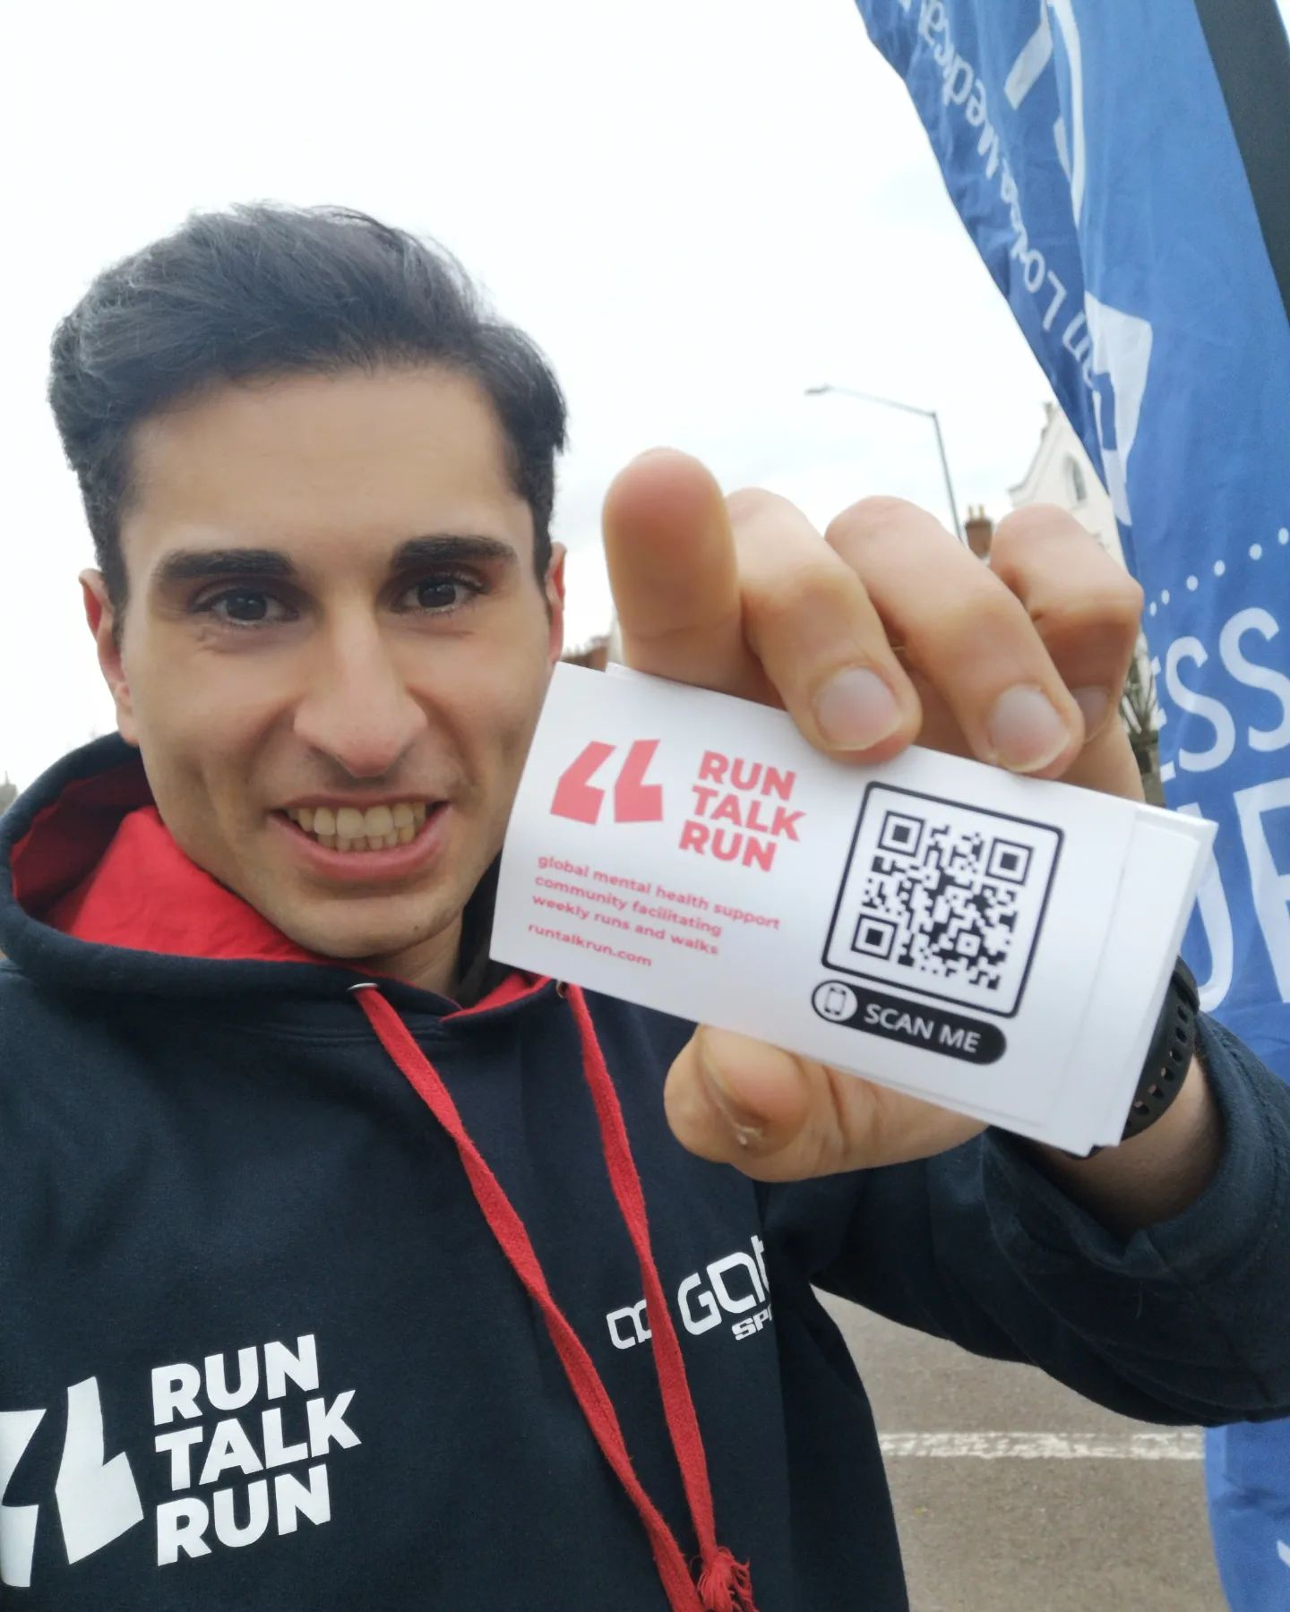

For those interested in joining our free staff & patient walking, jogging or runninggroups we meet up at Clarendon Lodge Medical Practice car park every Tuesday at 18:20pm. No sign ups & ALL are welcome. Just fresh air, physical activity & great conversation.
See you there, Hussain
Instagram: @irondoctorhaz

Coventry & Warwickshire GPN Strategy
We are so excited and proud to share with you the FULL Coventry and Warwickshire General Practice Nursing Strategy.
Click on the image below to open the document

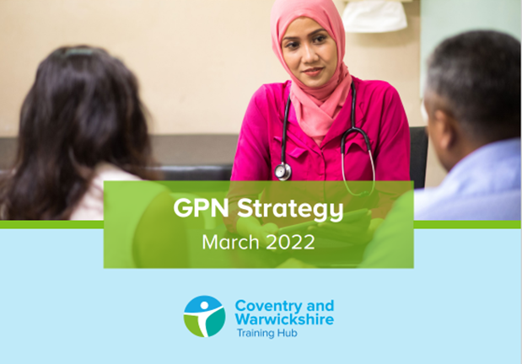

Expressions of Interest - Trainee Nursing Associates
We are assisting Coventry University with scoping PCN interest for trainee Nursing Associate (tNA) places for September 2022.
This really is a win-win offering for General Practice with ARRS funding for salary and Levy funding for education and HCA support for PCNs 3 days per week whilst in training.
This is in support of our Nursing Strategy for growing our own GPNs as these students have the opportunity to continue to progress through the system.

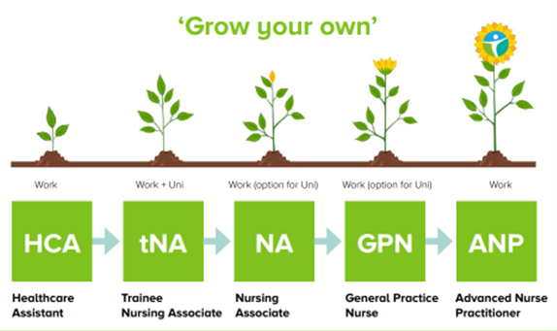

Click here for more information on the role, how the training hub can support, funding etc.
We will need to have expressions of interest from you by next Tuesday May 3rd for the September cohort of trainee Nursing Associates (this is not a firm commitment). The next opportunity will be in 2023, we hope you will consider this offer and support a great initiative!
Please send expressions of interest to cw.traininghub@nhs.net

Practice Manager Mentoring

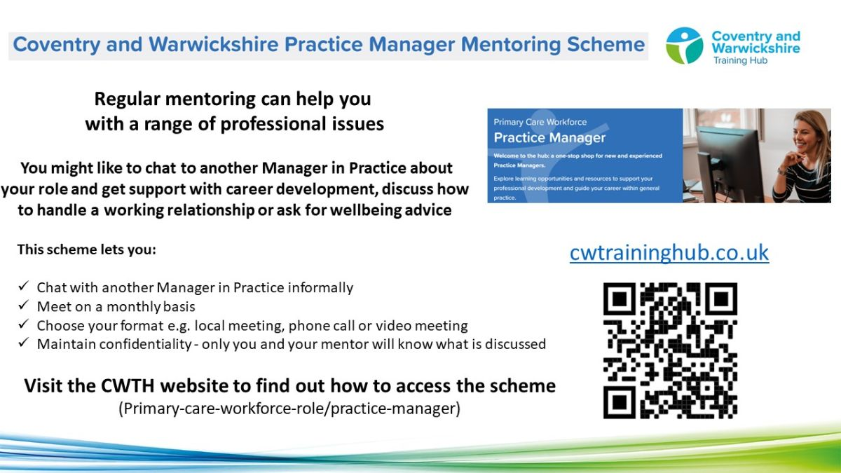

To find a mentor, complete the online registration form. During this registration process you will have the opportunity to view the Mentor Profile Pack and decide which mentor you think would be a good fit for you. The Clinical Lead will assign a mentor to you, considering your preferences and the mentor’s current capacity.



How to beat burnout in the new ways of working in Primary Care
Wednesday 25th May at 7:00pm


In this webinar, we explore the overarching principles which will enable health care professionals to:
- Work well through the new ways of working
- Take control of their time
- Maintain a good work-life balance
- Stay resilient through change and uncertainty

Click here to join and use these details to access: Meeting ID: 897 7772 6705, Passcode: 848610

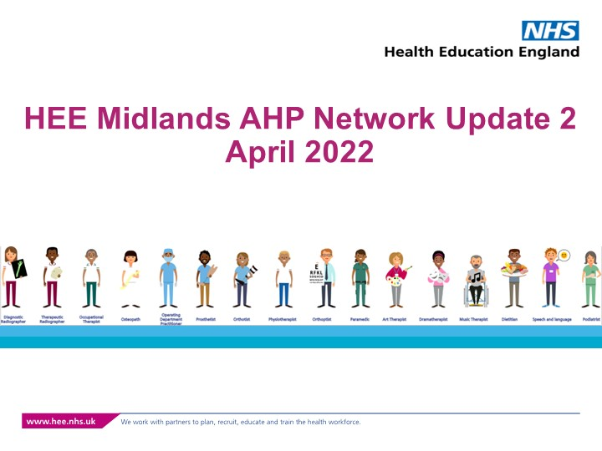

View the latest AHP Network update here



NHS Health Check programme refreshed

The NHS Health Check videos were recently refreshed by Health Education England and the Office for Health Improvement and Disparities (OHID) and provide introductory knowledge about the NHS Health Check, which compliments locally commissioned training.
A new, interactive townscape directs learners to a variety of external resources, which are relevant to the NHS Health Check. Topics include blood pressure, cholesterol, physical activity, alcohol, smoking, behaviour change, dementia, plus information on cardiovascular disease prevention and the NHS Health Check programme.
To read more about the resources, https://www.e-lfh.org.uk/programmes/nhs-health-check/



This year’s World Asthma Day (Tues 3 May 2022) focuses on closing gaps within asthma care.
To support the campaign, we’re providing free access to both a live online event and pre-recorded podcasts and webinars. Our World Asthma Day programme focuses on identifying gaps in asthma care and sharing potential solutions, and we’re speaking to associates and partners across the healthcare workforce to get their take.

View free asthma content



Training Hub Engagement Map

Below you can see how the 4 Places (Coventry, Rugby, South Warks and Warks North) within Coventry and Warwickshire are engaging with some of our different offers.
Figures are based on the number of individuals who have engaged with us. If you would like to find out more about any of these offers, please do get in contact via cw.traininghub@nhs.net

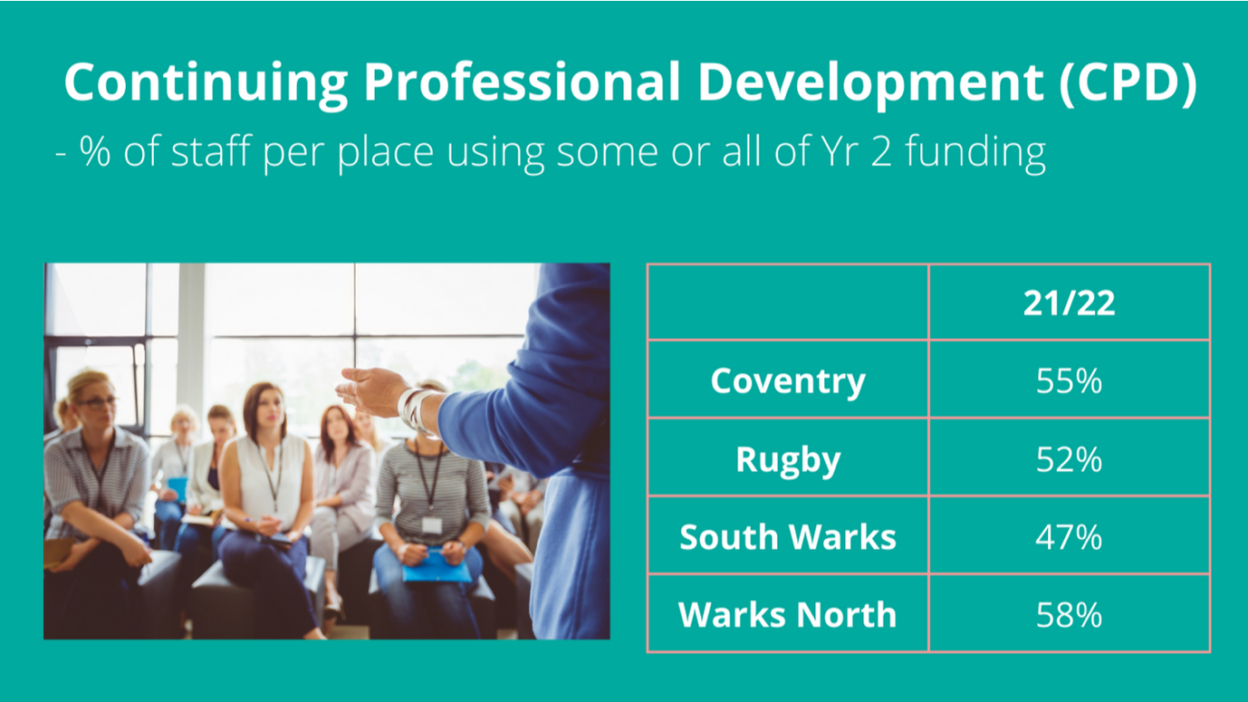

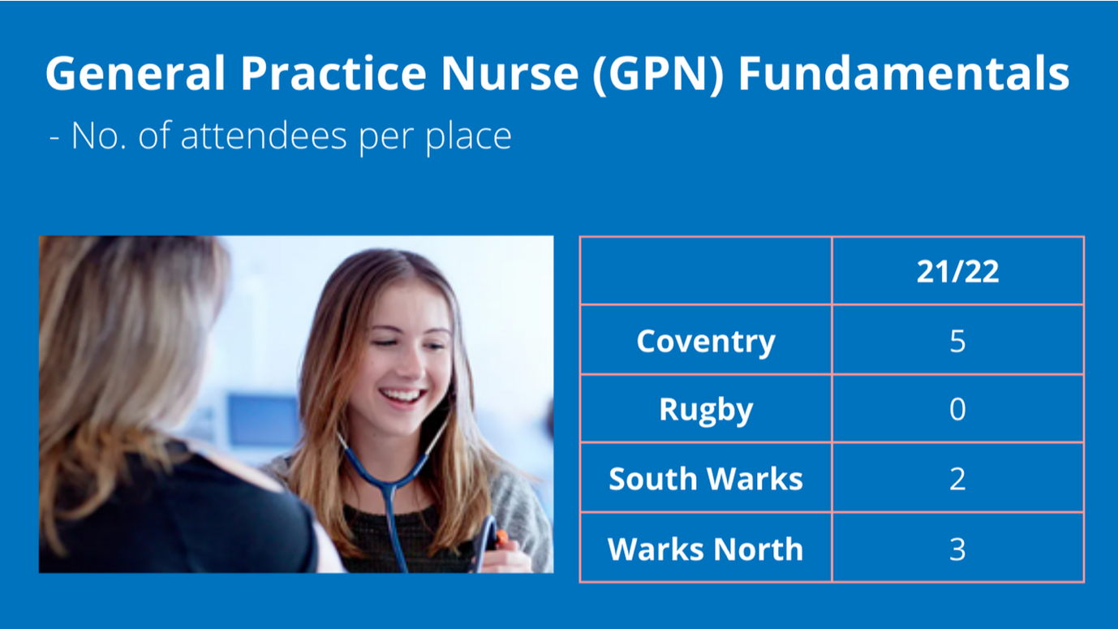

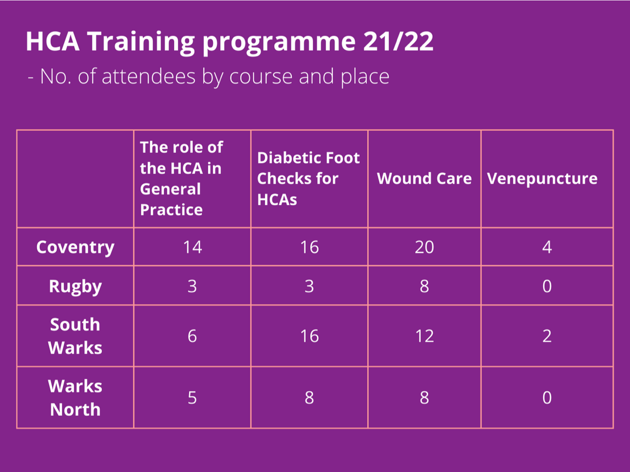

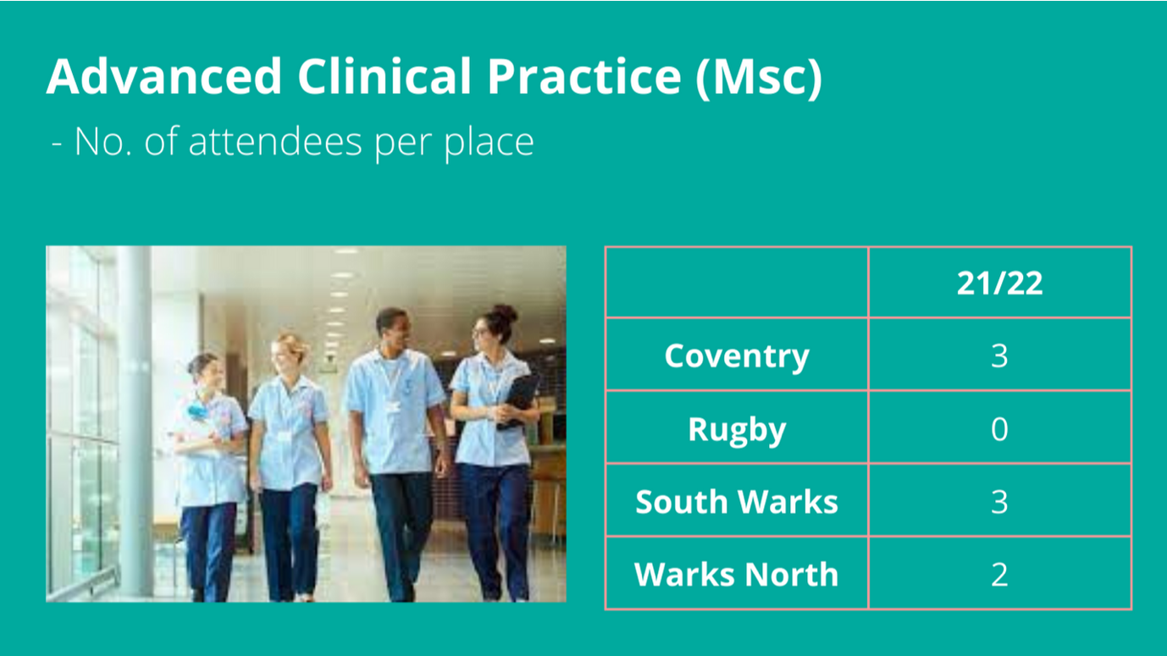

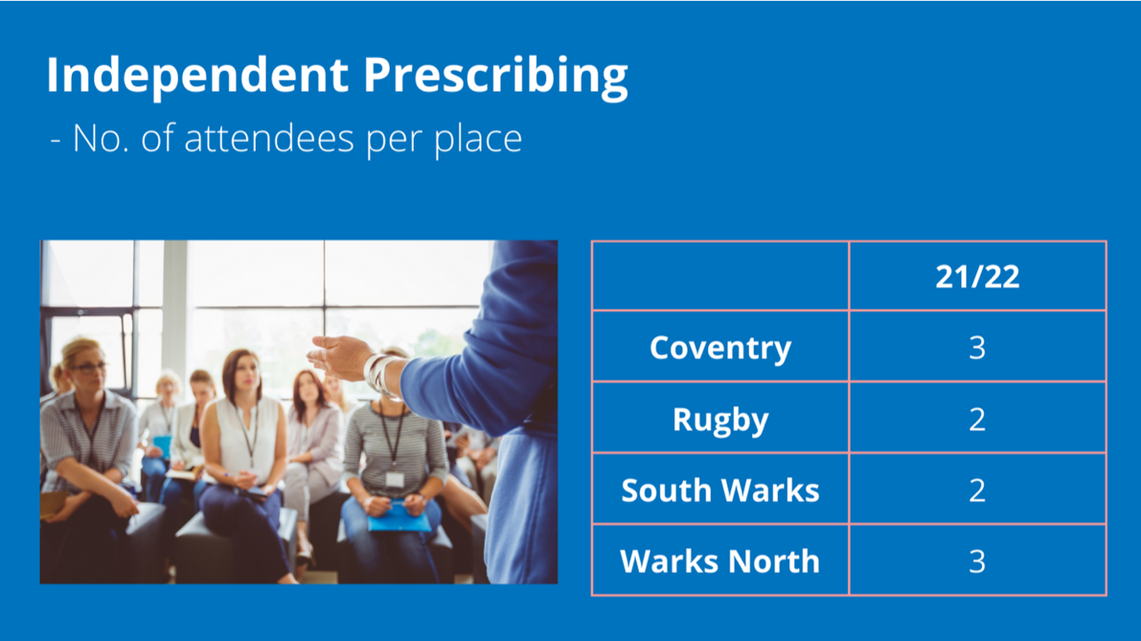

Training & CPD Calendar

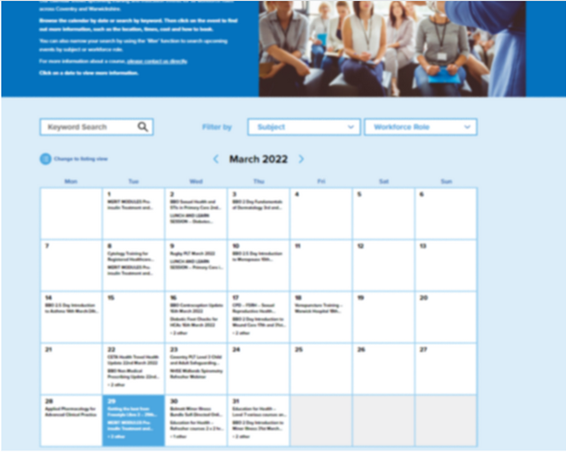
Our calendar shows upcoming training and education events for all workforce rolesacross Coventry and Warwickshire.
Browse the calendar by date or search by keyword. Then click on the event to find out more information, such as the location, times, cost and how to book.

Training & CPD Calendar

Healthy Ageing session added to All Our Health programme


To help address the widening gap in life expectancy, the Healthy Ageing session provides advice and information to help all health and care professionals.

- Understand specific activities and interventions that can support healthy ageing and provide holistic care
- Think about the resources and services available in your area that can help people to be happy, healthy and active into later life

Click here for more information and to access the Healthy Ageing session

Funded training for Healthcare Assistants

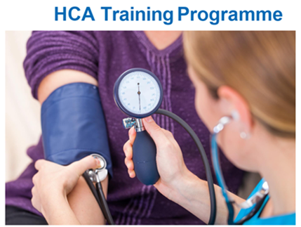
Upcoming Webinars:
- Hypertension update - 18th May, 12:00 - 13:30pm
- Chronic kidney disease & urine testing - 1st June, 14:00 - 15:30pm

To join any of the upcoming HCA webinars above, click here for the full programme where you will find more information and joining links.

Online Practice Assessor Training


This is an online two-day preparation to enable you to take on the role of Practice Assessor. This online event will be held using Zoom and a link to join will be sent to you prior to the course commencing.

The Practice Assessor is responsible for conducting evidence-based assessments of students to confirm student achievement of proficiencies and programme outcomes of practice learning and to record findings.

Click here to view upcoming dates and links to book

Diabetes Programme for Healthcare professionals

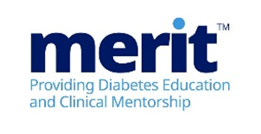
MERIT™ (Meeting Educational Requirements Improving Treatment) is a two-part flexible programme developed by Novo Nordisk. MERIT™ is a competency-based programme and is for all healthcare professionals involved in diabetes care.

What is the MERITTM programme?
The programme will combine the theory required to support diabetes management followed by the provision of tailored clinical support from specialist diabetes teams. It is recommended that all healthcare colleagues attend together to maximise learning opportunities back in practice.

Click here to view the Modules and for details on how to Book



Have you seen:
(These are links to other areas in the newsletter that share new and important updates for GPNs)

*NEW* FULL C&W GPN Strategy

Online Practice Assessor training

Save the date: 12th May 2022 - International Nurses Day

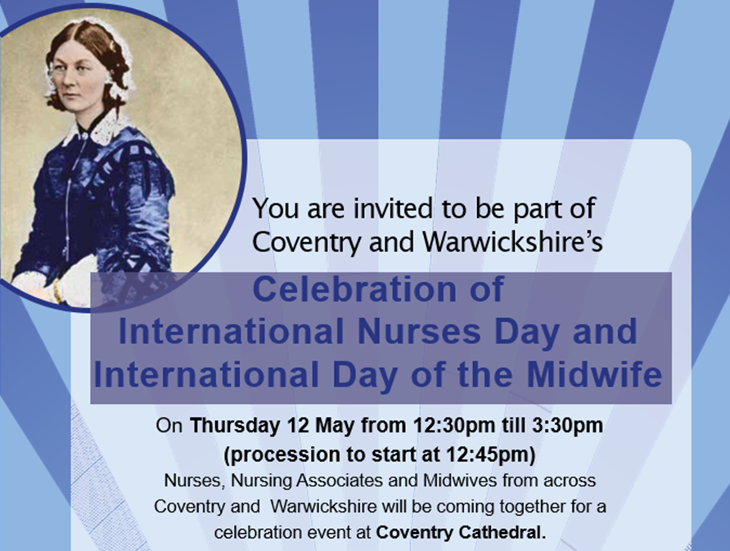

We want to ensure that all Nurses, Nursing Associates and Midwives are fully represented. Please share this invite with any retired Nurses you are in touch with. If you are interested in attending please book your place here.
Managers approval must be sought prior to booking. Photography will be taken at this event.

Peer Support for Nurses and ACPs


We realise how isolating General Practice can be and how much we rely on agile platforms such as WhatsApp to answer questions and vent.
We invite you to join the monthly peer support sessionhosted by Gillian Schweigert and Heather Randle for Nurses and ACPs across Coventry and Warwickshire.

We meet the 1st Thurs of every month from 1-2pm - click here to join!

Practice Nurse Mentoring

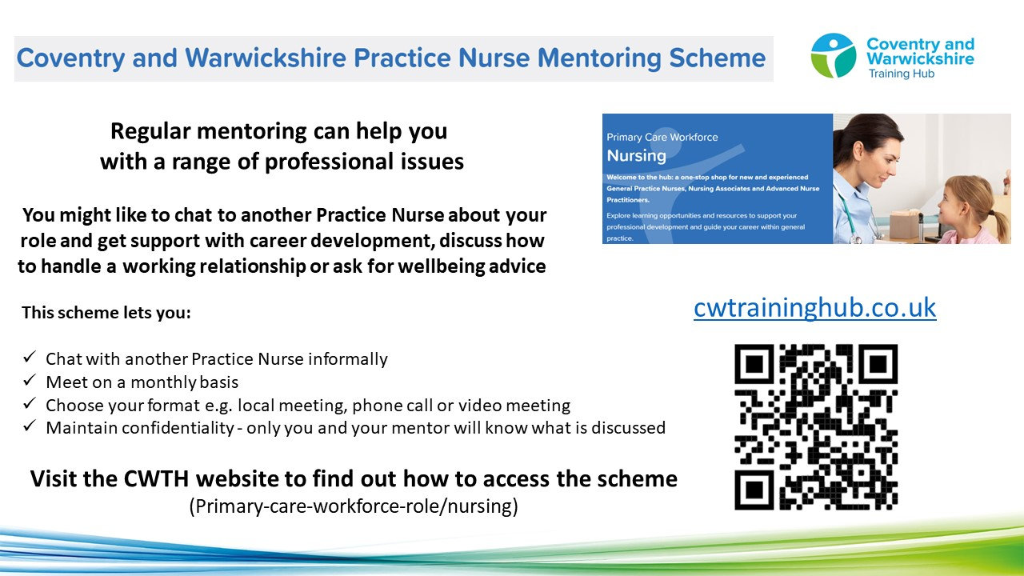

To find a mentor, complete the online registration form. During this registration process you will have the opportunity to view the Mentor Profile Pack and decide which mentor you think would be a good fit for you. The Clinical Lead will assign a mentor to you, considering your preferences and the mentor’s current capacity

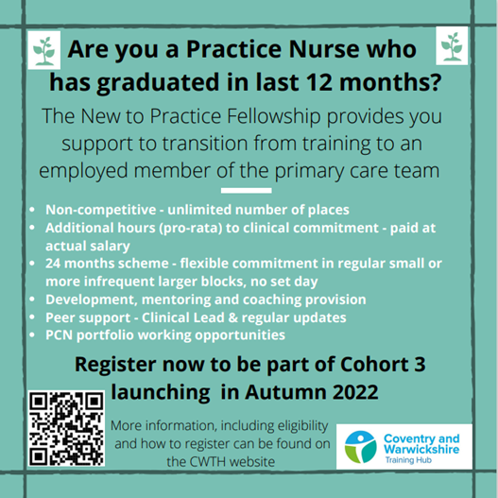



Trailblazer Fellowship (HEE) - Leaders in Deprivation
Are you a First5 GP working in a practice within an area of socio-economic deprivation?


The Trailblazer Fellowship is for First5 GPs, to work in practices and develop the skills, knowledge, experience and resilience to stay working in these challenging, but incredibly rewarding environments.

Launching in Autumn 2022, applications must be received by 06.05.22
More information on how to apply, including eligibility criteria, can be found here.

Professional Curiosity Scheme

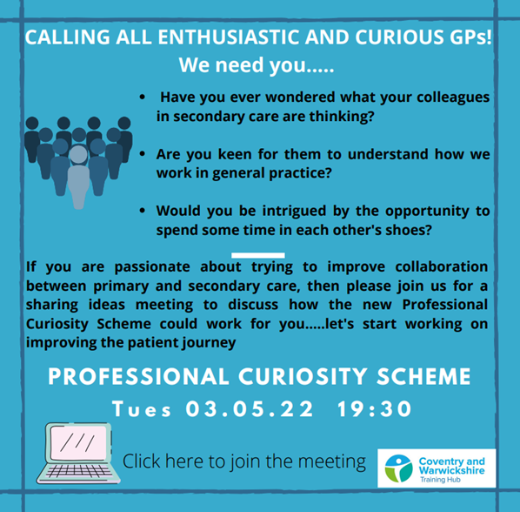

Click on the image above or here to join the meeting

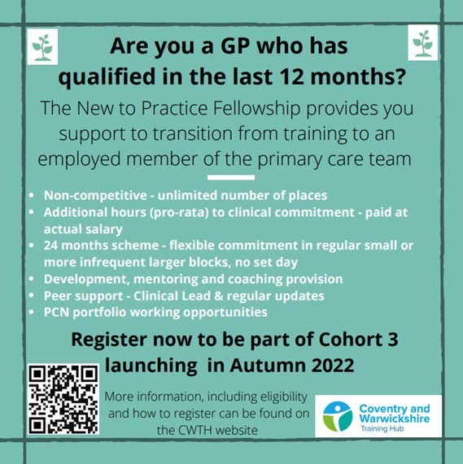

GP Mentoring Scheme

If you decide that you would like a Mentor, you will get the opportunity to view the GP Mentor Profile Pack and decide which Mentor you think would be a good fit for you. Apply here to view the Profile Pack: GP Mentor Scheme Registration.

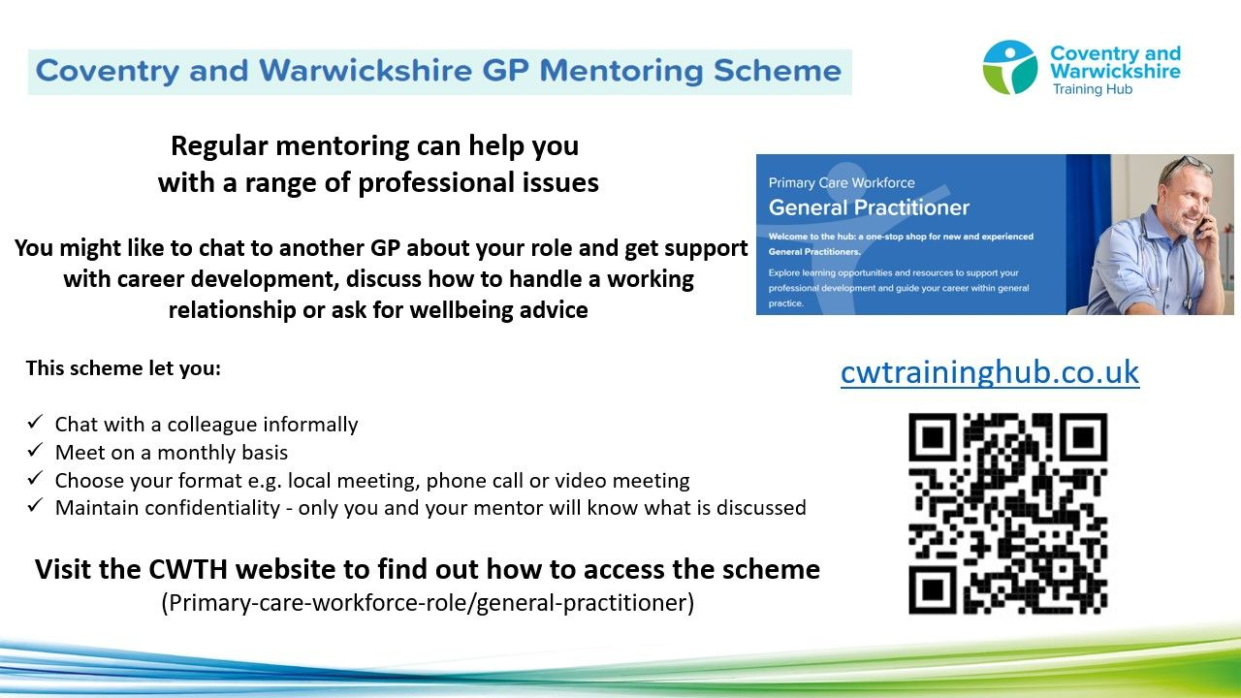

Taking into consideration each Mentor’s capacity, you will be allocated a Mentor, based on your preferred choices.
The Mentor will not disclose any details of any conversations between you both. You and your mentor will be asked for feedback, which can be given anonymously. We currently have 53 mentees utilising the scheme, which is supported by 20 Mentors from a wide range of background an experience. The offer is open to all GPs in C&W at any stage of their career.



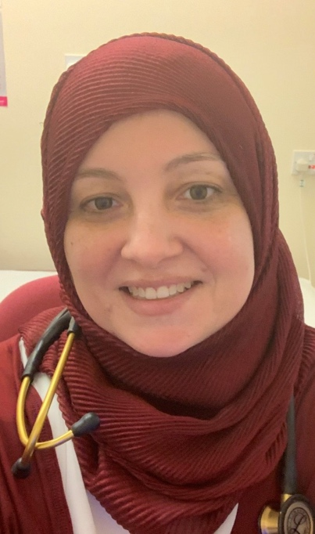
As the new Equality, Diversity and Inclusion Lead for Coventry and Warwickshire Training Hub, I have spent the last few months mapping and meeting different EDI stakeholders to help understand the national, regional and local EDI strategies in Primary Care. I have also been looking at ways in which we can work together to improve staff equality, diversity and inclusion in Primary Care across C&W.
Below are some updates I hope you will find useful.
Mai Elftise, Equality, Diversity and Inclusion Lead, Training Hub
Email: m.elftise@nhs.net

Primary Care Staff Networks


I am working on setting up Primary Care Staff Networks - a safe space to talk about racial equity, share knowledge and learn from each other. The networks will provide a space for you to share your personal experiences, learn how to talk about race, understand unconscious bias, microaggression, weathering and allyship.

Freedom to Speak Up Guardians in Primary Care


Myself and system leaders are looking at models around Freedom To Speak Up Guardians in Primary Care and how to implement locally, making sure staff from all backgrounds know who to contact and how, when raising concerns.
*Watch this space for updates*



Equality, Diversity and Human Rights week is taking place between 9th - 13th May 2022 with events across Coventry and Warwickshire. The week starts with a focus on Wellbeing and Mental Health in Primary Care on Monday 9th May. Click here for more information.




I am happy to share that I have put together an employment structure of First Contact Physiotherapists (FCPs) across Coventry and Warwickshire and have gained an increased understanding of the training and development needs of the FCPs in the area. Below are some updates I hope you will find useful.
Ed Baker, First Contact Physiotherapist Ambassador, Training Hub
Email: edward.baker2@nhs.net

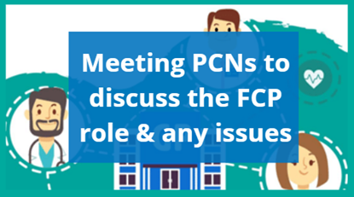
I am continuing to meet with PCNs to discuss role of FCP and issues PCNs may be having.
If you have any queries around FCPs please contact me via - edward.baker2@nhs.net

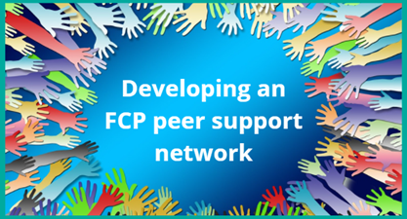
We are in the process of setting up an FCP network to enable peer to peer reflection and learning.
*Watch this space for updates*


For GP educators there is now an FCP supervisor e-Learning module that can be completed at a time to suit the educator. This replaces the 4 hour, pre-booked training that previously existed. Further information and links can be found here.


Explore learning opportunities and resources to support your professional development and guide your career within general practice - visit the First Contact Physiotherapist web page on the Training Hub website today!




The Training Hub is working with Coventry University and practices in Coventry and Warwickshire to arrange placements for Nurse, Paramedic and OT students in general practice.

We placed 7 nurse students and 1 paramedic student in practices in the autumn term, and 6 nurse students in January. We have more students coming out to general practice in the coming months including to practices who have not recently provided placements. We are keen to support more practices to host students in the future.

The feedback from students around their placements and the support programme has been extremely good.
Every student has mentioned how surprised they were at the breadth and depth of knowledge of practice nurses. The supervisors and assessors have done a fantastic job in showcasing general practice as the place to work.
Take a look at our dedicated Placements page on the website for more information or contact Rachel.james4@nhs.net.

Register your interest - Host a student in your Practice




You are always there for your patients, providing a first-class healthcare service.
So we want to support you to look after your own health and wellbeing.

We have compiled a variety of health and wellbeing support resources and services on our website to support you, below are some additional wellbeing resources for you. Our wellbeing page on the website can be found here.

Have you seen:
(These are links to other areas in the newsletter that share important updates around wellbeing)

Health and Well Being Offer - Employee benefits!

*NEW* Health and Well Being Champion spotlight

*NEW* How to beat burnout



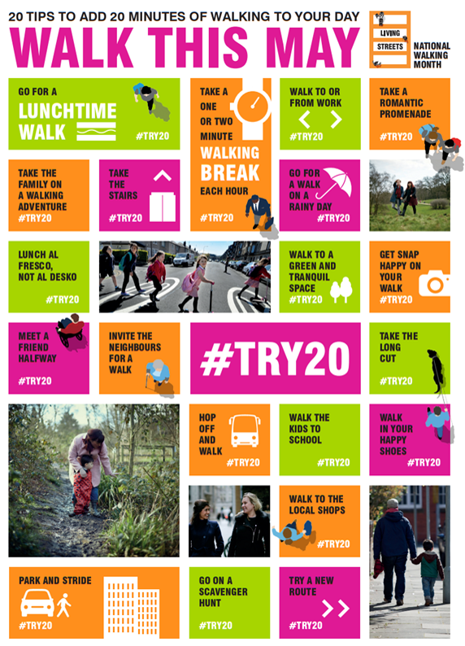

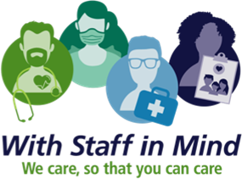

Wellbeing events are taking place during Mental Health Awareness Week in May, continuing throughout the month across Coventry and Warwickshire

Events include:
- Money Advice service & Webinar on Financial Wellbeing
- Healthy Sleep Tips
- Stress management workshops

Click here for all events

Financial Wellbeing Support
Financial concerns can have an impact on your overall wellbeing and mental health, for support and guidance, or some handful tips and tools, take a look at the links below.



- Money helper Service (formerly Money Advise Service or Money and Pensions Service) . They have a budget planner tool, debt advice locator tool etc. There is a specific support line for NHS Staff (0800 448 0826), WhatsApp (+447701342744) and Webchat.
- National Debt Helpline
- Cavell Nurses Trust
- Care Workers Charity
- Money Savings Expert

Lift someone out of loneliness

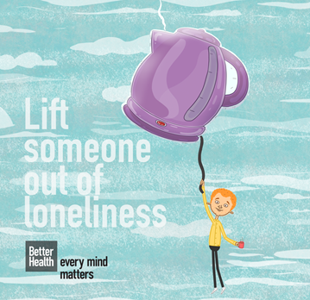
Feeling lonely is something that all of us can experience at any point and it can have a huge impact on our wellbeing. It’s important to remember that these feelings can pass and that there are lots of ways we can help each other too.
Click here for some practical advice and tips on how to help yourself or others if you or they are feeling lonely.



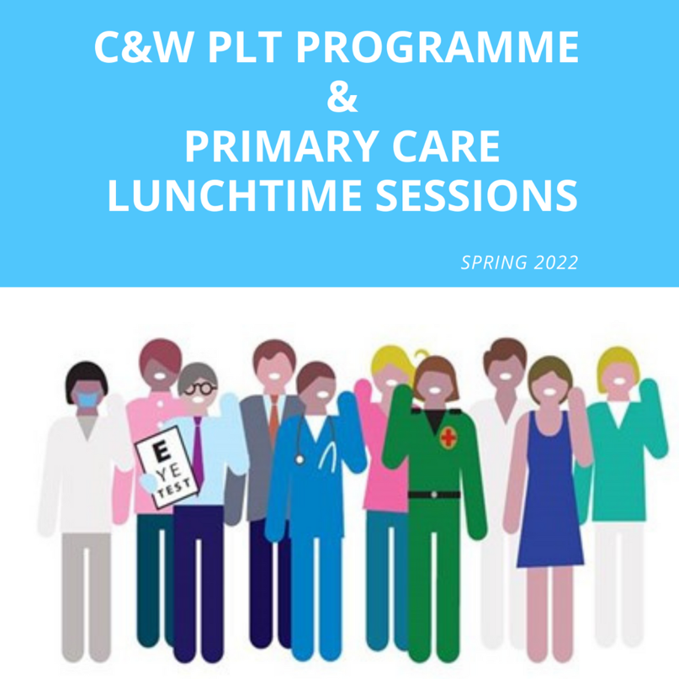
Click here for Coventry and Warwickshire PLT Programme and Primary Care Lunchtime sessions during Summer 2022.





Showcase your vacancies with us!

Our aim is to highlight the exciting and varied opportunities available in Primary Care across Coventry and Warwickshire.
This is not a duplication of NHS Jobs but rather an opportunity to showcase your vacancies.
If you would like to advertise a role with us, click on the button below to complete the short form or contact cw.traininghub@nhs.net

Post your job with us!



Below are a selection of resources for you, to view all resources, visit the 'Resources' page on our website by clicking here.


Primary Care New Roles Resource
HEE have developed the 'New Roles in Primary Care' National toolkit.

Long COVID elearning session
This elearning session has been developed to provide you with a basic introduction to long COVID and post-COVID-19 syndrome.


Cervical Screening Best Practice Poster
The poster contains important failsafe checks taken from the Cevical Sample Take Training guide and the Sample Take Acceptance policy.


To help us evaluate the C&W Training Hub Newsletter please take a few moments to complete the survey.
CLICK HERE

Copyright © 2022 C&W Integrated Primary Care, All rights reserved.
Want to change how you receive these emails?
You can update your preferences or unsubscribe from this list.

