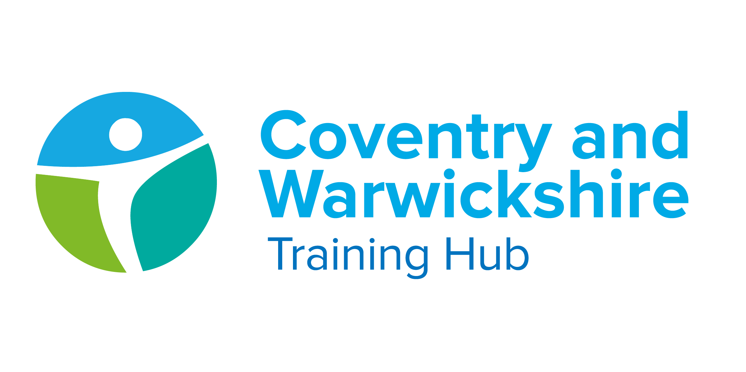

Issue 15 February 2022

Welcome to your latest Training Hub update – your monthly download of upcoming training and development opportunities for primary care in Coventry and Warwickshire, including nursing news and additional roles integration.
We are extremely proud of the hard work you all put in to provide a caring and resilient service to support patients. We are here to help you do what you do best, by delivering additional training, attracting new recruits and providing support.
This newsletter is one of the ways we’re able to keep you up to date with new opportunities – please take a few minutes each month to read it and share with colleagues as appropriate.

Jump to:

Training Hub News
Latest News
Training & Education
GPN
GP

Placements
Wellbeing
PLT Programme
Careers
Resources



Coventry & Warwickshire Health & Well Being programme


Phase one of the Coventry and Warwickshire Health & Well Being Programme for general practice staff, including staff working within federations and alliances will launch shortly.
We are excited to share the programme will include:
- Employee Assistance Programme
- Health & Well Being Champions for each PCN


Employee Assistance Programme (EAP)
- 24/7 confidential support is just a phone call away
- You can access a range of Self help resources
- Take advantage of offers and discounts

Health and Well Being Champions
Thank you to everyone who has promoted our PCN Health & Well Being Champion programme.
We have a small number of champions appointed and ready to be trained and we've received good interest in the last 4 weeks to become a Champion. We are working through interest with a view to interviewing soon and commencing training for cohort 1.

Press play below to find out what is involved in becoming
a Health and Well Being Champion!


For a downloadable copy of the Health and Well Being Champion Information Booklet, please click here.
If you are Interested in becoming a Health and Well Being Champion for your PCN, please ensure you have PCN and line manager support before expressing your interest. If you have any questions or wish to discuss the role or programme please email cw.traininghub@nhs.net.


Population Health Fellowship
Closing date for applications: Friday 11th March
We have a fantastic funded opportunity for healthcare professionals interested in population health and passionate about health inequalities.

Click here for more information and the application form

Practice Manager Mentoring


Regular mentoring can help you with a range of professional issues. You might like to chat to another Manager in Practice about your role and get support with career development, discuss how to handle a working relationship or ask for wellbeing advice.

This scheme lets you chat with another Manager in Practice informally on a monthly basis and in a format of your choosing, e.g. local meeting, phone call or video meeting. Conversations are confidential – only you and your mentor will know what is discussed.
To find a mentor, complete the online registration form. During this registration process you will have the opportunity to view the Mentor Profile Pack and decide which mentor you think would be a good fit for you. The Clinical Lead will assign a mentor to you, considering your preferences and the mentor’s current capacity.

Vacancy - Late Career GP Network: Clinical Lead GP
Coventry and Warwickshire Training Hub, in collaboration with system workforce partners, seek a Clinical Lead GP for the Late Career GP Network. This is a fantastic opportunity to develop this new initiative for Coventry & Warwickshire GPs, working both independently and with the wider support of the C&W Training Hub Clinical Lead and C&W GP Workforce Lead.

View the vacancy here



CQC guidance on First Contact Practitioners

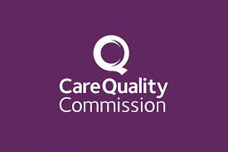
This CQC guidance describes the responsibilities for providers when recruiting and managing staff deployed in first contact practitioner (FCP) roles in primary care settings.

View the CQC guidance here



Training available for Personalised Care Roles

Claire Evans has produced a summary of essential training below together with a link to accredited training providers.
Please note:
- NHSE/I are currently in the process of producing ‘roadmaps’ for each of the three roles. When published, these will provide more detail on training and development opportunities.
- When accessing training on personalised care, please ensure that it is already accredited or in the process of being accredited by PCI.

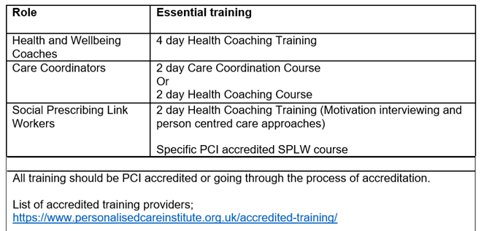

CPD Funding - Last call for 2021/2022 claim!


If you haven't claimed for your full amount of funding or not claimed at all - it's not too late. You have until the end of March 2022 to claim for your £333.

There are three ways to book onto a course:
- Independently and be reimbursed via your practice up to £333 by invoicing cw.traininghub@nhs.net
- Request reimbursement up to £333 of a course(s) already taken within the 21/22 financial year by invoicing via your practice to cw.traininghub@nhs.net
- Book your course through the Training Hub
Please contact cw.traininghub@nhs.net if you have any queries.

Click here for courses and links to book

Funded training for Healthcare Assistants

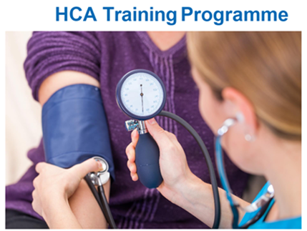

Click here to access the HCA Training Programme for 2022



If the answers to these questions are yes, please reserve a place on this FREE training by emailing: vigpractitioners@swft.nhs.uk. Please include your name, job role, where you work and a contact telephone and select your preferred date for training.
Places are very limited so book early to avoid disappointment

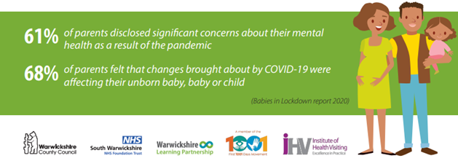

Diabetes Programme for Healthcare professionals

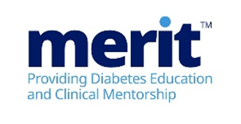
MERIT™ (Meeting Educational Requirements Improving Treatment) is a two-part flexible programme developed by Novo Nordisk. MERIT™ is a competency-based programme and is for all healthcare professionals involved in diabetes care.

What is the MERITTM programme?
The programme will combine the theory required to support diabetes management followed by the provision of tailored clinical support from specialist diabetes teams. It is recommended that all healthcare colleagues attend together to maximise learning opportunities back in practice.

Click here to view the Modules and for details on how to Book


New to Practice Fellowship
Are you in your first year in General Practice as a GP or a Nurse?
Have you qualified in the last 12 months?
Are you employed in a permanent position?

If so, you may be eligible for the Coventry & Warwickshire New to Practice Fellowship

Designed to give the Fellow access to peer support, mentorship and coaching, learning and development and PCN Portfolio working opportunities in a paid, protected session

Click here to Register

New to Practice Professional Development Course


Have you recently joined the Primary Care workforce?
After a highly successful and very informative programme in 2020/21, this opportunity is once again available to all new to practice colleagues.

- Free of charge, with unlimited, non-selective places to the whole workforce
- Warwick & Coventry Universities jointly delivering sessions
- Tailored to your needs by a steering group of GPs, Nurses and Practice Managers
- Providing a mix of practical management and professional leadership skills to help you establish yourselves in your first years in General Practice
- Speakers from a range of experts and practitioners, chosen to give you an excellent grounding in each of the subject areas
New to Practice PDC is a series of monthly evening seminars across Oct 21- June 22 with the option to register and join at any point.

Click here for more information and the link to Register



General Practice Nurse CARE programme


Nursing Workforce Recruitment and Retention Survey
* On behalf of Craige Claire, Practice Nurse *

Nurses have become integral to general practice in providing GMS and DES/LES services as well as working to meet QOF targets. Therefore, it is vital to ensure we have enough skilled nurses to continue to provide quality care.
In recent years local practices have found it difficult to recruit nurses and some new to general practice have not remained. This survey aims look at why this is and what might be done to improve this.
It is important to stress that results are COMPLETELY ANONYMOUS. Results can not be tracked back to an individual or employer. Please click here to complete the survey


Celebration Event
The GPN CARE celebration event will be taking place on Tuesday 15th March, all attendees will have received an invite for this.
If you have any queries, please contact us via cw.traininghub@nhs.net

General Practice Nursing Strategy

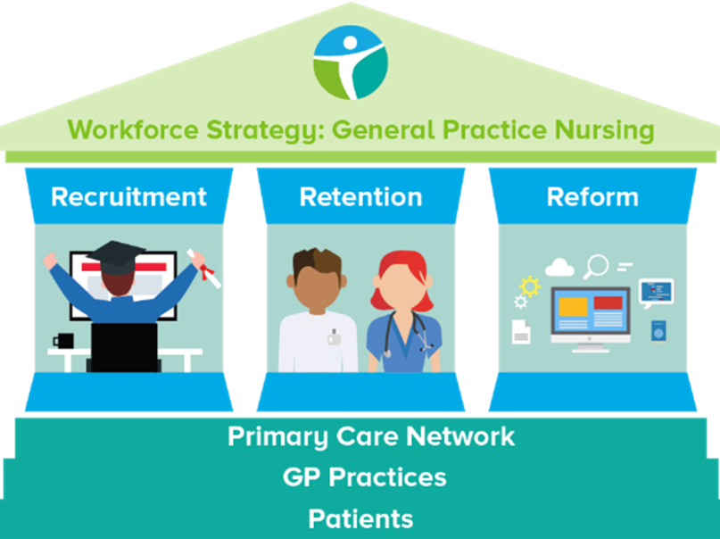
The GPN Strategy Working Group meet monthly and are currently working on:
- HCA upskilling - see programme here
- Trainee Nursing Associate pathway to Nursing Associate
- Ongoing education and training for GPNs (Click here for details on CPD funding of £333)

We meet the 2nd Thursday of every month and would appreciate input from anyone who would like to join.

Click here to contact us if you would like to join

Peer Support for Nurses and ACPs


We realise how isolating General Practice can be and how much we rely on agile platforms such as WhatsApp to answer questions and vent.
We invite you to join the monthly peer support sessionhosted by Gillian Schweigert and Heather Randle for Nurses and ACPs across Coventry and Warwickshire.

We meet the 1st Thurs of every month from 1-2pm - click here to join!

Risk Assessment Tool for Nursing Staff
The RCN has published a new risk assessment tool for nursing staff treating patients with confirmed or suspected COVID-19.
The aim of this toolkit is to support healthcare professionals consider and manage risks associated with the transmission of respiratory infections, specifically COVID-19, and aid local decision making on the level of personal protective equipment (PPE) required to protect them whilst at work.

Click here to access the toolkit

Practice Nurse Mentoring


Regular mentoring can help you with a range of professional issues. You might like to chat to another Practice Nurse about your role and get support with career development, discuss how to handle a working relationship or ask for wellbeing advice.

This scheme lets you chat with another Practice Nurse informally on a monthly basis and in a format of your choosing, e.g. local meeting, phone call or video meeting. Conversations are confidential – only you and your mentor will know what is discussed.
To find a mentor, complete the online registration form. During this registration process you will have the opportunity to view the Mentor Profile Pack and decide which mentor you think would be a good fit for you. The Clinical Lead will assign a mentor to you, considering your preferences and the mentor’s current capacity



Supervision Top Up Session for GPs


The Roadmap Supervision – Top Up Session for GP Educational Supervisors (GP ESs) video provides a supportive additional training session to the existing GP Educator Supervisors training.
It helps support understanding of the roadmap training for first contact practitioners and advanced practitioners.
On completion of the top up session the GP ES will:
- Be able to understand masters level practice
- Gain understanding of allied health professionals’ offer to primary care and their specific roadmap
- Gain understanding of the background of the educational roadmaps and the advanced practice agenda
The link can be accessed at any time and completed at a time to suit you. Click onto the button below to access the training.

Click here to access the training video

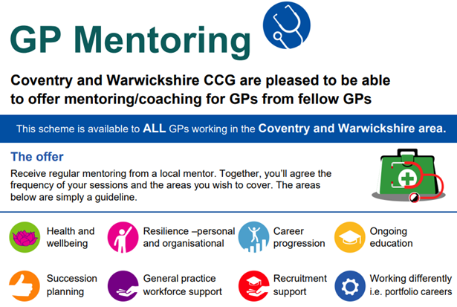

If you decide that you would like a Mentor, you will get the opportunity to view the GP Mentor Profile Pack and decide which Mentor you think would be a good fit for you. Apply here to view the Profile Pack: GP Mentor Scheme Registration.
Taking into consideration each Mentor’s capacity, you will be allocated a Mentor, based on your preferred choices.
The Mentor will not disclose any details of any conversations between you both. You and your mentor will be asked for feedback, which can be given anonymously. We currently have 53 mentees utilising the scheme, which is supported by 20 Mentors from a wide range of background an experience. The offer is open to all GPs in C&W at any stage of their career.

National Schemes

The National GP Retention Scheme is a package of financial and educational support to help doctors, who might otherwise leave the profession, remain in clinical general practice.
The New to Partnership Payment Scheme gives eligible participants a sum of up to £20,000 plus a contribution towards on-costs of up to £4,000 (for a full time participant) available to support establishment as a partner, as well as up to £3,000 in a training fund to develop non-clinical partnership skills. In order to participate in the scheme, applicants will be required to ensure that they submit an application form and supplementary evidence to NHSEI and meet the eligibility criteria.



We placed 7 nurse students and 1 paramedic in 8 practices in the autumn term. We have 7 student nurses coming out to practice in the spring term, and this includes three practices who are new to the programme.



We are still working with Coventry University on Paramedic and OT students; and the universities are placing PA students directly into practices.
The feedback from students around their placements and the support programme has been extremely good.
Every student has mentioned how surprised they were at the breadth and depth of knowledge of practice nurses. The supervisors and assessors have done a fantastic job in showcasing general practice as the place to work.
Take a look at our dedicated Placements page on the website for more information.

Register your interest - Host a student in your Practice




You are always there for your patients, providing a first-class healthcare service.
So we want to support you to look after your own health and wellbeing.

We have compiled a variety of health and wellbeing support resources and services on our website to support you, below are some additional wellbeing resources for you. Our wellbeing page on the website can be found here.

Financial Wellbeing Support
Financial concerns can have an impact on your overall wellbeing and mental health, for support and guidance, or some handful tips and tools, take a look at the links below.



- Money helper Service (formerly Money Advise Service or Money and Pensions Service) . They have a budget planner tool, debt advice locator tool etc. There is a specific support line for NHS Staff (0800 448 0826), WhatsApp (+447701342744) and Webchat.
- National Debt Helpline
- Cavell Nurses Trust
- Care Workers Charity
- Money Savings Expert

Lift someone out of loneliness

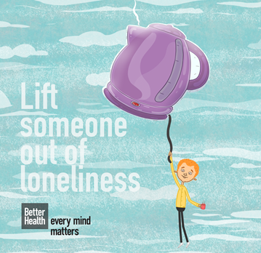
Feeling lonely is something that all of us can experience at any point and it can have a huge impact on our wellbeing. It’s important to remember that these feelings can pass and that there are lots of ways we can help each other too.
Click here for some practical advice and tips on how to help yourself or others if you or they are feeling lonely.

Wellbeing Wednesday

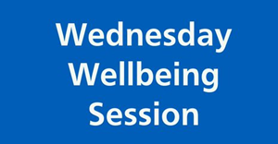
NHS Horizon will be hosting there next Wellbeing Wednesday session on 'Sleep' on Wednesday 9th March 2022 4pm to 5pm.
To join or to view previous sessions click here



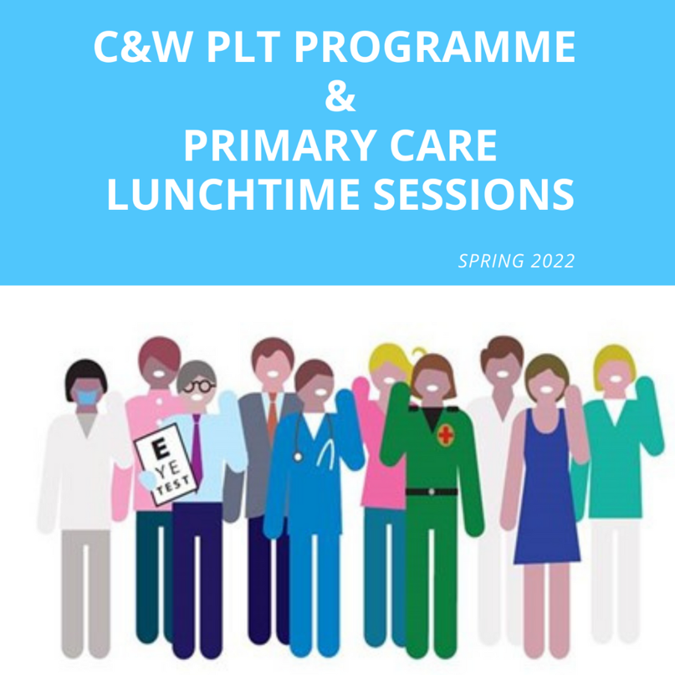
Click here for the Coventry and Warwickshire PLT Programme and Primary Care Lunchtime sessions during Spring 2022.





Showcase your vacancies with us!

Our aim is to highlight the exciting and varied opportunities available in Primary Care across Coventry and Warwickshire.
This is not a duplication of NHS Jobs but rather an opportunity to showcase your vacancies.
If you would like to advertise a role with us, click on the button below to complete the short form or contact cw.traininghub@nhs.net

Post your job with us!



Below are a selection of resources for you, to view all resources, visit the 'Resources' page on our website by clicking here.


Primary Care New Roles Resource
HEE have developed the 'New Roles in Primary Care' National toolkit.

Long COVID elearning session
This elearning session has been developed to provide you with a basic introduction to long COVID and post-COVID-19 syndrome.


Cervical Screening Best Practice Poster
The poster contains important failsafe checks taken from the Cevical Sample Take Training guide and the Sample Take Acceptance policy.


To help us evaluate the C&W Training Hub Newsletter please take a few moments to complete the survey.
CLICK HERE

Copyright © 2022 C&W Integrated Primary Care, All rights reserved.
Want to change how you receive these emails?
You can update your preferences or unsubscribe from this list.


