

Welcome from CCG Chair

Welcome to this week’s edition of Practice News

Welcome to the weekly newsletter. There are a lot of politics, uncertainty and perpetual change at the moment with "causal" comments dropped by leaders that can rock us. Our local system has it's microcosm of the change and politics and we are continuing to engage, discuss, listen to your views and will be out to you all soon with some local proposals for general practice in the ICS.
The newsletter below contains a number of useful bitesize information snippets.

I want to highlight the letter from NHSE providing information on the next steps for general practice following the accelerated COVID-19 vaccination booster campaign. It advises on how we can continue to support vulnerable patients against COVID-19 whilst restoring routine services that were paused. Thank you for the tireless work. Any questions or resilience issues please do contact you primary care place lead.

If you go further down, there are some useful resources to support you with promoting the vaccinations in various languages.

I’d also recommend you read about the Pathway to Partnership New Partner Development Programme. It’s available for new partners working in general practice with full funding from NHSE through the New to partnership payment scheme.

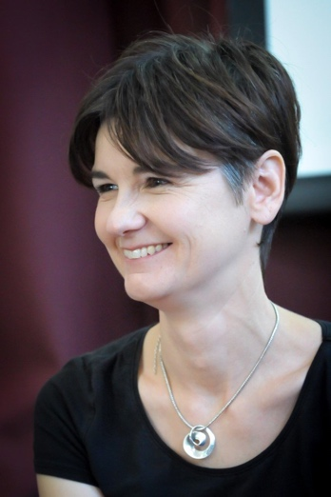

Dr Sarah Raistrick
CCG Chair
NHS Coventry and Warwickshire Clinical Commissioning Group

If you'd like to have Practice News and other relevant CCG updates sent to you directly, please email cwccg.communications@nhs.net

Latest information for practices

Next steps for general practice following the accelerated COVID-19 vaccination booster campaign letter
Please see the attached letter from NHSE.

Information regarding Booster vaccine
Please see the information below regarding vaccine booster information in different languages:

People aged 16 years and over, and those aged 12 years and over who are at risk (including health and social care workers) will be offered a booster dose of coronavirus (COVID-19) vaccine. You can book online, or call 119 to make an appointment to have your booster. Further information on the booster vaccination is available on NHS.UK.

Paper copies of the COVID-19 vaccination: a guide to booster vaccination for individuals aged 18 years and over and those aged 16 years and over who are at risk are available to order for free or download in the following languages:

English, Albanian, Arabic, Bengali, Bulgarian, Chinese, Estonian, Farsi, Greek,Gujarati, Hindi, Latvian, Lithuanian, Panjabi, Pashto, Polish, Portuguese,Romanian, Romany, Russian, Somali, Spanish, Tagalog, Turkish, Twi,Ukrainian, Urdu and Yiddish.

The COVID-19 vaccination: a guide to booster vaccination for individuals aged 16 years and over and those aged 12 years and over who are at risk leaflet in English is currently only available for download.

Supply issue with Bambuterol (Bambec®) 10mg Tablets
Please find attached Medicine Supply Notification for:

- A Tier 2 medicine supply notification for Bambuterol (Bambec) 10mg Tablets.
Medicine | Out of stock | Alternatives
Bambuterol (Bambec) 10mg Tablets | • Discontinuation of product.  • Stock expected to be exhausted by the end of June 2022. | • Inhaled β2-agonist therapy is the preferred route of administration.  • If ongoing treatment with an oral β2-agonist is deemed necessary, consider:  • Salbutamol tablets; or  • Terbutaline tablets  • See MSN for further details.

DHSC and NHSE/I have now launched an online Medicines Supply Tool, which provides up to date information about medicine supply issues. The contents of these MSNs can now be viewed on the Tool. To access the Tool you will be required to register with the SPS website.
Please be aware this communication is also being circulated separately to all community pharmacies in England.

Please note that for supply issues that have been categorised as tier 1 or 2, DHSC and the MSRG have requested that the NHSE&I commissioning routes are used to reach community pharmacy and GP practices. More serious supply issues are communicated via the Central Alerting System for action.
If you have any queries please contact: DHSCmedicinesupplyteam@dhsc.gov.uk

We need your views
UHCW is seeking the views of its partners, patients and communities on its’ Organisational Strategy. We would like to hear from GPs and primary care professionals on our aims and aspirations for the next eight years. You can read more about it in the attached summary document and use the QR codes to fill in a short survey and watch our video. Alternatively, you can email us your views at Strategy@uhcs.nhs.uk or we would be happy to come and speak to you at one of your existing meetings.

We are also posting a small quantity of leaflets for display in your practices, to encourage your patients to let us know their views too.

FGM Pathway - Antenatal Identification/Disclosure
Please find attached information about Antenatal identification/disclosure.

FGM - Zero Tolerance Day - 7th February 2022
To mark 6th of February International Day Of Zero Tolerance For FGM the Royal College of Midwives would like to invite you to join a free event to discuss Tacking Female Genital Mutilation. To register or find out more information, please click here.

GP Community Pharmacist Consultation Service (CPCS) - Coventry and Warwickshire
CPCS initially managed referrals from NHS 111 for face-to-face or remote consultations with community pharmacists but has more recently been rolled out to include GP practice referrals. The GP CPCS enables practice teams to direct patients with defined minor illness to a community pharmacist for their first contact, where they will receive clinical assessment and advice with an aim to reduce the burden on general practices. Its aim is to make sure that patients have access to the same levels of care, close to home and with a self-care emphasis.
Arden and GEM CSU Medicines Optimisation Team have arranged MS Teams drop-in sessions to support implementation of CPCS in practices. Future session dates are:

- Weds 9th Feb 12.30-1.30pm
- Fri 11th Feb 12-1pm
- Weds 16th Feb 12.30-1.30pm
- Fri 18th Feb 12-1pm
Practices can book onto these sessions by emailing agcsu.medicines@nhs.net.

Serious Shortage Protocol – paracetamol 120mg and 240mg suppositories
We are writing to inform you that a Serious Shortage Protocol (SSP) has been issued for paracetamol 120mg and 240mg suppositories.

The SSP will enable community pharmacists in England and Wales to supply patients with 1 x 125mg paracetamol suppository OR 1 x 250mg paracetamol suppository. This is now available to view on the NHS Business Service Authority (BSA)’s dedicated SSP web page, along with supporting guidance. The SSP came into effect on Tuesday 25 January 2022 and is currently due to expire on Friday 18 February 2022. Should this change, the SSP will be updated accordingly and published on this page.

If you have any questions regarding the SSPs please contact the NHS Prescription Service:
Email: nhsbsa.prescriptionservices@nhsbsa.nhs.uk

Get active and meet new people in 2022
We hope you’re enjoying a great start to 2022.

As you might be aware we’re always on the lookout for new referrals to our FREE mental health projects – MENtalk and WOMENtalk. These sessions are open for people to turn up to as we can sign people up on the day.

Beneficiaries don’t need to be fit or even talented sports people. We use sports and physical activities as a way of engaging people in a group environment while delivering positive mental health promotion messages.

All activities are suggested/decided on by participants and we regularly offer badminton, football, table tennis, basketball, indoor archery, bowls as well as various other indoor sports. We’re also currently giving free ticket vouchers for Coventry City FC fixtures to people who register with us.
Please encourage any friends, family or service users you feel might benefit from our sessions to come along to any of the following:

MENtalk
- Warwick: St Nicholas Park Leisure Centre (CV34 4QY) – every Tuesday, 11:00 – 13:00pm.
- Coventry: Moat House Leisure Centre (CV2 1EA) – every Thursday, 12:00 – 14:00pm.
- Nuneaton: Jubilee Sports Centre (CV10 7EZ) – every Friday, 14:00 – 16:00pm.

WOMENtalk
- Warwick: St Nicholas Park Leisure Centre (CV34 4QY) – every Wednesday, 11:00 – 12:30pm.
- Nuneaton: Jubilee Sports Centre (CV10 7EZ) – every Friday, 12:00 – 13:30pm.

Participants are able to come along and sign up on the day – they don’t need to be referred or contacted prior to sessions. However, if you or they would like to discuss either project with our staff, please contact:

MENtalk - Robbie Chandler - Robert.Chandler@sbitc.org.uk
WOMENtalk - Jack Clemons - Jack.Clemons@sbitc.org.uk

- Mentalk A5 Copy
- Womentalk A5 copy
- Men- Women Talk Doubled
- Mentalk Social Media
- Womentalk Social Media
- Womentalk A5
- Men and Women Talk A4

UHCW Inpatient Discharge Summary Upgrade Go live 02/02/2022
As part of on-going improvement works, a simple and effective upgrade is set to be introduced to our discharge system (CRRS). Inpatient discharge summaries (TTO’s) will be electronically signed by the prescriber (with name, contact and registration number), Pharmacist endorsements will also be made electronically into the discharge summary.

For general practice discharges will continue to be received in the same way, for primary care the main changes you will see are:
- TTO’s are electronically signed
- No handwritten endorsements
- TTO’s will now be transmitted electronically
- There are some new fields which will add clarity about medications started/stopped in hospital, plus supply considerations
- Area prescribing committee forms (e.g. DOAC initiation), will be uploadedelectronically and transmitted as we do with all other clinical correspondence, separately to the TTO

On behalf of the wider project group leading on this change we thank you for your support and hope you find the upgrade helpful.

Thank you
Deputy Chief Pharmacist at UHCW

Central PCN Update
Dr Hergeven Dosanjh has stepped down from his role as Clinical Director at Central PCN. The new Clinical Director taking over from Dr Dosanjh is Dr Manjari Bollu. The change is effective from 1st February 2022.

Training, events & surveys
Pathway to Partnership New Partner Development Programme
Pathway to Partnership development programme for new partners working in general practice, full funding available from NHS E through the New to partnership payment scheme.

We have started receiving expressions of interest in our next programme starting in April 2022 and wondered if you can please put the below information in your next Newsletter that you distribute to your PCNs and Practices.

Please see full details below:

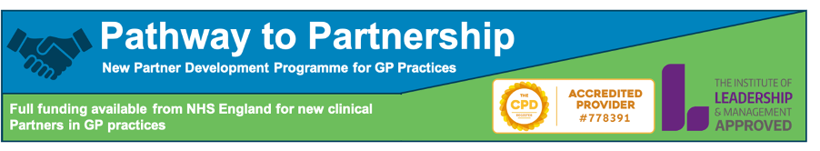

Now accepting registrations for April 2022 intake.
The Qualitas Pathway to Partnership development programme is for new and prospective partners in GP practices looking to accelerate their professional development and help their practice thrive and succeed.

We are now onto our third programme with outstanding feedback from past participants giving it a 4.8/5 star rating.

“My confidence [in my role as a Partner] is definitely increasing”

“Thank you very much - I have left the day filled with ideas and drive to make significant changes within the practice.”

“Another enjoyable day and looking forward to the next one. I think the project seems like a great way to begin showing influence and making changes”

“I thoroughly enjoyed the day. The speakers were inspiring. Useful networking!”

The past few years have been hugely challenging for general practice and has highlighted the need for partners to be able to confidently lead through the uncertainty whilst building sustainable practices for the future.

The Qualitas Pathway to Partnership programme looks to accelerate the professional development of new partners, providing the opportunity to learn new skills and knowledge, develop a network of colleagues across the country and learn from successful GPs and practices alongside business, accountancy, innovation and leadership experts. This comprehensive programme will position individuals and their practices to achieve the best outcomes.
Accredited by the Institute of Leadership and Management, our programme allows you to accumulate 60 CPD points and is structured around three key pillars – Leadership, Strategy and Operations.

View our video introducing you to our programme leaders and find out more about Pathway to Partnership.

Click for full information

Pathway to Partnership is being delivered by a range of primary care leaders and business experts. The programme will share with you the theory, models and knowledge you will need to excel in your new role but will bring these to life with examples and case studies from a range of GP practices in England.

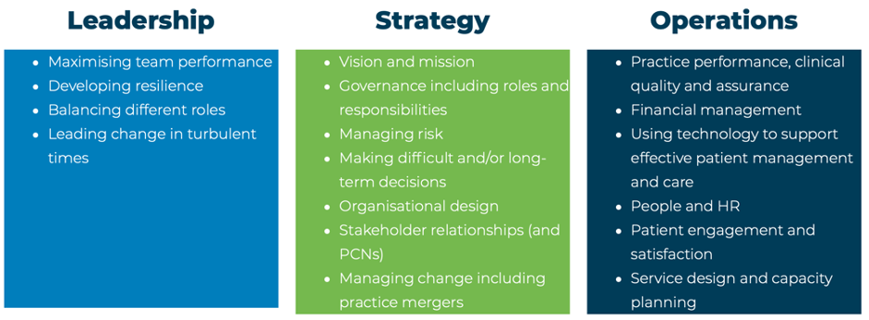

Starting on 4th May 2022, this is a 12-month hybrid programme spread over 6 full day face-to-face sessions, 8 peer-group virtual sessions and real exercises completed with your practice. You have the option of joining us in person or virtually or a mix of both that suits you.

For those new to partnership, NHS England offers full reimbursement for training here.
This development programme is open to anyone with an interest in complementing their clinical skills by developing the business and leadership skills required to lead a successful organisation.
For full details and to secure your place, please visit our website.

Training Webinar Pulse Oximeter Devices
Recently Coventry and Rugby Alliance helped distribute approx. 77 paediatric Pulse Oximeter devices across the system.

Masimo are running six 30-minute webinars in February to provide training and information about the devices, please see leaflet enclosed.

Newsletters
Prescribing Dashboard - Nov 21
Please find attached is the latest Prescribing Dashboard.
January Immunisation newsletter
Please find attached the latest Immunisation Newsletter.
Quality Matters newsletter
Please find attached the latest Quality Matters Newsletter.
Vacancies
None to report

