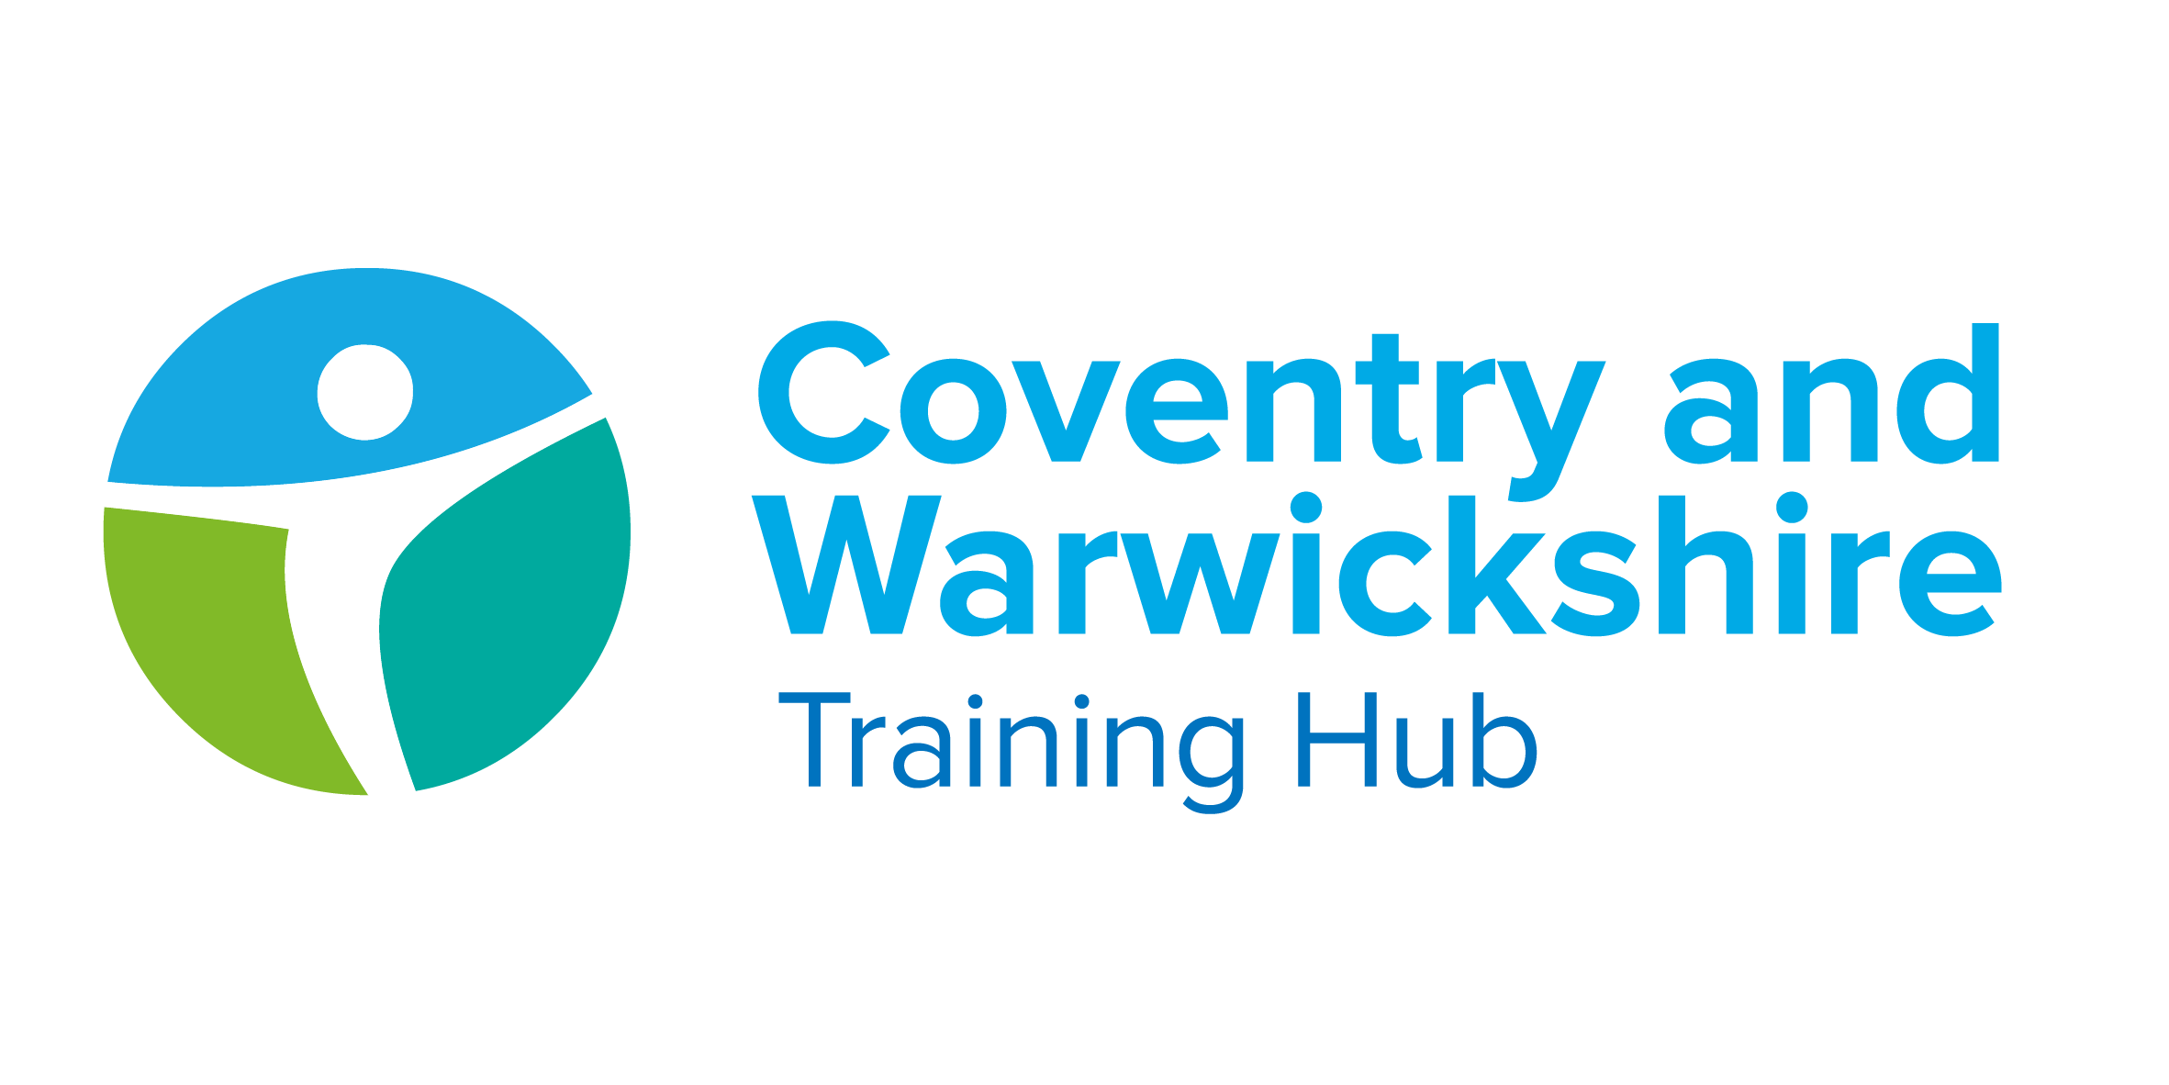

Issue 14 January 2022

Welcome to your latest Training Hub update – your monthly download of upcoming training and development opportunities for primary care in Coventry and Warwickshire, including nursing news and additional roles integration.
We are extremely proud of the hard work you all put in to provide a caring and resilient service to support patients. We are here to help you do what you do best, by delivering additional training, attracting new recruits and providing support.
This newsletter is one of the ways we’re able to keep you up to date with new opportunities – please take a few minutes each month to read it and share with colleagues as appropriate.

Jump to:

Training Hub News
Latest News
Training & Education
GPN
GP

Placements
Wellbeing
PLT Programme
Careers
Resources





First Contact Physiotherapist Ambassador & Equality and Diversity Lead
We are very pleased to be welcoming Ed Baker, First Contact Physiotherapist Ambassador and Mai Elftise, Equality and Diversity Lead to the Training Hub team.

Ed Baker - First Contact Physiotherapist Ambassador


Hello, I am delighted to have been selected as a First Contact Physiotherapist Ambassador for the Coventry & Warwickshire Training Hub.
I’ve worked as a Physiotherapist for the past 15 years, the past 7-8 years as an Extended Scope Practitioner and Lead MSK Physiotherapist and have been employed as a First Contact Physiotherapist for the past year in Coventry treating MSK conditions in Primary Care.

I am looking forward to starting this new Ambassador role. It will be great to be involved in the process of shaping the First Contact Physiotherapy roadmap and pathway in the region.
I look forward to meeting you all and working together.

Maisun Elftise - Equality and Diversity Lead

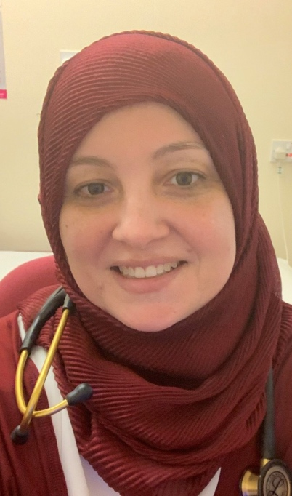
Hello, I am delighted to be selected as the EDI lead for Coventry and Warwickshire Training Hub.
I am looking forwards to working together with the Training Hub team and stakeholders to improve our work on Equality and Diversity in the area including accelerating BAME staff networks in Primary Care and looking at ways to improve EDI data collection in primary care.

Coventry & Warwickshire - Health & Well Being offer
Coventry and Warwickshire Training Hub are supplementing the national (Looking after you too) and system (With Staff in Mind) Health and Wellbeing offers with a Coventry & Warwickshire General Practice Health & Well Being offer.


What does the offer include?
- Employee Assistance Programme (launching soon)
- Health & Well Being Champions for each PCN with training and access to support tools for Champions and managers / leaders.
We have appointed a number of PCN H&WB Champions and commence training this month. We've had a number of expressions of interest in recent days but still aim for coverage at every PCN with more cohorts of training to follow.
As a Champion, you can make a real difference to the health and wellbeing of the people in your workplace, whilst also gaining useful personal knowledge and skills.

Click here to find out more about the role and how to apply

Practice Manager Mentors


Following a fantastic response to our call for Practice Manager Mentors, we are pleased to share that we have selected 8 individuals for the role.
We are hoping to be able to offer mentorship in February.



Risk Assessment Tool for Nursing Staff
The RCN has published a new risk assessment tool for nursing staff treating patients with confirmed or suspected COVID-19.
The aim of this toolkit is to support healthcare professionals consider and manage risks associated with the transmission of respiratory infections, specifically COVID-19, and aid local decision making on the level of personal protective equipment (PPE) required to protect them whilst at work.

Click here to access the toolkit

Personalised care ARRS Roles - Lunch & Learn Sessions
HEE Midlands Primary Care School would like to invite you to the next series of lunch and learn sessions, facilitated by Clare Evans PCN Advisor for the Midlands.

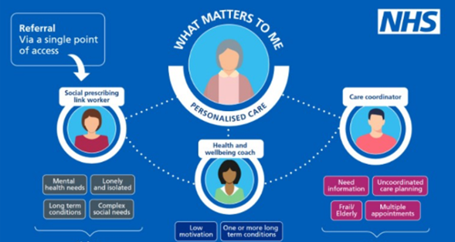
During the sessions you will be able to engage with experts supporting the roles, find out what opportunities and work is taking place near you, highlight any issues and share best practice. This event is suitable for PCN Clinical Directors and Managers with and interest in or responsibility for the ARRS roles.
If you would like to attend, please provide the following details to midlandsprimarycareschool@hee.nhs.uk - name, role, email, PCN, ICS and Region.
The next sessions are scheduled for 23rd February and 23rd March 12pm-1pm (agenda items to be confirmed).

Your chance to inform staff training in General Practice
The HEE Digital Technology team are working with the Digital First Primary care team to understand the training needs of General Practice staff and are conducting a survey as part of the discovery.


Who is this survey for?
This survey is for anyone working in a clinical or non-clinical role in general practice or a primary care network in England, including reception, administrative and practice management staff.
What is the purpose of this survey?
Your views will help Health Education England (HEE) and NHS England and NHS Improvement (NHSE/I) to design training to support general practice staff in delivering remote triage and online, telephone and video consultations.
This survey is designed to gather information about the tasks that you complete as part of your role, the training you have already received and the types of training that could support you.
Please complete this survey to tell us about your experiences and views.

*Places available* - Roadmap Supervision (RMSV) Training


Clinician eligibility criteria for 2-day RMSV:
- AHPs & Nurses with a full PG Masters
- Recognised FCPs on the HEE FCP directory
- Advanced Practitioners on the HEE Directory
- GPs
Currently supervisor trainers undergoing the 2-day RSMV course will need to complete both days unless they are a GP Educational Supervisor. GP Educational Supervisors are not required to undertake the 2-day RMSV course but can access a 2 hour top up session specific to the AHP workforce and masters level sign off.
Training Cohort - the cohort will comprise up to 16 supervisor trainees:
- Cohort 7: Day 1 – Thursday 10th March and Day 2 – Thursday 24th March 10:00am to 3pm. Click here to book
It is imperative that prospective supervisors understand the commitment to complete both days of training, and that they must meet the required criteria.



Funded training for Healthcare Assistants

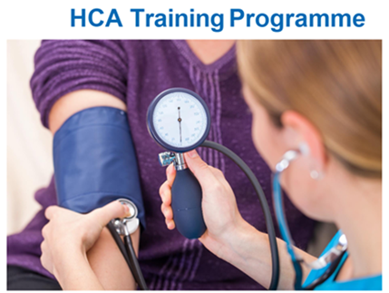

Click here to access the HCA Training Programme for 2022

CPD Funding


If you haven't claimed for your full amount of funding or not claimed at all - it's not too late. You have until the end of March 2022 to claim for your £333.

There are three ways to book onto a course:
- Independently and be reimbursed via your practice up to £333 by invoicing cw.traininghub@nhs.net
- Request reimbursement up to £333 of a course(s) already taken within the 21/22 financial year by invoicing via your practice to cw.traininghub@nhs.net
- Book your course through the Training Hub
Please contact cw.traininghub@nhs.net if you have any queries.

Click here for courses and links to book

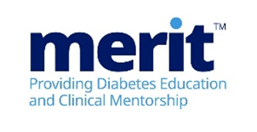

Diabetes Programme for Healthcare professionals

What is the MERITTM programme?
MERIT™ (Meeting Educational Requirements Improving Treatment) is a two-part flexible programme developed by Novo Nordisk. MERIT™ is a competency-based programme and is for all healthcare professionals involved in diabetes care.
The programme will combine the theory required to support diabetes management followed by the provision of tailored clinical support from specialist diabetes teams. It is recommended that all healthcare colleagues attend together to maximise learning opportunities back in practice.

Click here to view the Modules and for details on how to Book

Wounds Week: 14th February - 18th February 2022

The HARTMANN Midlands’ team are running a week of live online CPD Wound Care events. Wounds Week will run from 14th February - 18th February.
Attendance to all events is free of charge and CPD certificate’s will be awarded to attendees upon competition.



Click here to view the Agenda and to Register

Chronic Kidney Disease: What You Need To Know



Click here to view the Agenda and to Register

New to Practice Fellowship


Cohort 2 started on 5th Jan with 10 GPs and 1 GPN. All have received their Induction, joined their peer networks and registered for C&W Mentor Schemes to support their New to Practice Fellowship journey.

Are you due to CCT in February 2022? - Register here
Are you a GPN who has graduated in the last year? - Register here

New to Practice Professional Development Course

This opportunity is open to all new to practice GPs, Nurses, AHPs and ARRS roles.
This programme is open to all the wider Primary Care Workforce who are new to practice. This is a programme that has been tailored to your needs by a steering group of GPs, nurses and AHPs from within primary care.
The programme will comprise 8 sessions - each of them chosen to provide you with a mix of practical management and professional leadership skills to help you establish yourselves during your first years in General Practice, and to make your early years as fruitful and enjoyable as possible. The speakers will be a range of experts and practitioners, chosen to give you an excellent grounding in each of the subject areas.
Scheduled from Oct-June, it is based on a rolling non-competitive entry, click below for more information.

Click here for more information and the link to Register



General Practice Nursing Strategy

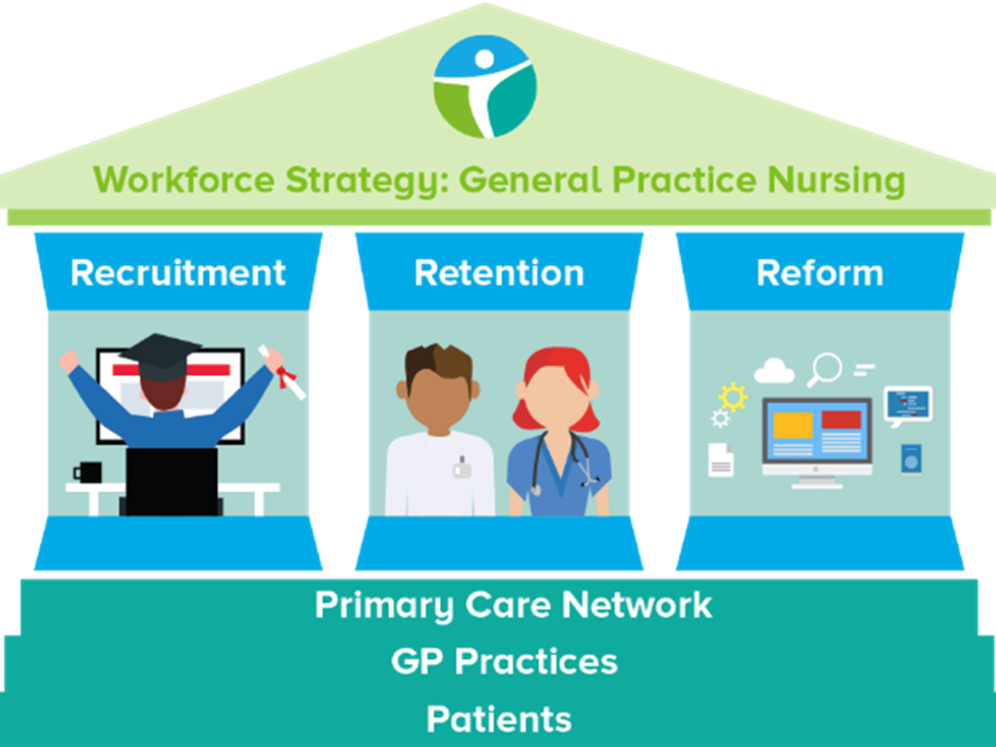

The GPN Strategy Working Group meet monthly and are currently working on:
- HCA upskilling
- Nursing Associate pathway
- Supporting our GPNs
- Expanding the number of learning opportunities and support available
We meet the 2nd Thursday of every month and would appreciate input from anyone who would like to join.

Click here to contact us if you would like to join

Peer Support for Nurses and ACPs

“It’s not always about getting or giving advice. It’s also about having a safe space to get things off our chest and occasionally sharing a laugh about it all!” (Mind, 2020)


We realise how isolating General Practice can be and how much we rely on agile platforms such as WhatsApp to answer questions and vent.
We invite you to join the monthly peer support session hosted by Gillian Schweigert and Heather Randle for Nurses and ACPs across Coventry and Warwickshire.

What are the benefits for you?
- Having the opportunity to reflect
- Building resilience and improving well-being
- Sharing your own experiences, new ideas, best practice and research
- Making links with colleagues across C&W
- Having the opportunity to build supportive networks

We meet the 1st Thurs of every month from 1-2pm - click here to join!



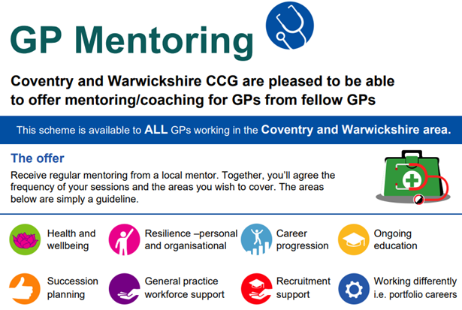

If you decide that you would like a Mentor, you will get the opportunity to view the GP Mentor Profile Pack and decide which Mentor you think would be a good fit for you.
Taking into consideration each Mentor’s capacity, you will be allocated a Mentor, based on your preferred choices. The Mentor will not disclose any details of any conversations between you both. You and your mentor will be asked for feedback, which can be given anonymously.
We currently have 53 mentees utilising the scheme, which is supported by 20 Mentorsfrom a wide range of background an experience. The offer is open to all GPs in C&W at any stage of their career.

To find a mentor, click here to complete the online registration form

Aspiring Leaders Fellowship


Coventry & Warwickshire Training Hub offer Aspiring Leaders Fellowships in Transformation, Digital Healthcare and Deprivation. Cohort 2 Fellows are involved in a wide variety of projects and initiatives across Coventry & Warwickshire.

Current work includes:
• Supporting integration of Docobo into PCNs in order to support care at home and care homes
• Establishing voluntary time banks and community cafes to support social prescribing
• Collaborating with community leaders to attend events and raise awareness of accessible health services in deprived areas
• Influencing patients to adapt to healthier lifestyles to prevent disease and also work to reduce long term analgesic prescription rates

Click here for more information and the link to register



We placed 7 nurse students and 1 paramedic in 8 practices in the autumn term. We have 7 student nurses coming out to practice in the spring term, and this includes three practices who are new to the programme.



We are still working with Coventry University on Paramedic and OT students; and the universities are placing PA students directly into practices.
The feedback from students around their placements and the support programme has been extremely good.
Every student has mentioned how surprised they were at the breadth and depth of knowledge of practice nurses. The supervisors and assessors have done a fantastic job in showcasing general practice as the place to work.
Take a look at our dedicated Placements page on the website for more information.

Register your interest - Host a student in your Practice




You are always there for your patients, providing a first-class healthcare service.
So we want to support you to look after your own health and wellbeing.

We have compiled a variety of health and wellbeing support resources and services to help you.
Visit the 'Wellbeing' page on our website here to view more offers, tips and tools to support your wellbeing.



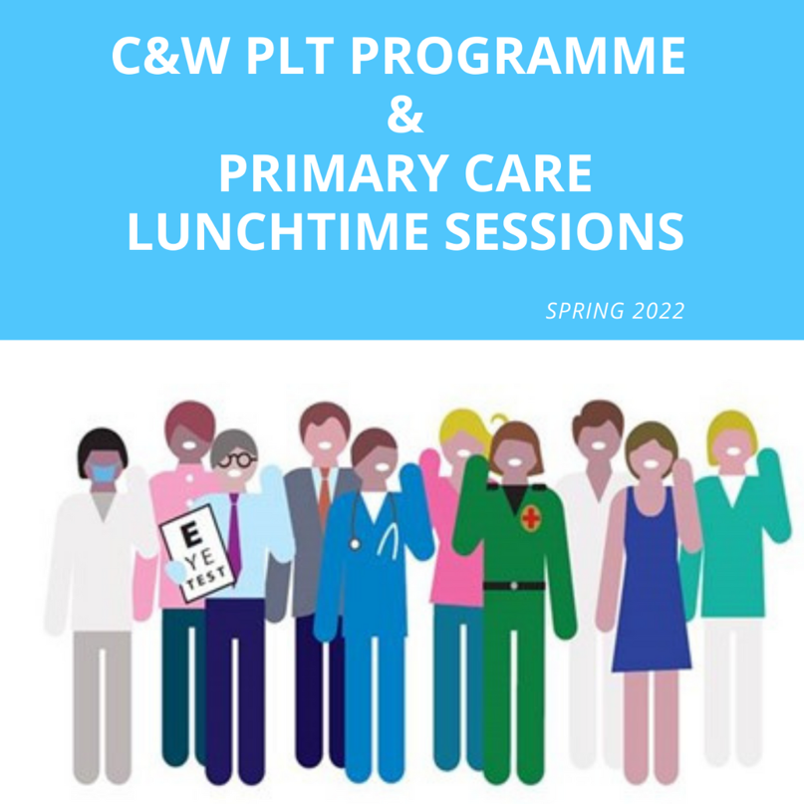
Click here for the Coventry and Warwickshire PLT Programme and Primary Care Lunchtime sessions during Spring 2022.





Showcase your vacancies with us!

Our aim is to highlight the exciting and varied opportunities available in Primary Care across Coventry and Warwickshire.
This is not a duplication of NHS Jobs but rather an opportunity to showcase your vacancies.
If you would like to advertise a role with us, click on the button below to complete the short form or contact cw.traininghub@nhs.net

Post your job with us!



Below are a selection of resources for you, to view all resources, visit the 'Resources' page on our website by clicking here.


Primary Care New Roles Resource
HEE have developed the 'New Roles in Primary Care' National toolkit.

Long COVID elearning session
This elearning session has been developed to provide you with a basic introduction to long COVID and post-COVID-19 syndrome.


Cervical Screening Best Practice Poster
The poster contains important failsafe checks taken from the Cevical Sample Take Training guide and the Sample Take Acceptance policy.


To help us evaluate the C&W Training Hub Newsletter please take a few moments to complete the survey.
CLICK HERE

Copyright © 2022 C&W Integrated Primary Care, All rights reserved.
Want to change how you receive these emails?
You can update your preferences or unsubscribe from this list.


