

Issue 13 December 2021


Whether you celebrate the festive season or not, we hope you will have the opportunity to put your feet up at some point and spend this time with those closest to you.
We understand the immense pressures you are under on the run up to the new year and so if you need someone to talk to, tips or tools to make the day a little easier, please visit the Wellbeing page on our website.

Jump to:

  Training & Education
  GPN
  GP
  New to Practice
  Placements
  Wellbeing
  PLT Programme
  Careers
  Resources





*NEW* Funded training for Healthcare Assistants

Click on the image below to access the HCA Training Programme for 2022

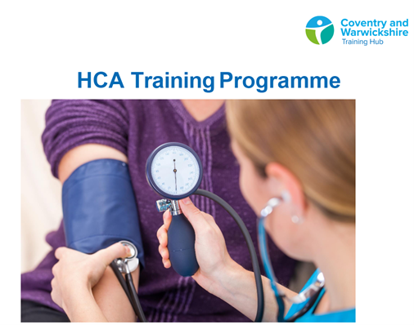

Funded training - 2021/2022

We are very excited to share that 49 colleagues across Coventry and Warwickshire were accepted on the below University courses. Courses were part/fully funded by Health Education England, Coventry & Warwickshire CCGs, Warwick University and CPD funding.

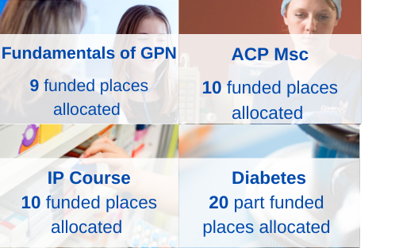

CPD Funding

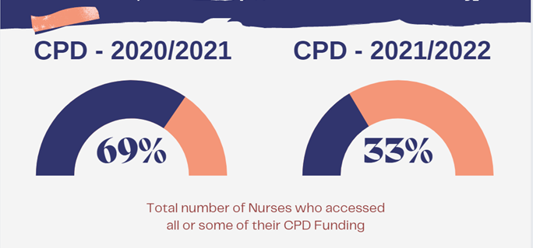

We have had a significantly low uptake of funding this financial year for CPD with
only 18 Nurses claiming the full amount of £333.
We understand this may be due to the demands that have been placed on your time during this challenging year.
If you haven't claimed for your full amount of funding or not claimed at all - it's not too late. You have until the end of March 2022 to claim for your £333.
There are three ways to book onto a course:
- Independently and be reimbursed via your practice up to £333 by invoicing cw.traininghub@nhs.net
- Request reimbursement up to £333 of a course(s) already taken within the 21/22 financial year by invoicing via your practice to cw.traininghub@nhs.net
- Book your course through the Training Hub
Please contact cw.traininghub@nhs.net if you have any queries.

Click here for courses and links to book

GPFV - Admin and Clerical training programme

233 places were booked for GPFV courses this year. Here is some feedback from our attendees.

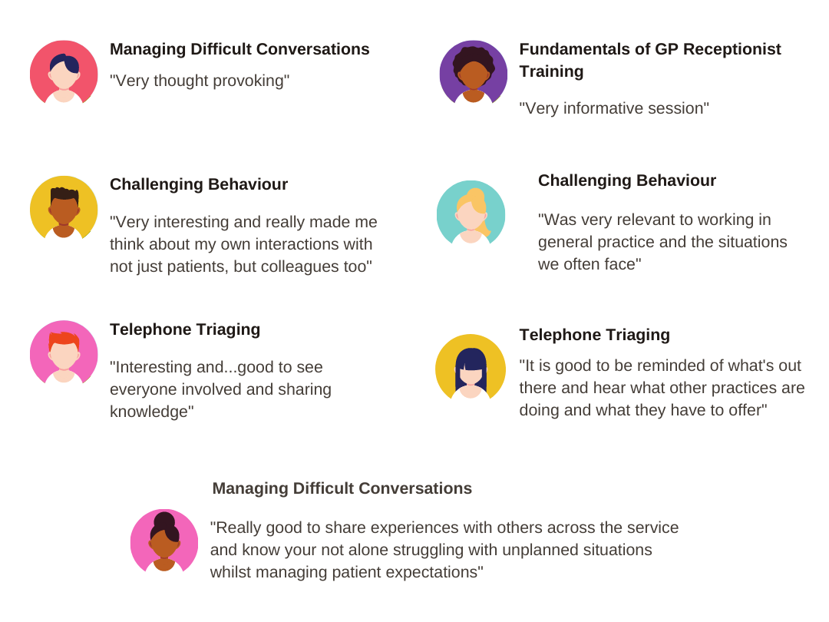



General Practice Nursing Strategy

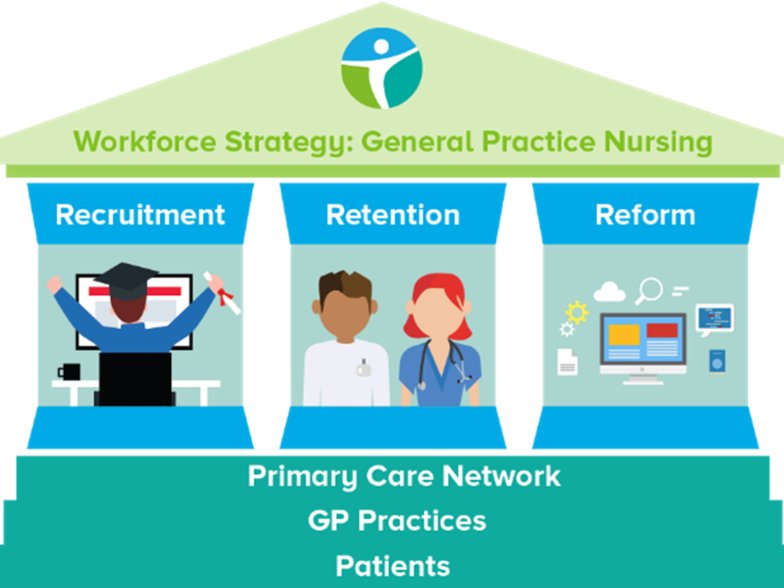

The GPN Strategy Working Group meet monthly and are currently working on:
- HCA upskilling
- Nursing Associate pathway
- Supporting our GPNs
- Expanding the number of learning opportunities and support available
We meet the 2nd Thursday of every month and would appreciate input from anyone who would like to join.

Click here to contact us if you would like to join

Practice Nurse Mentors

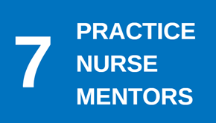
Following a fantastic response to our call for Practice Nurse Mentors, we are pleased to share that we have selected 7 individuals for the role. They are currently working on proformas and will undertake training in January 2022. We are hoping to be able to offer mentorship in February.

Peer Support for Nurses and ACPs



“It’s not always about getting or giving advice. It’s also about having a safe space to get things off our chest and occasionally sharing a laugh about it all!” (Mind, 2020)

We realise how isolating General Practice can be and how much we rely on agile platforms such as WhatsApp to answer questions and vent.
We invite you to join the monthly peer support session hosted by Gillian Schweigert and Heather Randle for Nurses and ACPs across Coventry and Warwickshire.
What are the benefits for you?
- Having the opportunity to reflect
- Building resilience and improving well-being
- Sharing your own experiences, new ideas, best practice and research
- Making links with colleagues across C&W
- Having the opportunity to build supportive networks

We meet the 1st Thurs of every month from 1-2pm - click here to join!

GPN CARE programme

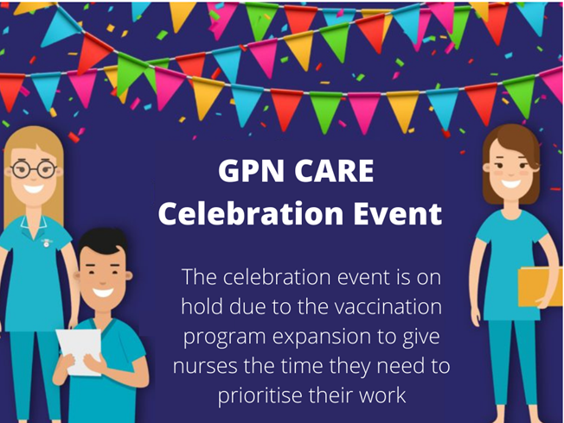



GP Mentor Scheme

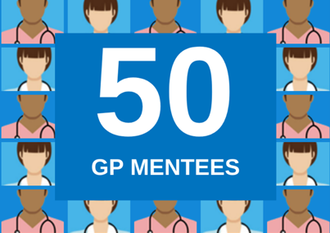
We currently have 50 mentees utilising the scheme, which is supported by 20 Mentors from a wide range of background an experience.

'New to Practice' fellows recent feedback is very positive and they are really appreciating mentoring (see below).



The offer is open to all GPs in C&W, to support both your wellbeing and career development.

To find a mentor, click here to complete the online registration form

Aspiring Leaders Fellowship

2021 saw the successful completion of the first cohort of Aspiring Leaders for C&W. Fellows have had opportunities to work at system level, been involved in various projects and work collaboratively, while acquiring skills and knowledge to develop into potential future leaders.
There is a current cohort of 6 fellows continuing to have this opportunity and we look forward to updating you more about their progress in the coming year.



New to Practice Fellowship

Cohort 1
11 GPs registered for the New to Practice Fellowship between April and September 2021.

Cohort 2
Cohort 2 will be starting in January 2022 with 10 GPs and 1 GPN.


Cohort 1 are accessing PCN working opportunities including:
- Introduction of PA in Care Homes
- Working to raise rates for bowel screen & Mammograms
- Developing safeguarding resources for mental health support
- Improving handover on discharge from hospital to care home to assist new GP

Click here for more information and the link to register

New to Practice Professional Development Course

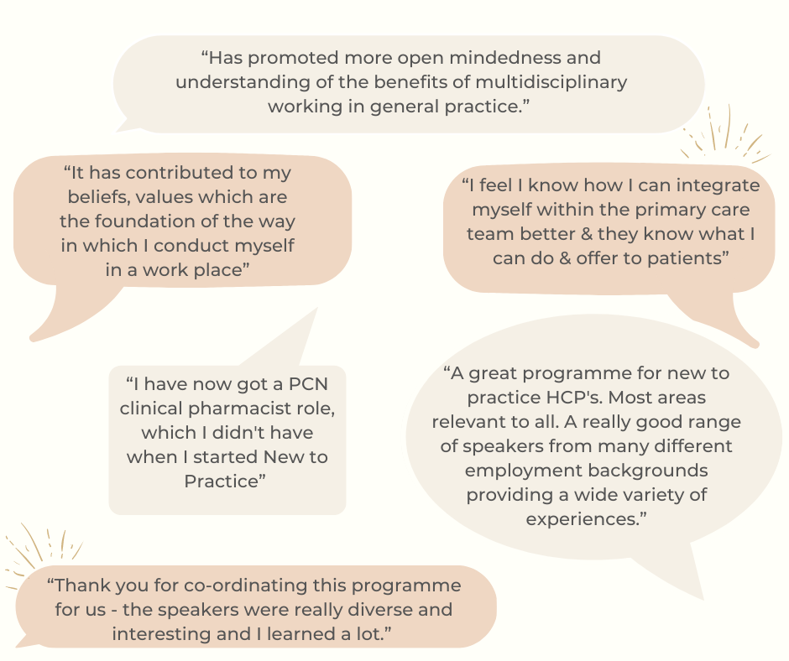

In primary care, the delivery of teaching sessions tends to be segregated by profession and this can lead to a lack of understanding of the different skills available in general practice.
The aims of delivering teaching sessions to an audience of newly qualified multi professional primary care staff were:
- To help develop an understanding of the different roles that they each bring into the patient journey
- To create a networking opportunity. This would then lead to better workforce cohesion and improve retention of staff.

The participants felt that they benefitted from the sessions and learned how primary care functions as well as gaining more clarity into the roles of the different members of the multi-disciplinary team.

Click here for more information and the link to register



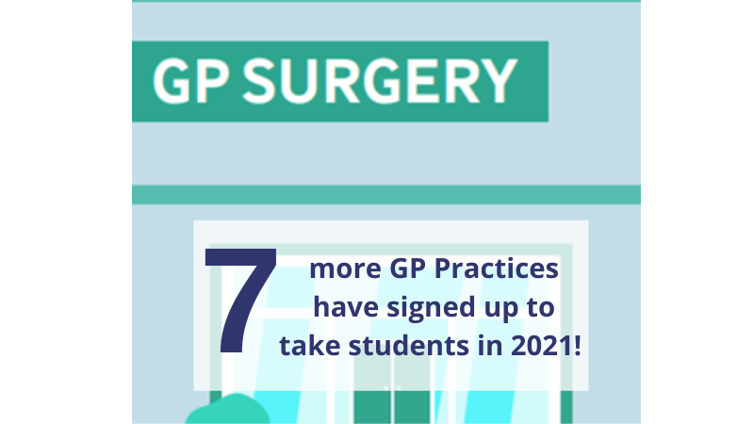

We are always looking for more practices to join the programme and host students of the following disciplines:
• Nurses
• Paramedics
• Physician Associates
• Occupational Therapists
Take a look at our dedicated Placements page on the website for more information.

Register your interest - Host a student from January 2022




You are always there for your patients, providing a first-class healthcare service.
So we want to support you to look after your own health and wellbeing.

We have compiled a variety of health and wellbeing support resources and services to help you.
Below is our featured wellbeing offer of the month, visit the 'Wellbeing' page on our website here to view more offers, tips and tools to support your wellbeing.

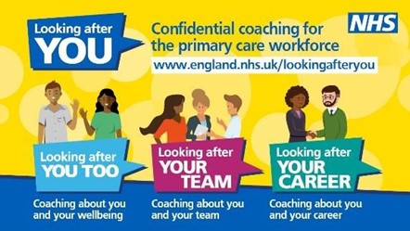



Coventry & Warwickshire CCG Education Programme
Spring Term 2022

  Coventry
  Wednesday 26th January
  Wednesday 16th February
  Wednesday 23rd March
  Rugby
  Thursday 13th January
  Thursday 3rd February
  Wednesday 9th March

  Warwickshire North
  Wednesday 19th January
  Wednesday 16th February
  Wednesday 16th March
  South Warwickshire
  Wednesday 19th January
  Thursday 17th February
  Wednesday 16th March





Showcase your vacancies with us!

Our aim is to highlight the exciting and varied opportunities available in Primary Care across Coventry and Warwickshire.
This is not a duplication of NHS Jobs but rather an opportunity to showcase your vacancies.
If you would like to advertise a role with us, click on the button below to complete the short form or contact cw.traininghub@nhs.net

Post your job with us!



Below are a selection of resources for you, to view all resources, visit the 'Resources' page on our website by clicking here.


Primary Care New Roles Resource
HEE have developed the 'New Roles in Primary Care' National toolkit.

Long COVID elearning session
This elearning session has been developed to provide you with a basic introduction to long COVID and post-COVID-19 syndrome.


Cervical Screening Best Practice Poster
The poster contains important failsafe checks taken from the Cevical Sample Take Training guide and the Sample Take Acceptance policy.


To help us evaluate the C&W Training Hub Newsletter please take a few moments to complete the survey.
CLICK HERE

Copyright © 2021 C&W Integrated Primary Care, All rights reserved.
Want to change how you receive these emails?
You can update your preferences or unsubscribe from this list.


This message originated from outside of NHSmail. Please do not click links or open attachments unless you recognise the sender and know the content is safe.

