

Welcome from CCG Chair

Welcome to this week’s edition of Practice News

I would like to start this week's introduction with a big thank you to everyone who attended our Annual General Meeting yesterday. 2020/21 was a challenging time for us both as an organisation and healthcare professionals and we embraced major organisational changes in the midst of a pandemic. The annual report for the predecessor organisations that we were reporting on can be found on our website or you can request a copy of the recording from the Communications team (in case you've exhausted Netflix).

For the seasoned of you it is no surprise that change continues – with a successfully completed merger we are currently working towards becoming part of the Coventry and Warwickshire ICS. The landscape is changing and "crisis or opportunity" depends on your perspective but one thing we can not ignore is that our "business as usual" as a membership organization is changing. The situation is urgent as it is time limited and we must work together as General Practice and as clinicians at Place to ensure leadership and influence at all levels of the ICS. I met with the WN Place clinical opportunities team who draw from LMC, PCNs, operational leads, Community and hospital specialties and work as a solid "Place unit" with GP Rachael Davies designated as the clinical lead for WN Place able to represent her local acute hospital, community and primary care to partners at system. There was no pretence that some storming had happened in their early days but the changes they are producing for patients and the strength of relationship they have is really positive. Lots to learn from as we all develop as places and mobilise to be strong clinical units within the ICS. I am listening, meeting smaller groups who are interested in getting on board and will be visiting existing Place clinical groups as well before a planned "summit" in early autumn. If you are interested or want to hear why we think there needs to be a sense of urgency then please get in touch with me or your CCG place representative (Deep, Jon, Imogen or Sukhi).

In terms of this week’s contents, I’d like to point you towards the 2021 edition of Coventry and Warwickshire Aspiring Leaders GP Fellowships – some really great opportunities. I have been really impressed by the work of the current cohort and know the chance to do one of these fellowships should be really popular and energising.

If you have any COVID-19 related queries, please send them through to: warnoccg.covid19primarycarecommunications@nhs.net.

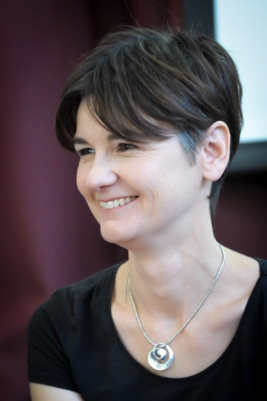

Dr Sarah Raistrick
CCG Chair
NHS Coventry and Warwickshire Clinical Commissioning Group

If you'd like to have Practice News and other relevant CCG updates sent to you directly, please email communications@coventryrugbyccg.nhs.uk.

Latest information for practices

Bedworth Civic Hall Covid Vaccinations
Please see the Swift Queue booking link for any patients who wish to book their Covid vaccination at the Bedworth Civic Hall.

Outbreak of Invasive Group A streptococcus
As you may be aware we have an outbreak of Group A streptococcus (GAS) in Coventry amongst our IDU (Injecting Drug Users) population, some of whom are rough sleepers or living in supported accommodation. GAS is infectious and we would like your support in raising awareness of and looking out for the symptoms of GAS with your service and supporting them to see a GP if they are showing any symptoms. Our GP, Ambulance, A&E and pharmacy colleagues will also be informed and asked to risk asses the relevant patients. Please support the control of this outbreak by:

- Passing on the warning notice to your teams citing the key symptoms and what to do if a service users displays the symptoms. Attachment: GAS warning for workers
working with the cohort.
- Raise awareness of the outbreak with your service users via the attached the poster citing key symptoms, safer injecting tips and what to do if they display any symptoms. Attachment: GAS poster warning.
- Warn your service users of the outbreak and alleviate the concern of your staff working with the cohort. Attachment: QA GASiGAS

For all enquiries, please contact Jane.Craig@coventry.gov.uk

Adult Hearing Service Suspension of Mediscan Diagnostics Services
Please be advised that one of the adult hearing service providers that cover all four places of our CCG has had to suspend services for a period of time as per CQC inspections in June and concerns in their processes have been raised. As a result they will not be providing Audiology clinics from 23rd June 2021 until 25th August 2021 or until CQC guidance.

The situation is being monitored by the contracting and quality team at the CCG to ensure the CCG is being updated on work being completed to rectify the issues raised and to obtain guidance when CQC are happy for the service to recommence. The provider has been temporarily removed from the booking system. The CCG is working with the provider to identify if any patients are currently booked in that will need to be changed to a different provider to complete their adult hearing service. The CCG will provide an update when the service is available as it will only be unavailable for a short period of time. There are 5 other providers for this service across the four places therefore this should not have a large effect on patients.

Long Covid & Weight Management Enhanced Services 21/22
Please find attached the sign-up sheet for the following 2021/2022 Directed Enhanced Services:
• Long Covid
• Weight Management
Please indicate which enhanced services your practice wishes to sign up to by putting either “Yes” or “No” in the relevant column (please delete whichever does NOT apply).
We would also ask you to ensure that the sign-up sheet is signed by someone with powers to bind the contract (i.e. a GP Partner). Due to the current Coronavirus situation, an electronic signature will be accepted. Please note that Practice Manager signatures will not be accepted unless the Practice Manager is listed as a partner on the contract.
Please return your completed sign-up sheet back to england.gp-contracting@nhs.net marked for the attention of Joseph Hartwell by no later than 31 July 2021.
PCN Updates
Please see below a graph of recent PCN updates;
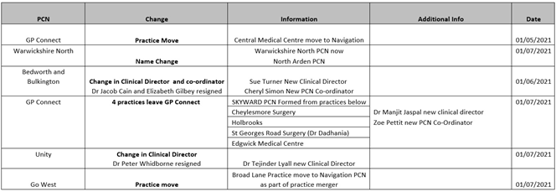
One Minute Guide - Carers & Young Carers
Please see attached a Carers and Young Carers Guide provided by the Coventry Safeguarding Adults Board.

Silent Sounds Crossing Language Barriers
We at Silent Sounds Crossing Language Barriers would like to promote the use of our Interpreting and Translation Services within Coventry and Warwickshire. Although we provide a full range of interpreting and translating services, we also specialise in Deaf communication and are passionate about promoting Deaf awareness.

We continually strive to ensure that Deaf/hearing impaired people have equal access to the services that they require and we also have hearing impaired members of staff working within our office based team. We work closely with the Deaf community and have earned their confidence and trust in using our services.

We ensure that all our interpreters and translators are qualified and hold a current Enhanced DBS Certificate. We also offer a DBS check service to people who don’t have a certificate or when their certificate has expired.

In addition, we provide further training and development courses for our office staff and interpreters to help enhance their skills and confidence.
We are committed to ensuring the safety and wellbeing of our office staff and interpreting workforce and have built up an excellent working relationship with them over the years.

For more information, please contact us on 01494 796030 or bookings@silent-osunds.co.uk

Notification of Infectious Diseases
We are still receiving past versions of the form from some of the Practices which does not include the additional information required.

All sections of the form must be completed. Currently only 28% of the forms sent to West Midlands Health Protection team include the vaccination status of the patient. It is essential that if the practices are reporting any of the below listed Vaccine Preventable Diseases that they include the patient’s vaccination status on the form. Occupation and workplace details if an adult, school/nursery details if a child should also be included on the form for all infections reported. All of this information helps us to do our risk assessment on what immediate public health action maybe required and identify outbreaks.

• Mumps*
• Measles*
• Rubella*
• Whooping Cough*
• Tetanus
• Diphtheria

For the infections that require an oral fluid test (OFT)* to confirm diagnosis, we are only currently receiving the samples returned in 50% of cases reported. Please remind Clinicians to inform patients during Consultation that they must return the oral fluid kit as per instructions. A copy of the instruction’s form on how to take the sample is attached for your information. This form is included with the OFT kit posted to the patient’s home address.

Consultant Connect – the importance of recording Advice & Guidance outcomes and how to earn CPD points
Did you know you can earn CPD points by recording the outcomes of your Advice & Guidance calls/messages? Please see attached for more information.

Trainings, events & surveys

C&W Aspiring Leaders GP Fellowships 2021/22
Coventry & Warwickshire Health and Care Partnership are proud to be offering fellowships in their Visionary & Transformation Programmes:

- Exciting opportunities for any GP to spend time working in local general practice with funded time to upskill in a particular field
- Develop your leadership potential and be able to access connections to experts in policy, research and industry to support their learning and will have funding available to support professional development, while enhancing both the primary care and wider healthcare system.
- Fellowships will empower GPs to become our future system leaders in priority areas for our healthcare system

Please see attached flyer for more information and how to apply.

Help us promote a survey on 0-5 Public Health Nursing Service provision in Warwickshire
Warwickshire County Council is asking parent and carers of young children in Warwickshire’s to share their views and experiences of the 0-5 Public Health Nursing Service to help inform future support and we would appreciate your support to raise awareness of the survey. Please print and display a poster about this survey. Click here to access the survey.

