**Jubilee Healthcare**

**Patient's Guide**

**To**

**Vasectomy &**

**Pre/Post Operative Care**

Jubilee Healthcare

41 Westminster Road

Earlsdon

Coventry

CV1 3GB

Tel: 024 7622 3565

**8th February 2020**

**People consider a vasectomy when they are sure their family is complete.**

It is one of the most effective forms of contraception.

However, it is a decision that needs a lot of thought and it needs to be recognised that personal circumstances can change, (e.g. a tragedy to existing partner or children, or a new partner in the future). Reversal operations are not always successful; they are not usually available on the NHS and can be costly. Studies suggest that up to 7% of patients being sterilized later express regret, especially when there have bene recent difficulties in the relationship with your partner.

**Who can have a vasectomy?**

Any man can have a vasectomy regardless of age, or whether they are married, single, divorced, widowed, and childless or have a family. If you have a permanent partner, their consent is not legally necessary. It is recommended however that your decision is discussed with her and that she agrees with it. You should be aware that if you are under 30 yrs old or not in a stable relationship, you are at a higher risk of regret and requesting a reversal in the future. It is also recommended that if your partner is pregnant, you should consider waiting until the baby is born and at least 6/12 month old before having your vasectomy.

# Special considerations if your partner is over 40

If you partner is in her 40s or above you should also consider the menopause in your decision making. If your partner is nearing the age when her mother went through the menopause or if your partner has menopausal symptoms (reduced frequency of periods, hot flushes, etc) it may be that the vasectomy will not be needed for very long and thus the risks of the procedure may outweigh any benefit.

We are happy for a woman to abandon the need for contraception if she is over 50 and has not had a period in 1 year or for women who are between 40 and 50 who have not had a period for 2 full years. When thinking about this bear in mind that the vasectomy does not work immediately and there is at least a 4 month wait until your first test.

Additionally if your partner were to consider HRT the safest way of giving HRT is with a progesterone releasing coil that will not only help with menuopausal symptoms (in conjunction with a tablet or patch) but will also provide effective contraception – so if your partner thinks she may use HRT please discuss your options more fully with your GP or alternatively call us and request a phone consultation with one of our doctors.

**How effective is a vasectomy?**

 A vasectomy is over 99.8% effective; currently 1 in 150 may fail initially if one of the tubes joins straight back after the operation (hence the requirement for a test at 4 months).

The operation is a lot easier than a female sterilisation, and more effective.

Failure can be due to one of two reasons:

1. Very rarely there can be an additional tube in one or both sides, in which case the post semen analysis test will be positive at the end of four months; or

2. the divided ends of one of the tubes can rejoin.

Even after the 'all clear' has been given a pregnancy can still occur many years later if micro-channels grow between the cut ends allowing live sperm to get through—this risk of pregnancy is about 1:2000

2

**What are the alternatives to Vasectomy?**

There is no ‘male pill’ yet. **However, it is essential that alternative forms of long-term contraception for your partner have been considered and discussed with your own GP**. These are called ‘LARCs’ and include hormonal implants, hormone injections and hormone (Mirena) coils. These are all very effective methods of contraception (risk of pregnancy is only about 1:1000), are ‘reversible’, can have benefits for many women with their periods, and have far fewer potentially serious / severe complications, (LARCs will not suit all women but can easily be stopped or removed if any side effects). Female sterilisation is not routinely available in Coventry, including the Essure device where a metal implant is inserted into the end of each Fallopian tube.

**Am I suitable for a vasectomy?**

Any man can have a vasectomy but some medical conditions (including severe obesity) may make the procedure more difficult. You must let your GP or surgeon know if you have had any infections or operations (including as a child) in the genital area (including hernias) and if you have any known abnormality of the urogenital system (e.g. kidneys, bladder).

**If you are taking any anticoagulant medication like warfarin or dabigatran, or anti-platelet medication like aspirin or clopidogrel, or any immune-suppressant medication, or have a clotting disorder such as haemophilia, or have any allergies (eg latex, local anaesthetic), you MUST ensure that the surgeon is informed at least 2 weeks before your appointment for your operation.**

**If you have diabetes, this should be under the best control that you can possibly achieve to minimize risk of post-operative complications**

**Complications of vasectomy.**

Important early complications that you should be aware of include in the first couple of weeks:

Infection, swelling and excessive bruising (1-2%); there is usually little pain and only discomfort that usually settles within 7-10 days.

Chronic post-vasectomy scrotal pain, sometimes occurring years later, is also a recognised complication; but is rarely severe.

Complications from any form of surgery can become severe enough to require further treatment, hospitalisation, surgery and/or affect long-term quality of life (1-2%).

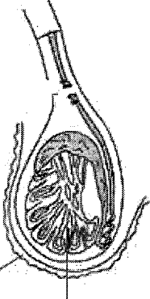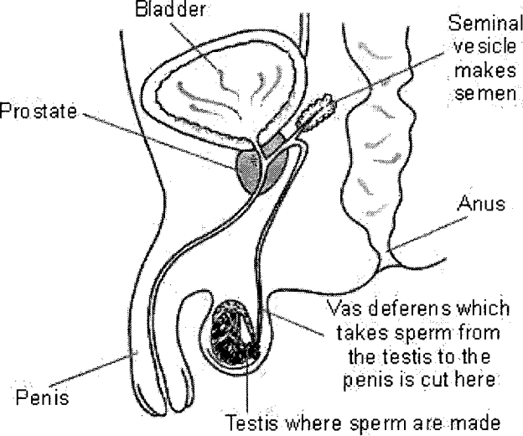

**Non-Scalpel / Minimally Invasive Vasectomy (NSV / MIV). How is it performed?**

A small local anaesthetic injection is given to a small area of skin in the middle of the scrotum. This numbs the area to enable the surgeon to access the vas deferens on each side through a small cut. (The vas deferens is a tube attached to the testis on either side; it transports the sperm to the penis.) With special instruments a small loop of the vas deferens on each side is brought outside the skin, cauterised and cut so the sperm can no longer pass through to the penis. Sperm is still made in the testes, but hit a "dead end", they then die and are dissolved.

The procedure should be almost painless, but some men experience some discomfort that can be felt like pressure or pinching.

Your wife/partner may be allowed to accompany you throughout the procedure if you wish. The operation itself takes about 15 minutes, after preparation, and you may be asked to wait and rest for about 20 minutes afterwards. You must not drive yourself home, and ideally, should be accompanied

Testis

Scrotum

Each tube is cauterized to block any sperm getting through

The sperm made in the testis then hit a dead end. They die and get dissolved' into the bloodstream.

 A small area of skin in the middle of the scrotum is numbed with an injection of local anaesthetic

A small opening is made in the skin. The vas deferens is found under the skin, a short loop pulled out and cauterized each side.

**The day of your operation.**

Immediately before coming, please have a bath or shower and wash the genital area thoroughly with soap and hot water and keep the area verywarm. **You do not need to shave** any of the genital area. Eat a light meal before arriving at the clinic and bring a pair of tight underpants (or jockstrap) to support the scrotum afterwards.

**Additional information on both male and female sterilization can be found at the following websites: the Association of Surgeons in Primary Care (www.aspc-uk.net), and the Faculty of Sexual and Reproductive Health:(www.fsrh.org/pdfs/MaleFemaleSterilisation.pdf). You are strongly advised to check these websites.**

**If you have any questions or concerns after your vasectomy, please phone us on 02476223565 and we will endeavour to get your surgeon to telephone you the same day**

**Post-operative Care and Advice.**

After approximately 1-2 hours the anaesthetic will begin to wear off. Over the counter analgesia may be taken e.g. Paracetamol, Ibuprofen or Co-codamol as per pack instructions. You will be offered Ibuprofen or Paracetamol immediately after your operation, but you should take some 1 hour before your appointment.

Use of an icepack on the scrotum (with eg a tea-towel to protect the skin from a cold burn) for 10-15minutes at a time may help reduce swelling and discomfort. **Keep yourself pain free for the first 4 days by taking regular painkillers *even if you are not in pain* as keeping the nerve ends desentisitised might reduce your risk of developing a long-term persistent pain.**

Some swelling and bruising on the scrotum and testicles is normal but if it is severe during the first few hours after the operation you should contact the surgeon immediately. If you are unable to contact him please contact a doctor through your own surgery and ensure your surgeon is informed in due course.

To minimise discomfort or swelling you should wear some tight fitting underwear, swimming trunks or jockstrap, for a few days. **(Bring them with you on day of procedure.)**

You must arrange for someone to drive you home and to be with you for the rest of the day. It is sensible to plan to relax at home for a few days, and should avoid any strenuous exercise, heavy lifting or driving long (>1hour) distances for 1-2 weeks.

After the procedure care should be taken with bathing for about 7 days, Even though the scrotum may be bloodstained, it is best not to wash for the first 24 hours.

It is advisable not to soak in the bath, but to have showers. Do not use excessive gels, shampoos or talc.

Sexual intercourse can be resumed when comfortable. It is essential to continue to use contraception until there are no more live sperm in the ejaculation. This can take at least 30 ejaculations.

Vasectomy has no known effect on masculinity, or on sexual arousal, performance or orgasm., nor any proven cause of prostate cancer.

Where the tubes have been cauterised and cut some scar tissue will form. This may be felt as a slightly lumpy, sometimes tender, area just above the testicle, called a sperm granuloma. This is quite normal, but if you do become concerned about any unusual lumps see your GP. There are no stitches to remove, there is only a small cut that will heal itself although may gape open a little and cause a slight blood stained discharge. You need only to seek medical advice if it is persistent, excessively smelly or inflamed. You may also see slight blood-staining the first few times you ejaculate.

If you have any questions or concerns at anytime, please contact us and ask to speak to the surgeon before you contact your own GP.

**Post-Vasectomy Semen Analysis.**

You will be required to give at least 1 specimen after about 4 months. This is the time when the risk of the tubes rejoining is the greatest and the operation has failed. This risk is up to 1:150.

**You will receive an email about 4 months after your operation to remind you about providing a semen sample for testing. Because it can take quite a long time for all remaining sperm to clear out of the tubes, and the first test requires there to be no sperm at all in the sample, you will need to have ejaculated at least 30 times before providing the sample, even if this takes longer than 4 months (Let us know if you anticipate any delay in providing the semen sample so that we do not send you unnecessary reminders). You may still be required to provide further samples before we can assure you that the vasectomy has been successful.** Some men take longer to clear the 'reservoir' of live sperm, and you should not worry if you are asked for further specimens.

Most menonly need to provide 1 sample at or soon after 4 months before they can be declared infertile, but some take longer. Your surgeon will advise if you need to repeat a test, and also when you are clear.

**UNTIL YOU HAVE WRITTEN CONFIRMATION THAT THE VASECTOMY HAS BEEN SUCCESSFUL YOU MUST CONTINUE TO USE CONTRACEPTION TO PREVENT PREGNANCY**

No assurance can be given that you are safe to stop alternative contraception without these tests.  Early failure does occur and can only be detected by semen analysis and no responsibility will be accepted for any resulting pregnancy if the required semen specimens are not submitted for analysis at the appropriate times.

At Jubilee Healthcare we train other students and doctors, both junior and experienced, as both GP’s and surgeons, experienced doctors, may be training to do vasectomies on the day of your surgery.

**YOU MUST TELL US IF YOUR CONTACT DETAILS CHANGE, ESPECIALLY YOUR EMAIL ADDRESS**

**If you have any questions or concerns after your vasectomy, please phone us on 02476223565 and we will endeavour to get your surgeon to telephone you the same day**

8