MONITORING YOUR OXYGEN LEVELS – PLEASE READ THIS DOCUMENT AND CALL THE TEAM ON 07881359254 IF YOU HAVE ANY QUESTIONS

Dear Patient

You have been assessed by our Doctor as likely to benefit from the monitoring of your COVID-19 symptoms or respiratory condition. Therefore, the Respiratory@home Team have provided you with this pack and information for you to monitor your oxygen levels and pulse rate, the Respiratory@home Virtual Ward Team will support you to monitor over the next 7 days (or longer if you are not improving) to ensure you remain safe.

The pack contains a small device called a ‘Pulse oximeter’ to take your oxygen levels and pulse rate.

Pulse Oximeter
This device is for adult use only.
How to take your pulse and oxygen levels:
  - Sit down
  - Remove nail varnish or false nails
  - Switch the device on
  - Open the device and insert your finger
  - Ensure the soft part of your fingertip is over the red light inside the mouth of the device
  - Bend your finger so that the monitor is in the palm of your hand (see picture)
  - Wait 30 seconds to make sure it is reading correctly
  - Record the two numbers when you are sitting down

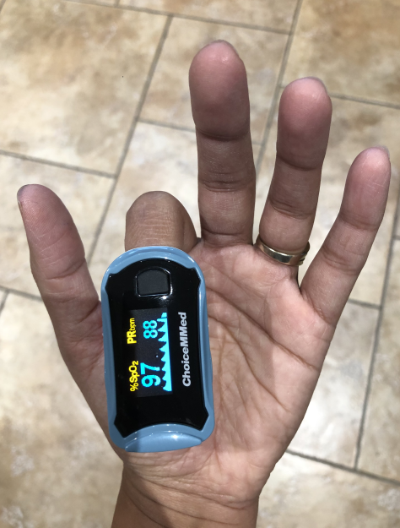
Oxygen levels
Pulse rate
Power Button

What to monitor:
You or your carer will need to take the following readings 3 times per day at approx. 8am, 12pm & 5pm and take action as necessary*.

- Your oxygen levels (using Pulse Oximeter)
- Your pulse rate (using Pulse Oximeter)
- Temperature (Using own thermometer if you have one, don’t worry if you haven’t gone one)
- Are you feeling? Better/same/worse
- How is your breathing? Better/same/worse
- Log your results onto the “Remote monitoring of COVID-19 diary”

Self-monitoring

If you feel like your symptoms are worsening and are facing difficulties in dealing with them, please contact us :

Respiratory@Home Contact Number: 07881 359254

Daily Monitoring

The Respiratory Oximetry@home Virtual Ward Team will call you daily to pick up your readings and to check on your wellbeing. At this point a call from the doctor can be booked if there are any concerns.

(between the hours of 08.00 and 18.00 Monday-Friday, 9:00-14:00 Saturday & Sunday)

*What to do if you experience the following symptoms;

Contact either NHS111 or your GP if you have one or more of the following symptoms and tell the operator you may have coronavirus:
- Feeling breathless or difficulty breathing especially when moving around
- Severe muscle aches or tiredness
- Shivers or shakes
- Your oxygen levels are 93 or 94% or are less than your normal blood oxygen level
- You feel something is wrong or you feel much worse than yesterday
Attend A&E within an hour or call 999 if you have one or more of the following symptoms and tell the operator you may have coronavirus:
- Your oxygen levels are 92% or less
- You are too breathless to complete short sentences
- Your breathing has suddenly got worse
- You feel cold and sweaty with blotchy or pale skin or a rash than does not fade when a glass is rolled over it
- You have collapsed or fainted
- You are very drowsy
- You are feeling confused or agitated
- You have stopped passing urine or are passing far less

If you are making your own way to the A&E department, as far as possible, try and notify them of your arrival before walking into the department, so you can be directed into the hospital appropriately.
Hospital Name/Address | Telephone Number | Additional detail
Warwick Hospital,  Lakin Road,  Warwick. CV34 5BW | 01926 567129 | A&E reception
George Eliot Hospital,  College Street,  Nuneaton. CV10 7DJ | 02476351351 | select option 1 for A&E reception
University Hospital Coventry & Warwickshire (UHCW)  Clifford Bridge Road  Coventry. CV2 2DX | 02476964000 | ask for A&E department

If you could update the Respiratory@home Virtual Ward Team on 07881359254 if you needed to seek help via 111/GP/ED/999 at your convenience.

At the end of the 7 day period
The Respiratory@home team will discharge you from the service and request return of the pack. This will be via a drop off location or collections.
The Pulse oximeter will be decontaminated and used to monitor other patients in the service. The equipment is NHS property and will be used to monitor the health and wellbeing of other patients in the same situation.

If you have any further questions after reading this document please contact the Respiratory@home Virtual Ward team on 07881359254.

THANK YOU

Remote monitoring COVID-19 diary

Patient Details
First name |  | Surname
D.O.B.

Day | Time | Date | Pulse | Oxygen Level % | Temperature | Feeling: better/same/worse | Breathing: better/same/worse

