Administration of admitting a patient into the COVID Oximetry @Home Virtual Ward
There are 2 types of admission;
- Directly booked onto EMIS
- Sent via email to crgpa.admin@nhs.net.
All admissions need to be entered onto the “COVID Oximetry at home Patient Journey log” spreadsheet. The “COVID Oximetry at home Patient Journey log” spreadsheet tracks the patient’s journey and ensures that necessary events occur during their time on the ward. Need to enter where this information is held.
Logging into EMIS;
You will need to open up 2 EMIS log-ins screens to operate this system.
- Firstly log-in using the username “covid at home” – password to be given at site. This will give you access to the patients record and to see the referral form.
- Next log-in using your usual EMIS log-in/smartcard. If you don’t have a smartcard or it doesn’t work at the Admin Lead/Team to help you sort this out.
If it’s your first time in the COVID Oximetry@home team you will need to add the new session holder filter to you usual EMIS log-in. Select Appts Config, your session holder filters, Covid@home, top arrow to move Covid@home to the chosen filters section
Your session holder filters Covid@home Appts Config Top arrow
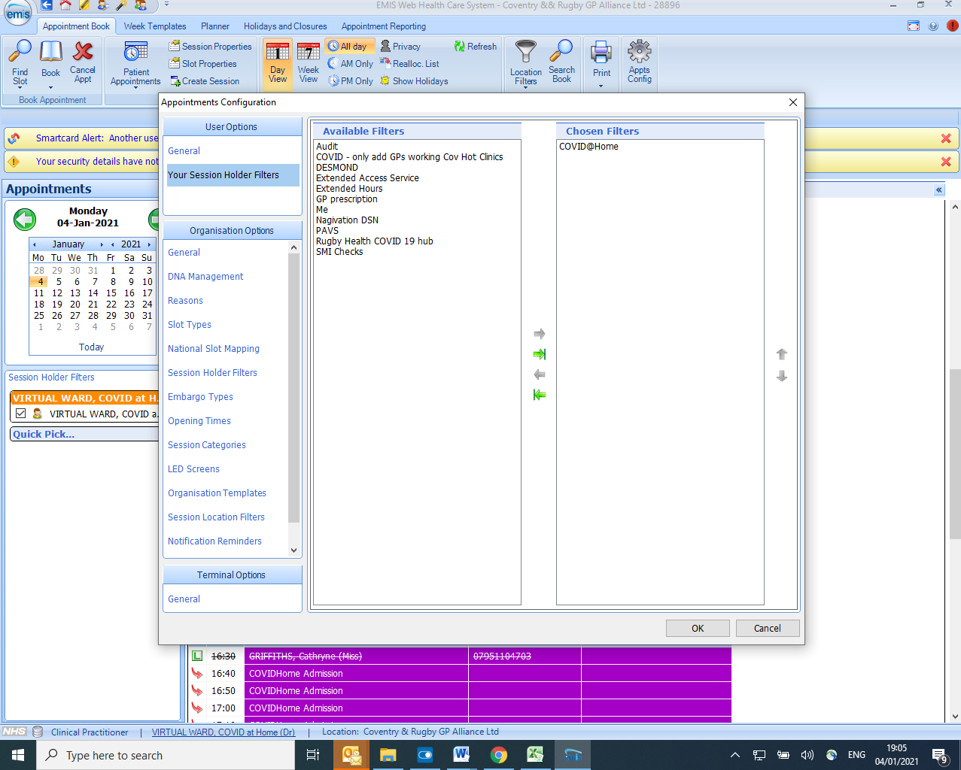
Access to email referrals;
You will need an nhs.net account and access to crgpa.admin@nhs.net.
If you have previously had access to this account to support nhs111 calls and your access has gone, contact IT on 02476844000 to get re-connected.
If you’ve never had an nhs.net account or access to the crgpa.admin@nhs.net account ask the admin Lead/team to help set this up for you.
Mobile Phone;
One of the team will need to hold and answer the service mobile phone 07881 359254. Patients and referrers could contact the mobile number 24/7. If the phone is busy then one person should take messages and the other calls people back. The phone will need to be checked in case a message has been left.
EMIS directly booked admissions
The Care Coordinators will need to monitor the EMIS Admission to COVID@Home Virtual Ward Clinic for new admission. You will need to refresh the screen regularly.
Once a new admission appears follow this process;
- Add the admission to the COVID Oximetry at home Patient Journey log
- Using the EMIS system that you have logged in on with “Covid at Home Dr” open up the patients notes; select the admission appointment, press the “a” button and then “s” button, you are now opening up the full patients record in the surgery EMIS system. You may need to pause and wait for this to load. If it doesn’t work first time press “c” twice and then start again pressing “a” & “s”.
- Once you have the patients record open, look for the form and open this up to review;
  - Check the telephone number that the patient needs calling on
  - Check if the patient has been given a pulse oximeter & pack
  - Check whether the patient has support
  - Check whether the patient needs a translator
- Once the above is known contact the patient to initiate the first call. Make any necessary notes on the COVID Oximetry at home Patient Journey log.
- The patient will need to be booked into the Daily Virtual Ward COVID@home round review same day/next day. If the patient is admitted between 8am-15:30 book the patient into the same day virtual ward. If the patient is admitted between 15:30-22:00 book them into next day virtual ward round.
  - You will need to book a cross org appt so that the Ward round GP can see the original booking and form in the patients notes.
  - You will need to make the appointment externally bookable (right click on appointment, select slot properties, change externally bookable from no to yes). Note; only do this for specific appointments as changing this status enables practices to book in directly.
  - Register the patient onto CRGPA emis system; ensure you have a smartcard in situ and use patient trace. Patient should be in your quick access toolbar at the top of the screen “shaped like a wand”.
  - Enter either the NHS no or the family name, gender & date of birth and hit search.
  - Select the correct patient and accept the registration.
  - The patient will now appear in a blue bar just above the clinics.
  - Select the next appointment in the Daily Virtual Ward COVID@home and book the patient in.
  - The patient now has 2 appointments, one for the Virtual Ward GP to see the patients’ full record and admission form and the other to document for the COVID Oximetry@home service.

Email admissions
The Care Coordinators will need to monitor the crgpa.admin@nhs.net account for COVID@Home Virtual Ward new admissions. The email should contain the admission form.
Once a new admission appears follow this process;
- Add the admission to the COVID Oximetry at home Patient Journey log
- Once you have the patients admission form open;
  - Check the telephone number that the patient needs calling on
  - Check if the patient has been given a pulse oximeter & pack
  - Check whether the patient has support
  - Check whether the patient needs a translator
- Once the above is known contact the patient to initiate the first call. Make any necessary notes on the COVID Oximetry at home Patient Journey log.
- The patient will need to be booked into the Daily Virtual Ward COVID@home round review same day/next day. If the patient is admitted between 8am-15:30 book the patient into the same day virtual ward. If the patient is admitted between 15:30-22:00 book them into next day virtual ward round.
  - Register the patient onto CRGPA emis system; ensure you have a smartcard in situ and use patient trace. Patient should be in your quick access toolbar at the top of the screen “shaped like a wand”.
  - Enter either the NHS no or the family name, gender & date of birth and hit search.
  - Select the correct patient and accept the registration.
  - The patient will now appear in a blue bar just above the clinics.
  - Select the next appointment in the Daily Virtual Ward COVID@home and book the patient in.
  - Save the admission form onto your desktop.
  - Select consultations from your quick access toolbar at the top of the screen “2 people”.
  - Select add, select document, select attach document, select desktop and the document you have saved. Once uploaded you will need to select a document type, select “Admission by doctor”. Select save.
Feedback from Virtual Ward Round
Care Coordinators must liaise with the virtual ward round doctor to understand admissions/discharges and any other actions required.
Follow-up calls for patients
Once the patient has received their pack they should contact the service to be taken through the second contact. If the patient does not contact the services within the expected timescale then the care coordinator should contact the patient to initiate the call and/or chase the pulse oximeter and patient pack arrival.
After a further 24 hours the care coordinator should contact the patient and initiate third contact and repeat as necessary. If the care coordinator feels the patient isn’t coping they should be booked into the Virtual ward round for review.
Contact the patient for daily observations via text/call

