**Therapy Department**

**Managing Breathlessness: A Patient’s Guide**

# Introduction

Breathlessness is an awareness of difficult or uncomfortable breathing. Feeling breathless is a normal and healthy response to an increase in physical exertion. However, sometimes people are breathless when they are not exerting themselves, and this can be uncomfortable and upsetting. It is important to remember breathlessness in itself is not harmful and you will recover your breathing.

This leaflet provides strategies to affect how you think, feel and behave when breathless; which should help you learn to regain control of your breathing.

# The Cycle of Breathlessness

Breathlessness can sometimes lead to anxiety and panic. Unfortunately, this can cause reduced activity and inefficient breathing, which will only make you more breathless. This can end up becoming a vicious cycle, as demonstrated below.

**Do not** avoid doing things that make you breathless, participate in activity that increases breathlessness in a controlled way, but use advice and strategies in this leaflet to independently recover and control your breathing.

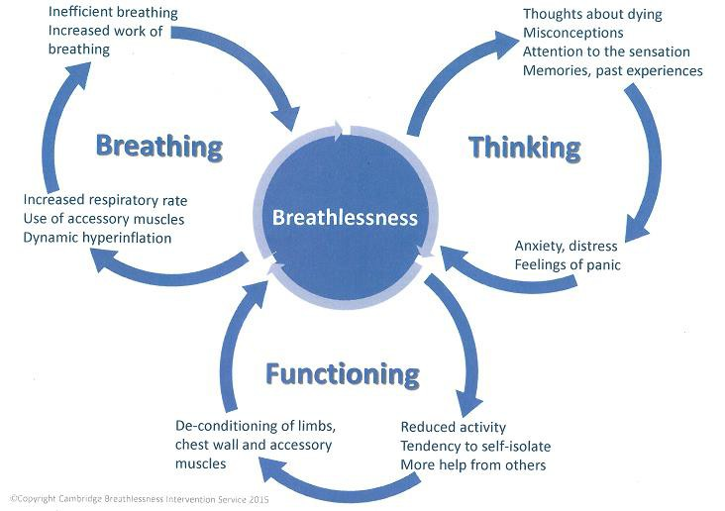

## Patient Information

**Pacing and Energy Conservation**

There are several changes you can make to everyday life to help manage your breathlessness;

* Slow down, take your time, do not rush to get the task done before you get breathless
* Pace individual activities, little and often, including mobilising, stairs, washing, drying and dressing. Stop each activity to rest and recover before you become too breathless
* Listen to your body, be aware of your limitations
* Avoid breath holding, common with bending, stairs, or rushing to get activity done, as this will make you feel more short of breath
* Plan your day so you don’t try to fit too much in, allow plenty of time to carry out tasks, and prepare by gathering everything you need before starting
* Prioritise your tasks, make sure you complete the most important, and consider spreading responsibilities over consecutive days or asking for help
* Consider sitting down during tasks like cooking and personal care
* After a shower or bath, sit in a towelling robe to dry and rest before dressing
* When dressing, consider loose clothing and dress your lower body first as this requires the most energy
* Minimise bending during tasks by using long handled aids like a helping hand, long handled shoe horn or a long handled wash aid
* Simplify tasks by using labour saving devices like electric cooking utensils
* Consider a walking aid to brace shoulders/ arms for breathing and energy support
* If going up and down stairs, try putting both feet onto one step, breathe in when standing on the step and out as you step up to the next one. Consider positioning a chair at the top or bottom of the stairs for resting
* Use cooling therapy, such as a hand held, desktop or floor standing fan, opening doors or windows to allow a gentle breeze, or using a cold wet flannel or mist water to the face
* If you are less breathless, you will recover quicker and therefore be less fatigued

# Focused Breathing Techniques

The following strategies can be used separately or together to help control breathing when completing activities;

1. **Pursed lip breathing** – Breathe in gently through your nose, then purse your lips making them into a narrowed ‘O’ shape and blow out, as if trying to whistle or blow out candles. Focus on trying to elongate the ‘out’ breath. You will find the ‘in’ breath takes care of itself. This technique keeps your airways open as you breathe out, allowing your lungs to empty properly, creating room for the next breath
2. **Blow as you go breathing** – Breathe in before you make an effort and breathe out as you make the effort. This is useful when bending, lifting, reaching, standing from a chair, or each step upstairs. For example, if you bend down to pick something up; breathe in beforehand and out as you lift the item. It may be helpful to breathe out through pursed lips
3. **Paced breathing** – Pace your breathing to your activity. This is useful during rhythmical or repetitive activities, like walking or climbing stairs. For example, when walking, breathe in for a step and breathe out for the next two steps. You can change the rhythm depending

on what works for you. It may be helpful to breathe out through pursed lips.

# Resting and Recovery Positions

Adopting certain positions can help you take control of your breathing. The positions outlined below help to stabilise your shoulders, allowing your diaphragm more room to move, and making your breathing more efficient.

# Sitting

Lean forwards, placing your elbows onto your knees or a table. Pillows or cushions on the table can make it into a comfortable resting position. Alternatively, you can sit upright in a chair with a firm back; rest your arms on the chair arms or your thighs and make your wrists and hands go limp to help you relax.

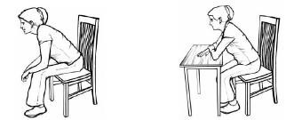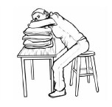

# Standing

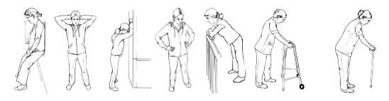Lean onto any fixed surface such as a wall, railing, windowsill or worktop. You can also brace through a walking aid, shopping trolley or long umbrella. Alternatively, you can support yourself by placing your hands on your hips, belt loops or handbag. Try to avoid slumping.

# Lying

Lie on your side with pillows to support your head and shoulders. You may also choose to place a pillow beneath your top arm or leg for comfort. Alternatively, sleeping propped up with pillows especially a v-pillow can help

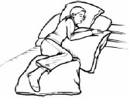

# Recovery Breathing Techniques

If unable to control breathing during activity, stop and rest, stop talking, sit down if possible or use the recovery positions previously mentioned. The following strategies can then be used separately or together to help control breathing when recovering from activities;

### The three ‘F’s

* + **Fan** – Cool air to the nose and mouth area can reduce the feeling of breathlessness. Hold a small hand held fan 10-15cm from your face. Aim the fan towards the central part of your face around your nose and above your top lip, keeping it still. Relief may be instant, or you may need to use the fan for 10 minutes or so before the effect is felt
  + **Forward** – Lean forwards onto your arms on a table or wall
  + **Focus** – Think about your breathing and block out any distractions. Focus on breathing out. You will find the ‘in’ breath comes naturally. As you start to feel better, try to

lengthen the ‘out’ breath

1. **Pursed lip breathing** (see focused breathing techniques section)

When your breathing has eased, remain seated/ rested for a few moments before moving again.

# Things to Consider

Many people assume feeling breathless must mean they require more oxygen. This is not necessarily the case. Sometimes breathlessness has nothing to do with the level of oxygen in your blood and oxygen does not always relieve breathlessness.

It is also common for people to feel they will never recover their breathing. Although breathlessness can be unpleasant and upsetting, it is rarely harmful; you will continue to breathe and recover and your breathing will settle.

For both these common thoughts you should try to learn strategies to independently recover and control your breathing, like those outlined in this leaflet, aiming to instead influence how you think, feel and behave.

### Images reproduced with kind permission from Cambridge Breathlessness Intervention Service

Produced by Emma Calcutt and Claire Lomas April 2020

### C:\Users\ghaiwals1\AppData\Local\Microsoft\Windows\INetCache\Content.Outlook\0XOICFL5\CRCCG_just_the_flu_web_banner.jpg[Rochdale News | News Headlines | Diabetes UK and Tesco team up for free Type 2 diabetes risk assessments - Rochdale Online](https://riskscore.diabetes.org.uk/start)

If you’re at high risk of developing type 2 diabetes you may be eligible to join your free local Healthier You NHS Diabetes Prevention Programme. Check your risk using the Diabetes UK risk tool. Search ‘Know Your Risk’ <https://riskscore.diabetes.org.uk/start>