CORNEA / ANTERIOR SEGMENT
REFERRAL WITHIN 24 HOURS
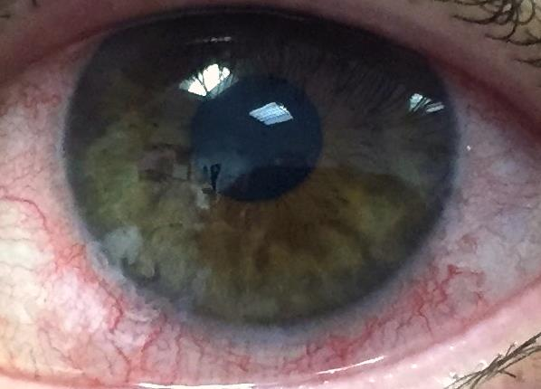
Iritis/Uveitis
- Presentation: Pain Red Photophobia Epiphora Blurred Vision
- Causes: Idiopathic; HLA B27 (Ank Spond) IBD Sarcoid etc
- Diagnosis: Previous episodes of iritis Relevant PMH Need SL exam to confirm
- Management: Topical steroids
Corneal Ulcer
- Presentation: Pain Red Photophobia Epiphora Blurred Vision
- Causes: Corneal abrasion that is infected (e.g. CLW, trauma)
- Diagnosis: White spot on cornea; Hypopyon; Perforation
- Management: Stop wearing contact lenses
- Refer to eye casualty (for corneal scrapes & topical Abx)
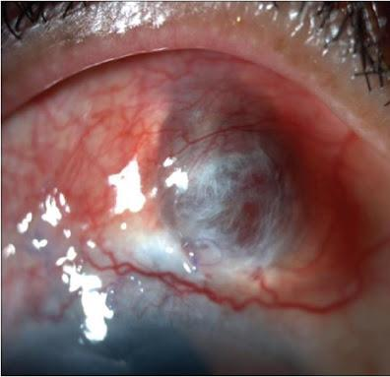
Scleritis
- Presentation: Extreme Pain (deep boring, wakes up at night) Red (purple) Photophobic Epiphora Possible vision loss
- Causes: Rheumatoid arthritis PAN SLE GPA Herpes zoster
- Diagnosis: Deep dark red Thin sclera Significant pain & photophobia
- Management: Eye casualty referral (often need systemic immunosuppression)

REFERRAL WITHIN 3 DAYS
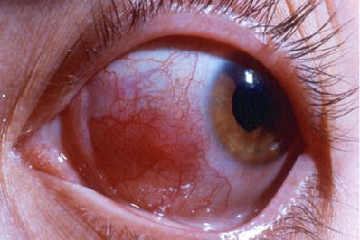
Episcleritis
- Presentation: Mild redness (usually localised) with mild discomfort
- Causes: Usually idiopathic and self-limiting
- Diagnosis: Sectoral redness Mild discomfort No photophobia or significant tenderness
- Management: Lubricants

