Oculoplastics Referral

REFERRAL WITHIN 12 HOURS
Orbital Cellulitis
- Presentation: Pre-septal cellulitis AND Conjunctival redness/swelling - Proptosis Pain on eye movements Reduced eye movements Reduced vision Fever
- Causes: Usually sinusitis
- Diagnosis: Lift the eyelid to have a look at the globe itself
- Management: Refer to A&E if systemically unwell, otherwise eye casualty
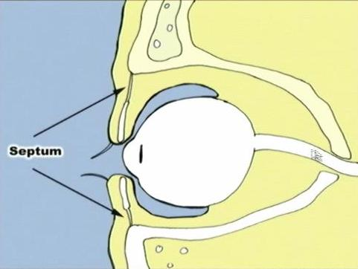

Position of infection related to septum

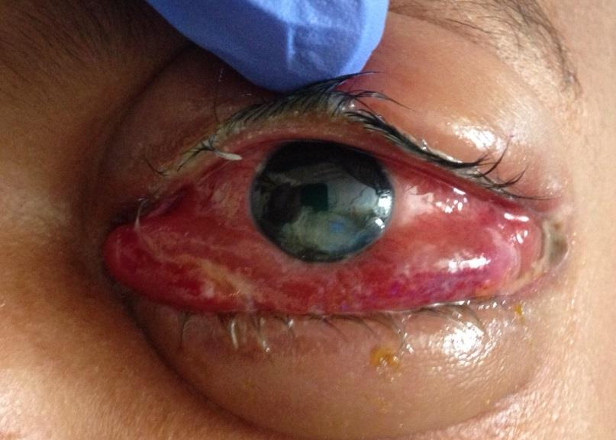

Infection behind septum
= Post-septal (Orbital) Cellulitis

REFERRAL WITHIN 24 HOURS
Pre-Septal Cellulitis
- Presentation: Eyelids are red/swollen/hot/tender/loss of function
- Causes: Usually skin-related (e.g. bite, trauma)
- Diagnosis: Lift the eyelid to have a look at the globe Lids will always be tender (cf conjunctivitis with swollen red non-tender lids)
- Management: Exclude orbital cellulitis Oral antibiotics (e.g. co- amoxiclav)
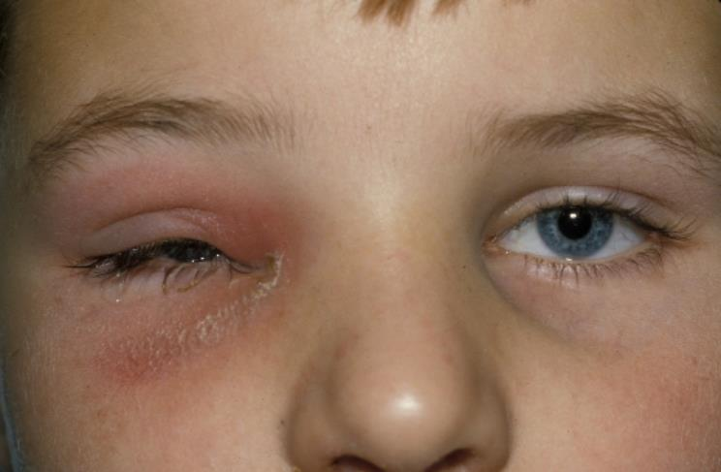
Infection in front of septum
= Pre-septal Cellulitis

ROUTINE CLINIC REFERRAL / COMMUNITY
Entropion / Ectropion (Clinic referral)
If significant pain / redness / watering / photophobia or vision loss, suggests possible corneal damage - Eye casualty within 3 days
Shingles
NO eye issues - GP management .If significant pain / redness / watering / photophobia or vision loss, suggests possible corneal ulceration - Eye casualty within 24 hours
Lid lumps (Clinic referral)
2 week cancer referral if appropriate

