IMMEDIATE REFERRAL
Central Retinal Artery Occlusion within 6 hours
- Presentation: Painless, Sudden loss of vision [“Stroke” of the retina ]
- Causes: Carotid embolism or GCA
- Diagnosis: Difficult without fundal exam
- Management: Refer for painless, sudden vision loss < 6 h
- See immediately if within 6 hours – Try to save retina from ischaemia
- See within 12 hours if beyond 6 hours – Determine cause and need for further investigation & management

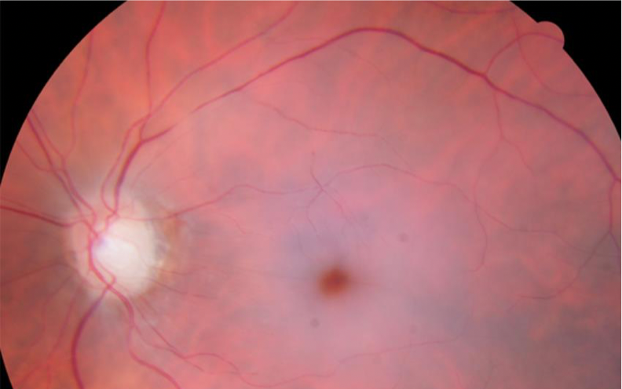

REFERRAL WITHIN 12 HOURS
Retinal tear / detachment
- Presentation: Flashes / Floaters / Field loss (if detachment) / Blurred vision (if macula-off)
- Causes: Short-sightedness, Age, Trauma
- Diagnosis: Need fundal exam for retinal tear vs detachment (but field loss or blurred vision suggest detachment)
- Management: Refer as per triage guidance May have laser treatment or surgery

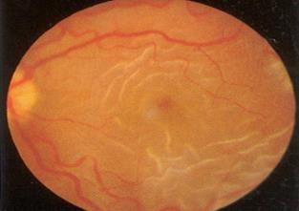
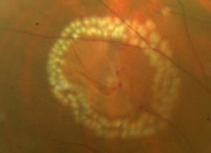
REFERRAL WITHIN 24 HOURS
Central Retinal Vein Obstruction
- Presentation: Painless, Sudden loss of vision
- Causes: HTN, DM, ↑ Chol
- Diagnosis: Difficult without fundal exam
- Management: Refer as per triage guidance
- Manage vascular risk factors
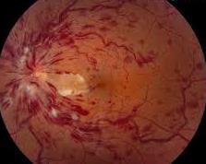
CLINIC REFERRAL / EYE CASUALTY TRIAGE
Wet AMD
- Presentation: Blurred or distorted vision
- Causes: Age Caucasian FHx Smoker (Dry = Wear & Tear; Wet = New leaky vessels)
- Diagnosis: Fundal exam Amsler chart
- Management: Rapid Access Referral
- Give intravitreal injections of anti-VEGF (e.g. Lucentis)
