Booking a Home Visit with the Paramedic Acute Visiting Service (PAVS)
There are two Electronic Patients Records (EPR) systems in Coventry, EMIS and VISION. This means there are two ways to refer patients into the PAVS. Please follow the normal referral criteria guidance, before this user guide to ensure that only appropriate patients are referred into the service, to ensure available capacity to those that need it. All telephone consultations completed by practices must be documented in the patient’s record, so the reason for the referral is available for the PAVS Clinician to review.

EMIS Practices
- Access Appointment Book.
Click , point to Appointments, and then select Appointment Book.
The Appointment Book is displayed.
- On the ribbon, click Find Slot and then select Find Cross-Organisation Slot.
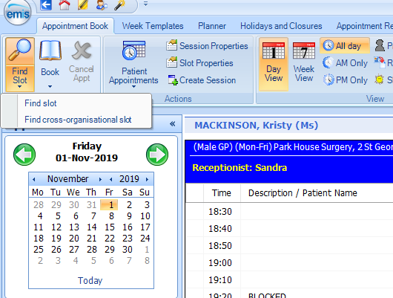
Organisation field will default to the Practice Name
- Click on Spy Glass next to Patient field to search for patient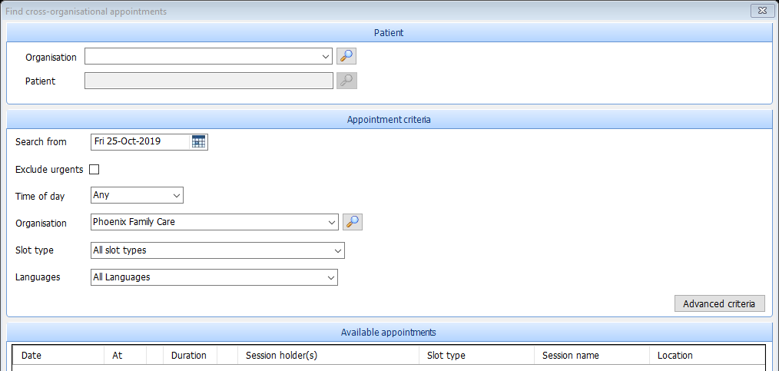

Mandatory Fields to search for patient: Family Name, Gender and DOB or alternatively search via NHS number
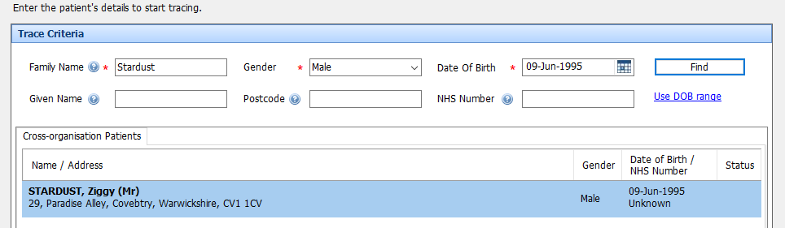
- Search using spy glass for Coventry and Rugby GP Alliance in ‘Location’ field: Once you have found this once you can use the drop-down menu to find the organisation.
- Under slot type filter to PAVS Home Assessment.
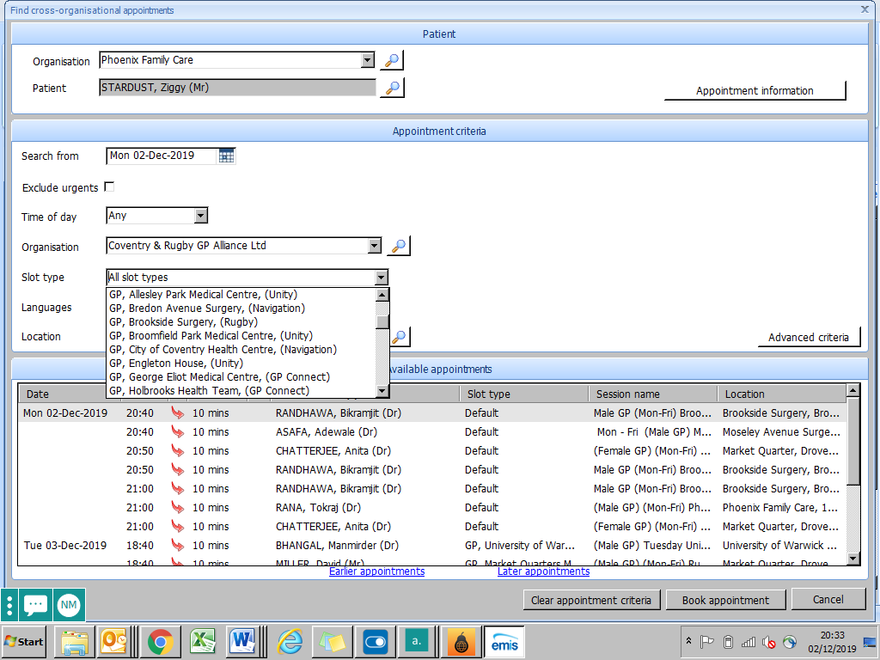
- Find suitable appointment and ‘Book Appointment’. Please ensure that you check the date of the patient’s appointment and ensure that the timescale matches the patients needs.
- Ask the patient for consent to share their full electronic health record with PAVS Clinician only – Click ‘Yes, this patient consents’
** Note (If the patient does not consent they cannot be seen in COVID-19 Hot Clinic service)
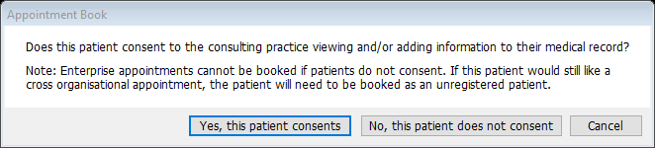

- Must enter GP name & contact number, along with patient’s telephone number in ‘Booking Notes’ and a reason for the appointment e.g. Fever, SOB.
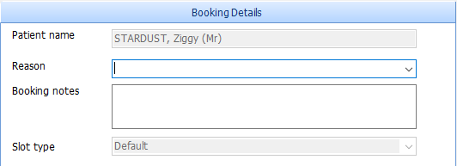
ENTER PATIENTS TEL NUMBER
- Click ‘Book Appointment’
If you want to cancel a Remote Consultation you must search for the patient within the Practice’s EMIS system, click Patient’s appointment and then cancel.
IMPORTANT: Whilst PAVS are operating an appointment booking system on EMIS, the times are a guide only; please do not promise a patient that the PAVS service will visit at the appointment time selected. The times are subject to change dependent upon other visits being more urgent.

VISION Practices
The Clinician must inform the patient of the referral to the PAVS and confirm the following:
- Patient consents for their information to be sent to PAVS Team.
- Please complete and send the PAVS Referral Form and send to crgpa.admin@nhs.net

IMPORTANT: On receipt of the referral the PAVS Paramedic will contact the GP as necessary to discuss the home assessment in more detail, in terms of appropriateness and to agreed actions following home assessment. To enable this process please ensure that the referring GPs contact details are within the referral.

