This clinic has been set up to allow more rapid access to Rheumatology services for assessment of patients with painful, stiff or swollen joints which may represent the onset of rheumatoid arthritis. It is not for patients with probable osteoarthritis or widespread pain symptoms.
Research has clearly shown that the best outcomes for rheumatoid arthritis sufferers are achieved when it is treated early, ideally within three months from the onset of persistent symptoms. Patients, however, often do not show signs of classical rheumatoid arthritis in the early stages of the disease and may, surprisingly, have little pain, normal inflammatory markers (ESR and CRP) and negative blood tests for Rheumatoid factor and anti-CCP antibody. Early morning stiffness of the small joints ( hands, wrists and feet), usually lasting at least thirty minutes, however, is a typical feature and swelling of varying degrees, is also very common. Ask yourself has this patient got the ‘S’ factor? This was a public awareness campaign launched in 2011 which aimed to highlight the early features of RA. Posters are available to download and print off or to be sent by post from NRAS.
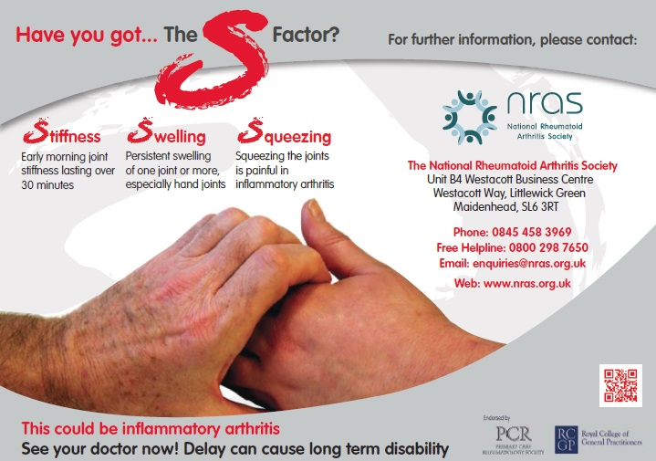
http://www.nras.org.uk/have-you-got-the-s-factor-
Referral to this clinic is via E-referrals like all other services at UHCW. It is listed specifically as ‘Early Arthritis Clinic’. Please advise patients to stop taking any NSAIDs for 24 hours beforehand and DO NOT prescribe steroids before referral. Simple analgesics like paracetamol or codeine can be prescribed, thank you.
PLEASE NOTE THE REFERRAL CRITERIA:
Patient must have symptoms of joint pain present for at least 4 weeks but LESS than one year
Early morning stiffness in joints of > 30 mins

PLUS either of the following:

- 2 or more swollen joints
- Tender metacarpophalangeal joints hands by squeeze test
NB It is not for patients with probable osteoarthritis, widespread pain symptoms or raised inflammatory markers ? cause patients.
If your patient is systemically unwell with raised ESR /CRP please discuss with medical Registrar on call.

If your patient has developed an acutely swollen, hot joint which may be septic or gouty in origin please contact the Registrar on call in Orthopaedics or Rheumatology to discuss the patient that day.
The E-referral will be reviewed by a Consultant and if felt appropriate for this particular clinic, an appointment will be sent out to the patient directly. If not, then a routine appointment will be made in the general clinics and the referring GP will be informed of the outcome. Please ensure we have up to date contact details, including a mobile telephone number for the patient, on the form.
For those confirmed with inflammatory arthritis, follow up appointments will be arranged approximately every 4-6 weeks in order to escalate the treatment until the disease activity is felt to be either in remission or at the lowest level possible for that particular patient. Please note that a summary letter outlining the patient's history, joints affected, analgesics and anti-inflammatories used together with previous medical history is also required.

