

**[The Third International Consensus Definition for Sepsis](https://www.ncbi.nlm.nih.gov/pmc/articles/PMC4968574/)**

**“A life-threatening organ dysfunction due to a dysregulated host response to infection.”**

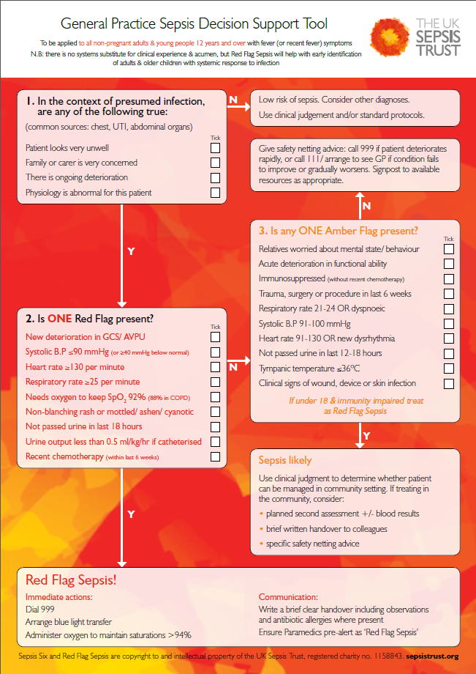

**Useful sepsis screening tools can be found on the links below for the appropriate age ranges:**

* [General Practice for all children aged 0-4.](https://sepsistrust.org/wp-content/uploads/2018/06/OOH-and-GP-telephone-triage-u5-NICE-Final-3.pdf)
* [General Practice for all children aged 5 to 11.](https://sepsistrust.org/wp-content/uploads/2018/06/OOH-and-GP-telephone-triage-5-11-NICE-Final-3.pdf)
* [General Practice for all patients aged 12 and over.](https://sepsistrust.org/wp-content/uploads/2018/06/OOH-and-GP-telephone-triage-Adult-NICE-Final-3.pdf)
* [General Practice; for all women who are pregnant, or who have given birth in the last 6 weeks](https://sepsistrust.org/wp-content/uploads/2018/06/OOH-and-GP-telephone-triage-Maternal-NICE-Final-3.pdf)

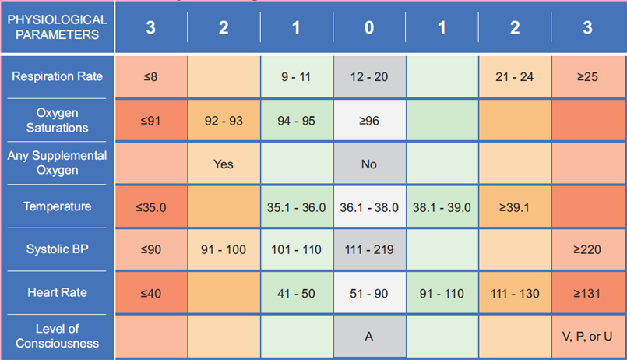

[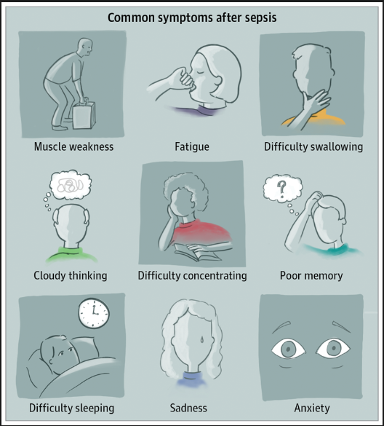](https://www.australiansepsisnetwork.net.au/awareness/highlighting-post-sepsis-syndrome)

**National Early Warning Score Chart (NEWS):**

* [**National Early Warning Score:** National Clinical Guideline No. 1](http://health.gov.ie/wp-content/uploads/2015/01/NEWSFull-ReportAugust2014.pdf)
* [New approach to NHS clinical assessment could save thousands of lives](https://www.england.nhs.uk/2017/12/new-approach-to-nhs-clinical-assessment-could-save-thousands-of-lives/)

[](https://www.uhcw.nhs.uk/news/sepsis-and-me/)

**[Click here to enlarge picture:](https://www.australiansepsisnetwork.net.au/awareness/highlighting-post-sepsis-syndrome)**

Click below for more information

* [Post Sepsis Syndrome:](http://www.sepsis.org/life-after-sepsis/post-sepsis-syndrome/)
* [Post sepsis Syndrome:](https://sepsistrust.org/post-sepsis-syndrome/)