Diabetic Foot Screening Checklist:
Complete at least once a year for all patients with Diabetes.
Complete the screening fully and record your findings.
- Ask the patient if they have:
  - Been having any problems with their feet?
  - Noticed any changes in skin colour or temperature?
  - Noticed any changes in feeling – tingling, numbness, and/or pains?

- Look at the patient’s socks and shoes:
  - A lot of patients do not wear socks which can increase the risk of friction stress on the foot – always recommend wearing well-fitting socks that are not too tight on the legs
  - Poorly fitting, or inappropriate style of footwear is one of the biggest causes of foot complications. Shoes should be supportive with a good thick sole and firm fastening (Velcro/lace/buckle). Check that the toe area is wide enough and deep enough for the shape of the toes.

- Examine the foot with the socks and shoes removed:
  - Do both feet look the same? Deformity of one foot around the ankle and mid foot can be an indication of Charcot foot. If the foot is hot, red, inflamed, and swollen refer to WISDEM Foot clinic for URGENT assessment and x-ray
  - Are there any cuts, wounds or ulcerations present? All active ulcerations should be referred immediately to WISDEM foot clinic for URGENT triage and assessment.
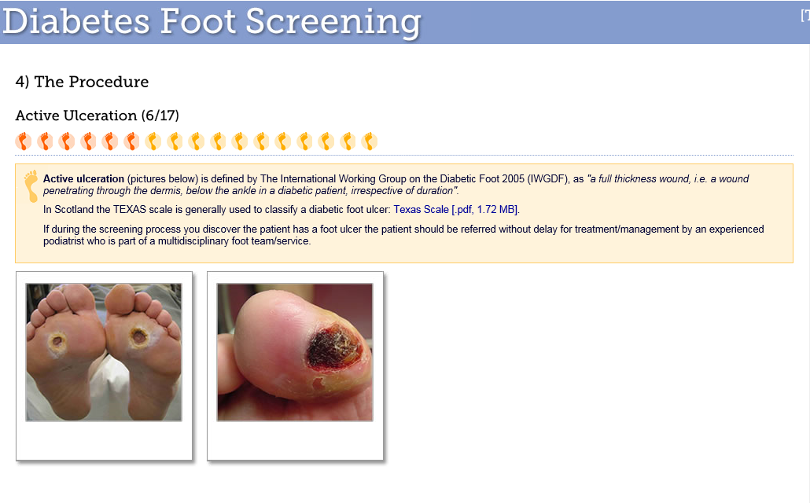

  - What is the skin colour and temperature like? Shiny, red, hairless skin can indicate peripheral arterial disease
  - What is the skin condition like? Is there any scar tissue or previous healed ulceration sites? Previous ulcerations are a risk factor for foot complications
  - Previous amputations are a risk factor for foot complications
  - Foot/toe deformities which increase the bony lumps and bumps on the feet, and clawing of the toes and pes cavus foot shape which can be indication of motor neuropathy, are risk factors for foot complications
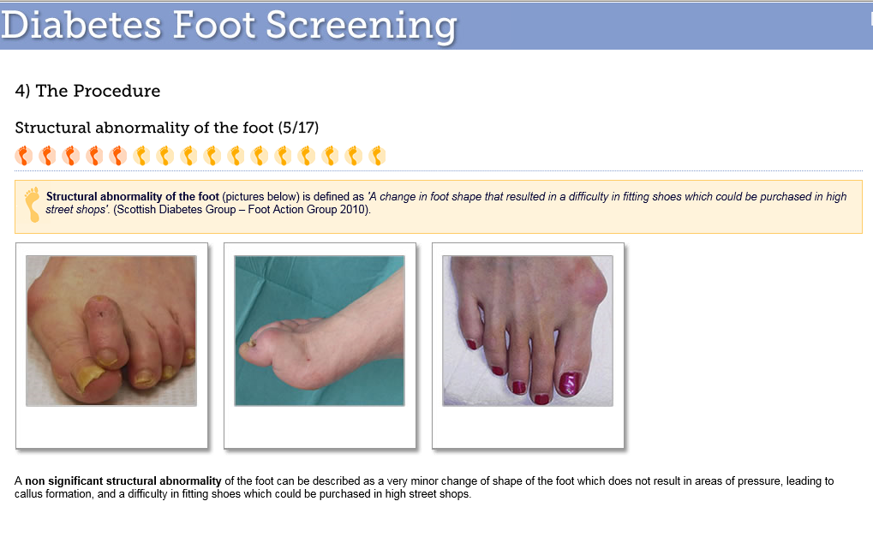

  - Significant callus (not just a bit of rough or hard skin, but something that looks as if it needs a blade to remove it!) is a risk factor for foot complications
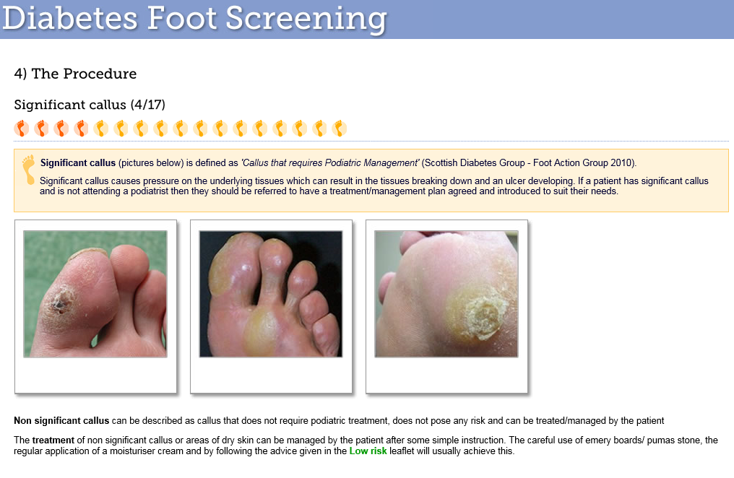
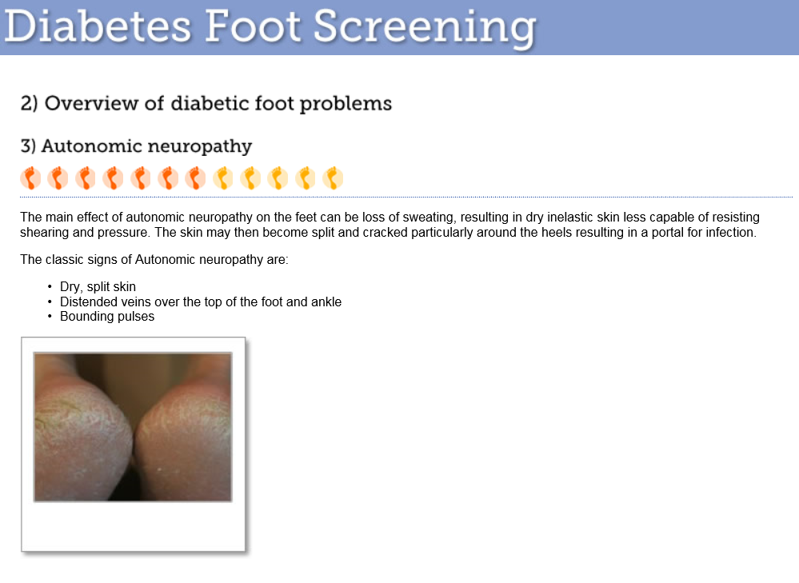
  - Very dry skin with split or fissured heels can be an indication of autonomic neuropathy and is a risk factor for foot complications.
Advise daily use of a good thick emollient across the whole of the foot but avoiding between the toes.

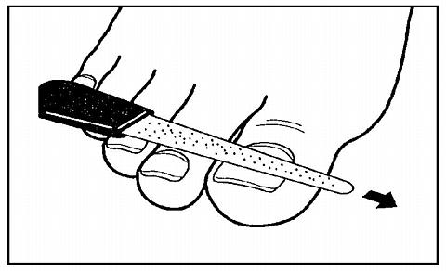

  - Look at the toe nails. Normal healthy nails, thick nails, and fungal nails can all be easily and safely managed with an emery board. If patients have no other risk factors it is fine for family and friends to help with this or for them to see a private Podiatrist.

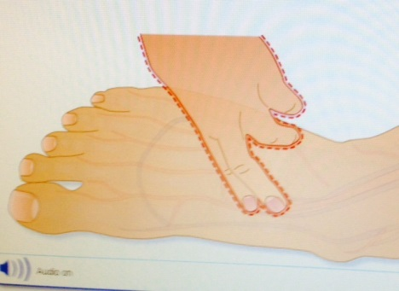
- Vascular Testing:
  - Palpate the Dorsalis Pedis pulse of both feet. Check for strength and regularity. 10% population do not have a DP pulse

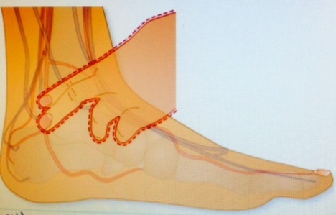
  - Palpate the Posterior Tibial pulse of both feet. Check for strength and regularity. Bounding pulses can indicate

- Neurological Testing:
  - Explain that it is a pressure test and will not be painful.
  - Show the patient what the 10g monofilament feels like by using it on your arm first and then on the patients arm.
  - Ask them to close their eyes and say ‘yes’ when they feel it touch their feet
  - See the chart below for test sites. You can test the top of the midfoot first as this is easy for most people to feel. The heel can also be tested but due to its thickness, it is common for people not to feel it here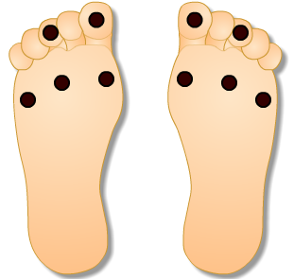
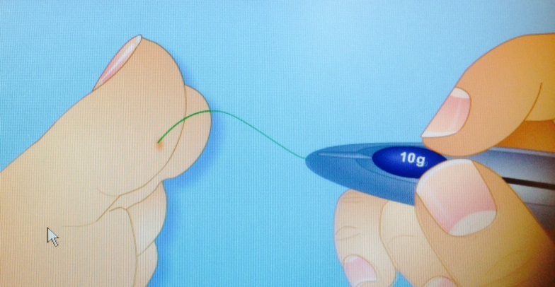
  - Apply the monofilament tip to the sites perpendicularly. Touch the skin for one second, letting the tip buckle, and remove it. Do not stab at it repeatedly

  - If the patient cannot feel the test, do not repeat it in the same place again.

What to do next?
- If a patient has no risk factors: tell them they are ‘LOW RISK’ and do not refer them to CWPT Podiatry. Provide as much foot care and foot wear advice as is needed and continue to screen them each year
- If a patient has one risk factor: tell them they are ‘MODERATE RISK’ of developing foot complications and refer them to CWPT Podiatry. We will assess them and provide ongoing management, or discharge them with advice
- If a patient has more than one risk factor: tell them they are ‘HIGH RISK’ of developing foot complications and refer them to CWPT Podiatry. We will assess them and provide ongoing management.
- If a patient has an active foot ulceration or suspected Charcot refer them to WISDEM foot clinic for URGENT triage and assessment
- For all life or limb threatening emergencies, send the patient to A&E or the GPAU at UHCW immediately

ALWAYS SHARE THE RESULTS OF YOUR LATEST FOOT SCREENING TEST WITH THE SERVICE YOU ARE REFERRING TO

